UNIVERSITY OF BUEA
FET
COMPUTER Eng. DEPARTMENT

Assignment: Wash house Database Management (Online System)

COURSE CODE &TITLE: DATABASE MANAGEMENT SYSTEM PRACTICE CEF304

by,
Mondjo Tchelibou Perside Rosalie FE14A137

Database For a Wash House Web Site
Requirements:
- The database is required to store and manage all the data conserning the online customers of a wash house, that is payement of all their services on the online platform of the wash house in question.
- A table 'Users' keeps trac of all the users.
- A table 'Orders' keeps trac of the commands or orders given by the users.
- A table 'ContactUs' store and records all the comments and feedback on the platform.
- A table 'Users_has_Orders' records the users request and orders including quantity ordered.
- The database should manage the account for all users and include privacy for each account.
- Use of passwords

Softwares used:
- Ubuntu14 OS
- MySql-Work-Bench
- Sublime text editor
- LiberOffice Writer
Hardwares used:
- Hp laptop
- 4G RAM capacity
- Dual core
- 500G hard disk space

ER-Diagram:
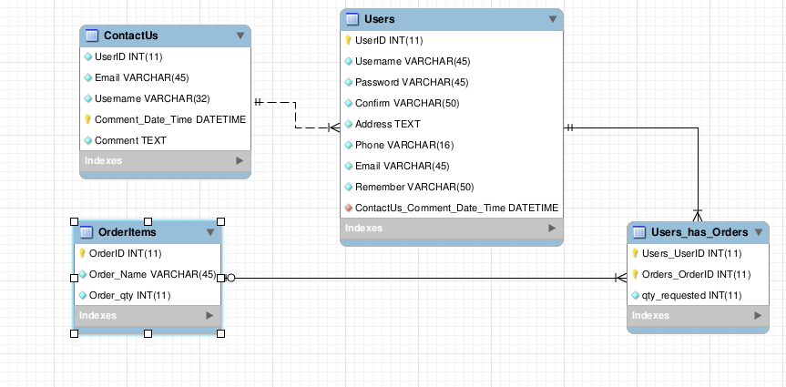
Source Code:

SET @OLD_UNIQUE_CHECKS=@@UNIQUE_CHECKS, UNIQUE_CHECKS=0;
SET@OLD_FOREIGN_KEY_CHECKS=@@FOREIGN_KEY_CHECKS, FOREIGN_KEY_CHECKS=0;
SET@OLD_SQL_MODE=@@SQL_MODE,SQL_MODE='TRADITIONAL,ALLOW_INVALID_DATES';

CREATE SCHEMA IF NOT EXISTS `Site` DEFAULT CHARACTER SET latin1 ;
USE `Site` ;

-- -----------------------------------------------------
-- Table `Site`.`ContactUs`
-- -----------------------------------------------------
CREATE TABLE IF NOT EXISTS `Site`.`ContactUs` (
`UserID` INT(11) NOT NULL,
`Email` VARCHAR(45) NOT NULL,
`Username` VARCHAR(32) NOT NULL,
`Comment_Date_Time` DATETIME NOT NULL,
`Comment` TEXT NOT NULL,
PRIMARY KEY (`Comment_Date_Time`))
ENGINE = InnoDB
DEFAULT CHARACTER SET = latin1;

-- -----------------------------------------------------
-- Table `Site`.`Orders`
-- -----------------------------------------------------
CREATE TABLE IF NOT EXISTS `Site`.`Order` (
`OrderID` INT(11) NOT NULL,
`Order_Name` VARCHAR(45) NOT NULL,
`Order_qty` INT(11) NOT NULL,
PRIMARY KEY (`OrderID`))
ENGINE = InnoDB
DEFAULT CHARACTER SET = latin1;

-- -----------------------------------------------------
-- Table `Site`.`Users`
-- -----------------------------------------------------
CREATE TABLE IF NOT EXISTS `Site`.`Users` (
`UserID` INT(11) NOT NULL AUTO_INCREMENT,
`Username` VARCHAR(45) NOT NULL,
`Password` VARCHAR(45) NOT NULL,
`Confirm` VARCHAR(50) NOT NULL,
`Address` TEXT NOT NULL,
`Phone` VARCHAR(16) NOT NULL,
`Email` VARCHAR(45) NOT NULL,
`Remember` VARCHAR(50) NOT NULL,
`ContactUs_Comment_Date_Time` DATETIME NOT NULL,
PRIMARY KEY (`UserID`),
UNIQUE INDEX `Email` (`Email` ASC),
INDEX `fk_Users_ContactUs_idx` (`ContactUs_Comment_Date_Time` ASC),
UNIQUE INDEX `ContactUs_Comment_Date_Time_UNIQUE` (`ContactUs_Comment_Date_Time` ASC),
CONSTRAINT `fk_Users_ContactUs`
FOREIGN KEY (`ContactUs_Comment_Date_Time`)
REFERENCES `Site`.`ContactUs` (`Comment_Date_Time`)
ON DELETE NO ACTION
ON UPDATE NO ACTION)
ENGINE = InnoDB
AUTO_INCREMENT = 4
DEFAULT CHARACTER SET = latin1;

-- -----------------------------------------------------
-- Table `Site`.`Users_has_Orders`
-- -----------------------------------------------------
CREATE TABLE IF NOT EXISTS `Site`.`Users_has_Orders` (
`Users_UserID` INT(11) NOT NULL,
`Orders_OrderID` INT(11) NOT NULL,
`qty_requested` INT(11) NOT NULL,
PRIMARY KEY (`Users_UserID`, `Orders_OrderID`),
INDEX `fk_Users_has_Orders_Orders1_idx` (`Orders_OrderID` ASC),
INDEX `fk_Users_has_Orders_Users1_idx` (`Users_UserID` ASC),
CONSTRAINT `fk_Users_has_Orders_Users1`
FOREIGN KEY (`Users_UserID`)
REFERENCES `Site`.`Users` (`UserID`)
ON DELETE NO ACTION
ON UPDATE NO ACTION,
CONSTRAINT `fk_Users_has_Orders_Orders1`
FOREIGN KEY (`Orders_OrderID`)
REFERENCES `Site`.`Orders` (`OrderID`)
ON DELETE NO ACTION
ON UPDATE NO ACTION)
ENGINE = InnoDB
DEFAULT CHARACTER SET = latin1;

SET SQL_MODE=@OLD_SQL_MODE;
SET FOREIGN_KEY_CHECKS=@OLD_FOREIGN_KEY_CHECKS;
SET UNIQUE_CHECKS=@OLD_UNIQUE_CHECKS;

OutPut:
