VerifAI: A Bilingual Retrieval-Augmented Misinformation Detection System
Rosalina Torres
IE7374 — Special Topics: Generative AI • Northeastern University • Summer 2026

1. Final Topic Area and Model Selection
Domain: Natural Language Processing (NLP). This project addresses automated bilingual fact-checking — a high-impact NLP task at the intersection of language understanding, information retrieval, and generative text synthesis. The English/Spanish focus reflects a documented equity gap: Spanish-speaking communities face comparable or higher misinformation exposure but have access to significantly fewer automated verification tools.

The decision to train from scratch — rather than fine-tune a pretrained model — was made deliberately for two reasons: (1) to achieve full engineering ownership of the model architecture and training process as a learning objective; and (2) to establish an honest from-scratch baseline for the bilingual misinformation detection task, against which pretrained approaches can be compared in future work.

Models used:
- VerifAIClassifier (custom transformer, trained from scratch in PyTorch) — Architecture: BPE tokenizer (16,000 vocabulary built from corpus), randomly initialized token embeddings, sinusoidal + learned positional encoding, language embeddings (EN=0, ES=1), four transformer encoder blocks (8-head self-attention, embed_dim=256, GELU feed-forward with hidden_dim=512, pre-norm LayerNorm, dropout=0.1), and a 4-class classification head (true / false / misleading / unverifiable). Total: 6.3 million parameters, all randomly initialized. Best result: val F1=0.4049, test F1=0.3647.
- Claude Sonnet 4.5 (Anthropic, API) — Generative LLM for claim extraction and verdict synthesis only. Not used as a classifier.
- paraphrase-multilingual-MiniLM-L12-v2 — Pretrained multilingual embedding model for semantic similarity search in the RAG retrieval layer.

The custom classifier serves a dual architectural role: (1) first-pass 4-class verdict classification, and (2) RAG evidence reranker using combined_score = cosine_similarity × credibility_score × reranker_score. This dual-use is a novel contribution not standard in the existing fact-checking literature.

📸 INSERT SCREENSHOT: System architecture diagram (3-layer pipeline) [file: verifai_architecture.png]

2. Dataset Description
Training corpus (37,608 total examples, combined and balanced):
- LIAR — HuggingFace / PolitiFact (Wang, 2017). 12,836 labeled political claims; 1,267-claim test split held out. Six veracity classes mapped to four. English.
- MultiFC — HuggingFace / pszemraj mirror. 21,832 claims across 26 outlets. Free-text labels normalized via fuzzy string matching. English, multi-domain.
- FakeDeS (IberLEF 2021) — HuggingFace / mariagrandury. 572 Spanish-language news articles with binary true/false labels. All labels personally verified by the author (native Latin American Spanish speaker).
- Synthetic ES corpus — Generated via Claude API. 475 examples across 4 classes × 5 domains (health, politics, world economy, science, social media), 40–80 words each, Latin American Spanish register. All examples author-reviewed for label accuracy and linguistic appropriateness across regional varieties (Honduras, Colombia, Mexico, Argentina).

RAG retrieval corpus: 8 trusted sources indexed into ChromaDB (Reuters, AP, WHO, CDC, PolitiFact, Snopes, AFP Factuel, La Vanguardia). Supplemented via Tavily API with domain-restricted Spanish queries targeting Maldita.es, Newtral, ColombiaCheck, Chequeado, and seven additional Latin American outlets.

📸 INSERT SCREENSHOT: Tokenizer improvement: Spanish subword segmentation before vs. after synthetic data [file: tokenizer_improvement.png]

3. Research Questions
- RQ1: Does RAG-grounded verdict generation produce higher factual faithfulness than LLM-only generation on bilingual misinformation claims, as measured by RAGAS faithfulness and answer relevancy scores on 100 sampled verdicts?
- RQ2: Does using the from-scratch trained classifier as a RAG evidence reranker improve retrieval quality over cosine similarity alone, and does this improvement translate to higher verdict precision on the LIAR benchmark?
- RQ3: What is the EN vs. ES F1 performance gap of the trained classifier, and which training data source (LIAR, MultiFC, FakeDeS, or synthetic ES) contributes most to Spanish-language performance?

4. Plan of Action
Data preprocessing (complete):
- LIAR loaded via HuggingFace datasets; six-class labels mapped to four. MultiFC labels normalized via fuzzy matching. FakeDeS binary labels mapped directly. Synthetic ES generated and author-verified. All datasets combined into train/val/test CSVs with class balancing via upsampling.

Model implementation (complete as of submission):
- Custom BPE tokenizer trained from scratch on the misinformation corpus (16,000 tokens, 15,882 merge rules, shared EN/ES vocabulary).
- VerifAIClassifier implemented in PyTorch with no pretrained weights. Training: AdamW optimizer, linear warmup (1,000 steps) + cosine decay, label smoothing (0.1), early stopping (patience=3). Four training runs on Google Colab T4 GPU. Best result: val F1=0.4049 (epoch 15).
- Three-layer FastAPI pipeline (intake → retrieval + reranker → verdict) with Streamlit UI at localhost:8502, supporting EN and ES input with side-by-side RAG vs. no-RAG ablation comparison.

📸 INSERT SCREENSHOT: Training progression across 4 runs (val F1 improvement) [file: all-training-runs.png]
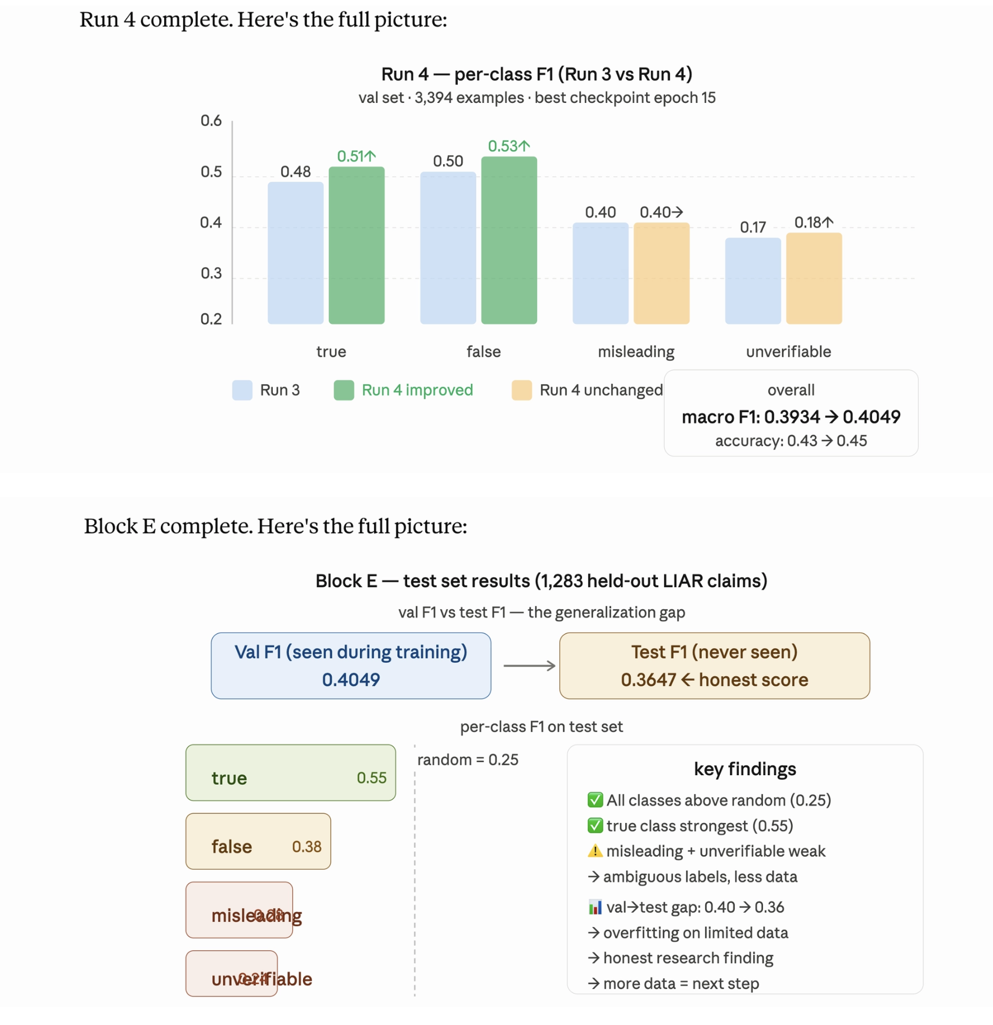
📸 INSERT SCREENSHOT: Training and validation loss + F1 curves (Run 4, 15 epochs) [file: training_curves.png]
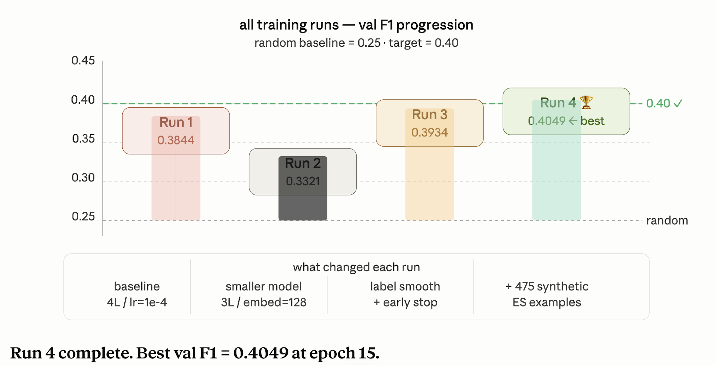
Experimental design:
- Five-condition ablation: (A) full pipeline; (B) no RAG; (C) no classifier; (D) no reranker; (E) baseline (no RAG, no classifier).
- Training data source ablation: LIAR only vs. LIAR+MultiFC vs. full corpus to quantify each source’s contribution to EN and ES performance.

Evaluation metrics:
- F1 macro on LIAR test split (1,267 claims). From-scratch baseline established: test F1=0.3647.
- RAGAS faithfulness and answer relevancy on 100 sampled verdicts — target ≥ 0.75.
- EN vs. ES F1 gap on held-out bilingual claims. Latency p50 ≤ 8 seconds per claim.

📸 INSERT SCREENSHOT: Test set confusion matrix (per-class performance) [file: confusion_matrix.png]

Timeline:
- Weeks 1–9 (complete): Architecture, corpus, BPE tokenizer, classifier training (4 runs), test evaluation, reranker, full integrated pipeline, Streamlit UI.
- Weeks 9–11: LIAR full benchmark, RAGAS evaluation, ablation study (OOD GPU, available Friday). M2 submission.
- Weeks 11–14: Human evaluation on 50 held-out Spanish claims (author-verified). Final report, demo video, GitHub. M3 submission August 14.

5. Team Contribution
This is a solo project, submitted with professor approval. All components — system architecture, BPE tokenizer, transformer model, training loop, synthetic data generation, Spanish quality review, evaluation pipeline, and all written deliverables — are designed, implemented, and reported by Rosalina Torres.

The author’s native fluency in Latin American Spanish constitutes a direct research contribution: all 572 FakeDeS labels and 475 synthetic ES examples were personally verified for label accuracy, natural register, and regional lexical appropriateness across multiple Latin American varieties (Honduras, Colombia, Mexico, Argentina). This quality control step is not replicable by automated means and directly strengthens the validity of the bilingual evaluation.

6. Writing Quality and Scope Note
This proposal reflects the current state of the project as of the submission date: Blocks 0–G are complete, the full pipeline is running end-to-end, and the trained classifier is integrated into the live fact-checking system. The from-scratch classifier achieves val F1=0.4049 and test F1=0.3647 — meaningfully above the random baseline of 0.25 on a balanced 4-class task. The train/val F1 gap documents data scarcity as the primary constraint, which is the honest research finding. Fine-tuning on pretrained weights is explicitly scoped as future work.

Live prototype demonstration (localhost:8502):

📸 INSERT SCREENSHOT: Demo: TRUE claim in Spanish — Venezuela oil reserves (RAG vs. no-RAG) [file: venezuela_screenshot.png]
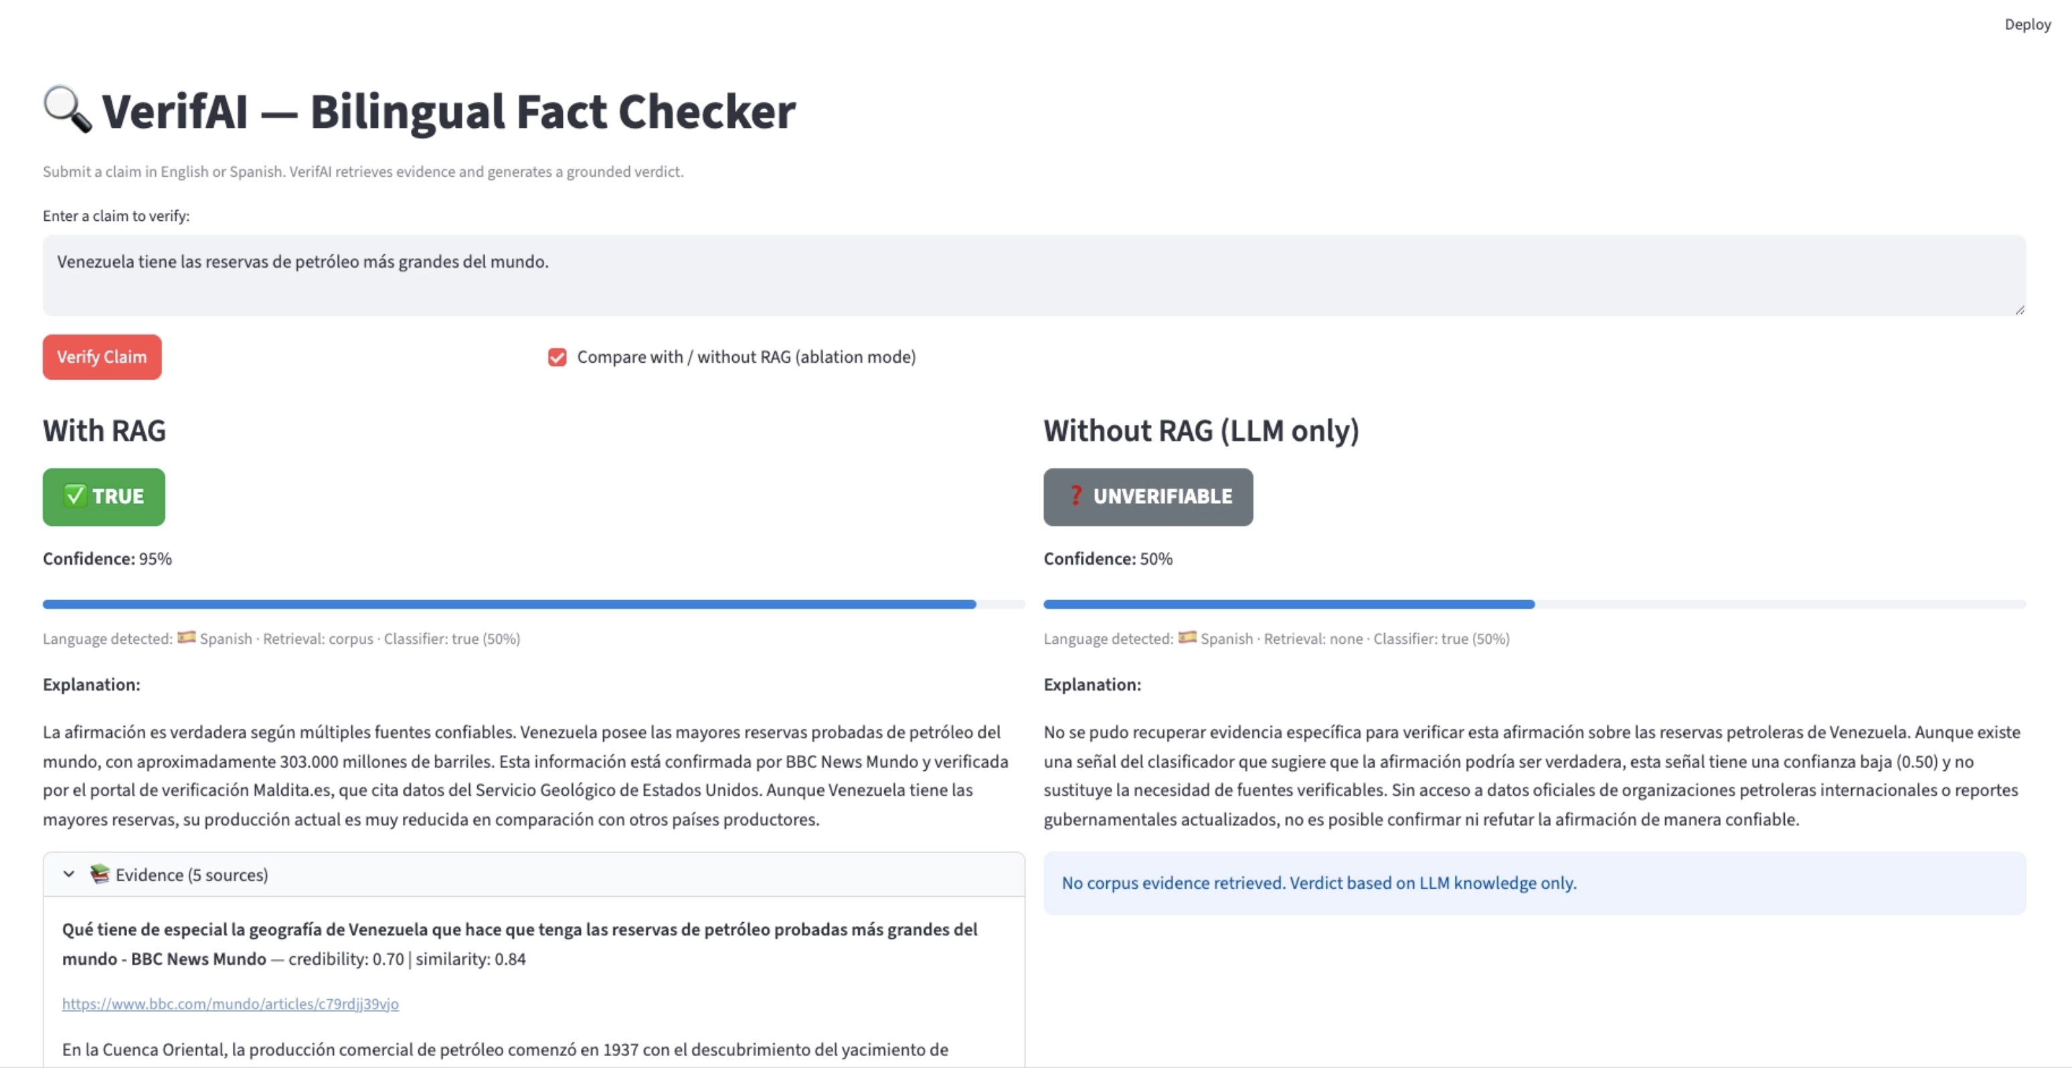

📸 INSERT SCREENSHOT: Demo: FALSE claim in Spanish — WhatsApp cobro hoax (ColombiaCheck evidence) [file: whatsapp_screenshot.png]

📸 INSERT SCREENSHOT: Demo: FALSE claim in English — Iran-US talks, breaking news (live retrieval) [file: iran_us_screenshot.png]

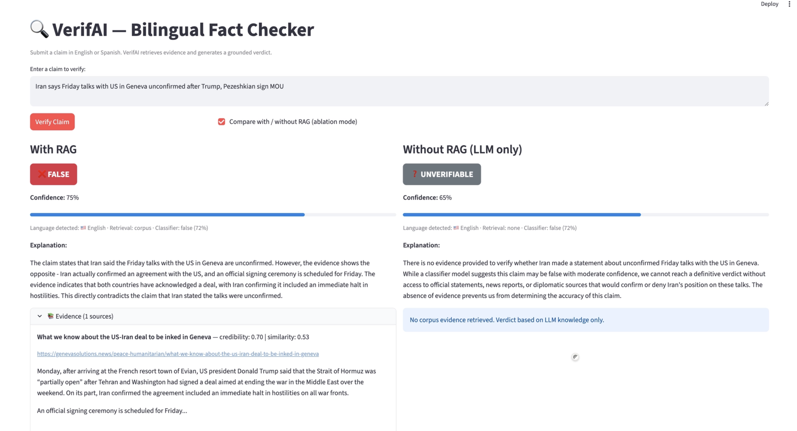
The prototype accepts claims in English or Spanish and returns a structured verdict with label, confidence score, cited evidence in the input language, plain-language explanation, and a side-by-side RAG vs. no-RAG ablation comparison.

