Driver Board and Motor Instructions

Preparing the motor for the driver board.

A small modification to the wiring for the 28BYJ-48 stepper motor is is required for it to work with the GRBL CNC driver board.

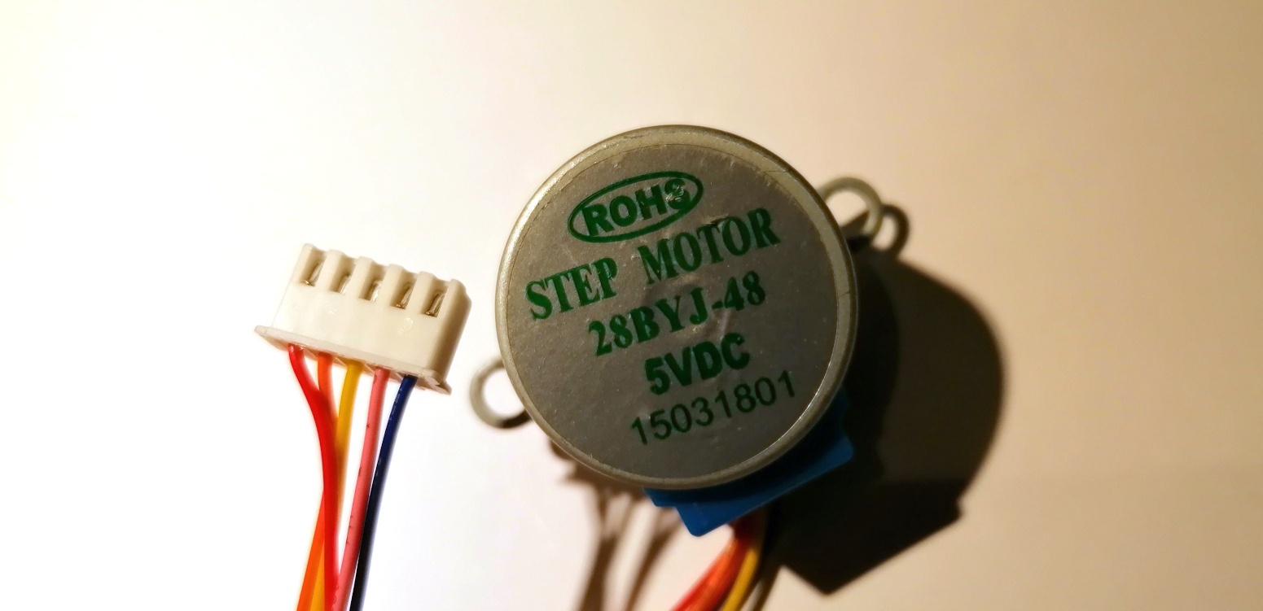

Press the retaining tab on the pin for the red wire to release it. The red wire is not required.

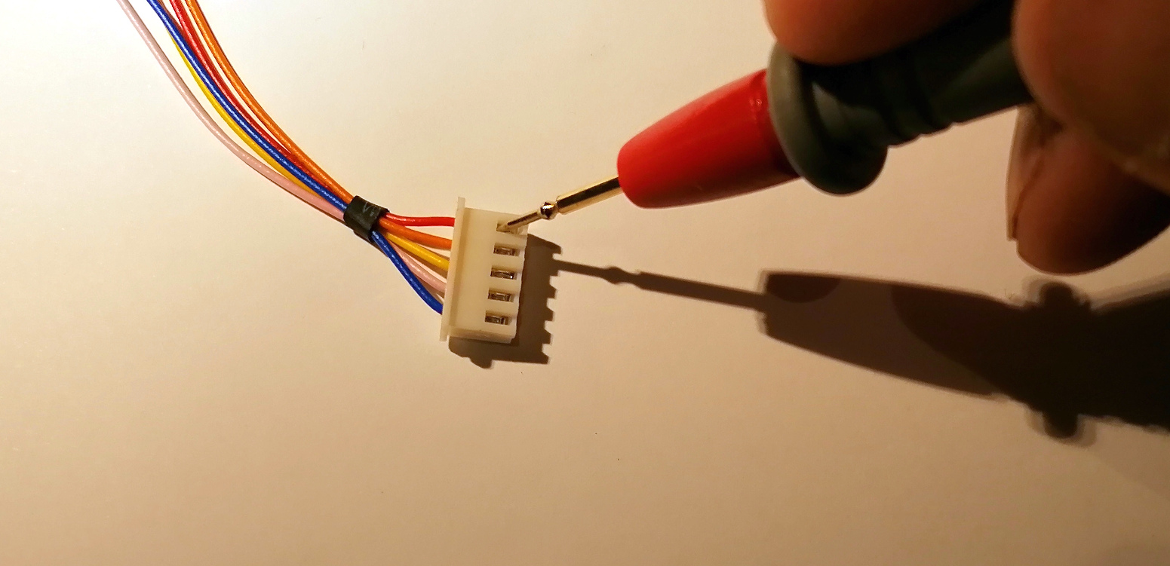

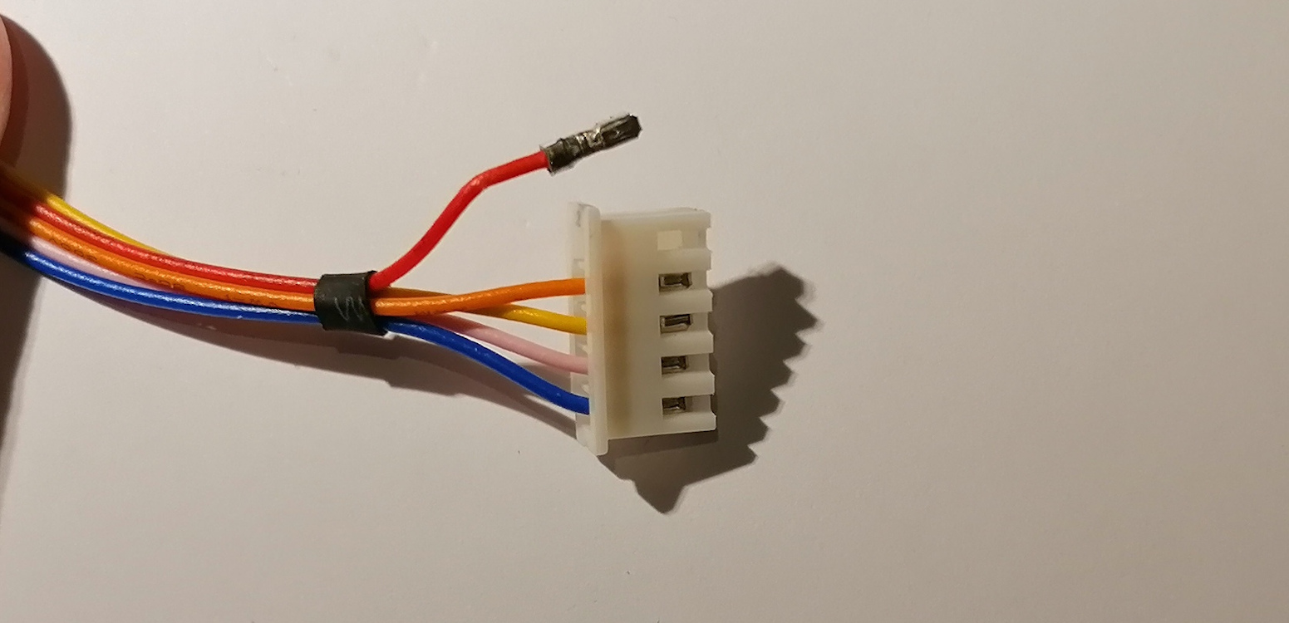

Now release and swap the pink and yellow wires.

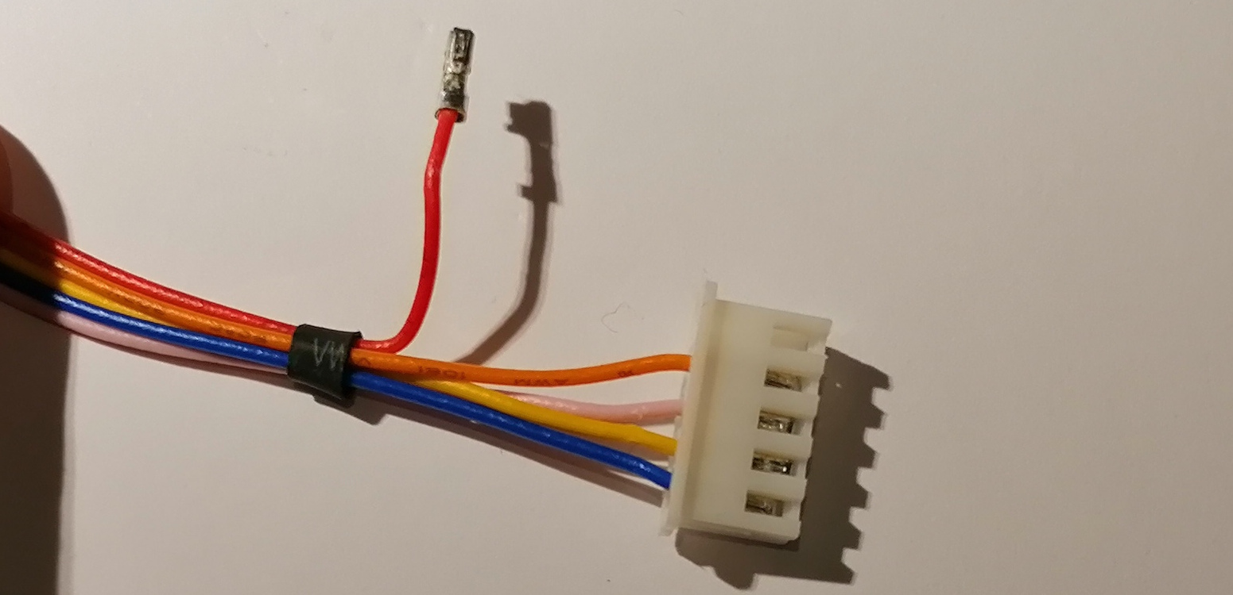

Plug the connector into the board as shown below. It’s a good idea to snip the red wire at the black rubber collar.

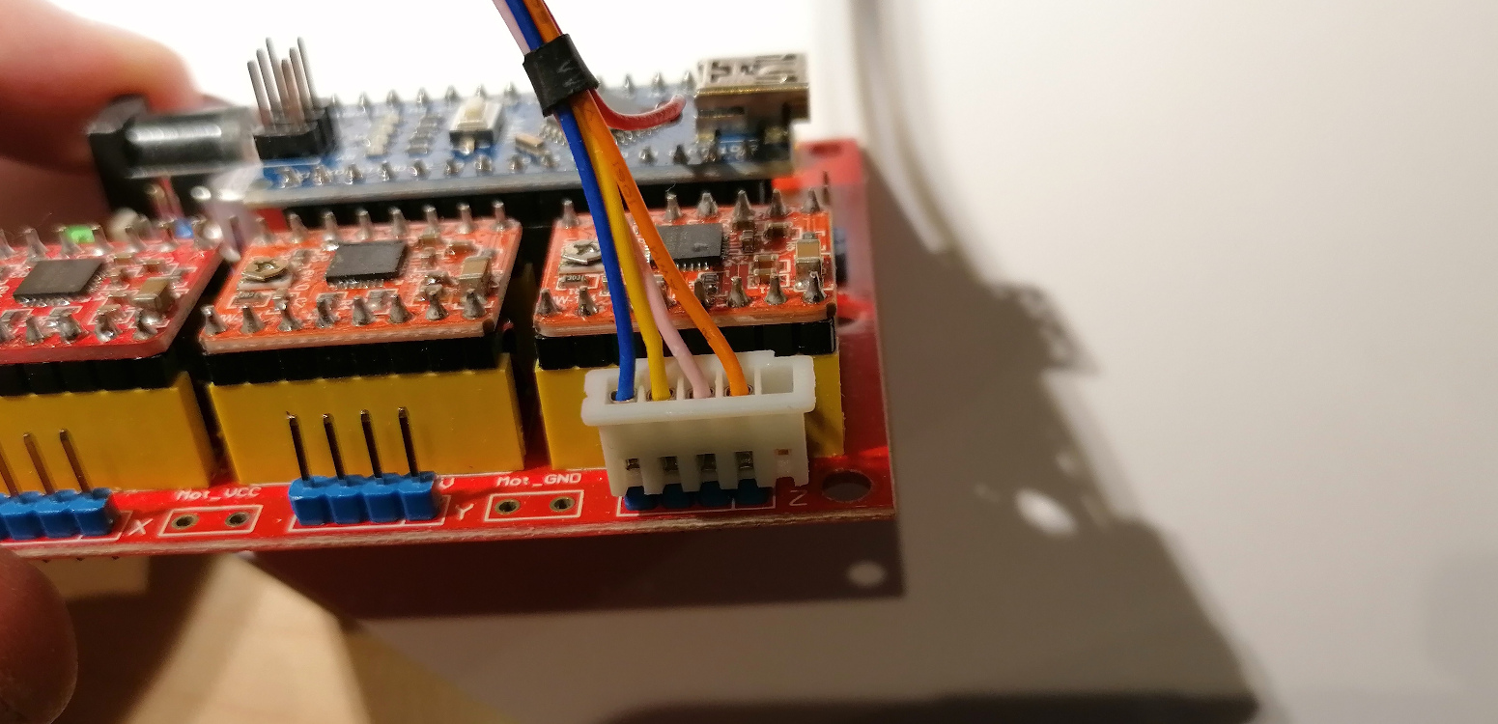

Now do the same for the other two motors.

