Instructions

Parts list

- 3 x 28BYJ-48 stepper motor
- GRBL CNC Driver board V3 or V4
- Arduino Nano
- 12 x m3 x 10 mm self tapper screws
- 3 x m3 c 20 mm hex bolts
- 4 x m3 nuts
- 1 x m3 x 10 cap head bolt
- Optional Spiral Spring (5mm OD 8mm Length Light Load Compression Mould Die Spring)

3d printed parts

- Base.stl
- DeltaBot_Top.stl
- SlideClip.stl
- DeltaBot_Bottom.stl
- LED_Post.stl
- ThumbWheel.stl

Preparing the motor for the driver board.

A small modification to the wiring for the 28BYJ-48 stepper motor is is required for it to work with the GRBL CNC driver board.

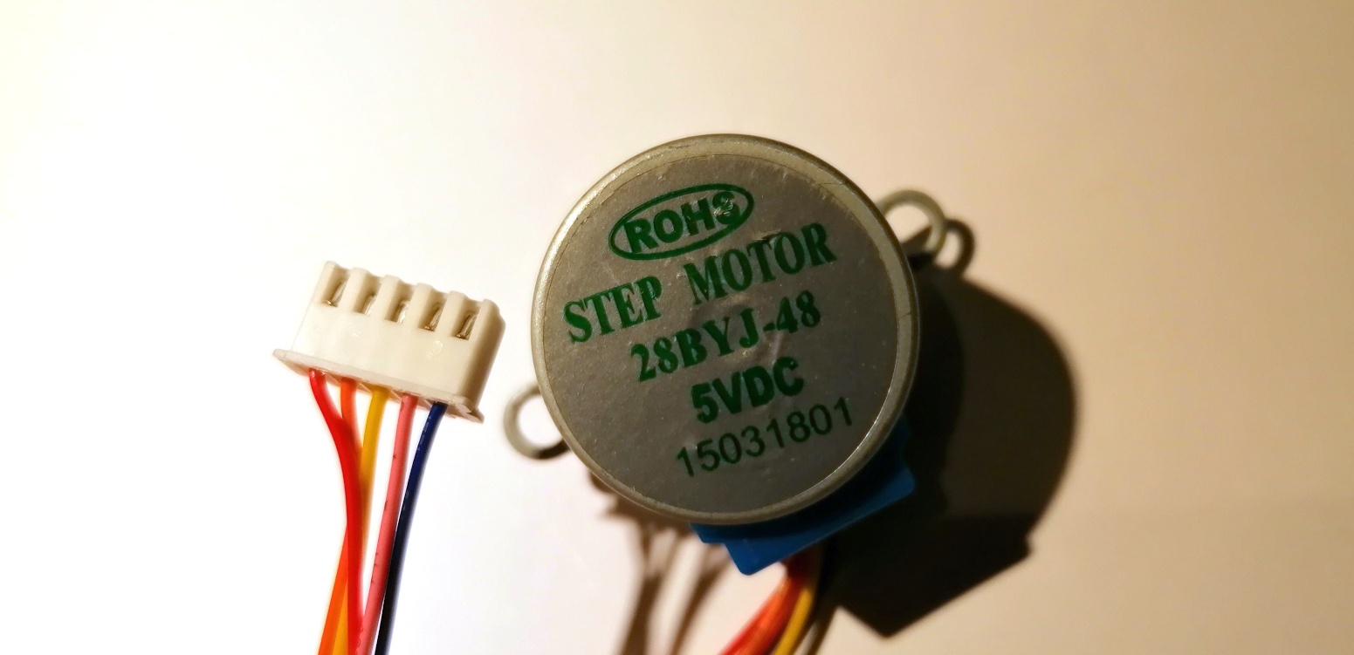

Press the retaining tab on the pin for the red wire to release it. The red wire is not required.

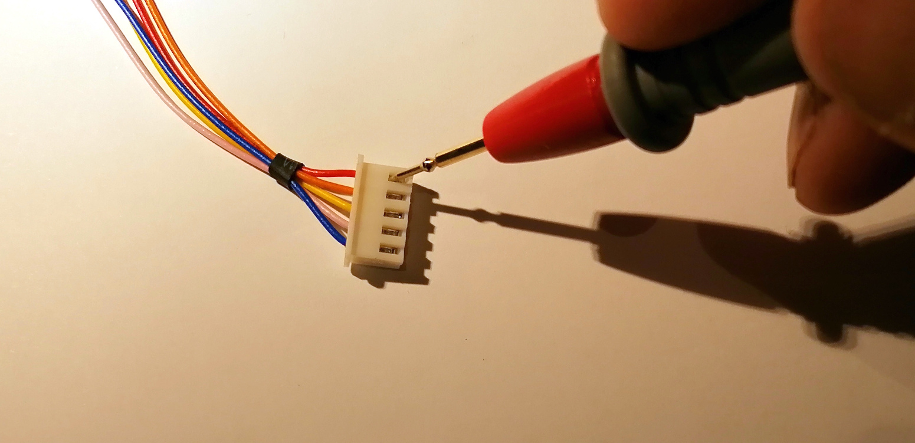

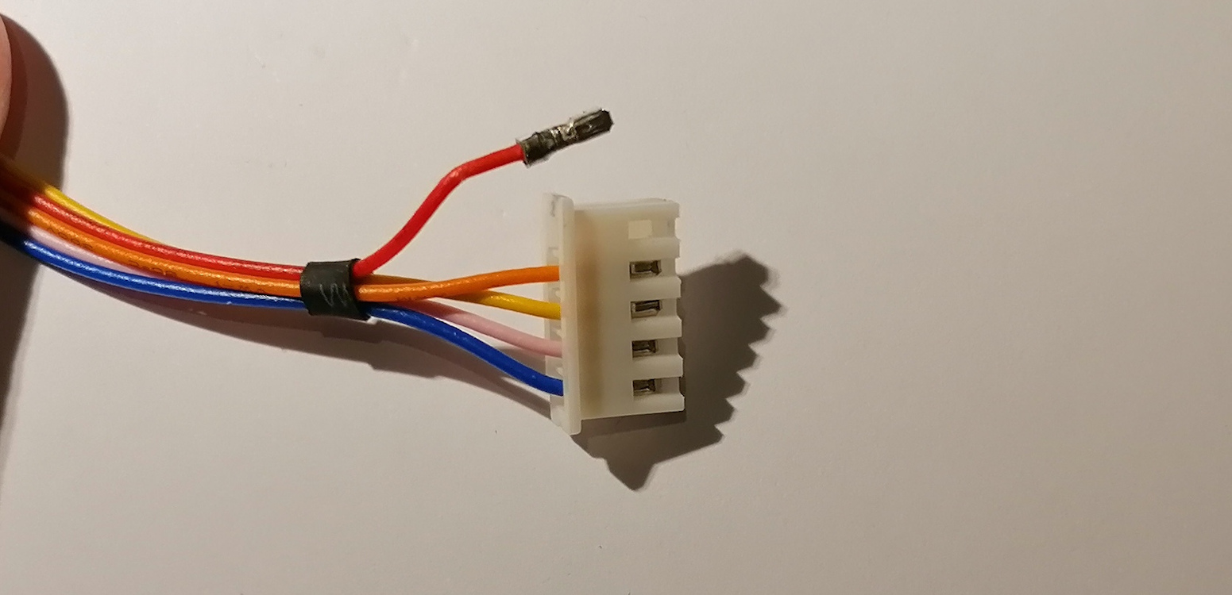

Now release and swap the pink and yellow wires.

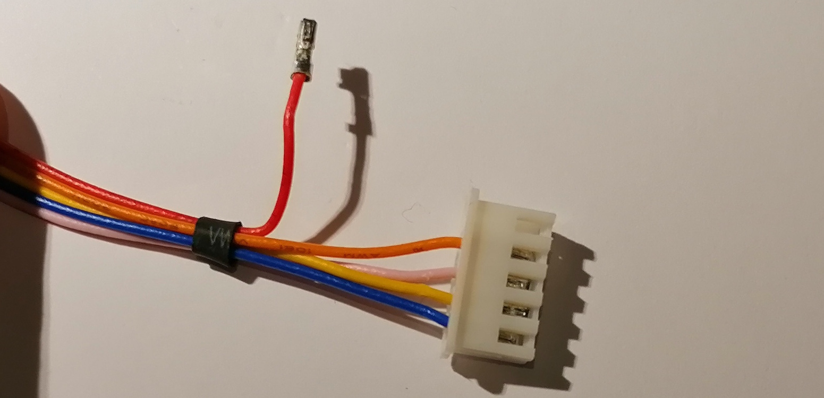

Plug the connector into the board as shown below. It’s a good idea to snip the red wire at the black rubber collar.

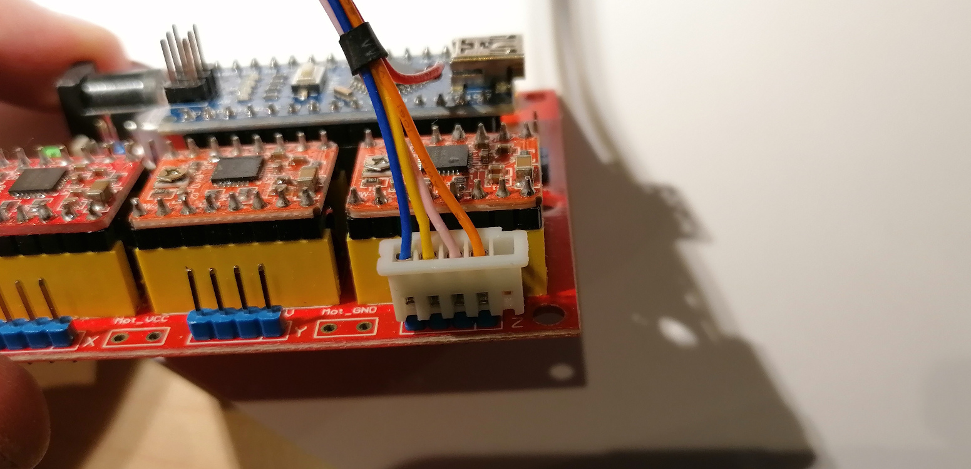

Now do the same for the other two motors.

Software

A basic example sketch for driving the motors can be found in the Arduino folder (ThreeMotorStepper.ino).

Supporting documentation for AccelStepper and be found here: https://www.airspayce.com/mikem/arduino/AccelStepper/index.html

Printing and Building the DeltaBot

There is a stl file for each of the parts in the STL folder. Drag these into your favourite slicing software (Cura is an excellent choice for this https://ultimaker.com/software/ultimaker-cura)

Attach the driver board to the to the base using m3 x 10 self tappers.
Press the drive nuts into the bottom of the delta bot (not the base housing).

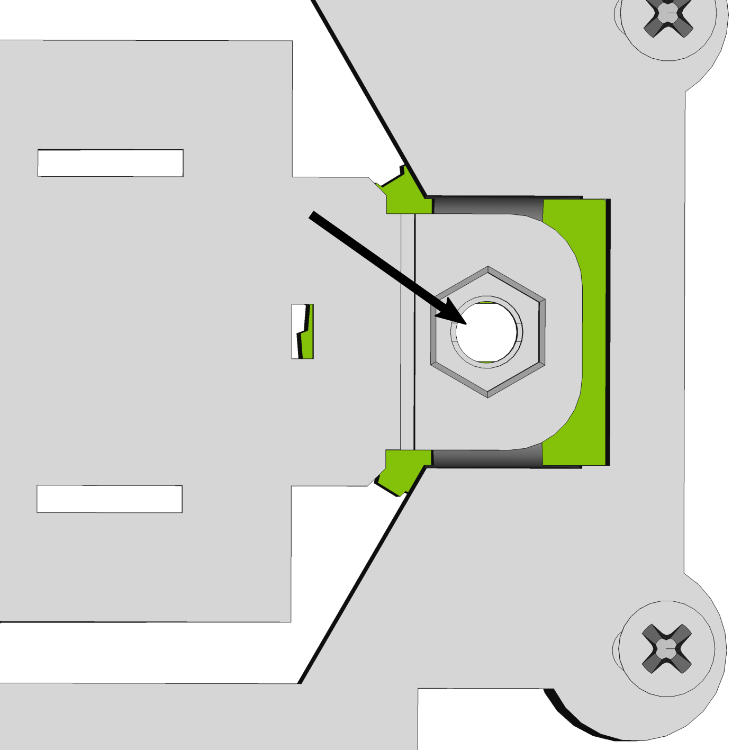

Press the motor into the thumb wheel.

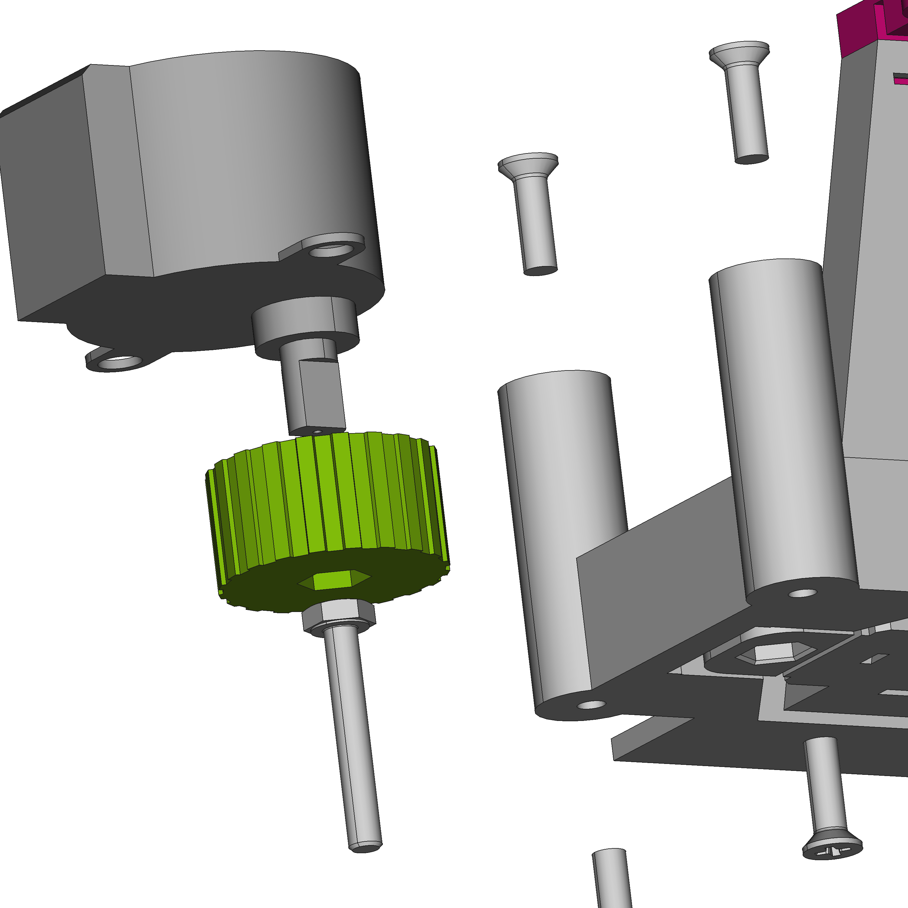

Screw the m3 x 20 hex bolt into the drive nut then press the thumb wheel onto the back of the bolt.
Use the self tappers to lock the motors in place.

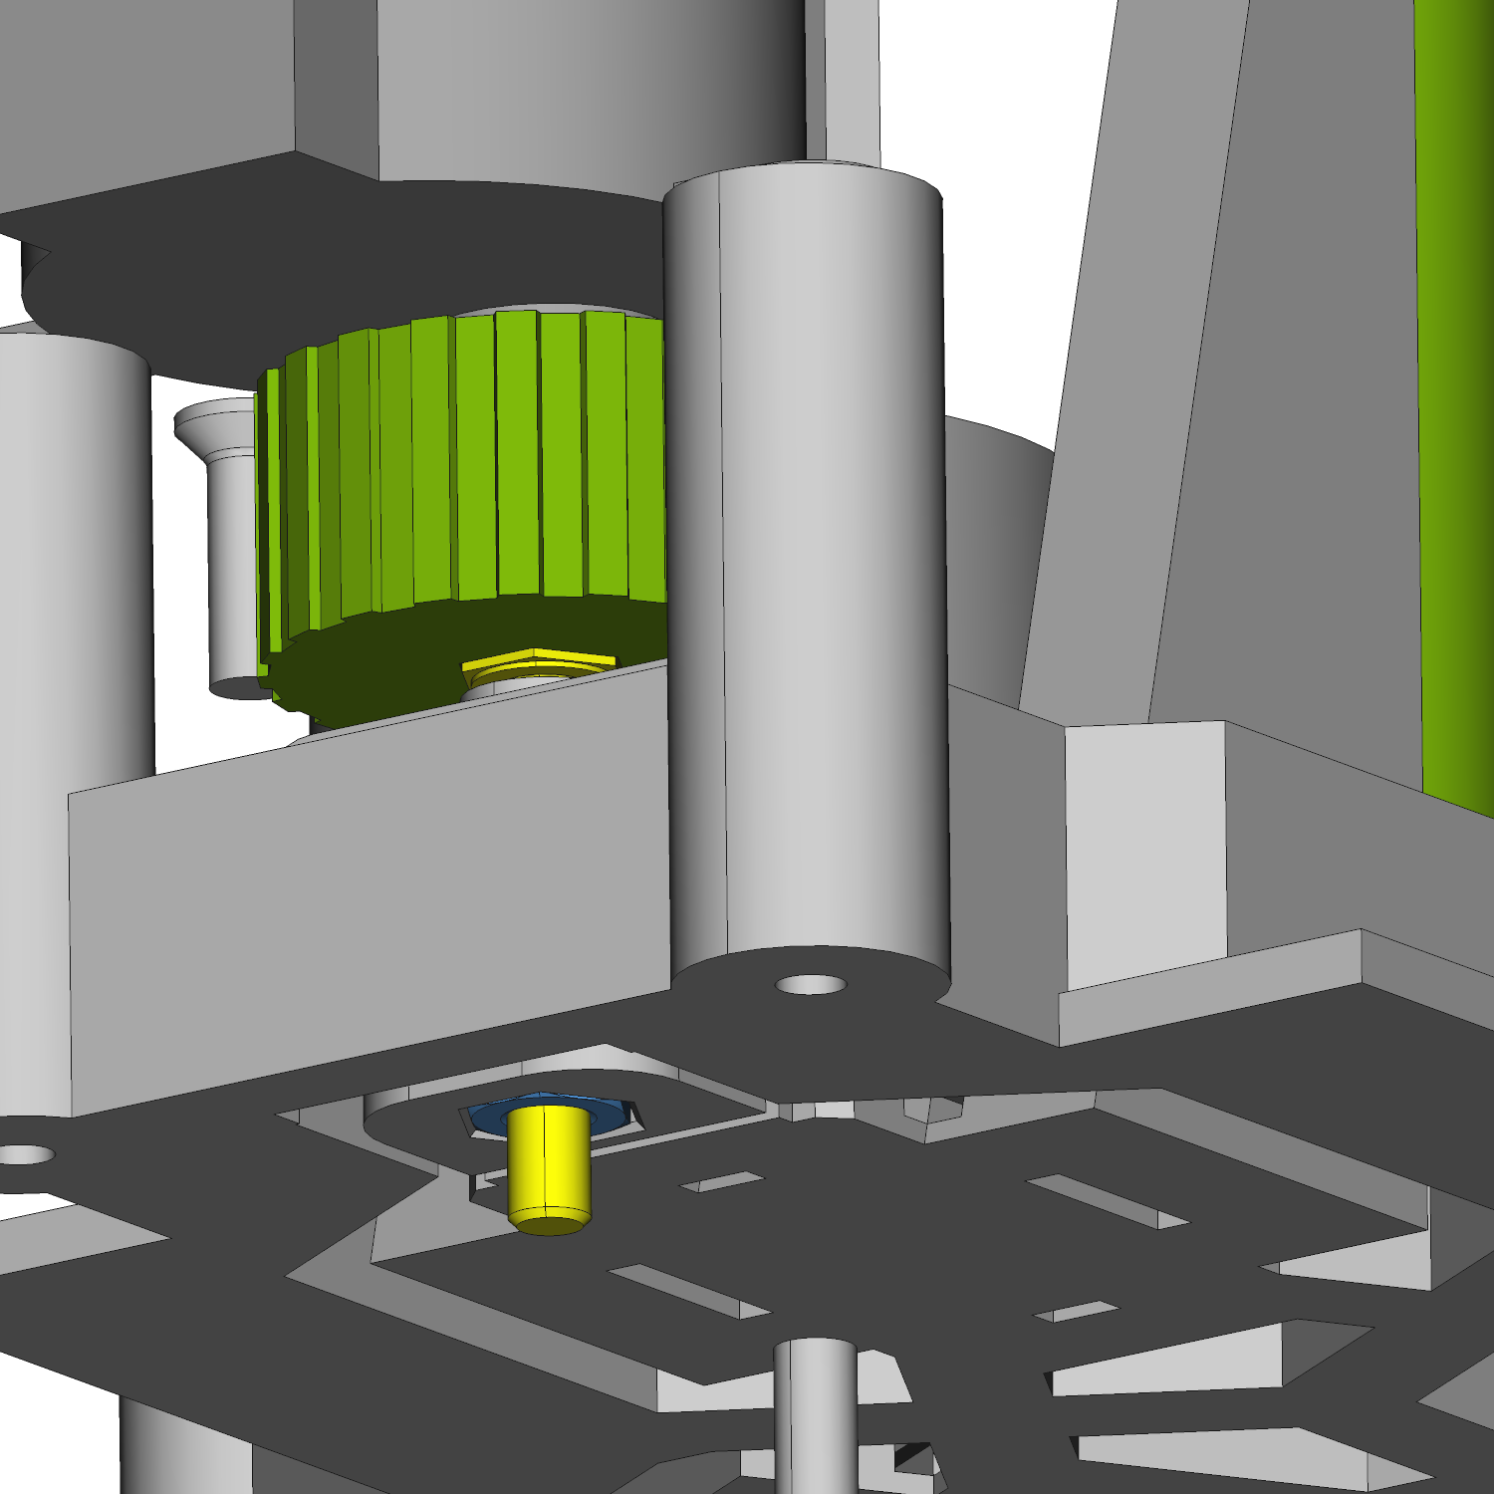

An optional Spiral Spring (5mm OD 8mm Length Light Load Compression Mould Die Spring) can be placed in the arch and the flexible actuator for preloading.

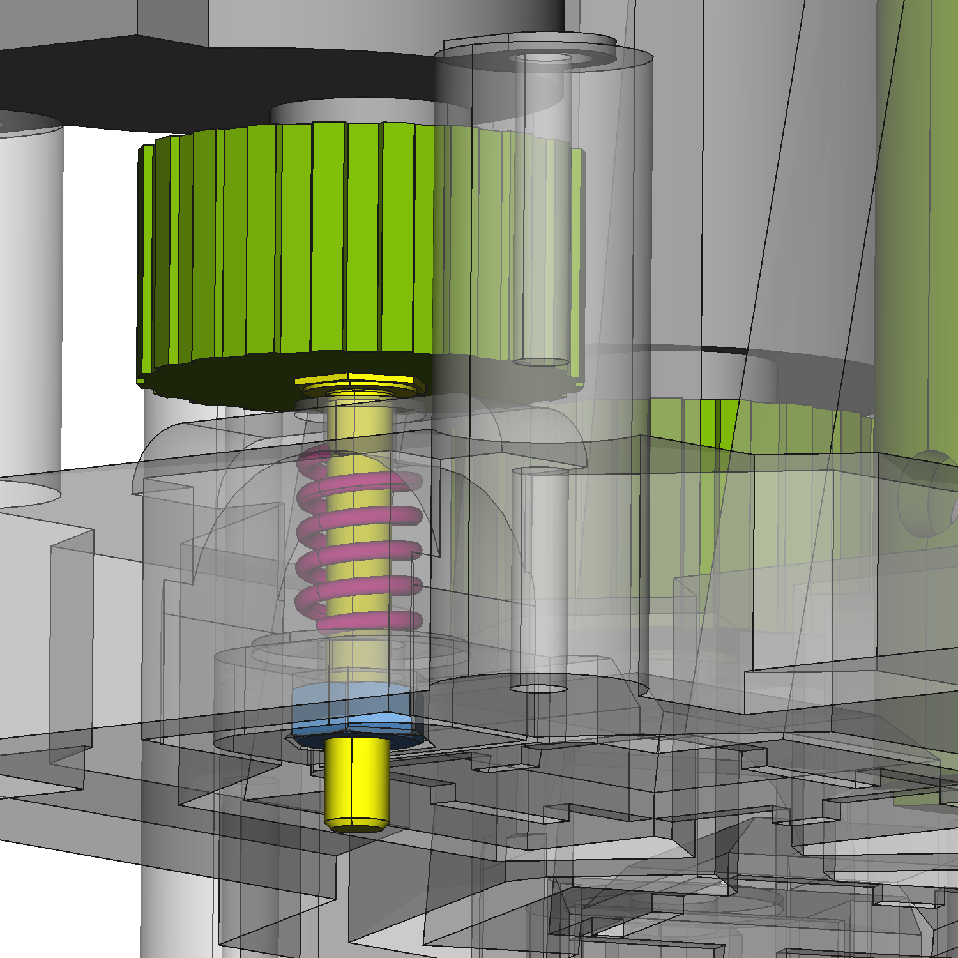

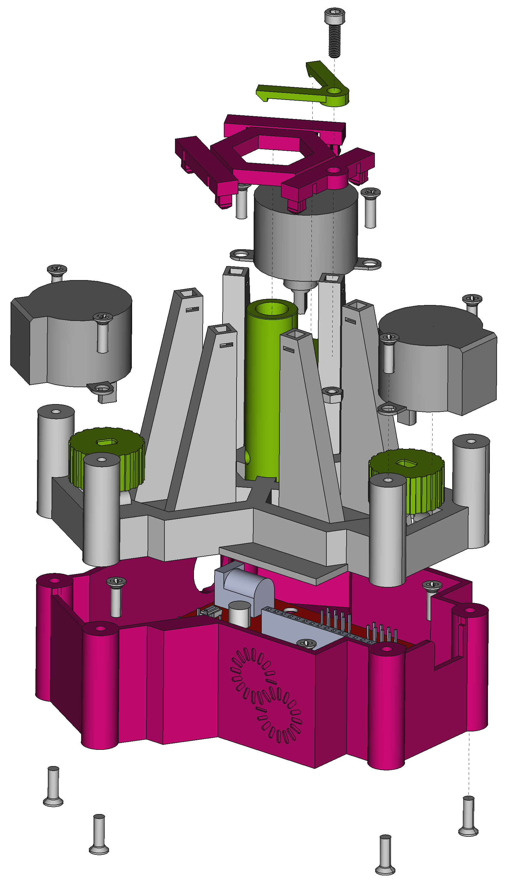
Press the top hexagonal plate into the DeltaBot legs.

Attach the slide clip using an m3 x 10 cap head bolt.

Finally attach the base to the bottom of the DeltaBot using three m3x10 self tappers.

