[11/21/20 10:20 AM] Zezhong Zhang

Those numbers are a tabulation (not a functional parameterisation) of the atomic scattering factor for scattering vector magnitude s values of 0.0, 0.025, 0.05, 0.1, 0.2, 0.3, 0.4, 0.5, 0.625, 0.75, 0.875, 1.0, 1.5, 2.0, 2.5, 3.0, 3.5, 4.0, 5.0, 6.0, 7.0, 8.0, 9.0, 10.0, 12.0, 14.0, 16.0, 18.0, 20.0 inverse angstrom.

g = 2*s

The description for the data"These files contain ionization potentials for EDX and EELSEach element contains the data for a range of incident energies 50kev-400 kev in steps of 50keV.

Each line has 29 numbers, the first 5 lines for each data block pertain to E`ELS. This is because we have 5 difference energy window ranges that were calculated. The last line (the 6th) pertains to EDX, there is only 1 possible energy window, the entire edge."

[1/5 1:59 PM] Zezhong Zhang

Multislice theory of fast electron scattering incorporating atomic inner-shell ionization

​[1/5 2:01 PM] Zezhong Zhang

https://github.com/HamishGBrown/py_multislice

​[1/5 2:01 PM] Zezhong Zhang

<https://github.com/flexible-atomic-code/fac>

Electron energies (E_0)

Atomic number (Z)

atomic orbitals (1s,2s…): Read scattering factors from all orbitals in the dataset

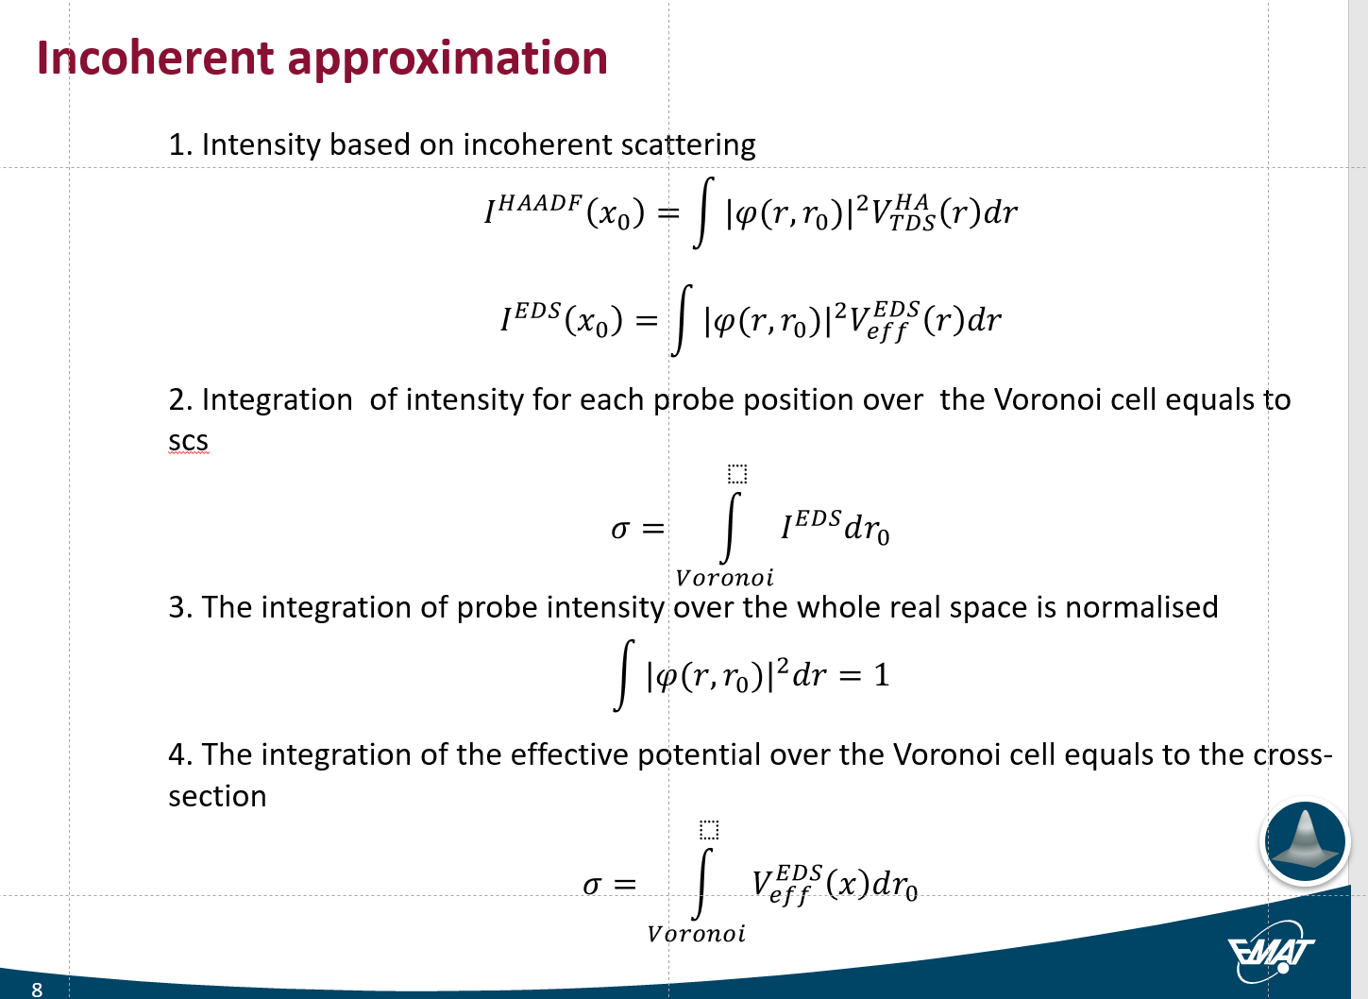

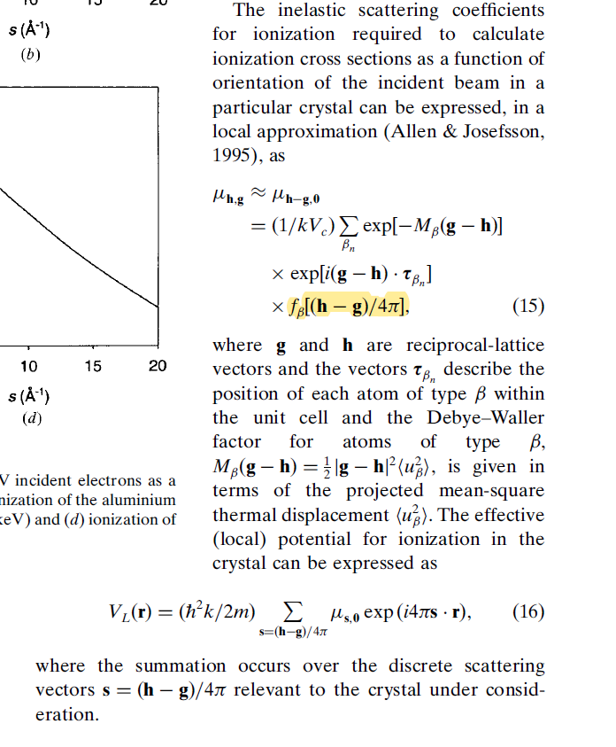

15/01/2021

MATLAB

1. Create 3d data cube: E_0, Z, atomic orbitals
2. Crate a function, which get the tabulated table of the V_EDX and V_EDX’ in log scale.