**Chapter 4 Review Questions**

1. What two conditions must be met before an entity can be classified as a weak entity?

Give an example of a weak entity.

## Condition 1: The entity is existence-dependent; it cannot exist without the entity with which it has a relationship

## Condition 2: The entity has a primary key that is partially or totally derived from the parent entity in the relationship

## Example below shows the DEPENDENT is a weak entity because the DEPENDENT entity cannot exist without the EMPLOYEE entity. The DEPENDENT entity also inherit part of its primary key from EMPLOYEE entity.



1. What is a composite entity, and when is it used?

## Composite entities are bridge entities that is composed of primary keys from each of the entities that are to be connected. They are used to transform (break down) Many to Many (M:N) relationships to 1 to many (1:M) relationships

1. Suppose you are working within the framework of the conceptual model in Figure Q4.5

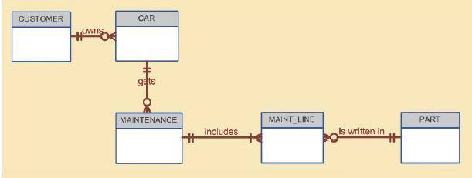

Given the conceptual model in Figure Q4.5:

1. Write the business rules that are reflected in it.

## A customer can own 0 or many cars

## Each car can only be owned by one customer

## A car can get 0 or more maintenance checks

## Each maintenance check is only done by one car

## One maintenance check can include many parts

## One part can be included in many maintenance checks

## A maintenance check might not include any parts

1. Identify all of the cardinalities.

## 

1. How would you (graphically) identify each of the following ERM components in a Crow’s Foot notation?
   1. An entity

## A rectangle box with the entity title in a different color then the attributes



* 1. The cardinality (0,N)

## The cardinality is written near the beginning or end of the crow’s foot in the format (0,N), (1,1), (1,N), etc. connecting to the entity



* 1. A weak relationship

## A dotted line connecting the two entities



* 1. A strong relationship

## A solid line connecting the two entities



1. Discuss the difference between a composite key and a composite attribute. How would each be indicated in an ERD?

## A composite key is a primary key that consists of more than one attribute. It is usually shown at the top with a PK and can include FK next to the attributes to indicate primary key and foreign key. It is also underlined

## A composite attribute is one that can be subdivided into different meaningful attributes. Example CUSTOMER_NAME can be divided into CUSTOMER_FNAME, CUSTOMER_MNAME, CUSTOMER_LNAME.

1. What is a derived attribute? Give an example.

## Is an attribute that is calculated from other attributes. It does not need to be physically stored within the database.

## Example is an employee’s age attribute can be calculated using the employee’s birthdate and the current date.

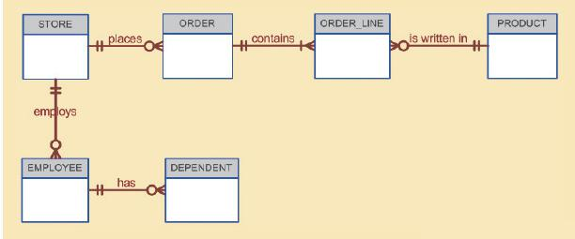

1. Write the 10 cardinalities that are appropriate for this ERD.



1. Write the business rules reflected in this ERD.

## A store may place 0 or more orders

## Each order can only be placed by one store

## A store employs 0 or more employees

## Each employee can only work at one store

## An employee can have 0 or more dependents

## Each dependent can only have one employee

## An order can contain many products

## A product can be written in many orders

## An order line can only be contained in one order

## Each order line has only one product written in it

1. Describe precisely the composition of the DEPENDENT weak entity’s primary key.

Use proper terminology in your answer.

## The DEPENDENT entity will contain a composite key that will include the EMPLOYEE entity primary key as well as its own primary key such as a DEPEDENT_NUM. Therefore we can say An DEPENDENT will exist only if there is an EMPLOYEE entity.

**Chapter 4 Problems**

1. Use the following business rules to create a Crow’s Foot ERD. Write all appropriate connectivities and cardinalities in the ERD.

* A department employs many employees, but each employee is employed by only one department.
* Some employees, known as “rovers,” are not assigned to any department.
* A division operates many departments, but each department is operated by only one division.
* An employee may be assigned many projects, and a project may have many employees assigned to it.
* A project must have at least one employee assigned to it.
* One of the employees manages each department, and each department is managed by only one employee.
* One of the employees runs each division, and each division is run by only one employee.



1. Automata, Inc. produces specialty vehicles by contract. The company operates several departments, each of which builds a particular vehicle, such as a limousine, a truck, a van, or an RV.

* Before a new vehicle is built, the department places an order with the purchasing department to request specific components. Automata’s purchasing department is interested in creating a database to keep track of orders and to accelerate the process of delivering materials.
* The order received by the purchasing department may contain several different items. An inventory is maintained so the most frequently requested items are delivered almost immediately. When an order comes in, it is checked to determine whether the requested item is in inventory. If an item is not in inventory, it must be ordered from a supplier. Each item may have several suppliers.

Given that functional description of the processes at Automata’s purchasing department, do the following:

* 1. Identify all of the main entities.

## CUSTOMER, INVOICE, VEHICLE, SUPPLIER, ITEM, DEPARTMENT, ORDER

* 1. Identify all of the relations and connectivities among entities.



* 1. Identify the type of existence dependence in all the relationships.

## See above ERD

* 1. Give at least two examples of the types of reports that can be obtained from the database.

## Inventory Report: showing an inventory of all items including stock quantities and items that needs to be requested.

## Department Report: showing a list of items each department purchased and how many orders they placed.

## Supplier Report: showing breakdown of items ordered from each supplier