**Review Questions:**

1) What two conditions must be met before an entity can be classified as a weak entity? Give an example of a weak entity.

A weak entity must satisfy the following conditions:

* The Primary Key of the weak entity must have within it the Primary Key of a related entity
* The weak entity is existence-dependant on the entity with which it is related

4) What is a composite entity, and when is it used?

A composite entity will demonstrate the following features:

* Its Primary Key is a composite key made of the PKs of the two (or more) entities it relates
* It serves as a bridge entity to implement M:N relationships
* It may contain additional non-connective attributes to provide certain information

5) Suppose you are working within the framework of the conceptual model in Figure Q4.5. Given the conceptual model in Figure Q4.5:

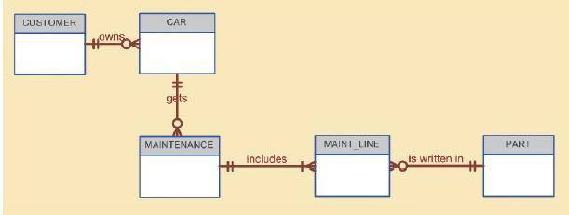

a.   Write the business rules that are reflected in it.

* One CUSTOMER may own many CARs
* Each CAR must belong to only one CUSTOMER
* One CAR may receive many MAINTENANCEs
* Each MAINTENANCE must be given to only one CAR
* One MAINTENANCE includes many MAINT_LINEs
* Each MAINT_LINE must belong to only one MAINTENANCE
* One PART may be written in many MAINT_LINEs
* Each MAINT_LINE must have only one PART written within it

 b.   Identify all of the cardinalities.

* CUSTOMER (1,1) owns CAR (0,N)
* CAR (1,1) gets MAINTENANCE (0,N)
* MAINTENANCE (1,1) includes MAINT_LINE (1,N)
* PART (1,1) is written in MAINT_LINE (0,N)

7) How would you (graphically) identify each of the following ERM components in a Crow’s Foot notation?

 a.   an entity:

Represented as a box with a Title, PK Separator, and list of Attributes



 b.   the cardinality (0,N)

Represented on both sides of a relationship in parenthesis



 c.   a weak relationship

Represented as a dotted line



 d.  a strong relationship

Represented as a solid line



8) Discuss the difference between a composite key and a composite attribute. How would each be indicated in an ERD?

* A composite key is a specific kind of Primary Key that is made up of multiple attributes.
* A composite attribute is an attribute that can be further subdivided into simpler attributes
* In Crow's Foot, all attributes that appear before the primary key separator and contain the "PK" symbol next to them are part of the composite key
* It is impossible to indicate a composite attribute in Crow's Foot notation as it appears identical to its non-composite counterparts.

10) What is a derived attribute? Give an example.

A derived attribute is an attribute whose value is derived from other attributes, not to be confused with aggregate functions. For example, you can derive an employee's age by subtracting his known date of birth and the known current date.

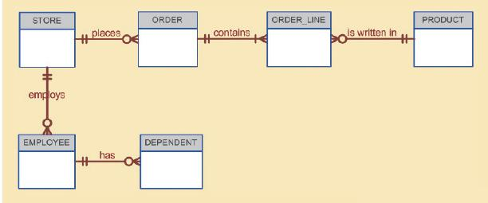

17) Write the 10 cardinalities that are appropriate for this ERD.

* EMPLOYEE (1,1) has (0,N) DEPENDANT
* STORE (1,1) employs EMPLOYEE (0,N)
* STORE (1,1) places ORDER (0,N)
* ORDER (1,1) contains ORDER_LINE (1,N)
* PRODUCT (1,1) is written in ORDER_LINE (0,N)

18) Write the business rules reflected in this ERD.

* An EMPLOYEE may have many DEPENDANTs
* Each DEPENDANT must belong to an EMPLOYEE
* A STORE may employ many EMLOYEEs
* Each EMPLOYEE must belong to a STORE
* A STORE may place many ORDERs
* Each

20) Describe precisely the composition of the DEPENDENT weak entity’s primary key. Use proper terminology in your answer.

The DEPENDENT entity's primary key will be a composite key containing the EMPLOYEE entity's primary key.

**Problems:**

1) Use the following business rules to create a Crow’s Foot ERD. Write all appropriate connectivities and cardinalities in the ERD.

* A department employs many employees, but each employee is employed by only one department.
* Some employees, known as “rovers,” are not assigned to any department.
* A division operates many departments, but each department is operated by only one division.
* An employee may be assigned many projects, and a project may have many employees assigned to it.
* A project must have at least one employee assigned to it.
* One of the employees manages each department, and each department is managed by only one employee.
* One of the employees runs each division, and each division is run by only one employee.



6) Automata, Inc. produces specialty vehicles by contract. The company operates several departments, each of which builds a particular vehicle, such as a limousine, a truck, a van, or an RV.

•    Before a new vehicle is built, the department places an order with the purchasing department to request specific components. Automata’s purchasing department is interested in creating a database to keep track of orders and to accelerate the process of delivering materials.

•    The order received by the purchasing department may contain several different items. An inventory is maintained so the most frequently requested items are delivered almost immediately. When an order comes in, it is checked to determine whether the requested item is in inventory. If an item is not in inventory, it must be ordered from a supplier. Each item may have several suppliers.

Given that functional description of the processes at Automata’s purchasing department, do the following:

a.   Identify all of the main entities.

CONTRACT, VEHICLE_DEPT, VEHICLE, ORDER, PURCHASING_DEPT, COMPONENTS, INVENTORY, SUPPLIER

b.   Identify all of the relations and connectivities among entities.



c.   Identify the type of existence dependence in all the relationships.

INVENTORY is existence-dependent on both SUPPLIER and COMPONENT.

All other relationships are existence-independent.

d.   Give at least two examples of the types of reports that can be obtained from the database.

* What components are needed to build a particular specialty vehicle
* A list of all known suppliers who provide a specific component