**COMP 1630 – Module 2 Discussion Questions and On-line Work**

***Group 1 – Renin Catungal, Xiaochen Dai, Wing Chu, Gael Attal***

Chapter 2: Problems 10-15; Chapter 3: Problems 17-23

**Chapter 2 Problems:**

1. United Broke Artists (UBA) is a broker for not-so-famous artists. UBA maintains a small database to track painters, paintings, and galleries. A painting is created by a particular artist and then exhibited in a particular gallery. A gallery can exhibit many paintings, but each painting can be exhibited in only one gallery. Similarly, a painting is created by a single painter, but each painter can create many paintings. Using PAINTER, PAINTING, and GALLERY, in terms of a relational database:
2. What tables would you create, and what would the table components be?

**Solution:**

|  |  |
| --- | --- |
| TABLE | COMPONENTS |
| PAINTER | PAINTER_ID, PAINTER_FNAME, PAINTER_LNAME, PAINTER_ADDRESS, PAINTER_PHONE |
| PAINTING | PAINTING_ID, *PAINTER_ID*, *GALLERY_ID*, PAINTING_NAME, PAINTING_COST |
| GALLERY | GALLERY_ID, GALLERY_NAME, GALLERY_ADDRESS, GALLERY_PHONE |

1. How might the (independent) tables be related to one another?

**Solution:**

* The table PAINTING will have a primary key: PAINTING_ID and two foreign keys: *PAINTER_ID* and *GALLERY_ID*
* The foreign key *PAINTER_ID* in the PAINTING table will be linked to the primary key PAINTER_ID in the PAINTER table indicating one painter can paint many paintings.
* The foreign key *GALLERY_ID* in the PAINTING table will be linked to the primary key GALLERY_ID in the GALLERY table indicating one gallery can exhibit many paintings.



1. Using the ERD from Problem 10, create the relational schema. (Create an appropriate collection of attributes for each of the entities. Make sure you use the appropriate naming conventions to name the attributes.)

**Solution:**

* PAINTER( PAINTER_ID, PAINTER_FNAME, PAINTER_LNAME, PAINTER_ADDRESS, PAINTER_PHONE )
* PAINTING( PAINTING_ID, *PAINTER_ID*, *GALLERY_ID*, PAINTING_NAME, PAINTING_COST )
* GALLERY( GALLERY_ID, GALLERY_NAME, GALLERY_ADDRESS, GALLERY_PHONE )

1. Convert the ERD from Problem 10 into a corresponding UML class diagram.

**Solution:**



1. Describe the relationships (identify the business rules) depicted in the Crow’s Foot ERD shown in Figure P2.13.

FIGURE P2.13 The Crow’s Foot ERD for **Problem 13**

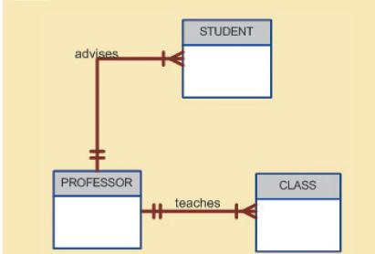

**Solution:**

* One professor teaches many classes
* Each class can only have one professor
* One professor advises many students
* Each student can only have one professor

1. Create a Crow’s Foot ERD to include the following business rules for the ProdCo company:
   1. Each sales representative writes many invoices.
   2. Each invoice is written by one sales representative.
   3. Each sales representative is assigned to one department.
   4. Each department has many sales representatives.
   5. Each customer can generate many invoices.
   6. Each invoice is generated by one customer

**Solution:**



1. Write the business rules that are reflected in the ERD shown in Figure P2.15. (Note that the ERD reflects some simplifying assumptions. For example, each book is written by only one author. Also, remember that the ERD is always read from the “1” to the “M” side, regardless of orientation of the ERD components.)

FIGURE P2.15 The Crow’s Foot ERD for **Problem 15**

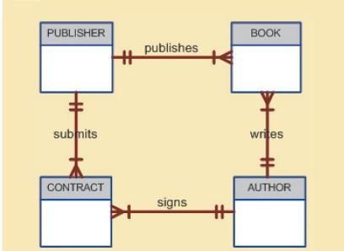

**Solution:**

* One publisher publishes many books
* Each book is published by only one publisher
* One author writes many books
* Each book is written by only one author
* One author signs many contracts
* Each contract is signed by only one author
* One publisher submits many contracts
* Each contract is submitted by only one publisher

**Chapter 3 Problems:**

FIGURE P3.17 The Ch03_TransCo database tables

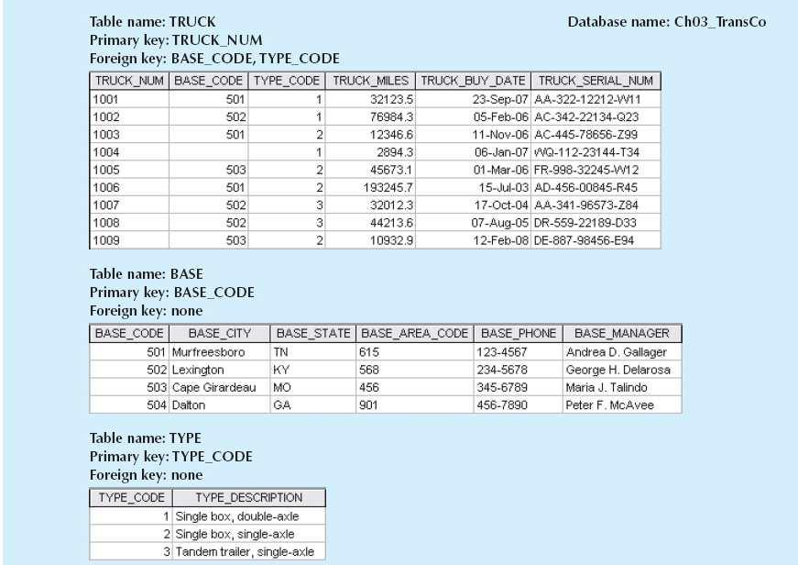

1. For each table, identify the primary key and the foreign key(s). If a table does not have a foreign key, write *None* in the space provided.

**Solution:**

|  |  |  |
| --- | --- | --- |
| TABLE | PRIMARY KEY | FOREIGN KEY(S) |
| TRUCK | TRUCK_NUM | BASE_CODE, TYPE_CODE |
| BASE | BASE_CODE | None |
| TYPE | TYPE_CODE | None |

1. Do the tables exhibit entity integrity? Answer yes or no, and then explain your answer.

**Solution:**

|  |  |  |
| --- | --- | --- |
| TABLE | ENTITY INTEGRITY | EXPLANATION |
| TRUCK | Yes | Each value in the primary key TRUCK_NUM is unique and have no nulls |
| BASE | Yes | Each value in the primary key BASE_CODE is unique and have no nulls |
| TYPE | Yes | Each value in the primary key TYPE_CODE is unique and have no nulls |

1. Do the tables exhibit referential integrity? Answer yes or no, and then explain your answer. Write NA (Not Applicable) if the table does not have a foreign key.

**Solution:**

|  |  |  |
| --- | --- | --- |
| TABLE | REERENTIAL INTEGRITY | EXPLANATION |
| TRUCK | Yes | Each value in the foreign keys BASE_CODE and TYPE_CODE contains null or matching entries in its related table |
| BASE | N/A | N/A |
| TYPE | N/A | N/A |

1. Identify the TRUCK table’s candidate key(s).

**Solution:**

* TRUCK_NUM, TRUCK_SERIAL_NUM

1. For each table, identify a superkey and a secondary key.

**Solution:**

|  |  |  |
| --- | --- | --- |
| TABLE | SUPERKEY | SECONDARY KEY |
| TRUCK | TRUCK_NUM | TRUCK_BUY_DATE |
| BASE | BASE_CODE | BASE_CITY |
| TYPE | TYPE_CODE | TYPE_DESCRIPTION |

1. Create the ERD for this database.

**Solution:**



1. Create the relational diagram for this database.

**Solution:**

