**COMP 1630 – Module 3 Discussion Questions and On-line Work**

Group A – Gael Attal, Renin Joseff Catungal, Wing Chu, Xiaochen Dai

Chapter 4: Questions (1, 4, 5, 7, 8, 10, 17, 18, 20); Problems (1, 6)

**Question 1**: What two conditions must be met before an entity can be classified as a weak entity? Give an example of a weak entity.

**Solution:**

The two conditions are:

1. The entity is existence-dependent; it cannot exist without the entity with which it has a relationship.
2. The entity has a primary key that is partially or totally derived from the parent entity in the relationship.

The Figure below shows an example of a weak entity. A company insurance policy insures an employee and any dependents. An EMPLOYEE might or might not have a DEPENDENT, but the DEPENDENT must be associated with an EMPLOYEE. Moreover, the DEPENDENT cannot exist without the EMPLOYEE; that is, a person cannot get insurance coverage as a dependent unless the person is a dependent of an employee. DEPENDENT is the weak entity in the relationship “EMPLOYEE has DEPENDENT”.



**Question 4**: What is a composite entity, and when is it used?

**Solution:**

A composite entity is also called an associative entity, or a bridge entity. It is composed of primary keys from each of the entities to be connected.

A composite entity is used to represent an M:N relationship between two or more entities. It may contain additional non-connective attributes to provide certain information.

**Question 5**: Suppose you are working within the framework of the conceptual model in Figure Q4.5.

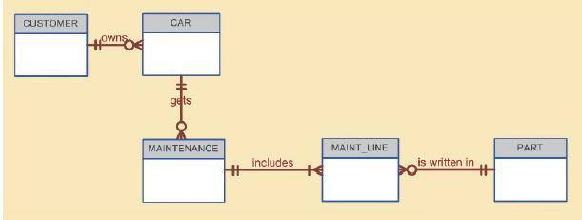

Given the conceptual model in Figure Q4.5:

1. Write the business rules that reflected in it.
2. Identify all of the cardinalities.

**Solution:**

1. The business rules are as follows:
2. One customer may own many cars.
3. Each car must belong to only one customer.
4. One car may get many maintenance checks.
5. Each maintenance check must be done to only one car.
6. One maintenance check includes many maintenance lines
7. Each maintenance line must belong to only one maintenance check.
8. One part may be written in many maintenance lines.
9. Each maintenance line must have only one part written within it.
10. The cardinalities are listed and also shown in the figure below.

* CUSTOMER (1, 1) owns CAR (0, N)
* CAR (1, 1) gets MAINTENANCE (0, N)
* MAINTENANCE (1, 1) includes MAINT_LINE (1, N)
* PART (1, 1) is written in MAINT_LINE (0, N)



**Question 7:** How would you (graphically) identify each of the following ERM components in a Crow’s Foot notation?

1. an entity
2. the cardinality (0, N)
3. a weak relationship
4. a strong relationship

**Solution**:

1. An entity is represented by a rectangle that contains the entity’s name and a list of attributes in capital letters. The primary keys are highlighted in bold and underlined letters.



1. The cardinality (0, N) is written near the beginning or end of the Crow’s Foot, connecting to the entity.



1. A weak relationship is depicted by placing a dashed relationship line between the entities.



1. A strong relationship is depicted by placing a solid relationship line between the entities.



**Question 8:** Discuss the difference between a composite key and a composite attribute. How would each be indicated in an ERD?

**Solution:**

* A composite key is a primary key composed of more than one attribute. In an ERD, all attributes that appear before the primary key separator and contain the “PK” symbol next to them are part of the composite key.
* A composite attribute is an attribute that can be further subdivided to yield additional attributes. It cannot be indicated in an ERD as it appears identical to its non-composite counterparts.
* For example, in the ERD above, the composite key consists of CRS_CODE and CLASS_SECTION. The composite attribute CLASS_TIME is composed of day, hour, and minute.

**Question 10:** What is a derived attribute? Give an example.

**Solution:**

* A derived attribute is an attribute whose value is calculated from other attributes. It does not need to be physically stored within the database.
* For example, an employee’s age, EMP_AGE, may be found by computing the integer value of the difference between the current date and the EMP_DOB, which is the employee’s date of birth.

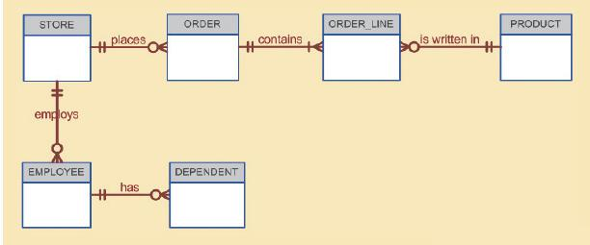

**Question 17:** Write the 10 cardinalities that are appropriate for this ERD.

**Solution:**

The cardinalities are listed and also shown in the figure below.

* EMPLOYEE (1, 1) has DEPARTMENT (0, N)
* STORE(1, 1) employs EMPLOYEE(0, N)
* STORE(1, 1) places ORDER(0, N)
* ORDER(1, 1) contains ORDER_LINE (1, N)
* PRODUCT(1,1) is written in ORDER_LINE (0, N)



**Question 18:** Write the business rules reflected in this ERD.

**Solution:**

1. A store may places many orders.
2. Each order must be placed by one and only one store.
3. An order contains one or more than one lines.
4. Each order line must belong to one and only one order.
5. A product may be written in many order lines.
6. Each order line must be used for one and only one product.
7. A store may employ many employees.
8. Each employee must be employed by one and only one store.
9. An employee may have many dependents.
10. Each dependent must be associated with one and only one employee.

**Question 20:** Describe precisely the composition of the DEPENDENT weak entity’s primary key. Use proper terminology in your answer.

**Solution:**

DEPENDENT (**EMP_ID**, **DEP_ID**, DEP_FNAME, DEP_LNAME, DEP_DOB)

The DEPENDENT entity has a composite key which consists of EMP_ID and DEP_ID. EMP_ID is the primary key of EMPLOYEE entity, and DEP_ID is DEPENDENT entity’s own primary key.

**Problem 1:** Use the following business rules to create a Crow’s Foot ERD. Write all appropriate connectivities and cardinalities in the ERD.

* A department employs many employees, but each employee is employed by only one department.
* Some employees, known as “rovers”, are not assigned to any department.
* A division operates many departments, but each department is operated by only one division.
* An employee may be assigned many projects, and a project may have many employees assigned to it.
* A project must have at least one employee assigned to it.
* One of the employees manages each department, and each department is managed by only one employee.
* One of the employees runs each division, and each division is run by only one employee.

**Solution:**



**Problem 6:** Automata, Inc. produces specialty vehicles by contract. The company operates several departments, each of which builds a particular vehicle, such as a limousine, a truck, a van, or an RV.

* Before a new vehicle is built, the department places an order with the purchasing department to request specific components. Automata’s purchasing department is interested in creating a database to keep track of orders and to accelerate the process of delivering materials.
* The order received by the purchasing department may contain several different items. An inventory is maintained so the most frequently requested items are delivered almost immediately. When an order comes in, it is checked to determine whether the requested item is in inventory. If an item is not in inventory, it must be ordered from a supplier. Each item may have several suppliers.

Given that functional description of the processes at Automata’s purchasing department, do the following:

1. Identify all of the main entities.
2. Identify all of the relations and connectivities among entities.
3. Identify the type of existence dependence in all the relationships.
4. Give at least two examples of the types of reports that can be obtained from the database.

**Solution:**

1. CONTRACT, VEHICLE, DEPARTMENT, ORDER, ORDER_LINE, ITEM_INVENTORY, ITEM_LINE, SUPPLIER.
2. Please see the ERD below.



1. Types of existence dependence:

* ITEM_LINE is existence-dependent on SUPPLIER and ITEM_INVENTORY.
* ORDER_LINE is existence-dependent on ORDER and ITEM_INVENTORY.
* VEHICLE is existence-dependent on DEPARTMENT and CONTRACT.
* ORDER is existence-dependent on DEPARTMENT.
* All other relationships are existence-independent.

1. Examples of the types of reports:

* Inventory Report: showing an inventory of all items including stock quantities and times that needs to be requested.
* Department Report: showing a list of items each department purchased and how many orders they have placed.
* Supplier Report: showing breakdown of items ordered from each supplier.