|  |  |
| --- | --- |
|  |  |
| Due Date: | Feb 20, 9AM (9:01AM is late) 20% deducted each day this is late. |
| Percentage mark: | 15% |
| Submission Location: | Assignment 1 Drop Box |
| Submission Details: | Submit an archive of your project files so your project is ready to run once it is extracted. |
| Late Penalty: | 20% deducted each day this assignment is late. |

TIPS:

* Use an IDE like PHP Storm / Web Storm / Sublime/ Visual Web Developer Express which is free.
* **** Use debugging tools either in Firefox. ****
* If data does not appear view your application with Firefox.
* Use the starter project.

# Weather application

In this assignment, you are to make a weather reporting application with the help of a properly architected AngluarJS application. Please note the following requirements. Your one-page AngularJS application:

* Calls Yahoo for live data from efficient custom service(s). (5 marks) Remember, services encapsulate logic which may be used by multiple controllers.
* Uses a radio button with ng-model to toggle between functional Celsius and Fahrenheit displays. (5 marks)
* Provides options inside a select tag that work with an orderBy filter inside an ng-repeat directive. (3 marks)
* Implements working hyperlinks with the help of routing within the angular application. (3 marks)
* Selects appropriate controllers from application routing. (2 marks)
* Shows city detail and all city listings from separate partial views. (3 marks)
* Displays your main logo, Celsius / Fahrenheit section option, and home link from the parent view. (2 marks)
* The main page shows the date only once along with the current weather information for all cities. (2 marks)
* The detail page shows the 5 day forecast for the selected city. (2 marks)
* Shows a professional looking logo image for your application. (3 marks)
* Displays daily weather conditions using the appropriate icon. (3 marks)

(A forecast *code* value of 32 is mapped to http://l.yimg.com/a/i/us/we/52/32.gif)

* The main logo and celsius Fahrenheit selector are displayed in a menu that is written in the parent view. (5 marks)

TIP: Do not call getWeather() more than once. It should only execute one time to get the data during the first request to the application. Do not get the data again when navigating between the views. A timing delay between the time when data is requested and when the page displays can give incorrect results so just use the same data that is stored in memory from the first request when switching views.

# Deductions

* Code duplication.
* Hard coded numbers.
* Un-descriptive naming.
* Poor alignment.
* Unprofessional appearance.
* Requested features are missing.

# Samples

Sample city and detail views are below.

## Sample Home Page Listing (All information shown is required)

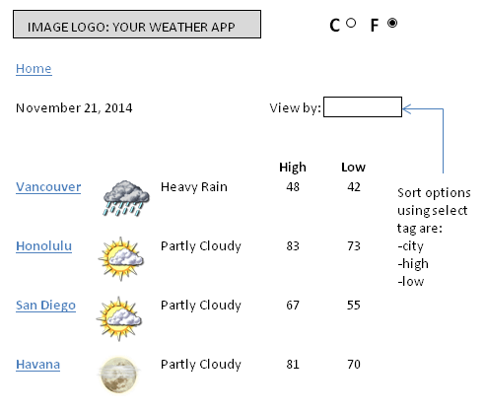

## Sample Detail Listing (All information shown is required)

