# Assignment 2

## Due: March 23, 9AM

## Weight: 15%

## Submission Instructions:

Submit your working project to the drop box.

(20% deducted each day this is late.)

Using AngularJS, create a custom directive that includes a form which allows a user to enter and submit a name and password. Inside your directive, include validation for these inputs. Only enable the submit button when the form is valid. A form is valid but only when:

* A name is provided. (1 mark)
* Passwords and verify password inputs match. (2 marks)
* Passwords are a minimum of 8 characters but cannot be greater than 20 characters. (2 marks)

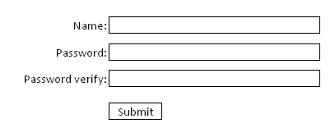

If the form is invalid notify the user why with a helpful user-friendly error message. (2 marks)

Apply css styles to color the font of the error messages and backgrounds of the input boxes when inputs are invalid. Use the ng-dirty directive to implement the styling so you can apply the style after the user leaves the control. (2 marks)

Hint: Here is a quick way to enable the button if the password and verify password are the same.

<input type="password" ng-model="value1" equals="**{{**value2**}}**">

<input type="password" ng-model="value2" equals="**{{**value1**}}**">

<input type="submit" ng-disabled="value1!=value2" />

**Important Requirement**: Do not use the **template** option in your directive. Instead your directive must use the **templateUrl** option.

Load your directive on a page of your AngularJS application. If the form is valid and is submitted, display a new partial view which displays the listing of first and last names that are available in JSON format from http://ssdprogram.ca/testJson2.php

Use the $q promise library to delay display of the data until it is received. (5 marks)