PhotoShop Orientation

- Launch PhotoShop (PS) from the Start: Programs menu.
- Once launched, choose Edit: Preferences: Performance and change the History States to 75.
- Next, choose Edit: Preferences: Cursors and select Precise option in Other Cursors.
- Next, choose Edit: Preferences: Units & Rulers. In the Units section, choose Pixels for the Ruler option.
- Choose File: New (Ctrl + N) and make the following specifications:
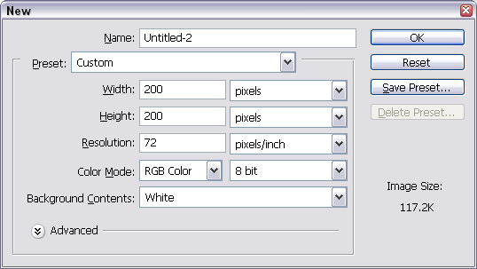

- Choose View: Rulers (Ctrl + R) to see the following:
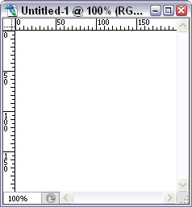

- Experiment with moving some palettes around to give yourself more room. You can drag and resize them, or snap them together or minimize them to icons. If you accidentally close one, you can get it back by choosing Window and selecting the palette you want.
- In the Swatches palette, click and hold the palette options arrow and select Load Swatches… to bring up some choices for colour palettes. Choose a Web palette.
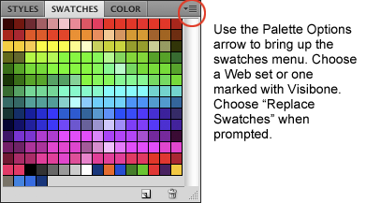

- Notice that when you move your cursor over the swatches, it changes to an eyedropper. Click on a swatch to set the foreground colour (see second handout for toolbar descriptions).
- In the layers palette, click on the New Layer icon to create a new layer.
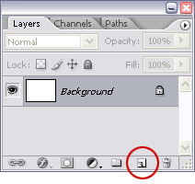
- Make sure that the layer is selected (highlighted). Select the Marquee tool and then click and drag within the window of the new document you created above. You should have something that looks like this:
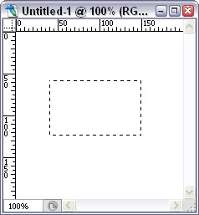
- Choose Edit: Fill to call up the fill selection dialog. Or, hold down the Alt key and press Backspace to fill with the foreground colour (Ctrl+Backspace to fill with background colour).
- You should now have something like this:
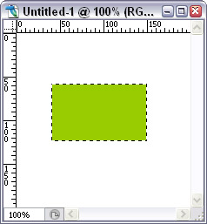
- Choose Select: Deselect or press Ctrl+D to deselect the filled image.
- Choose the Move tool and click anywhere in the window to move the filled image around.
- Repeat steps 10 through 15 to create another filled image on its own layer. Then, click on Layer 2 and drag it below Layer 1.
- Choose the Move tool again and click anywhere in the window to move the layers around.

Shortcut keys:
Ctrl+C Copy
Ctrl+X Cut
Ctrl+V Paste
Ctrl+A Select All
Ctrl+D Deselect All
Ctrl+R Show/hide rulers
Alt+BkSp Fill with foreground colour
Ctrl+BkSp Fill with background colour
Ctrl++ Zoom in
Ctrl+- Zoom out
Ctrl+; Show/hide guides

