Internship Report – Task 1

# 1. Introduction

This report documents the completion of Task 1 as part of the internship at NULLCLASS. The task involved developing a chatbot with basic analytics features using Streamlit and Python.

# 2. Background

The chatbot was designed to handle basic user queries and log interaction data to analyze topics and user engagement.

# 3. Learning Objectives

- Learn Streamlit UI development  
- Implement simple chatbot logic  
- Add analytics like query count, ratings  
- Improve UI with custom styles and emojis

# 4. Activities and Tasks

The main activities included:  
- Creating a chatbot logic file  
- Building a UI with Streamlit  
- Logging user input, topic detection  
- Displaying metrics and basic analytics

# 5. Skills and Competencies

Skills improved:  
- Python (functions, pandas)  
- Streamlit  
- UI/UX thinking  
- File handling & analytics  
- GitHub repo management

# 6. Feedback and Evidence

Screenshots and testing confirmed the chatbot worked well. Input box and analytics metrics were tested and displayed accurately.

# 7. Challenges and Solutions

- First time using Streamlit: Researched docs and used trial-error

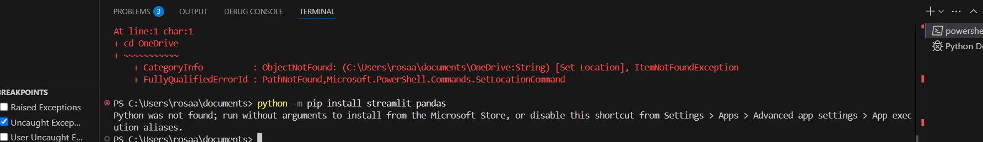

- UI didn’t show properly at first: Fixed menu condition check

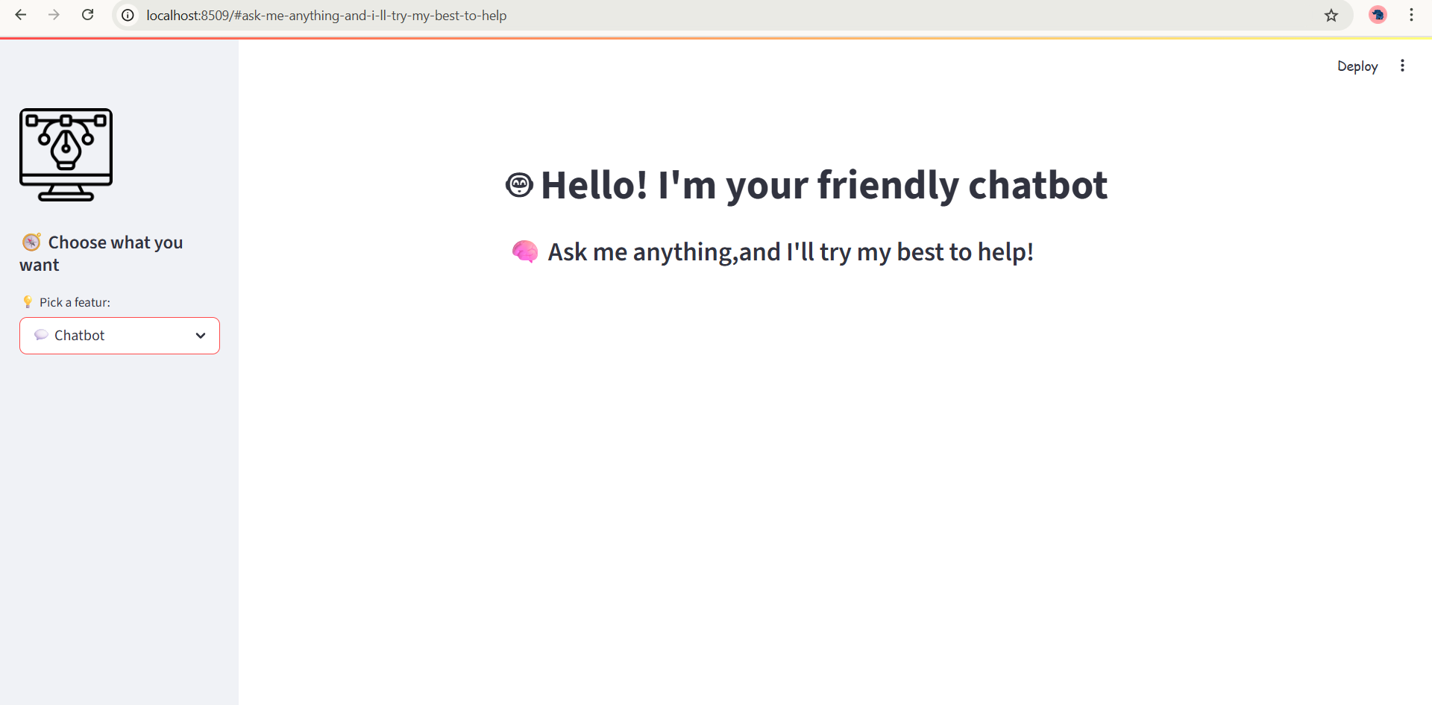

- Emoji and custom font: Used HTML + Streamlit markdown

# 8. Outcomes and Impact

Successfully built a chatbot that interacts with users, logs queries, shows analytics, and has a fun friendly UI. Task 1 was completed with full features.

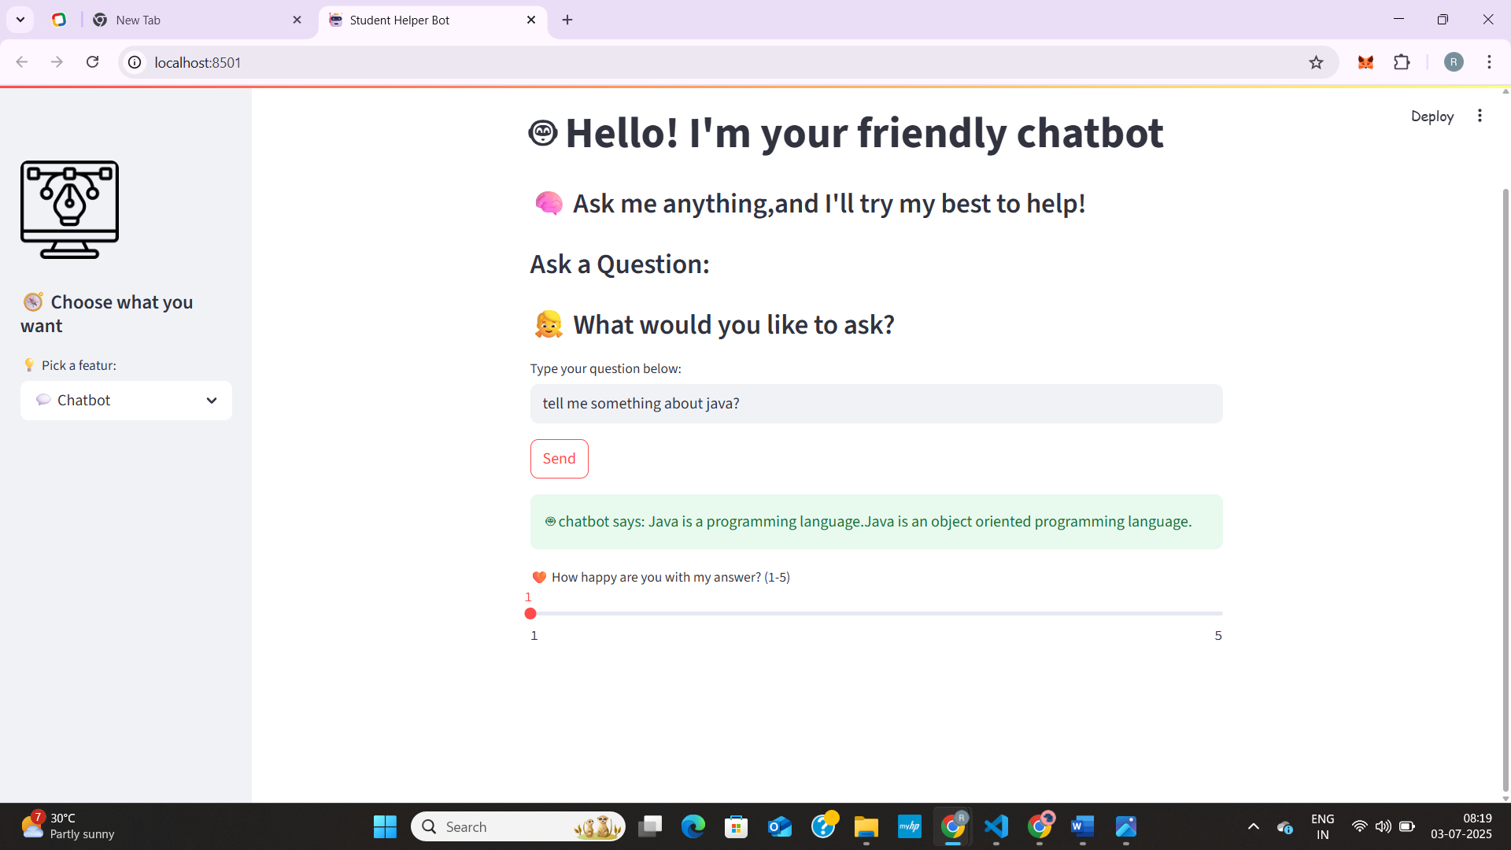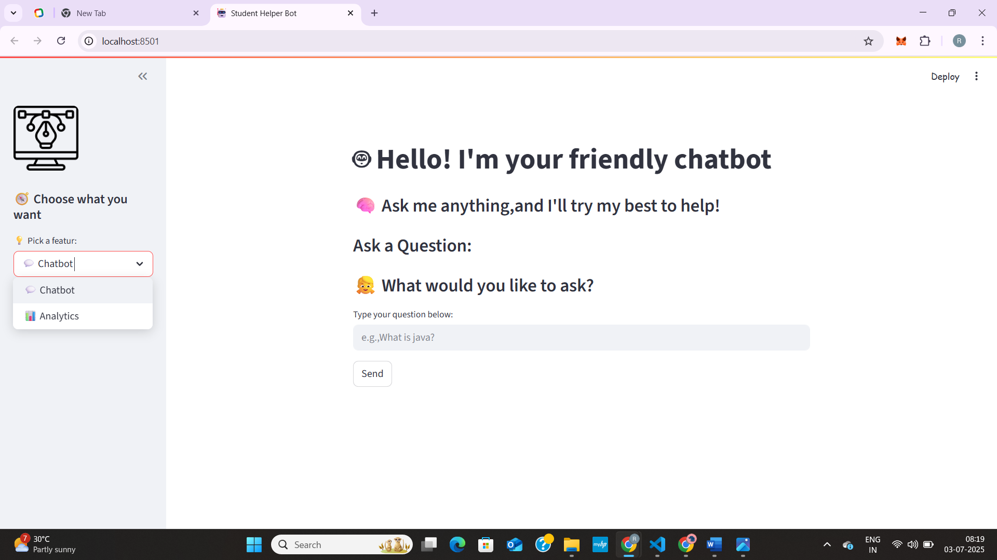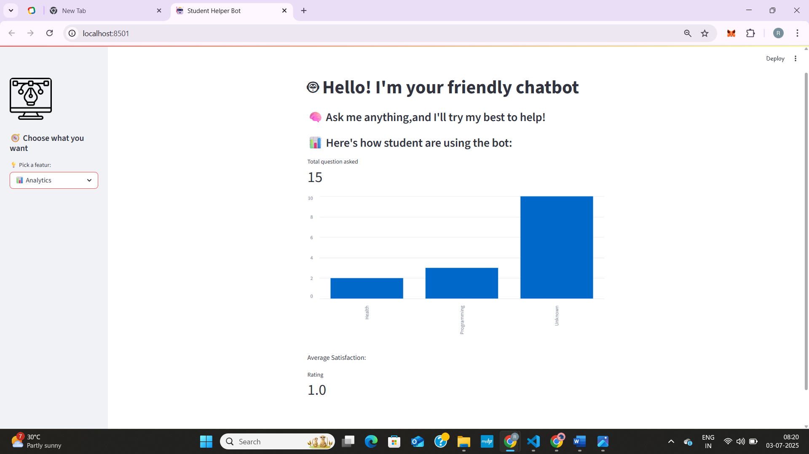

# 9. Conclusion

Task 1 helped improve practical Python and UI skills. The experience was useful in building a deployable, user-friendly mini-app. Ready to move on to Task 2.