10 minutes maximum. You do not have to use all 10 minutes. A strong 6 minute presentation is better than a rushed 10 minute one. If you go over 10 minutes, you will be stopped.
1
CAPSTONE
Presentation Guide
Your presentation is yours. You decide what to share. These rules are the only things that are
required.
10
min max
You do not have to use
all of it
Run it live
Screenshots do not
count
Your story
At least half your time
Slides
optional
Welcome, not required
The Rules
- You must run your program live. Show us that it works and meets the requirements.
Screenshots or recordings do not count.
Suggested time split (10 minute max)
Part | Time
Live demo | 2 to 3 minutes
Your capstone experience | 4 to 6 minutes
Wrap up | 1 minute
- Most of your time is about YOUR experience. At least half of your presentation should be about what you went through during the capstone: what was hard, how you figured things out, and what you learned.
Do not walk us through your code.
We have seen your code. We want to hear your
story.
4
PowerPoint is welcome, but not required. If you use slides, keep them simple.
5
1
Presentation Order
STEP 1
Run your program
Have it open and ready before
you start. Running it is how
you show it meets the
requirements, so there is no
need to explain what it does.
STEP 2
Talk about your
experience
This is the biggest part. Use
Part 2 for ideas.
STEP 3
Wrap up
End with "Thank you, any
questions?"
2
Questions You Could Answer
These are the kinds of questions I would ask myself if I were presenting. You do not need to answer all of them. Pick the ones that matter most to your story and build your presentation

around them.
What did you already know before this project?
What felt confusing or scary at the beginning?
What did you think would be easy that turned out to be hard?
What was the hardest part of this project?
What is one bug or error you got stuck on?
What happened?
How did you feel when things did not work?
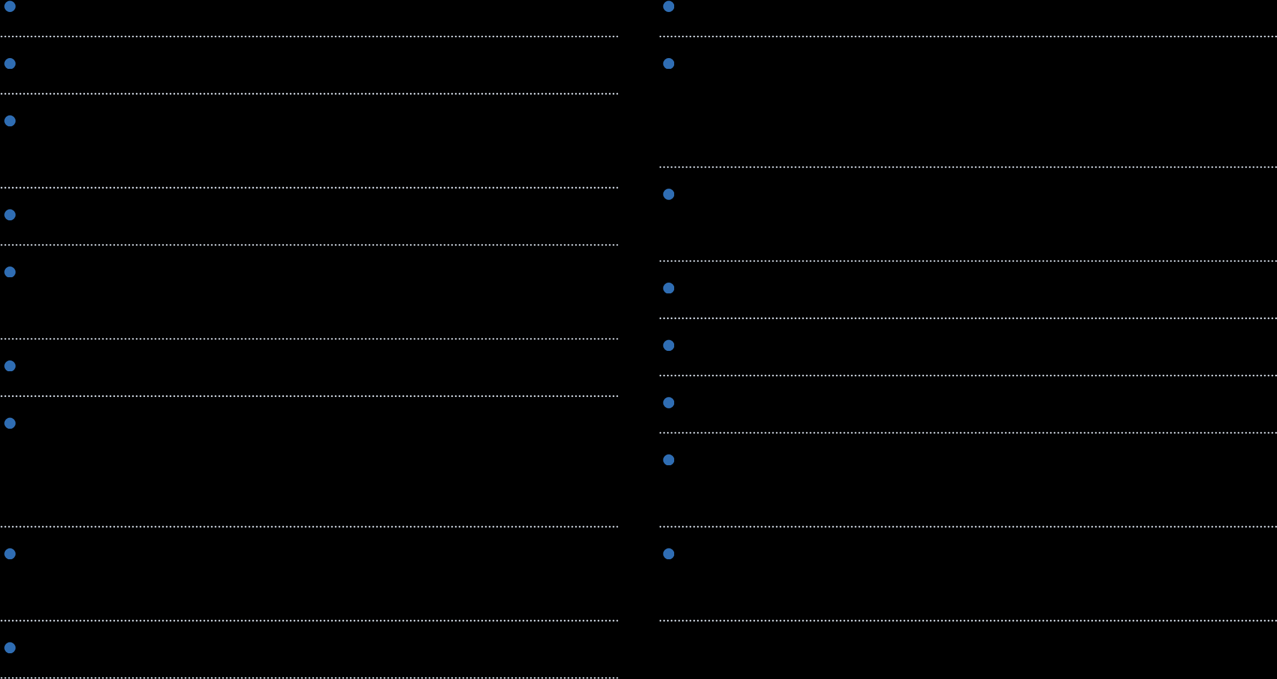
How did you figure things out? Trial and error, debugging, looking things up, asking for help, using AI to explain?
Tell us about one problem you solved, from start to finish.
Who or what helped you the most?
When did something finally "click" for you?
What is one technical thing you learned? (loops, methods, classes, file reading, and so on)
What problem solving skill did you get better at?
What would you do differently next time?
What are you most proud of?
What was the most frustrating part?
If you had two more weeks, what would you add or fix?
Do you feel more confident as a developer now? Why or why not?

Every box must be checked before your presentation day.
3
Before You Present
My program runs from start to finish without crashing.
I practiced my demo at least 2 times.
I know exactly what I will type or click during the demo.
I know roughly how long each part of my presentation takes.
I picked the questions from Part 2 I want to talk about.
I practiced the whole presentation out loud with a timer.
My practice run was 10 minutes or less.
My program is open and ready before it is my turn.
If I am using slides, they are open and ready too.

