1. **Create a GitHub Account**

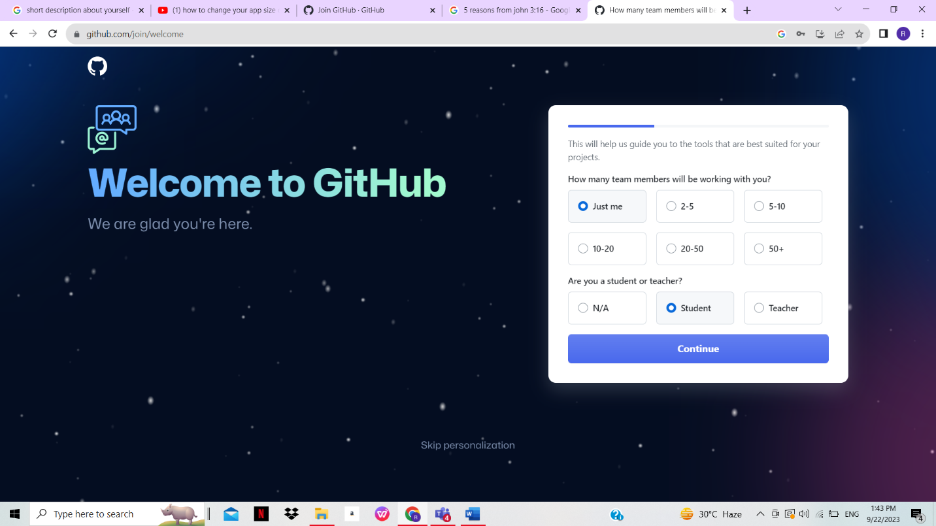

**2. On your account, create a repository named Lastname_Firstname_Year&Section**

1. **On the left side, click the “Branch”**

1. **Under the September 22 2023 IPT2 Activity**

