- There was a console TypeError from auth.js
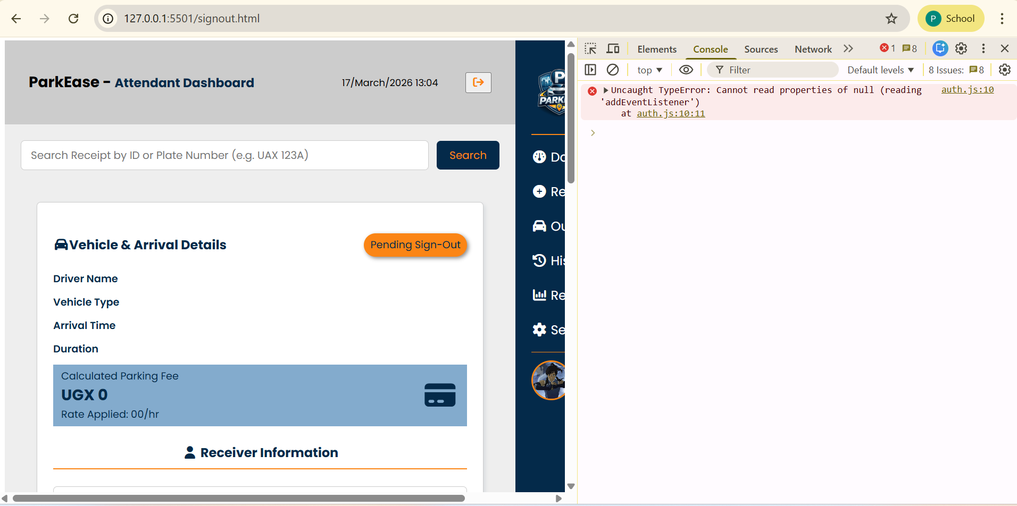

Debugging
Added a breakpoint and watched the value of the loginForm variable
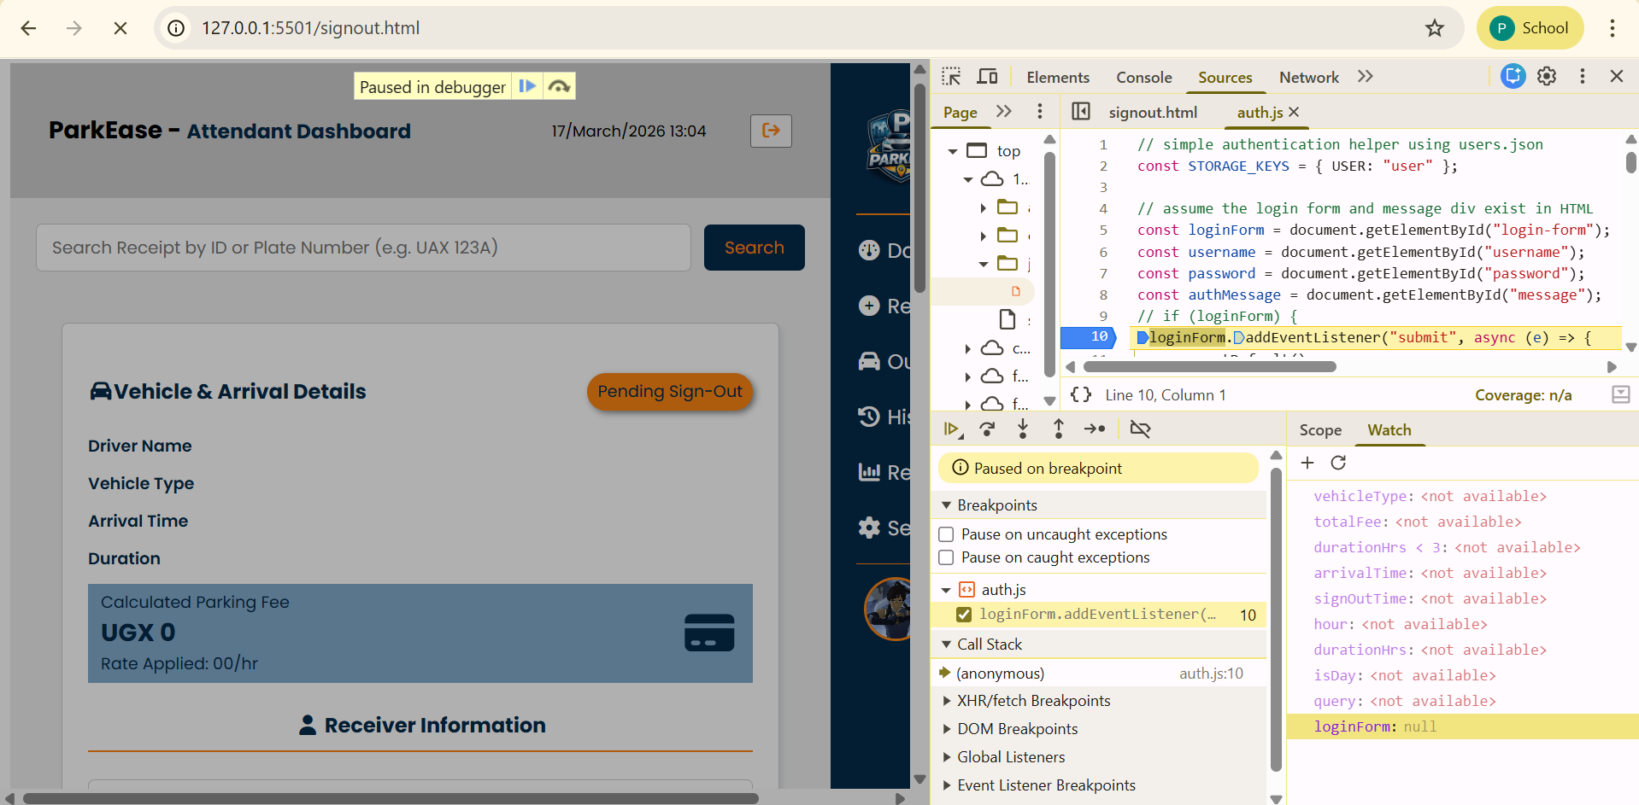
It was found to be null at that point. The eventListener was accessing the null value of loginForm hence the typeError.
Fixing
Added a condition for the eventlistener code to only run when loginForm had a value

- Search input not displaying error when no input is submitted but continued to search using null value in signout.html
Debugging
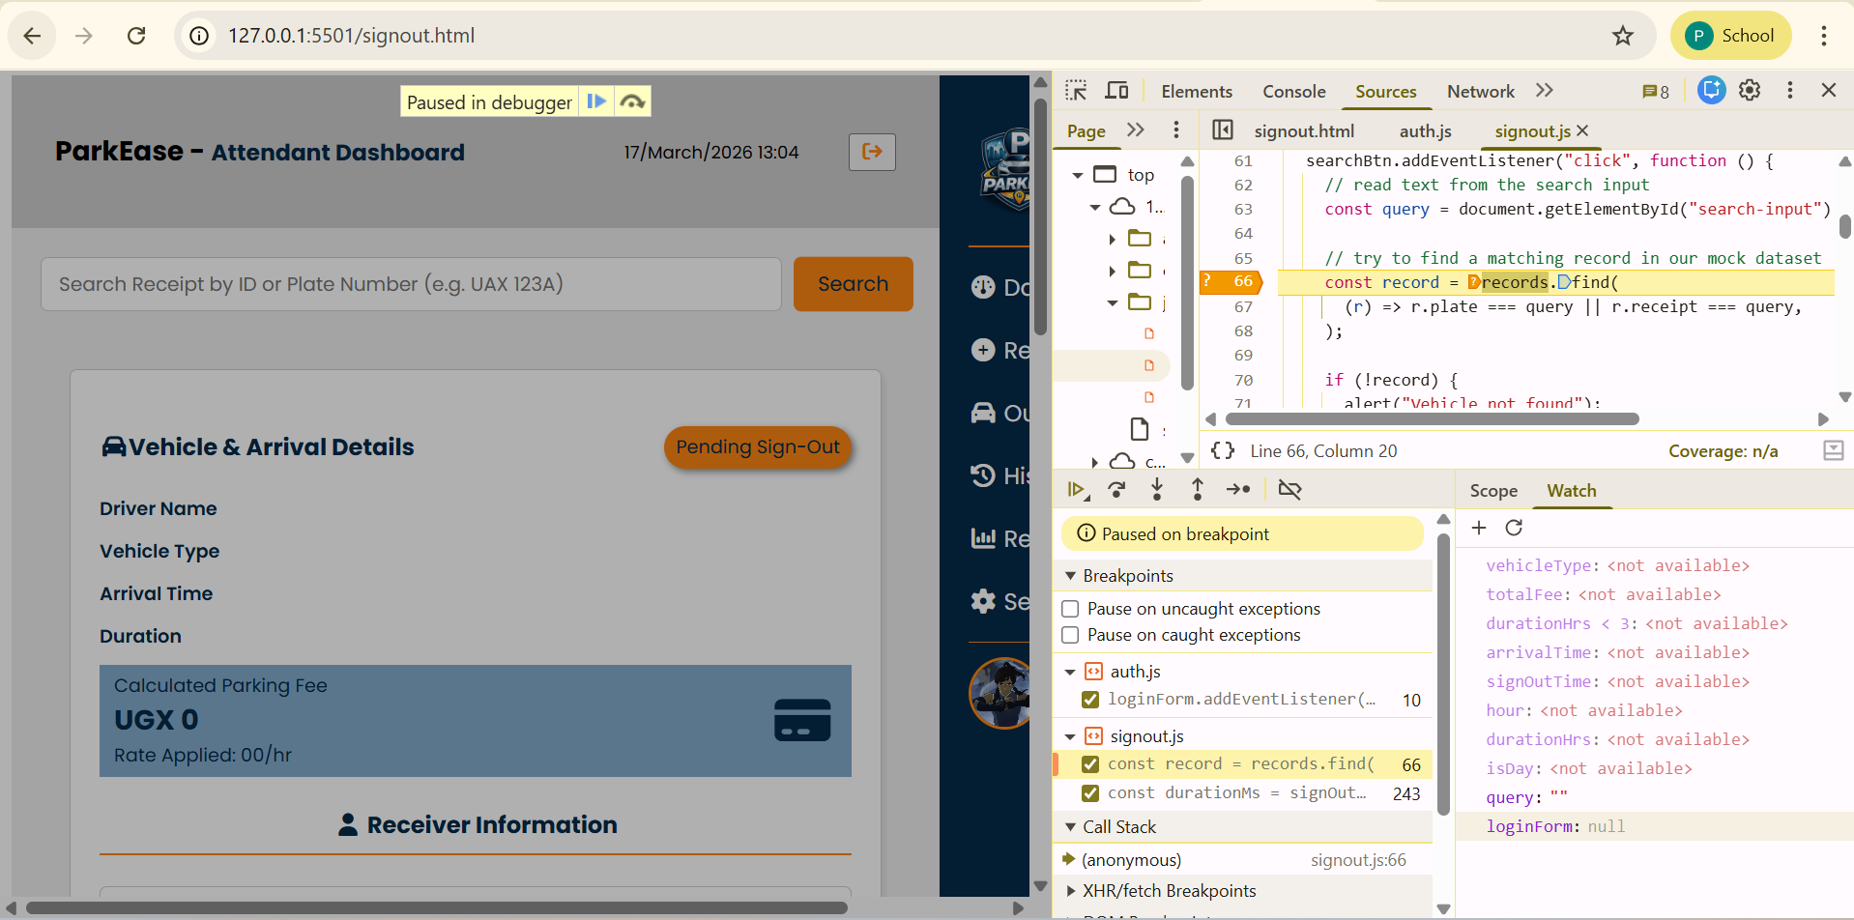
Added a conditional breakpoint to only to pause execution if search input value was null
Fixing
Added validation for empty input and notifying the user before searching for the record

