RCRAInfo API Keys
Explained Simply
What they are, who makes them, and what happens once the download program runs on its own at night.
Prepared for MDE management · Phase 1 · September 4, 2026 · Revision 1
Please read this first.
This document says what we know today, and it is honest about what we do not know yet.
Anything we have not confirmed is marked clearly in Section 9. Please do not assume those items are settled — several of them need a decision from management, or an answer from EPA, before we can finish building.
The whole thing, in six sentences
1. To download data from EPA, our program has to prove who it is. EPA will not send data to a stranger.
2. It proves who it is with two secrets that EPA gives us: an API ID and an API Key. Think of them as a username and a password, made for a program instead of a person.
3. A human being had to log in to EPA's website and click a button to create those two secrets. No software can do that step. There is no button EPA offers to a program.
4. Every time our program runs, it shows EPA the ID and the Key, and EPA hands back a token. The token is a temporary pass. It stops working after 20 minutes.
5. The program gets fresh tokens by itself, all night, forever. Nobody is called. Nobody is woken up. This is normal and expected.
6. The program can never make itself a new API Key. Only a person, on EPA's website, can do that.

The question everyone is asking: “How does the app get a new API Key?”
It does not — and it does not need to.
What the app renews, over and over and entirely by itself, is the 20-minute token. That is the thing that keeps expiring, and the app handles it without help.
The API Key is a different thing. It is long-lived, and replacing it is always a human task on EPA's website. Sections 4 and 9 explain exactly when that becomes necessary.
1 There are two different things. Do not mix them up.
Almost every misunderstanding about this topic comes from one confusion: treating the API Key and the token as the same thing. They are not. One is made by a person and lasts a long time. The other is made by the program and lasts 20 minutes.
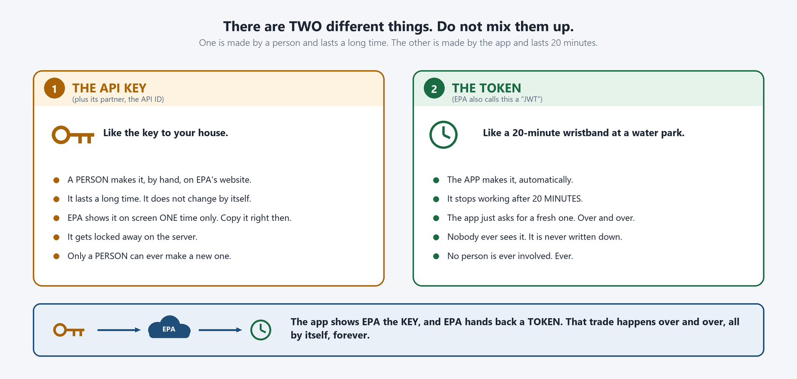
Figure 1 — The API Key is like a house key. The token is like a wristband that expires.
The two, side by side
 | The API Key (and API ID) | The token
Who makes it | A person, on EPA's website | The program, automatically
How long it lasts | A long time — see Section 9 | 20 minutes
How often it changes | Almost never | Constantly, all night
Who sees it | The person who generated it | Nobody; it is never written down
Where it lives | Locked up on our server | In memory only, then discarded
If it is lost | A person must generate a new one | The program simply asks for another
2 Where an API Key comes from
Getting an API Key is entirely a people process. Five steps, and every one of them needs a human being. The important part for planning is that two of the steps involve waiting on someone else.
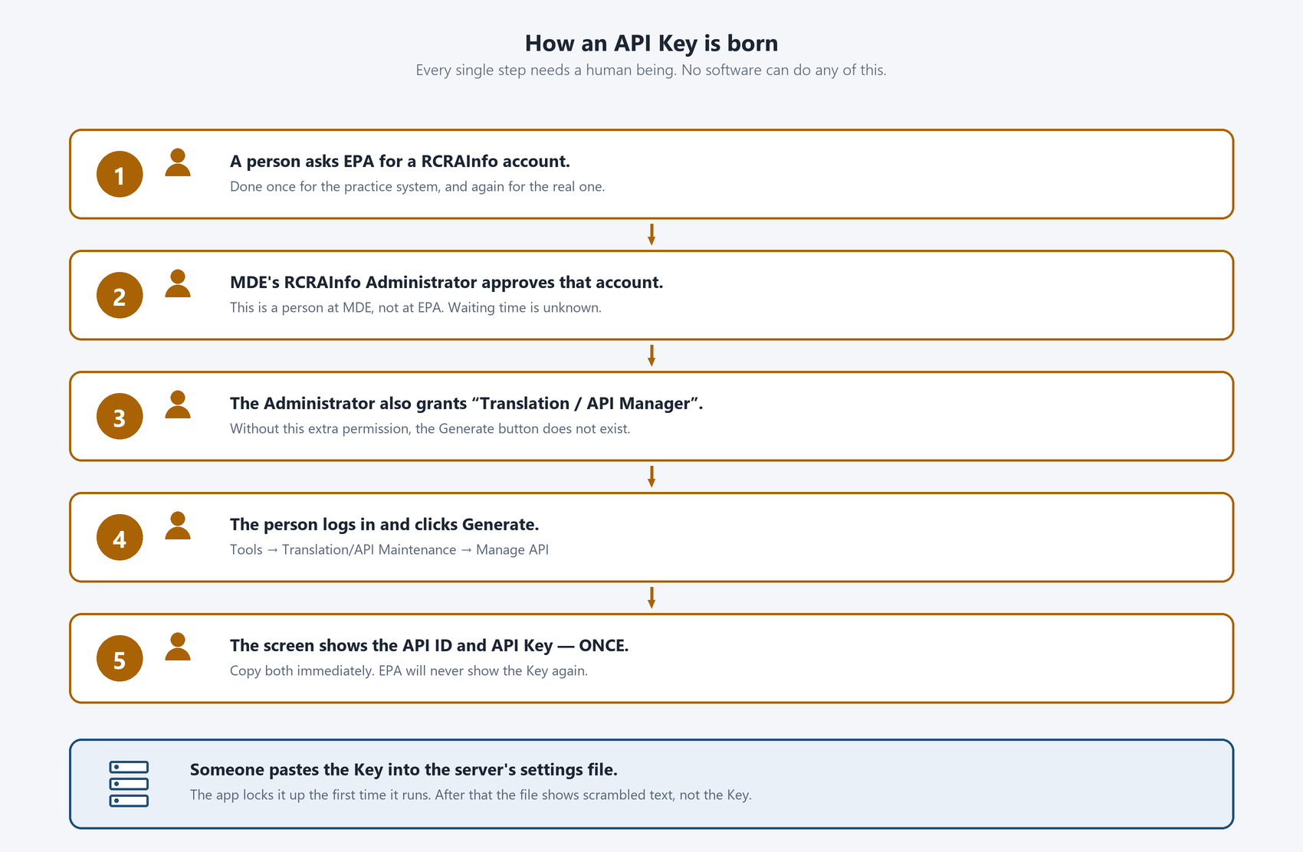
Figure 2 — Every step needs a person. No software can do any of it.
The Key is shown on screen exactly once.
When the Generate button is clicked, EPA displays the API ID and the API Key together, one time. Close that page without copying the Key and it is gone for good — the only remedy is to generate a brand new one.
This is why the person who generates the Key must be ready, at that moment, to put it straight onto the server. It must not travel through email, chat, or a note on a desk.
3 What happens every night, all by itself
This section is the direct answer to the question that started this document. Below is everything the program does on a normal night. Notice that no person appears anywhere in it.
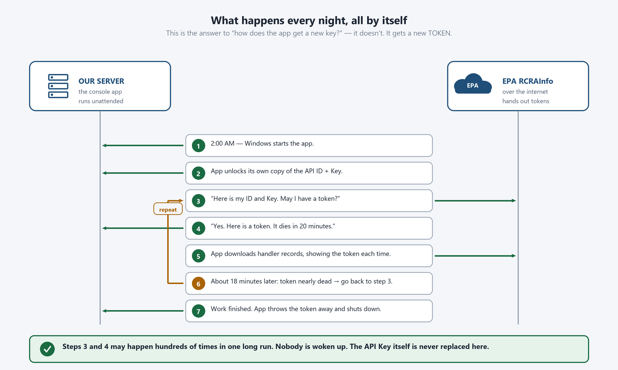
Figure 3 — The app trades its Key for a 20-minute token, and keeps trading for a fresh one until the work is done.
The loop between steps 3 and 4 may run hundreds of times during a long download. Each turn of that loop is a routine, expected, invisible event. It is not an error, it is not a warning, and it does not need to be reported to anyone.
Two words that sound alike but mean very different things
Renewing the TOKEN happens every 20 minutes, automatically, forever. Nobody is involved.
Replacing the KEY happens rarely, by hand, on EPA's website. A named person is always involved.
4 When does a person actually have to step in?
Only four situations require a human being. Everything else the program handles quietly on its own.
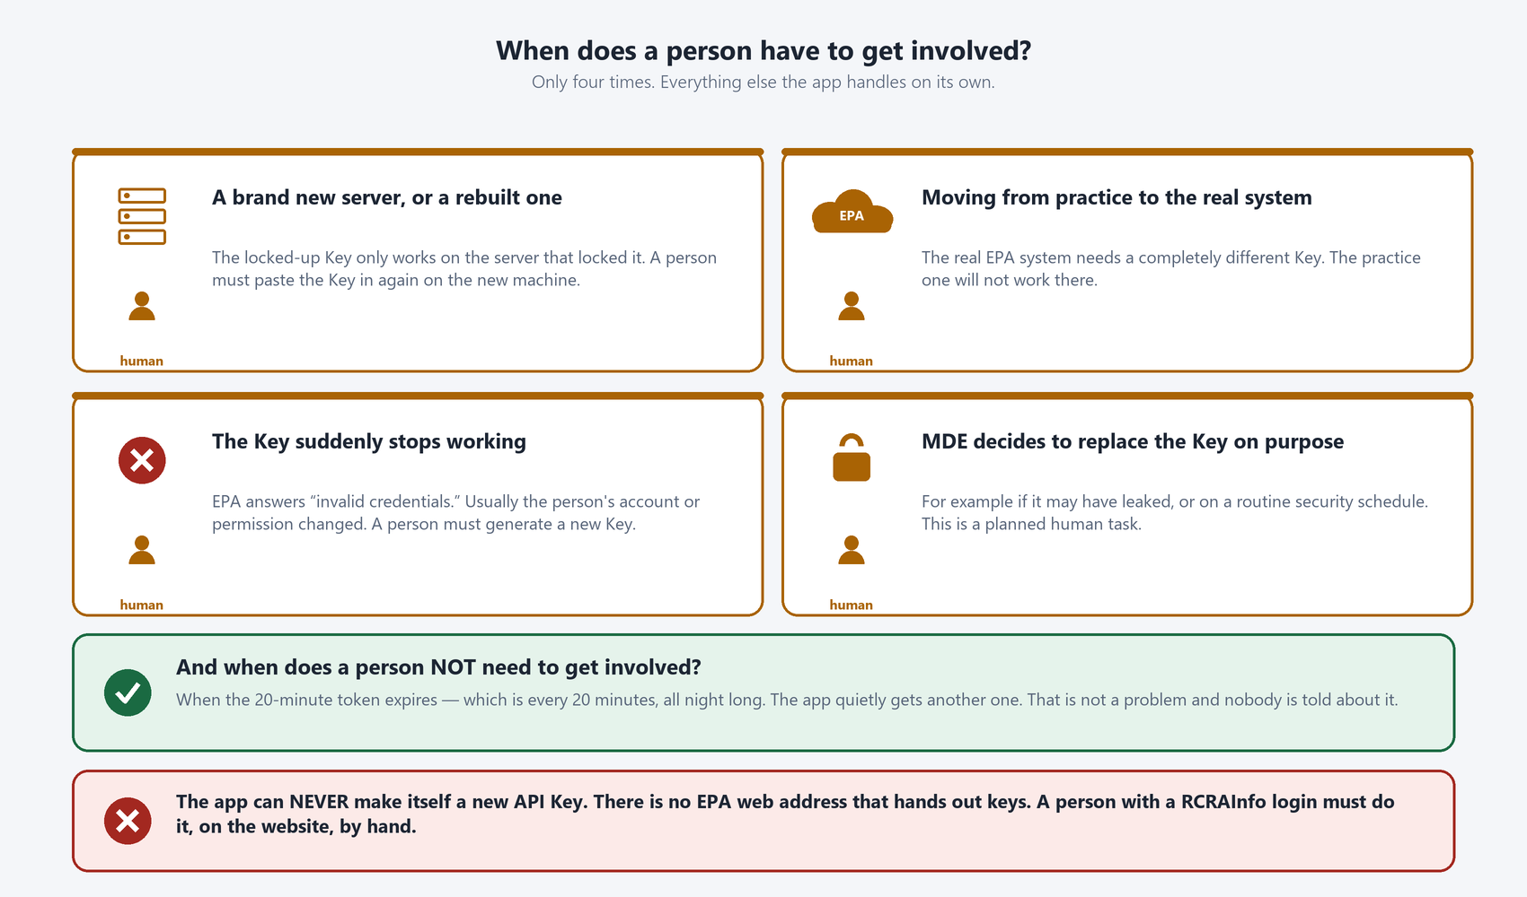
Figure 4 — Four situations need a person. Token expiry is not one of them.
The same four situations, in a table
Situation | What has to happen | How often we expect it
A new or rebuilt server | A person pastes the Key in again on that machine | Once per server, plus any rebuild
Moving from practice to the real system | A completely different Key is generated and installed | Once, at go-live
The Key stops working | A person generates a new Key and installs it | Unknown — see Section 9
MDE chooses to replace the Key | A planned, scheduled human task | However often MDE policy says
5 Practice and Real are two completely separate worlds
EPA runs two RCRAInfo systems: a practice one for testing and the real one holding actual regulated-business data. They share nothing. Two accounts, two approvals, two Keys.
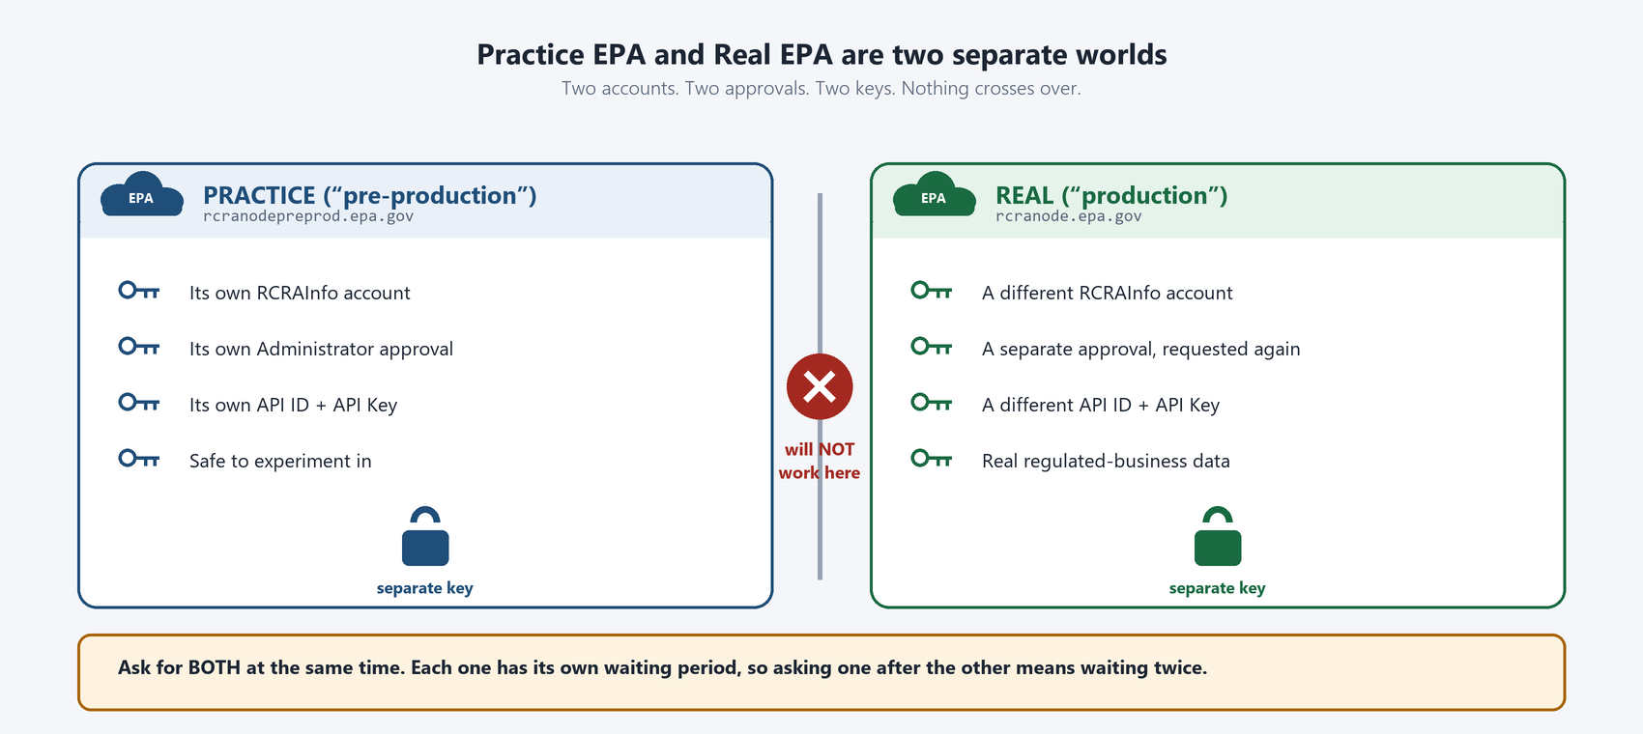
Figure 5 — Nothing crosses over between the practice system and the real one.
This has a schedule consequence worth acting on now.
Each account needs its own approval, and each approval has its own waiting period. Requesting one, waiting, then requesting the other means waiting twice.
Recommendation: request the real-system account at the same time as the practice one, even though we will not use it for months.
6 Once locked up, the Key only works on one server
The Key is not left sitting in a readable file. The first time the program runs, it locks the Key up using a feature built into Windows. That lock is tied to the specific machine that performed it.
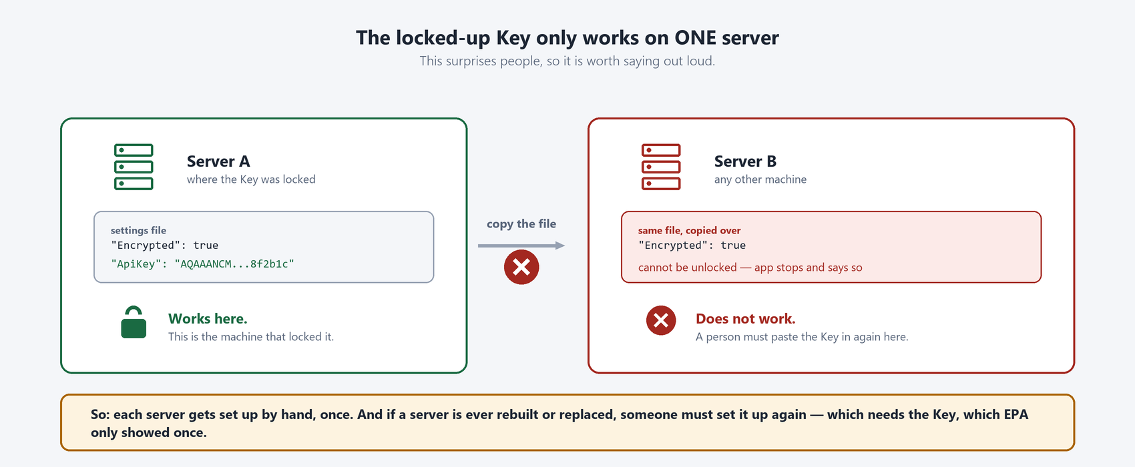
Figure 6 — Copying the settings file to another machine does not carry the Key with it.
In plain terms: the locked-up Key cannot be copied from one server to another. That is a security benefit — stealing the file gains an attacker nothing. It is also an operational cost: every server must be set up by hand, once, by someone holding the Key.
7 Whose Key is it? This is the real risk.
This is the part of the picture we would most like management to look at, because it is a people problem rather than a software one.
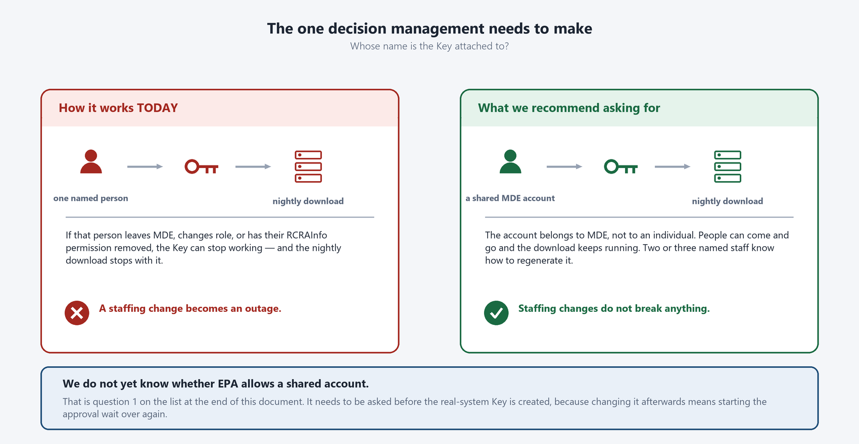
Figure 7 — Today the Key belongs to one named individual's EPA account.
Today, an API Key is generated from one person's RCRAInfo account. The nightly download therefore depends on that individual's account remaining active and keeping its permission. If that person leaves, changes role, or has their access reviewed, we believe the Key stops working and the nightly load fails — and the only fix is for someone with the right permission to generate a new Key.
What this means in practice
A staffing change can become a data outage, with no code change and no warning.
We would like to ask EPA whether a shared MDE account, not tied to one individual, may hold the Key instead. We do not yet know whether EPA permits this.
Whatever the answer, MDE should name at least two people who are permitted and trained to generate a replacement Key.
8 If the Key stops working, what will you see?
It is worth knowing in advance, because the failure is abrupt and total rather than gradual.
1. The program cannot get a token. EPA answers with a refusal that means, roughly, “these credentials are not valid.”
2. The run stops immediately. It does not try to carry on with partial data. Nothing is half-loaded, so there is no cleanup to do.
3. The failure is recorded. The reason, the time, and EPA's own reference number for the refusal are all written down.
4. The monitoring website shows it. The status for that night's run turns to failed, with the reason visible — this is what the web application in Phase 1 is for.
5. A person generates a new Key and installs it. This is the manual step from Section 2, done again.
6. The run is started again. Nothing is lost. The next run picks up from where the data left off.

The good news
Because a bad Key stops the run at the very first step, there is no risk of loading half of a night's data or of silently loading nothing while appearing to succeed. It fails loudly, immediately, and visibly.
9 What we know for certain, and what we do not
Confirmed — we have done these ourselves or read them in EPA's documentation
- There are two values, an API ID and an API Key, and both are needed.
- A developer can generate them on EPA's practice site today. This has been done.
- The Key is displayed one time only, at the moment it is generated.
- Generating a Key requires an extra permission, granted by MDE's own RCRAInfo Administrator, not by EPA.
- Trading the ID and Key for a token is a single request, and the token lasts 20 minutes.
- The practice system and the real system need separate accounts and separate Keys.
- There is no EPA request a program can make to create or replace an API Key.
Not known — these are open questions for EPA
Question for EPA | Why it matters to MDE
Does an API Key expire on its own, and if so after how long? | Determines whether we need a scheduled human task on the calendar.
Can a Key be replaced without downtime — can two Keys be valid at once? | Decides whether a Key change needs a maintenance window.
May a shared MDE account hold the Key instead of one named person? | This is the single biggest continuity risk. See Section 7.
What happens to the Key if the account holder's role or access changes? | Tells us whether HR and access reviews can silently break the nightly load.
Does EPA warn anyone before a Key stops working? | Decides whether we can act in advance or only react after a failure.
How long does MDE Administrator approval usually take? | Needed to schedule Phase 1 realistically.
Does EPA limit how often we may request tokens or download records? | Affects how fast the nightly download can safely run.
10 What we are asking management to decide
# | Decision or action | Who we think should own it
1 | Name the role that owns the API Key — and name at least two people trained to replace it. | MDE management
2 | Decide who contacts EPA with the seven questions in Section 9, and by when. | MDE management
3 | Decide whether to formally request a shared MDE account to hold the Key. | MDE management, with EPA
4 | Request the real-system RCRAInfo account now, in parallel with the practice one. | Project team, needs approval
5 | Approve that each server — test, acceptance, production, and any rebuild — gets one manual Key installation. | MDE management and IT
6 | Approve a short written procedure for replacing the Key outside business hours. | MDE management and IT

Nothing here is blocked on software.
The program can be built and tested with the practice Key we already have. Every item above is about people, accounts, and permissions — which is precisely why they take longer than the software does, and why we are raising them now rather than later.
11 Words you may hear
Word | What it actually means
API | A way for one program to ask another program for data, with no person clicking anything.
API ID | The program's user name at EPA. Not secret in the same way the Key is, but still not published.
API Key | The program's password at EPA. Long-lived. Shown once. Made by a person.
Token (or JWT) | A temporary pass, good for 20 minutes, that the program gets by showing its ID and Key.
Credentials | A collective word for the ID and the Key together.
Environment | One separate copy of a system. EPA has a practice one and a real one; MDE has several of its own.
Pre-production | EPA's name for the practice system.
Production | EPA's name for the real system, with real data.
Encrypted | Scrambled so it cannot be read. Here it also means locked to one specific server.
Rotation | Deliberately replacing a Key with a new one, on a schedule, as a security practice.
Handler | EPA's word for a regulated business or site. Handler records are the data we are downloading.
12 Where to go for more detail
This document is deliberately simplified. Nothing in it is untrue, but a great deal has been left out on purpose.
If a technical reviewer needs the exact requests we send to EPA, the exact refusals EPA can send back, how the Key is stored, or the numbered list of every open question, all of that lives in the two project documents below. They are kept up to date as answers arrive.
Document | What it contains
Phase1-Analysis.md | The verified facts about EPA's interface, the error codes, and the numbered register of every open gap — including the API-key questions in Section 9 of this document.
Phase1-Plan.md | The work plan: what gets built, in what order, who owns each piece, and which items are waiting on a decision or on EPA.

One last thing worth remembering
The single most useful sentence in this whole document is this: the app renews its 20-minute token by itself, forever, and it can never renew its API Key. Everything else follows from that.

