Abstract Memory Object Interface
By Greg Bronevetsky, May, 2011
Modified by Chunhua Liao, 7/12/2011

Description of Interface
This interface represents all of the application memory locations as a set of abstract objects. Each abstract object refers to some subset of memory locations and may describe a wide variety of subsets. For example, an abstract object may correspond to an individual variable on the stack, all the elements in an array or all memory locations that have a given type. Abstract objects may also be empty. The interface enables compiler analyses to determine whether the memory objects that are referred to by various expressions may or must be equal to each other or may or must overlap each other. The abstractions may have of arbitrary precision and complexity and the interfaces hides the details of how these abstractions are implemented.
The interface organizes abstract memory objects into four categories: scalars, labeled aggregates, arrays and pointers.
- Scalars are contiguous memory region that have no internal structure that is meaningful to the compiler.
- Labeled aggregates represent objects such as structs, classes and bitfields that contain a finite number of other objects that have discrete labels.
- Arrays represent contiguous sequences of memory objects that have the same type. Arrays are indexed via subscripts in an n-dimensional integral space and may have an unbounded number of elements.
- Pointers are objects that refer to other objects but do not include any objects.
The interface specifies six abstract classes that must be implemented by specific implementations: 1) MemObjSet, 2) MemObjSetFactory, 3) scalar, 4) labeledAggregate, 5) array and 6) pointer. In the documentation below all methods must be provided by specific implementations of the interface, unless explicitly indicated otherwise.
- MemObjSet:
A set of memory objects. It is the root class from which the others are derived. All memory locations and regions are modeled as an object set. If an MemObjSet corresponds to one real memory object, the corresponding MemObjSet will have a size of 1. It provides the following functionality:
Type of abstraction:
Return true if this object set includes memory objects that May be the same or Must be the same
bool maySet();
bool mustSet();
Granularity of abstraction:
The number of real memory objects that this object set corresponds to. Returns a concrete number if it is known or the constant unboundedSize if no static bound is known.
static const int unboundedSize=MAX_INT;
int size();
Type of memory:
The types that all elements of the set may/must have. If the set of types this abstract object may have is unknown or very large, returned list contains an object of type SgAllType. If the set of types the object must have is unknown or very large, returns an empty list.
set<SgType*> getType();
Object overlap relations:
Returns true if this object set and that object set may/must overlap. A separate version of this method is provided for each possible type of memory object set to make sure that if we add more memory object types, all implementations of the memory object abstraction will not type-check unless they provide explicit support for the new types.
bool overlaps(const scalar& that);
bool overlaps(const labeledAggregate& that);
bool overlaps(const array& that);
bool overlaps(const pointer& that);
Equality relations (implemented by interface):
Returns true if this object set and that object set may/must refer to the same memory objects.
bool operator == (const MemObjSet& o1, const MemObjSet& o2);
Total order relations (implemented by interface):
General comparison operators. Provide a total order among different object types (scalar, labeledAggregate, array or pointer). These operators have no semantic meaning and are primarily intended to be used to put all objects into a total order, which makes it possible to use them in data structures such as std::map.
bool operator < (const MemObjSet& o1, const MemObjSet& o2);
bool operator <= (const MemObjSet& o1, const MemObjSet& o2);
bool operator > (const MemObjSet& o1, const MemObjSet& o2);
bool operator >= (const MemObjSet& o1, const MemObjSet& o2);

- MemObjSetFactory:
Implements a factory method for instances of MemObjSet of a given abstraction
Returns an abstraction for the memory represented by the given SgExpression. The get() function allocates the object by the caller must delete it.
MemObjSet* MemObjSetFactory::createMemObjSet(SgExpression* expr) const
MemObjSet* MemObjSetFactory::createMemObjSet(SgDeclaration* decl) const;

- scalar:
Implements the abstraction of a scalar memory object that has no internal structure.
Extends MemObjSet.
Equality relations:
Returns true if this object and that object may/must refer to the same scalar memory object.
bool operator == (const scalar& that) const;
Total order relations (implemented by interface):
Comparison operator to make it possible to provide a total order among all scalar objects.
bool operator < (const scalar& that) const;

- labeledAggregate:
Implements the abstraction of a memory object that contains a finite number of explicitly labeled memory objects, such as structs, classes and bitfields. Extends MemObjSet.
Element access:
Returns a map that maps field labels to their respective object sets.
list<labeledAggrField*> getElements();
Returns the field at the given index.
labeledAggrField* getElements(int index);

The labeledAggrField class has the following fields:
The field's name
string name;
The field's index within its parent object (the first field has index 0,
second has index 1, etc.)
size_t index;
The number of bytes this field takes up within its parent object (in contrast, MemObjSet::size() returns the number of real memory locations the abstract
MemObjSet corresponds to)
size_t size;
Ponter to an abstract description of the field
MemObjSet* field;
Equality relations:
Returns true if this object and that object may/must refer to the same labeledAggregate memory object.
bool operator == (const labeledAggregate& that) const;
Total order relations (implemented by interface):
Comparison operator to make it possible to provide a total order among all labeledAggregate objects.
bool operator < (const labeledAggregate& that) const;

- array:
Implements the abstraction of a memory object that contains an unbounded number of memory objects that are indexed using d-dimensional integral vectors. Extends MemObjSet.
Element access:
Returns a memory object that corresponds to all the elements in the given aggregate
MemObjSet* getElements();
Returns the memory object that corresponds to the elements described by the given abstract index, which represents one or more indexes within the aggregate.
MemObjSet* getElements(abstractIndex* ai);

The abstractIndex class is an abstraction that represents d-dimensional integral vectors. It encapsulates a variety of abstract representations for such vectors such as polyhedral constrants and strided indexes. However, since we don’t currently understand the common functionality of such abstractions, the structure of this class has not been developed yet.

The number of dimensions in the vectors
int numDims() const;
Equality relations:
Returns true if this object and that object may/must refer to the same array memory object.
bool operator == (const array & that) const;
Total order relations (implemented by interface):
Comparison operator to make it possible to provide a total order among all array objects.
bool operator < (const array & that) const;

- pointer:
Implements the abstraction of a memory object that points to other memory objects.
Extends MemObjSet.
Reference:
Returns the target of the pointer
MemObjSet* getTarget() const;
Equality of pointer targets(implemented by interface):
Returns true if this pointer refers to the same abstract object as that pointer.
bool equalPoints(const pointer & that);
Equality relations:
Returns true if this object and that object may/must refer to the same pointer memory object.
bool operator == (const pointer & that) const;
Total order relations (implemented by interface):
Comparison operator to make it possible to provide a total order among all pointer objects.
bool operator < (const pointer & that) const;

Implementations of the Abstract Memory Object Interface

Implementation of a Syntax-Driven Memory Abstraction
We illustrate the design of the abstract memory object interface by presenting a simple alias analysis implementation. This is a primitive implementation that only considers syntactic information in the application source code and does not use any additional flow- or path-based analysis. It assumes that the application is type-safe but may have aliasing. As such, it only provides fine-grained information about un-aliased local and global variables as well as individual expressions. For memory objects that are accessible through pointers (e.g. aliased variables or heap buffers) the implementation provides very coarse information, differentiating objects according to their type and nothing more. Unions are currently not supported and the abstraction only provides may-information.

Abstractions by Syntax
This implementation represents memory objects using three different abstractions, depending on how much syntactic information is available about the object: 1) SgExpression temporary variables, 2) named memory objects and 3) aliased memory objects. Further, it differentiates between scalars, labeled aggregates, arrays and pointers within each of the above object types.
- SgExpressions in the application’s AST that do not correspond to a variable or an explicitly allocated memory region are represented as temporary memory objects. A temporary object of SgExpression E is defined when the E is executed and is used by the SgExpression that directly incorporates E. Two temporary objects are equal if and only if they correspond to the same SgExpression. This can always be determined statically. Since it is not possible to alias these temporary objects, no temporary object equals another type of object. A temporary object overlaps with another object if and only if they correspond to the same SgExpression and one is contained inside the other.
- Named memory objects correspond to variables that are explicitly named in the source code. These include local, global and static variables as well as all their fields. Named objects may not directly alias each other since they must be stored disjointly. As such, two named objects are equal to each other if they correspond to the same entry in the application’s symbol table. Two named objects overlap if one is contained inside the other. Because this abstraction assumes that the application is type-safe and has no unions, it is not possible for named variables to partially overlap.
- Aliased memory objects correspond to memory regions that may be accessible via a pointer. Examples are heap memory, which is only available via pointers, as well as variables that are referenced through a pointer. Since this implementation of the memory abstraction does not track aliases, it only maintains type information about such objects. An aliased memory object and an aliased or named object may be equal if they have the same type. Further, an aliased object x may-overlap an aliased or named object y if they have the same type or if x has an aggregate type and this type contains elements of the type of object y.

Abstractions by Type
The abstraction also divides objects according to their type, as discussed in Section I: scalar, labeled aggregate, array and pointer. Scalars correspond to C++ base types. Labeled aggregates correspond to C++ structs and classes. Arrays model C++ arrays. Pointers model C++ pointers and references.

Implementation of the Abstraction
Figure 1 shows the classes implemented by this abstraction. It implements base classes for expression, named and anonymous objects. It also implements base classes for scalars, labeled aggregates, arrays and pointers. Then it creates specific classes such as “named arrays” by inheriting from the appropriate base classes from the above lists
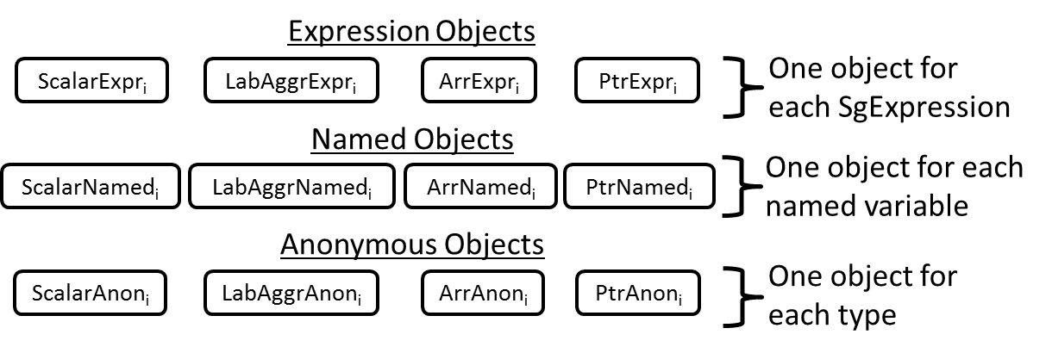
Figure 1: Structure of Syntactic Memory Abstraction
Examples:
For an intuition of how this abstraction represents memory regions consider the following code example.
class aggr {
int i;
double d;
aggr* pAggr;
};
int foo() {
int a, b, c;
int *pa = &a, *pb = &b;
int x[100];
aggr l;
l.pAggr = new aggr;
return a + *pb + x[5] + l.pAggr->i + l.d;
Variables a, b and c are represented as named scalars. As such, they are known to not be equal. Variables pa and pb are named pointers and are also not equal to each other. However, the abstraction considers that the objects pointed to by these pointers are equal since they have the same type and may be aliased to each other.x is a named array that contains a single named scalar object. However, since the abstraction cannot differentiate different indexes of x, it considers objects x[0] and x[50] to be equal. Variable l is a named labeled aggregate that contains named scalars l.i and l.d, as well as named pointer l.pAggr. l.pAggr points to an aliased labeled aggregate and thus, objects l.pAggr->i and l.pAggr->d are aliased scalars of type int and double, respectively. Because aliasing is not tracked, the abstraction considers that l is equal to l.pAggr and l.pAggr->i is equal to a. Finally, the return statement is a tree of SgExpressions, each of which corresponds to a temporary memory object. SgVarRefExp “a” is an named scalar, while SgExpressions “a + *pb”, “a + *pb + x[5]”, etc. are all expression scalars. All these expression scalars are known to be not equal to any named or aliased memory objects since such temporary variables cannot be aliased.
Base Classes:
Expression and named objects are associated with an “anchor” object that connects them with a specific lexical object in the ROSE abstract syntax tree. For expression objects it is an SgExpression and for named objects it is an SgSymbol. Objects that represent components of expression and named objects (e.g. fields in a struct or elements in an array) are associated with the anchors of their parent objects and also maintain pointers to these objects. Since the only syntactic information available about aliased objects is their type, there is no need to maintain any anchors to syntactic objects or links to parent objects. As such, we only maintain their SgType.
The pseudocode below presents the base classes for expression, named and aliased objects, showing their fields and methods that create new instances of these objects.
class ExprObj {
SgExpression* anchor;
SgType* type;
ExprObj* parent;
};
class NamedObj {
SgSymbol* anchor;
SgType* type;
ExprObj* parent;
};

// Create a new instance of an expression or named object
MemObjSet* createExpression / createNamedMemObjSet
(SgType t,SgExpression* anchor,MemObjSet* parent)
{
Let @@@ = “Expression” or “Named”

// Return an object that corresponds to t,
// has the same anchor as this object and
// records this object as its parent
switch (t) {
case base type:
return scalar@@@_Impl(anchor, t, parent);
case struct/class type:
return labeledAggregate@@@_Impl(anchor, t, parent);
case array type:
return array@@@_Impl(anchor, t, parent);
case pointer type:
return pointer@@@_Impl(anchor, t, parent);
}
}

class AliasedObj {
SgType* type;
};

// Create a new instance of an aliased object
MemObjSet* createAliasedMemObjSet(SgType* t) {
// Return an object that corresponds to t,
// has the same anchor as this object and
// records this object as its parent
switch (t) {
case base type:
return scalarAliased_Impl(t);
case struct/class type:
return labeledAggregate*_Impl(t);
case array type:
return array@_Impl(t);
case pointer type:
return pointer@_Impl(t);
}
}
The following pseudocode lists the prototypes of the base classes for scalars, labeled aggregates, arrays and points, which inherit from their respective general virtual classes and implement their virtual methods. The implementations of their methods are defined below.
class scalar_Impl : scalar {
...
};
class labeledAggregate_Impl : labeledAggregate {
...
};
class array_Impl : array {
...
};
class pointer_Impl : pointer {
...
}

Derived classes:
This pseudocode show how an individual class is created by inheriting from one instance of each type of base class.
class scalarExpression_Impl : scalar_Impl, ExprObj {
...
};
class arrayNamed_Impl : array_Impl, NamedObj{
...
};
…

Implementations of getElements() methods:
A getElements() method of a labeledAggregate returns an abstraction that describes the objects inside it. Objects that represent components of expression and named objects are associated with the anchors of their parent objects. Components of aliased objects only keep track of their types and do not maintain anchors or parent links. The pseudocode below describes the structure of the getElements() methods for all three cases.
list<labeledAggrField*> labeledAggregateExpression_Impl::getElements()
list<labeledAggrField*> labeledAggregateNamed_Impl::getElements()
list<labeledAggrField*> labeledAggregateAliased_Impl::getElements()
{
Let @@@ = “Expression”, “Named” or “Aliased”
list<labeledAggrField*> list;
Iterate through the fields of type {
Let ftype = type of current field;
create labeledAggrField f (.name=…, .index=…, .size=…)
if(@@@ = “Expression”, “Named”)
f.field = create@@@MemObjSet(t, anchor, this));
elsif(@@@ = “Aliased”)
f.field = create@@@MemObjSet(t));
List.push_back(f);
}
return list;
}
getElements() objects of arrays are similar, except that we do not differentiate between individual array entries. Instead, all array entries are represented using a single MemObjSet.
list<labeledAggrField*> arrayExpression_Impl::getElements()
list<labeledAggrField*> arrayNamed_Impl::getElements()
list<labeledAggrField*> arrayAliased_Impl::getElements()
{
Let @@@ = “Expression”, “Named” or “Aliased”
Let eltType = type but with one level of indirection removed
if(@@@ = “Expression”, “Named”)
return create@@@MemObjSet(eltType, anchor, this));
elsif(@@@ = “Aliased”)
return create@@@MemObjSet(eltType));
}
Implementations of getTarget() methods:
Because our implementation does not keep track of aliasing, memory objects obtained through any pointers may be aliased with other aliased or named memory objects of the same type. Thus, the getTarget() method of all pointer classes returns an aliased object of the pointer’s target type.
MemObjSet* pointer_Impl::getTarget()
{
return createAliasedMemObjSet(eltType));
}

Implementation of equality operators:
An expression or named object of a given abstraction type (scalar, labeled aggregate, etc.) are equal to another expression or named object if they share the same anchor and appear in the same location inside their parent objects, if any. Expression objects are never equal to named objects or aliased objects. There relationships are illustrated in Figure 2.
bool operator==(ExprObj o1, ExprObj o2)
bool operator==(NamedObj o1, NamedObj o2)
{
// If both objects have the same anchor
if(o1.anchor == o2.anchor) {
// If both have parents
if(o1.parent!=NULL && o2.parent!=NULL) {
f1 = field within e1.parent.getElements() that corresponds to o1
f2 = field within e2.parent.getElements() that corresponds to o2
// If both correspond to the same index within their parents
if(f1.index == f2.index)
// o1 == o2 if their parents are equal
return *(o1.parent) == *(o2.parent);
// Else, if neither have parents
if(o1.parent==NULL && o2.parent==NULL)
return true;
}
return false;
}
bool operator==(ExprObj e1, NamedObj n2) { return false; }
bool operator==(ExprObj e1, AliasedObj a2) { return false; }

bool operator==(AliasedObj o1, NamedObj o2)
bool operator==(AliasedObj o1, AliasedObj o2)
{
// o1 and o2 are equal if their types are
return o1.type == o2.type;
}

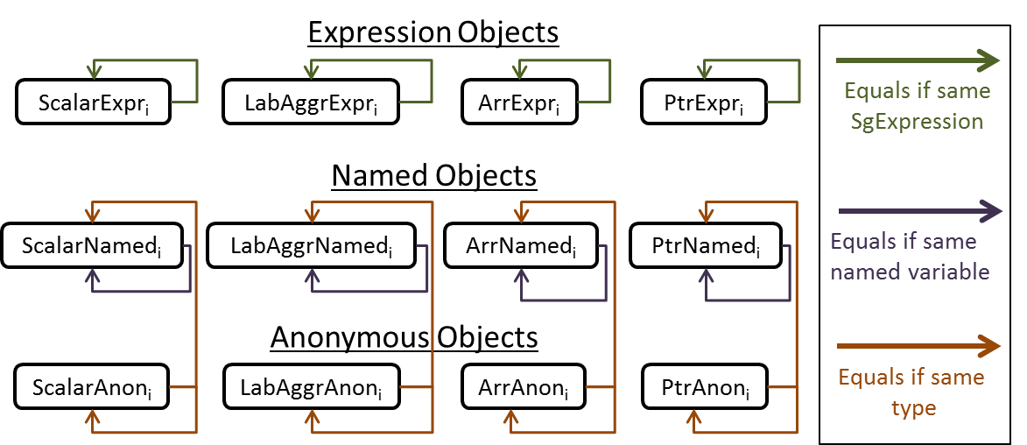
Figure 2: Equality relations among abstract object types
Implementation of total order relations:
An expression or named object of a given abstraction type (scalar, labeled aggregate, etc.) are equal to another expression or named object if they share the same anchor and appear in the same location inside their parent objects, if any. Expression objects are never equal to named objects or aliased objects. There relationships are illustrated in Figure 2.
bool operator<(ExprObj o1, ExprObj o2)
bool operator<(NamedObj o1, NamedObj o2)
{
// If both objects have the same anchor
if(o1.anchor == o2.anchor) {
// If both have the same parent
if(o1.parent!=NULL && o2.parent!=NULL &&
*(o1.parent)==*(o2.parent)) {
// Order them according to their index within their parent
if(o1.parent and o2.parent are labeled aggregates) {
f1 = field within e1.parent.getElements() for o1
f2 = field within e2.parent.getElements() for o2
return f1.index < f2.index;
} else if(o1.parent and o2.parent are arrays)
// The elements within arrays are not distringuised
return false;
else
return *(o1.parent)<*(o2.parent);
} else
// If the objects have different anchors, compare them
return o1.anchor < o2.anchor;
}

bool operator<(AliasedObj o1, AliasedObj o2)
{
// Use the ordering between types
return o1.type < o2.type;
}

Connection Between ROSE AST Nodes and Abstract Objects
Every memory object abstraction must define the MemObjSetFactory class, which generates abstract objects from SgExpressions. The syntax-driven abstraction does this as follows.
SgVarRefExpr:
- If this expression stands alone, it corresponds to named variables denoted by the symbol in the SgVarRefExp.
- If it is the right-hand-side of an SgDotExp that has a non-reference type “expr.var”
  - If the expr corresponds to an expression or named abstract object, var is an expression or named sub-object with the same parent SgExpression or named variable.
  - Otherwise, it is an anonymous object with the appropriate type.
- If it is right-hand-side of an SgDotExp that has a reference type or an SgArrowExp, var is an anonymous object with the appropriate type.
SgDotExp or SgArrowExp: Same abstract object as its right-hand-side expression.
SgRefExp: Anonymous object of the same type as the expression being referenced, plus one level of indirection.
SgPointerDerefExp: Anonymous object of the same type as the expression being referenced, minus one level of indirection.
Static or Dynamic Up-cast (static_cast<baseType>(ptrExpr), dynamic_cast<baseType>(ptrExpr)): Anonymous object of type baseType.
Dynamic Down-cast (e.g. static_cast<derivedType>(ptr_expr)): Anonymous object of type derivedType.
Static Down-cast or Reinterpret-cast: not allowed since it violates type-safety.
Other SgExpressions (e.g SgValueExp, SgFunctionCallExp): Expression object of a type that corresponds to the value produced by the expression.

Some notes about discussion on July 12, 2011
- Use boost share pointers (smart pointers) to avoid memory leaks
- Support lookup x from y for references like x.y
- Support intersection and union operations on MemObjSet
- Skip overlaps() for now
- Three use cases: def-use analysis by George, alias analysis by Faizur, and constant propagation/live variable by Phil.
- abstractIndex: a separate abstract class, similar to MemObjSet
- Pointer: provide getDereference() and getElement(), users choose which one to use. ???
- Name change: ObjSet -> MemObjSet
- Figure 2. Anonymous objects: equals if same type or one type is a subtype of the other.

