COMPUTER PROGRAMMING
ASSIGNMENT

1. To display number of columns required and the first 10 lines:
- cut f1-3 filename : display columns from 1 to 3
- head : display the first 10 lines

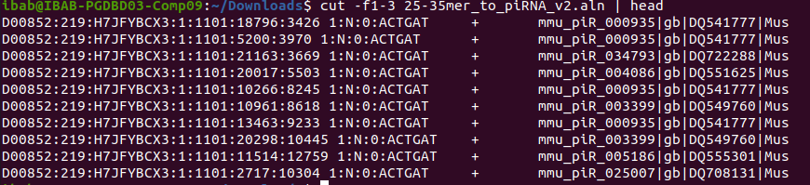
2. To display the particular column and choose number of lines:
- cut -f5 filename : display only column 5
- head -n 20 : display first 20 lines

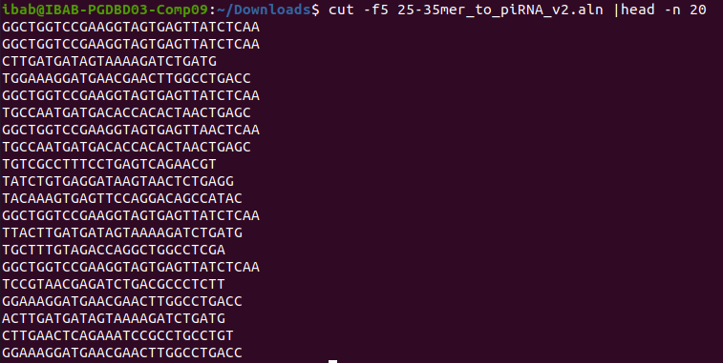

3. To find number of the word in the file : grep “word” filename | wc -l
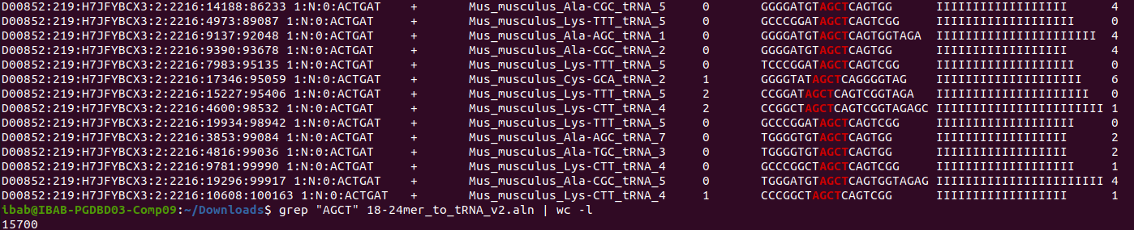
4. To display last 20 lines and sort the lines in alphabetical order
- tail -n20 : display last 20 lines
- sort : display them in alphabetical order
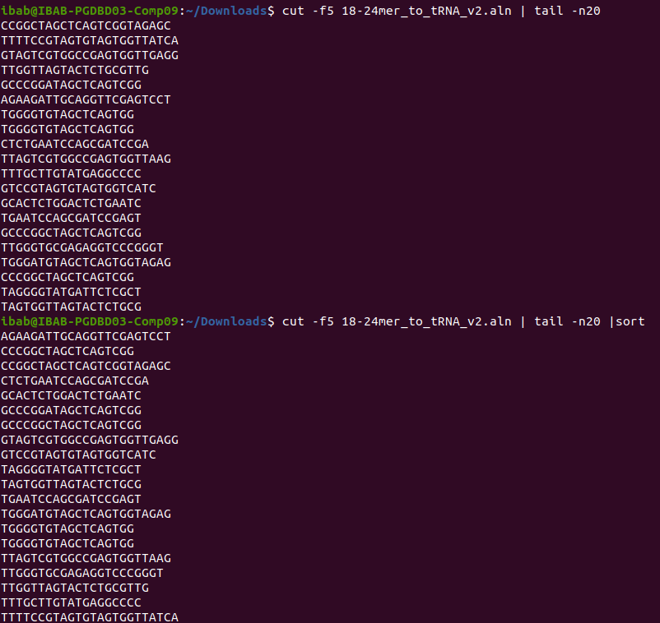

5. To find certain numbers in a particular column :

