Data Mining – HW#3 Razie Doregard – 40435056
4. Data Preprocessing
1- Load the dataset and report its shape:
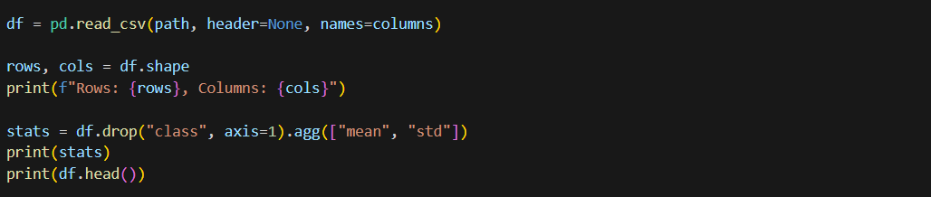
2- Compute and report the mean and standard deviation of each feature
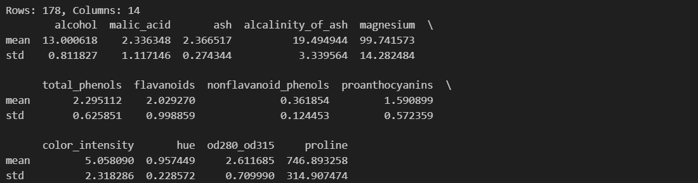
3- Verify the absence of missing values
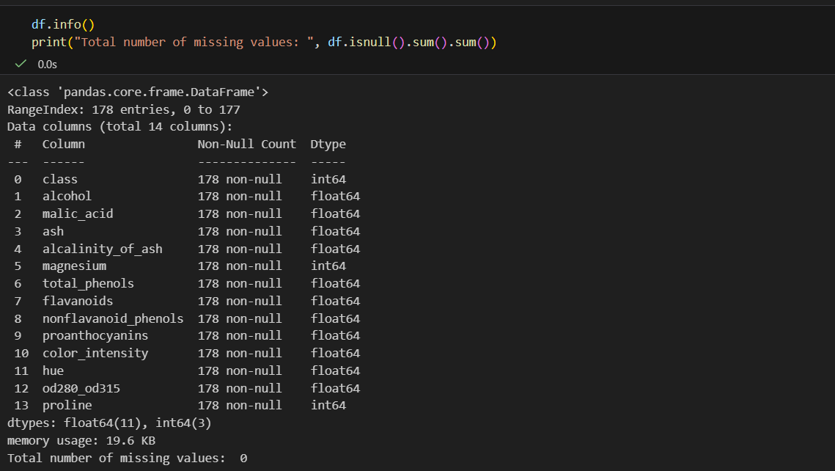
4- Create three versions of the dataset
- Raw data: the df we already have
- Z-score normalized data:
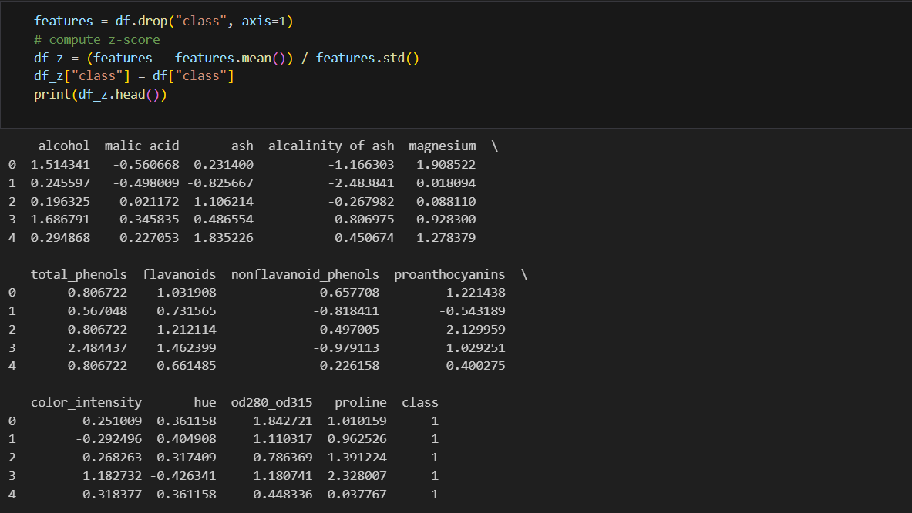
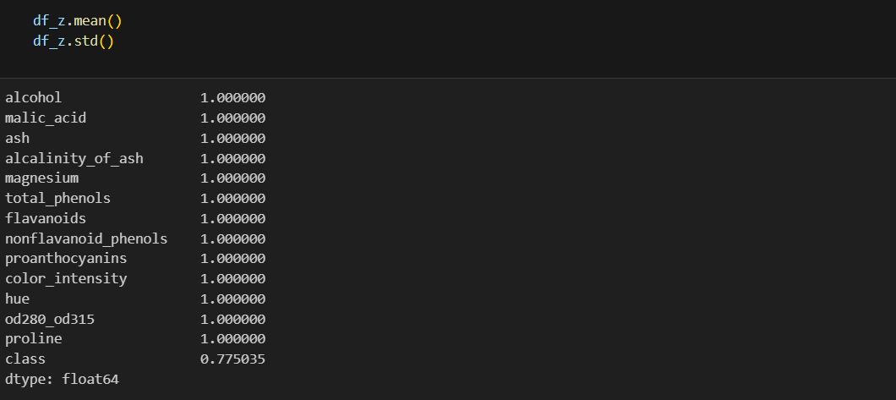

- Min-Max normalized data (scaling on 0,1)
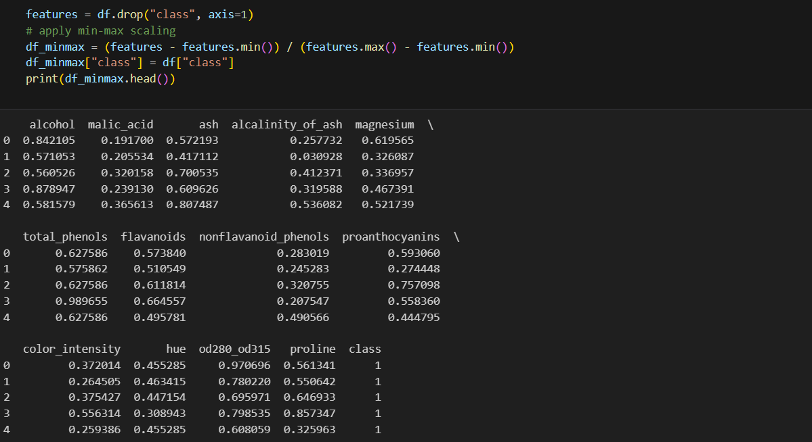
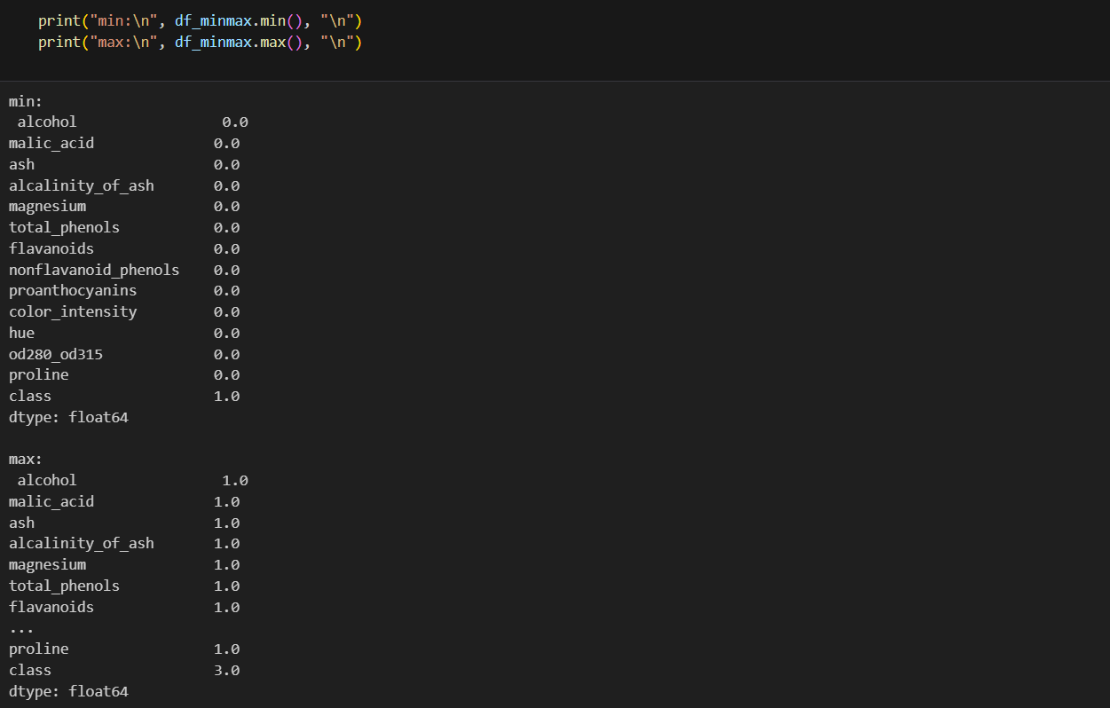

5. Exploratory Data Analysis (EDA) and Visualization
a. Generate a summary statistics table for all numerical features 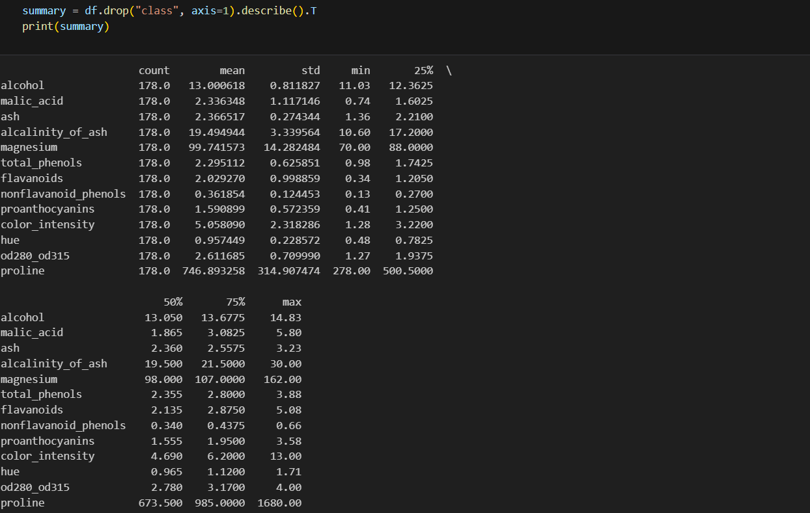
Every feature has 178.0 count
That strongly indicates no missing values. Clean dataset
Feature Scales (Very Important)
variables are on very different scales:
- hue → mean ≈ 0.96
- nonflavanoid_phenols → mean ≈ 0.36
- alcohol → mean ≈ 13
- magnesium → mean ≈ 100
- proline → mean ≈ 747
proline ranges from 278 to 1680 — huge compared to others.
This dataset definitely needs feature scaling

Spread & Variability
standard deviations:
- proline → 314.9 (very high variability)
- color_intensity → 2.31
- flavanoids → 0.99
- ash → 0.27 (relatively tight spread)
Some features vary a lot more than others — again reinforcing the need for scaling
Potential Skewness / Outliers
Compare median (50%) vs mean:
- proline: mean = 746, median = 673
→ slightly right-skewed
- color_intensity: mean = 5.05, median = 4.69, max = 13
→ likely right-skewed with some high-value wines
- flavanoids: max = 5.08, Q3 = 2.87
→ possible high-end outliers
So yes — some features likely have right skew / high-value tails
b. Plot histograms for at least five selected features
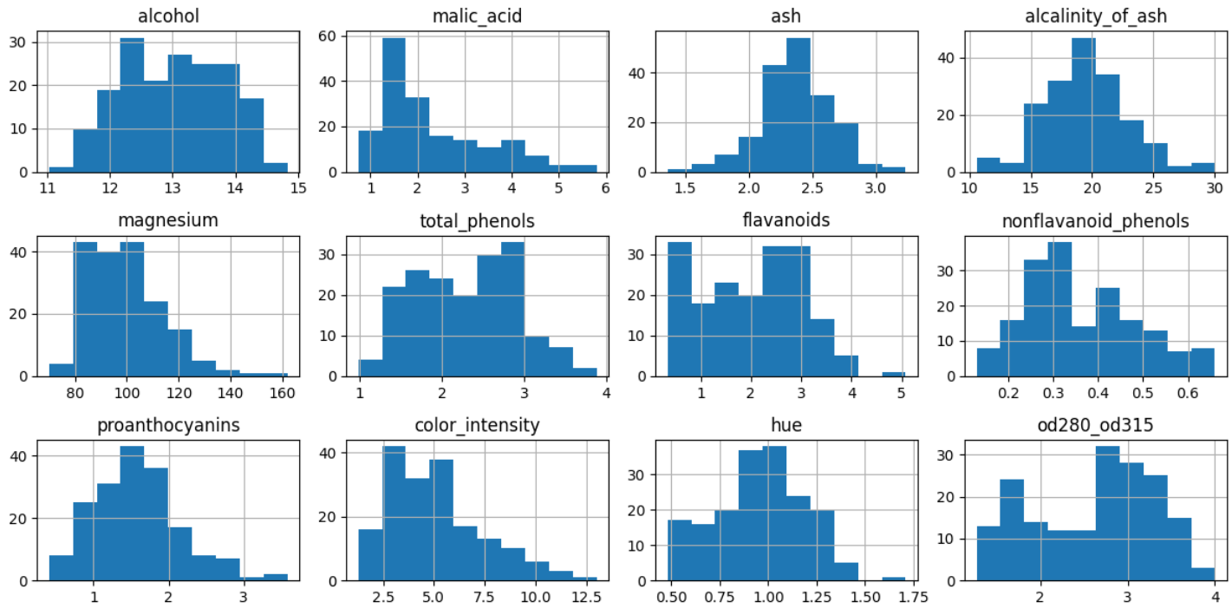
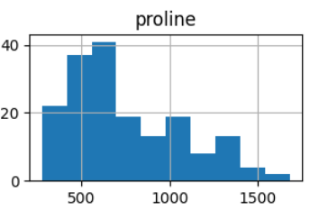
As already indicated from the summary, it can be seen from the histograms that proline and color_intensity, and magnesium are both right-skewed; The one that are almost normal is the alcanity_of_ash.
c. Compute and visualize the correlation matrix using a heatmap
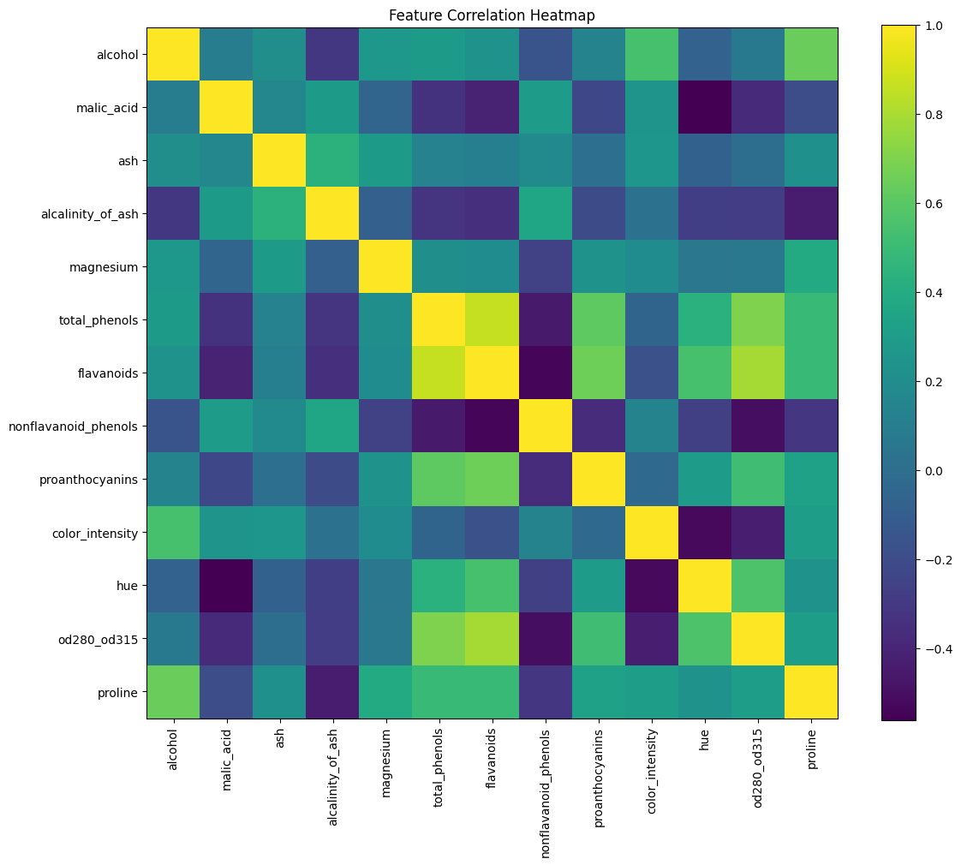
- +1 → strong positive relation
- 0 → independent
- -1 → strong negative relation
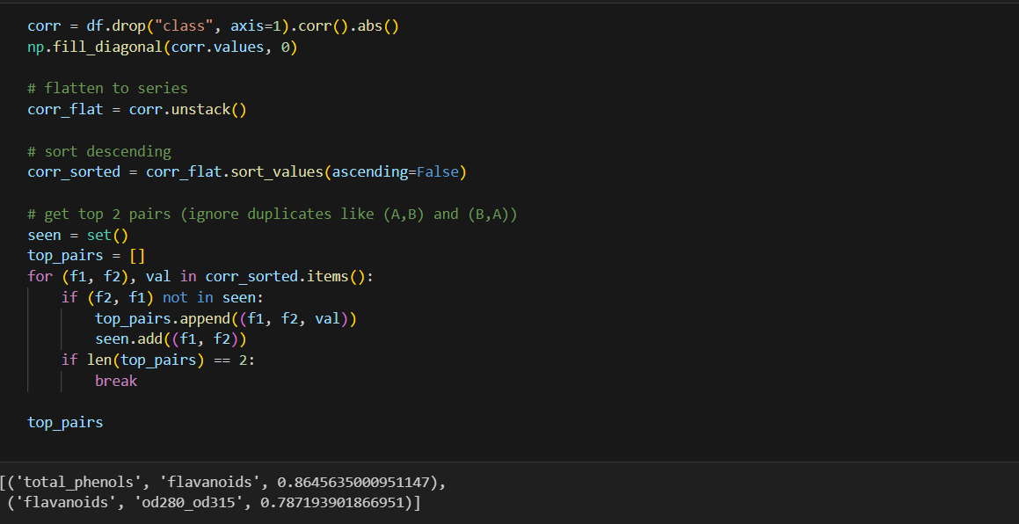
After sorting the values of the heatmap, the highest correlation is a positive correlation between the pairs: total_phenols, flavonoids and flavonoids, od280_od315
d. Create scatter plots for at least two meaningful pairs of features
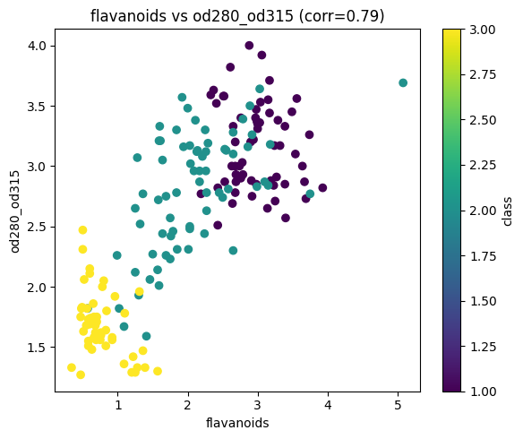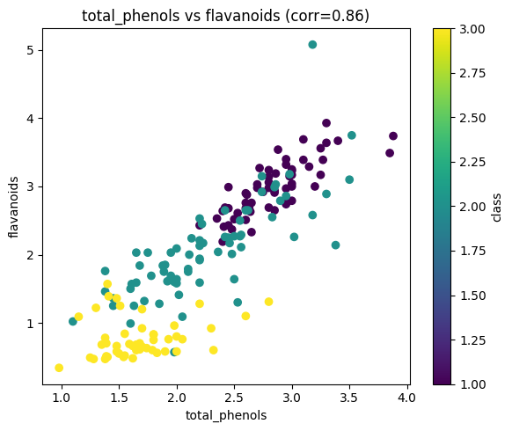
The ones with highest correlation, therefore the scatter plot shows a linear relation between the attributes.

5.2 Dimensionality Reduction for Visualization
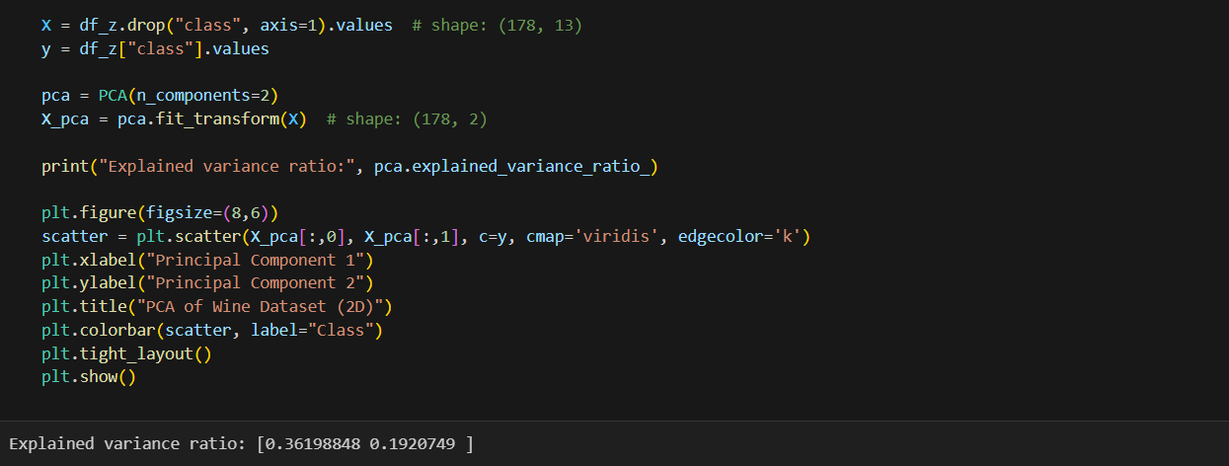
Principal Component Analysis (PCA) was applied to reduce the dimensionality of the dataset from 13 features to 2 principal components. The first component explains 36.2% of the total variance, while the second explains 19.2%, resulting in a combined explained variance of approximately 55.4%. This indicates that more than half of the dataset’s variability is preserved in the two-dimensional representation, providing a reasonable low-dimensional visualization while retaining a substantial portion of the original information.
Notice. Because PCA is variance-based, and variance depends on scale
we must use the normalized data to apply PCA on.
The PCA algorithm was applied on z-score normalized data, I also tried it on min-Max normalized data and it wasn’t that different in terms of the variance ratio and overall correlation of the dimensions.
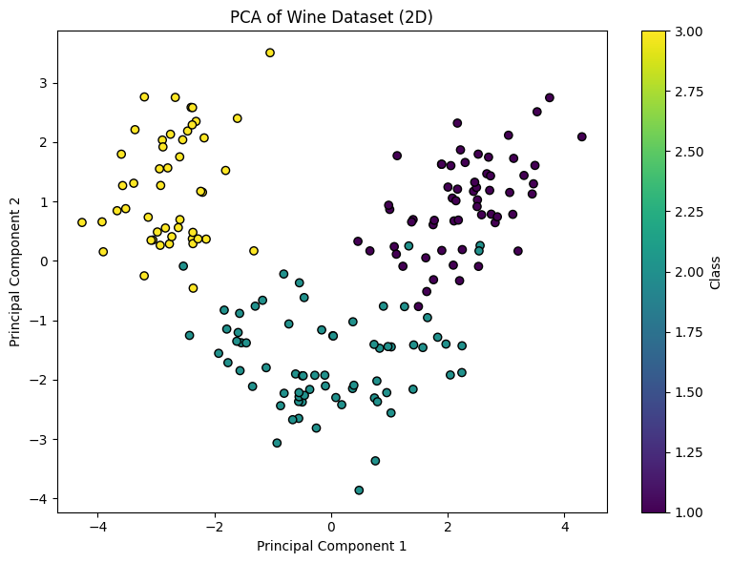

6. Part 1: Distance Behavior in High-Dimensional Space
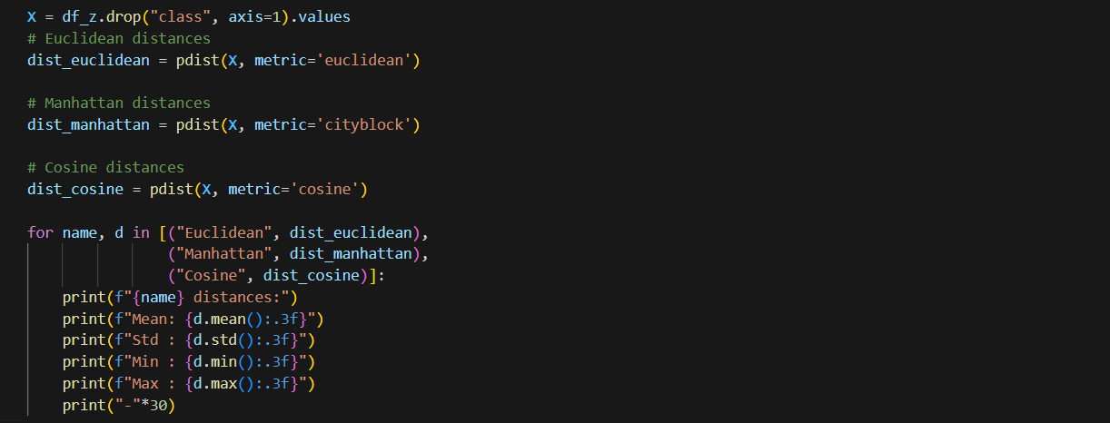
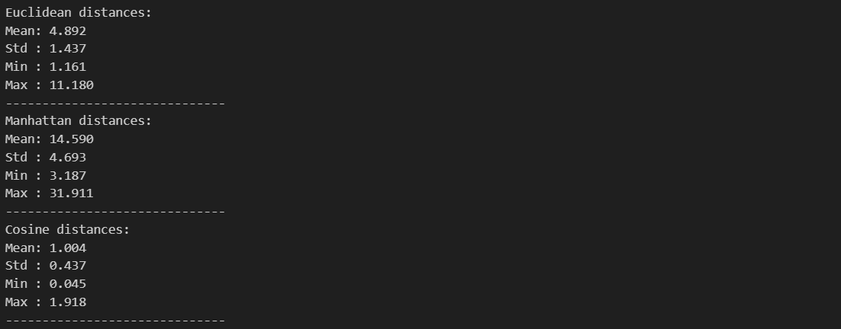
Pairwise distance analysis in the 13-dimensional feature space shows moderate dispersion among samples.
The mean Euclidean distance is 4.89 (±1.44), indicating that observations are reasonably separated but not excessively dispersed.
Manhattan distances scale consistently with dimensionality, while the average cosine distance of approximately 1.0 suggests that sample vectors are roughly orthogonal on average. Overall, the dataset exhibits meaningful geometric variation without severe distance concentration effects.

7. Part 2: Impact of Feature Scaling on K-Means
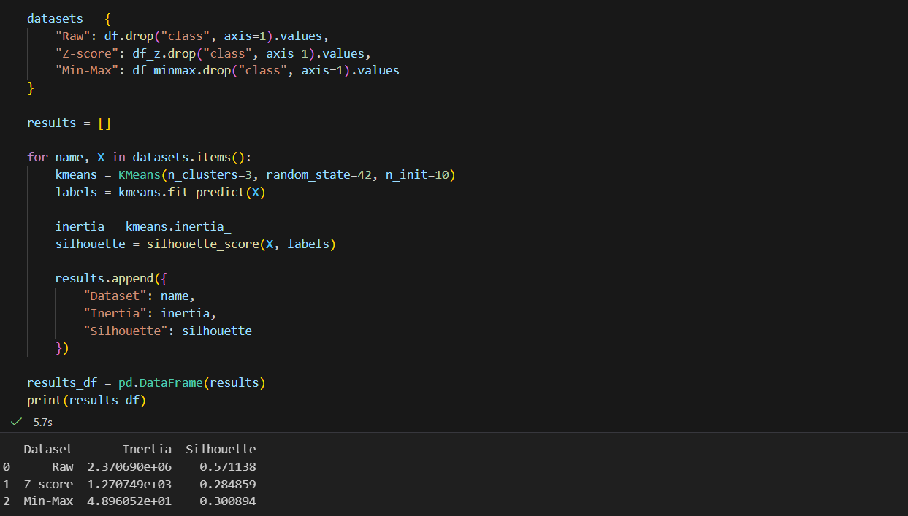
Inertia (Within-Cluster Sum of Squares)
- Used mostly with k-means. It measures how tightly the points in a cluster are grouped around the cluster center
- Smaller inertia → points are closer to their cluster centers → tighter clusters
- Larger inertia → clusters are more spread out → less compact
- Important: inertia always decreases if you increase the number of clusters, even if the new clusters aren’t meaningful. So it’s not enough by itself to pick k
Silhouette Score
- Measures how well-separated the clusters are, considering both cohesion (within-cluster) and separation (between clusters)
- a = average distance to other points in the same cluster (intra-cluster distance)
- b = average distance to points in the nearest other cluster (nearest-cluster distance)
- +1 → sample is well-matched to its own cluster and far from others (good)
- 0 → sample is on or very close to the decision boundary between clusters
- -1 → sample may be in the wrong cluster
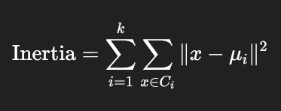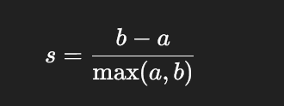
Dataset | Inertia | Silhouette
Raw | 2,370,690 | 0.571
Z-score | 1,270 | 0.285
Min-Max | 48.96 | 0.301
Raw data:
- Very high inertia → makes sense because your features are on wildly different scales (proline dominates, hue is tiny).
- Silhouette ≈ 0.57 → actually not bad. Shows clusters are reasonably separated
Standardized data:
- Inertia dropped massively (because data now has unit variance). That’s expected
- Silhouette also dropped a lot → clusters are less well-separated in normalized space
- K-means is now treating all features equally:
- Features like proline no longer dominate
- Small chemical differences get equal weight
- Clusters that were obvious in raw scale are now blurred
Min-Max scaled data:
- Again, inertia is tiny (scaling effect).
- Silhouette slightly better than z-score, but still low → clusters are not very distinct in this space
Overall interpretation:
  - On raw data, k-means is “seeing” the few big-scale features (proline, magnesium) → forms clusters largely along them. That’s why silhouette was higher
  - On normalized data, all features contribute equally → cluster boundaries blur → silhouette drops
  - Absolute inertia doesn’t tell much without context (it depends on scale). Silhouette is more meaningful
  - Silhouette ≈ 0.28–0.30 → poor clustering. 0.5+ is usually decent; >0.7 is strong
8. Part 3: K-Means Implementation from Scratch
Dataset | Method | Inertia | Iterations | Runtime (s)
Raw | Custom K-Means | 2,370,689.69 | 10 | 0.0034
Raw | scikit-learn K-Means | 2,370,689.69 | 6 | 0.0144
Z-score | Custom K-Means | 1,270.75 | 10 | 0.0061
Z-score | scikit-learn K-Means | 1,270.75 | 7 | 0.0195
Min-Max | Custom K-Means | 48.97 | 8 | 0.0031
Min-Max | scikit-learn K-Means | 48.96 | 4 | 0.0205

- Lower inertia → tighter clusters:
    - Min-Max scaled dataset has the lowest inertia (~48.96–48.97)
- Fewer iterations → faster convergence:
- scikit-learn K-Means generally converges faster than custom, especially for scaled data:
    - Min-Max scikit-learn: 4 iterations (fewest overall)
- Custom K-Means is slightly faster on small datasets (0.003–0.006 s):
    - Scikit-learn is slightly slower on small datasets (0.014–0.020 s), but scales better for large datasets

For k = 3, K-Means clustering was applied to the dataset under three preprocessing conditions: raw, Z-score normalized, and Min-Max scaled. Across all datasets, both the custom implementation and scikit-learn’s K-Means converged to nearly identical inertia values, indicating consistent clustering solutions. The number of iterations required for convergence varied slightly, with scikit-learn generally requiring fewer iterations due to optimized initialization, while runtime differences were minor and dataset-dependent. Notably, the inertia decreases substantially after normalization, reflecting the effect of scaling on the magnitude of within-cluster variance, but the relative clustering structure remains consistent across implementations.

9. Part 4: Hierarchical Clustering Stability Analysis
Cophentic:
- Imagine building a dendrogram (hierarchical tree)
- For any pair of samples, trace up the tree until their branches meet
- The vertical distance at that point = cophenetic distance
- ~1: Dendrogram faithfully preserves original distances → good clustering representation
- ~0: Dendrogram does not preserve distances well → clustering may not reflect true structure
Rank | Linkage Method | Cophenetic Correlation
1 | average | 0.7591
2 | ward | 0.6623
3 | complete | 0.5917
4 | single | 0.5436
The average method is the most stable one as it provides the highest cophentic correlation, meaning the cluster distances on the tree is higher than the other methods, meaning the clustering is working quite well!
10. Part 5: Automated Density-Based Clustering
Density-based clustering groups together points that are densely packed, and separates areas of low density as noise or outliers
Unlike k-means, you don’t need to predefine the number of clusters
Key concepts (DBSCAN as example)
- ε (epsilon): radius around a point to look for neighbors
- MinPts: minimum number of points required within ε to form a dense region
- Core points: points with ≥ MinPts neighbors in ε-radius
- Border points: points in ε-radius of a core point but with < MinPts neighbors
- Noise points: points that are neither core nor border
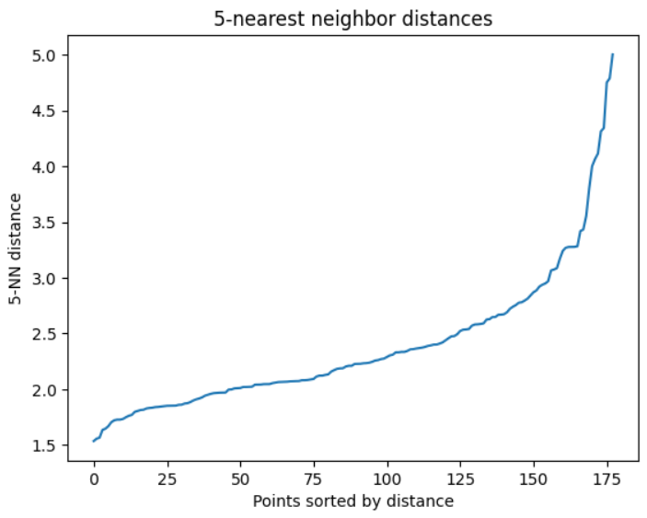
- Estimated epsilon: 3.0048055712308877
- Detected clusters: 1
- Noise points: 10
Interpretation:
- When ε is too big: most points fall into a single dense region → DBSCAN merges everything → you get 1 cluster
- DBSCAN only detects clusters if there are dense regions separated by empty space.
- Your 13D wine data is relatively uniform in density after Z-score normalization → DBSCAN struggles
Solution: PCA to reduce the dimensionality
- Estimated epsilon: 0.675159736194372
- Detected clusters: 2
- Noise points: 7
Interpretation:
- 7 points are labeled as outliers because they didn’t have enough neighbors within ε
- DBSCAN works well after PCA or other dimensionality reduction when high-dimensional data is too sparse.
- Having 2 clusters + a few noise points is realistic for the wine dataset; it reflects real separations in the main chemical profiles

11. Part 6: Fully Automated Clustering System

