# NATIONAL INSTITUTE OF TECHNOLOGY PUDUCHERRY

## (An Institution of National Importance under MHRD, Govt. of India)

**KARAIKAL – 609 609**

**DEPARTMENT OF COMPUTER SCIENCE AND ENGINEERING**

|  |  |  |  |
| --- | --- | --- | --- |
| **Roll Number:** | CS19B1068 | **Name:** | Aneesha Rose Sunil |
| **Semester:** | V | **Class:** | BTech. 3rd Year |
| **Subject Code:** | CS305 | **Subject Name:** | UNIX PROGRAMMING |

1)Find the factorial of a number

**PROGRAM:**

echo "Enter number-"

read num

factt= 1

while [ $num -gt 1 ]

do

factt=$(( factt * num ))

num=$(( num - 1 ))

done

echo "The factorial is $factt"

**OUTPUT:**

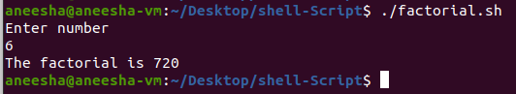

2)Find Fibonacci series

**PROGRAM:**

echo "Enter the number"

read n

first=0

second=1

echo "Fibonacci series -"

for (( i=0; i<n; i++ ))

do

echo -n "$first "

third=$(( first + second ))

first=$second

second=$third

Done

**OUTPUT:**

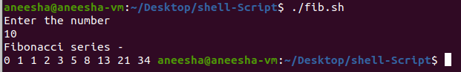

3)Find sum of n numbers

**PROGRAM:**

echo "Enter the count"

read a

sum=0

i=1

echo "Enter the numbers-"

while [ $i -le $a ]

do

read num

sum=`expr $num + $sum`

i=`expr $i + 1`

done

echo "Sum is- $sum"

**OUTPUT:**

