# NATIONAL INSTITUTE OF TECHNOLOGY PUDUCHERRY

## (An Institution of National Importance under MHRD, Govt. of India)

**KARAIKAL – 609 609**

**DEPARTMENT OF COMPUTER SCIENCE AND ENGINEERING**

|  |  |  |  |
| --- | --- | --- | --- |
| **Roll Number:** | CS19B1068 | **Name:** | Aneesha Rose Sunil |
| **Semester:** | V | **Class:** | BTech. 3rd Year |
| **Subject Code:** | CS309 | **Subject Name:** | DBMS Lab |

**Assignment   3   
Schema for a Library Database**  
  
  
BOOK (Book_id, Title, Publisher_Name, Pub_Year)  
BOOK_AUTHORS (Book_id, Author_Name)  
PUBLISHER (Name, Address, Phone)   
BOOK_COPIES (Book_id, Branch_id, No-of_Copies)  
BOOK_LENDING (Book_id, Branch_id, Card_No, Date_Out, Due_Date)  
LIBRARY_BRANCH (Branch_id, Branch_Name, Address)  
  
  
Write SQL queries to  
1. Retrieve details of all books in the library – id, title, name of publisher, authors, number  
of copies in each branch,etc.  
2. Get the particulars of borrowers who have borrowed more than 3 books, but from Jan  
2021 to Jun2021  
3. Delete a book in BOOK table. Update the contents of other tables to reflect this data  
manipulation operation.  
4. Partition the BOOK table based on year of publication. Demonstrate its working with a  
simple query.  
5. Create a view of all books and its number of copies that are currently available in the  
Library.

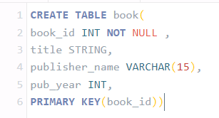

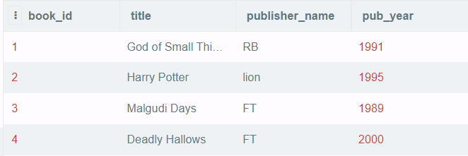

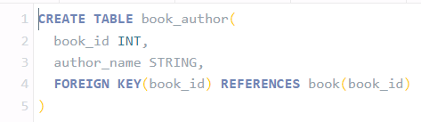

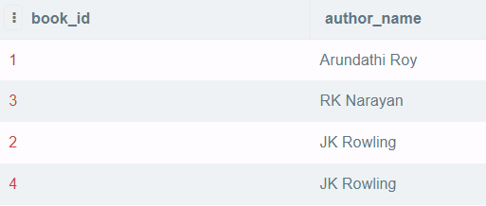

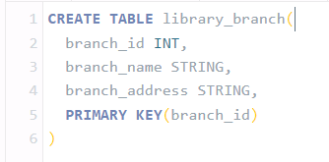

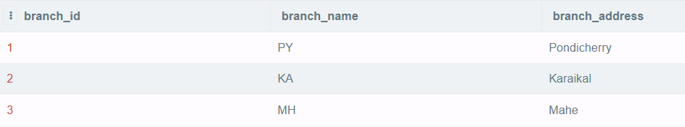

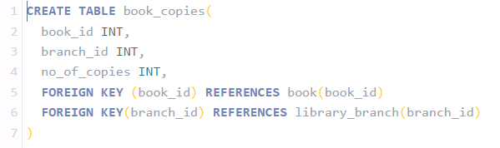

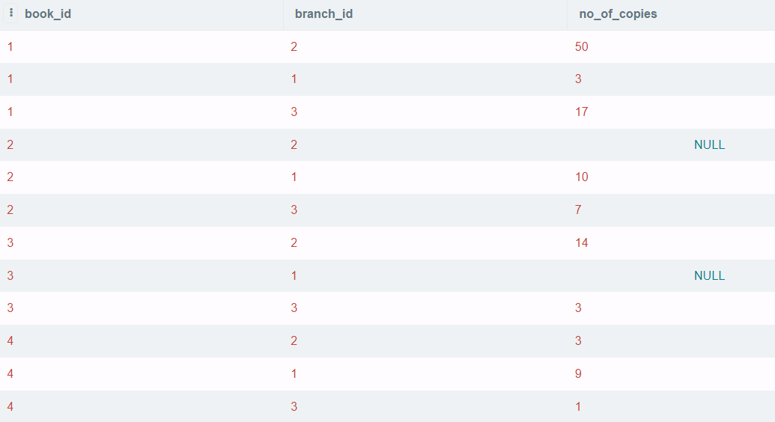

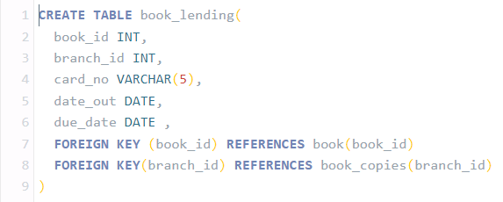

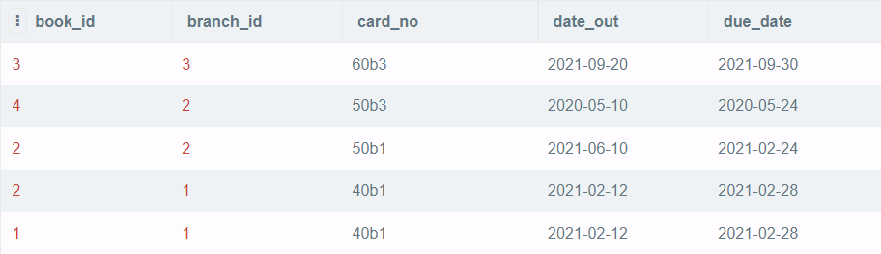

1.)

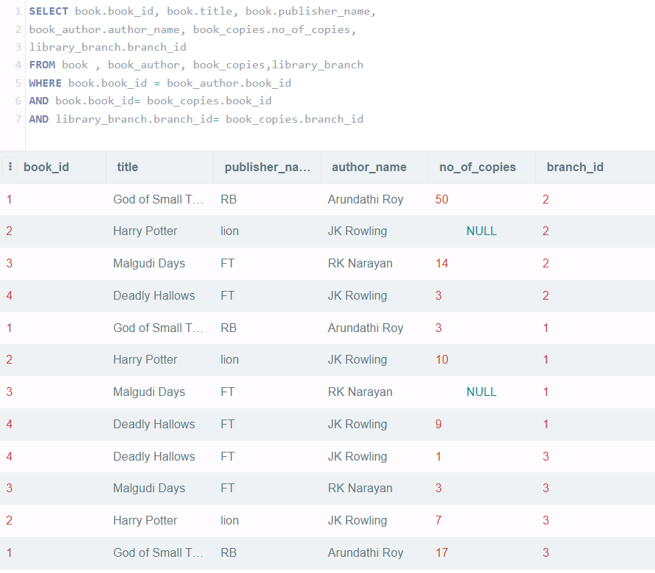

1. )

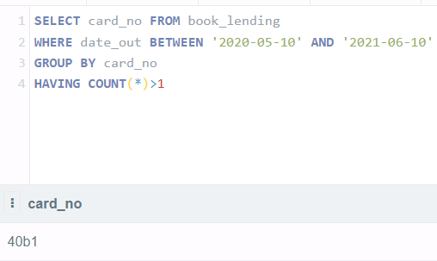

1. )



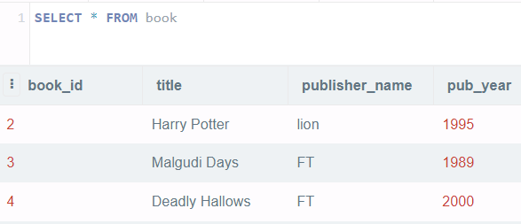

1. )

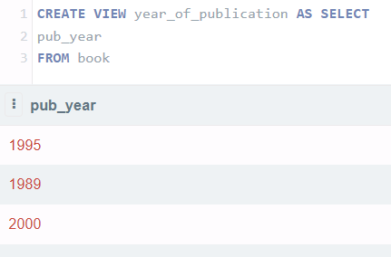

1. )

