**گزارش تمرین کامپیوتری 2**

**سیستم های مخابراتی**

**تهیه­کننده:**

**زهرا ملکی**

**بهار 1403**

سوال 1)

$$m\left(t\right)=2\sin\left(2π8kt\right)-\frac{1}{4}\cos\left(2π\left(10k\right)t\right)+\frac{1}{4}\cos\left(2π\left(6k\right)t\right)+\sin\left(2π\left(12k\right)t\right)+\sin\left(2π\left(4k\right)t\right)-\frac{3}{4}\cos\left(5π8kt\right)+\frac{3}{4}\cos\left(π8kt\right)-\cos\left(2π\left(32k\right)t\right)+cos⁡(2π\left(8k\right)t)$$

$$H\left(m\left(t\right)\right)= -2\cos\left(2π8kt\right)-\frac{1}{4}\sin\left(2π\left(10k\right)t\right)+\frac{1}{4}\sin\left(2π\left(6k\right)t\right)-\cos\left(2π\left(12k\right)t\right)-\cos\left(2π\left(4k\right)t\right)-\frac{3}{4}\sin\left(5π8kt\right)+\frac{3}{4}\sin\left(π8kt\right)-\sin\left(2π\left(32k\right)t\right)+sin⁡(2π\left(8k\right)t)$$

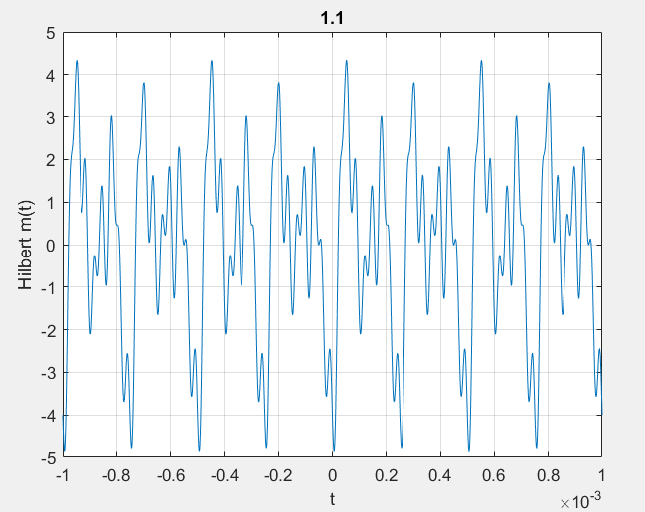



hm2 = hilbert(imag(m));

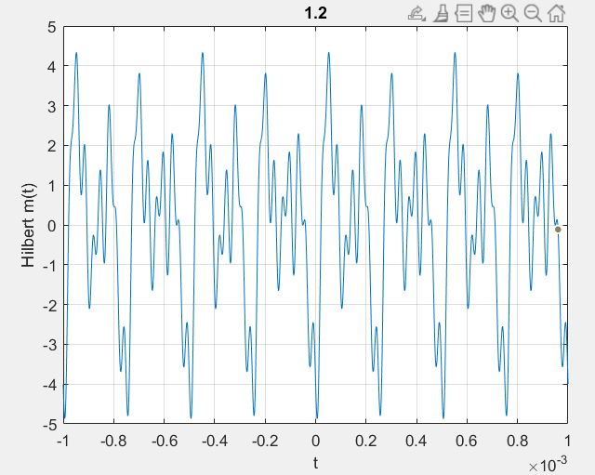

The signals are the same.



Use the hilbert function to obtain the analytic signal. The real part is equal to the original signal. The imaginary part is the Hilbert transform of the original signal. Plot the real and imaginary parts for comparison.

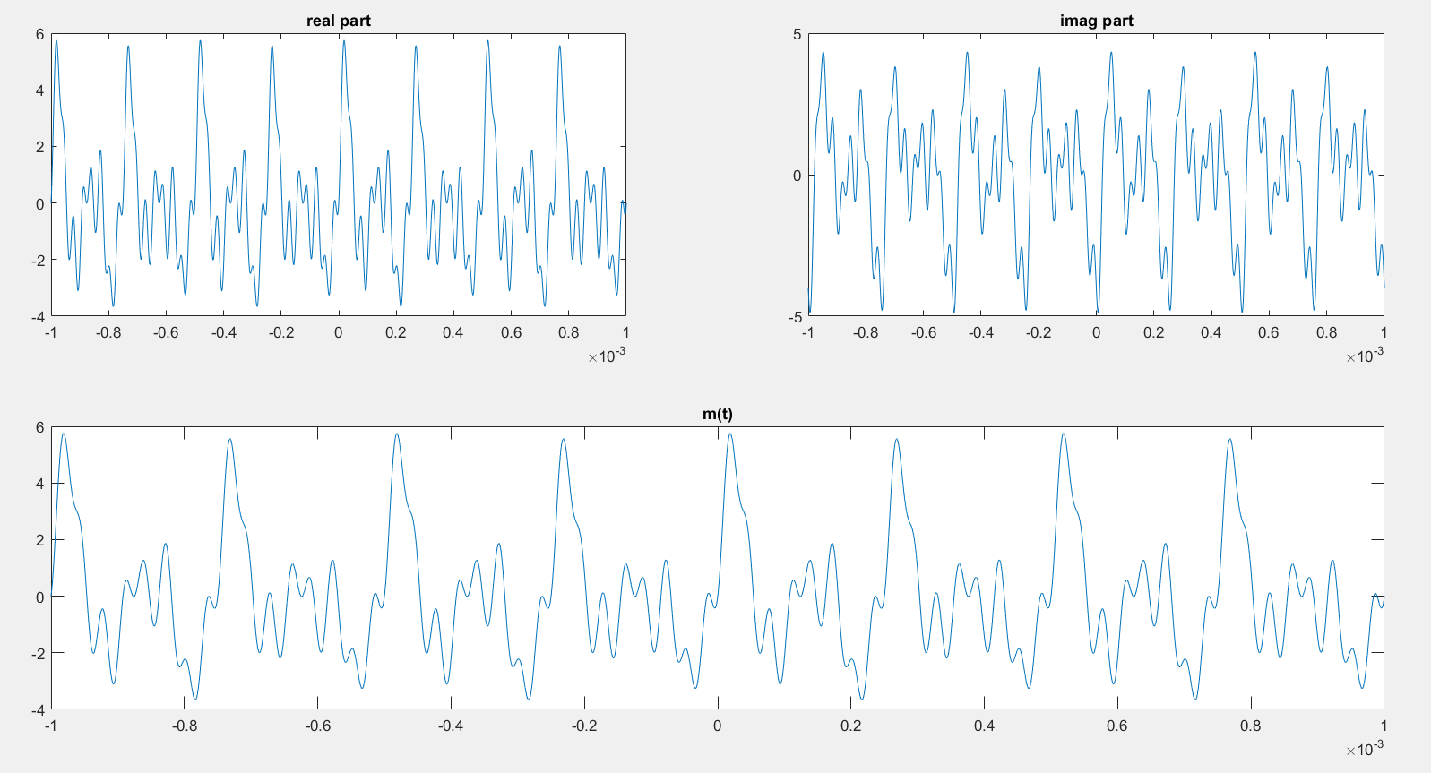



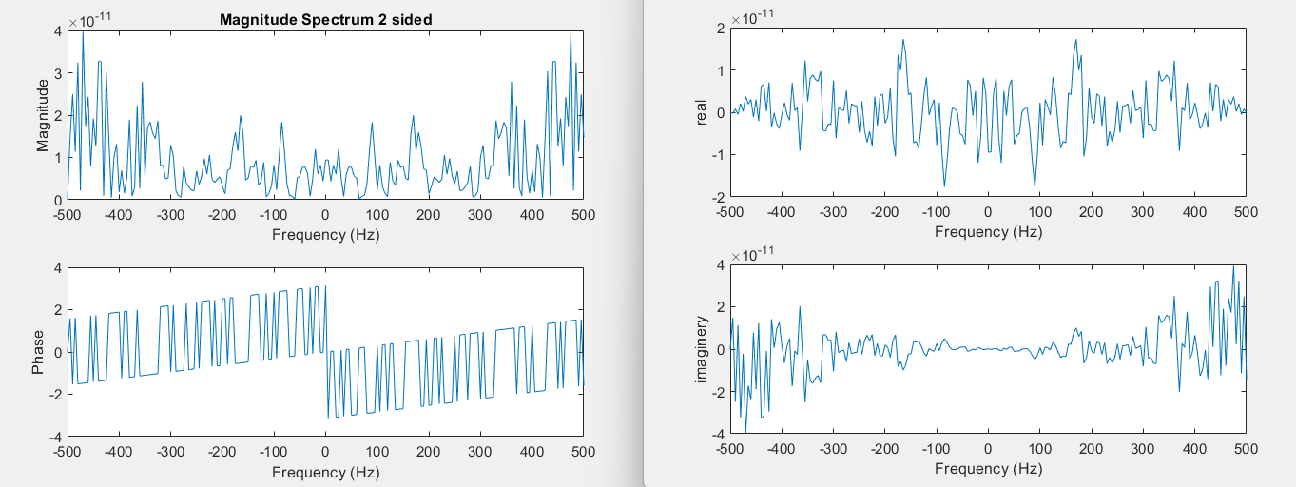



The difference between the fft of the signal and the fft of its Hilbert transform is understandable based on their relationship: F(H(m)) = -j sign(f) F(m). Also, because Hilbert transform of the signal is equal to the imaginary part of the Analytic signal, its plots are understandable as well.

6.

signal analytics is a versatile data analysis technique that finds applications in numerous industries and domains. By analyzing sensor signals and various data sources, valuable insights can be extracted, leading to better decision-making regarding maintenance, prediction, and process improvement in systems and operations.

سوال 2)

1.

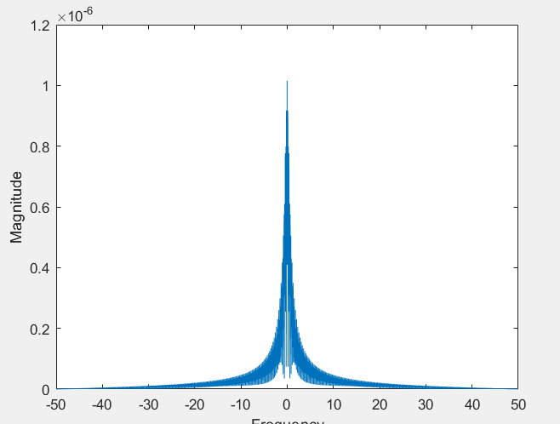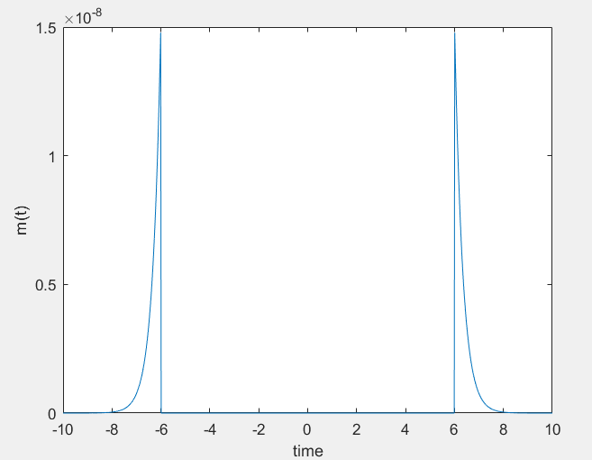

The band width is 40 approximately.

2.

Fs > 2 *40 = 80 Hz

Fs = 100Hz

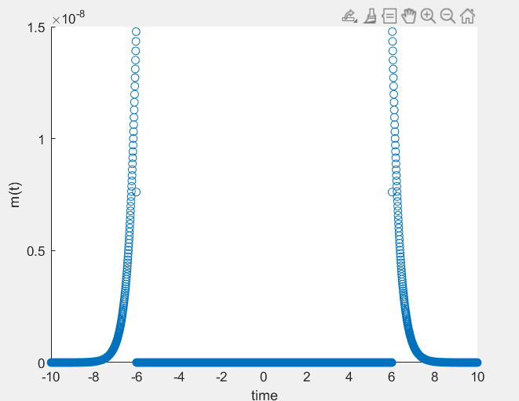

3.

A = 0.5;

fc = 1000;

M_modulated = ( 1 + A * m ).* cos(2*pi*fc*t);

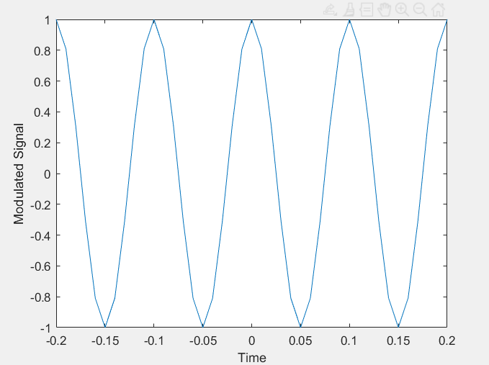

4.

5.

τ = sqrt(R * C)

A larger time constant leads to a slower response of the circuit. In this case, input variations are not fully reflected in the output, and the time-dependent effects of the capacitor are displayed in a non-linear manner.

Regarding the series connection of a resistor with a diode, it increases the charging and discharging rate of the capacitor in the circuit. By placing a resistor in series with a diode, the capacitor reaches its steady state (with a constant voltage value) more quickly, and the time-dependent effects are reduced.

6.

function output = rc_circuit(input_signal, time_constant, initial_output)

output = zeros(size(input_signal)); % Initialize the output with zeros

output(1) = initial_output; % Set the initial output value

for i = 2:length(input_signal)

dt = input_signal(i) - input_signal(i-1); % Time step

d_output = (input_signal(i) - output(i-1)) / sqrt(time_constant); % Change in output

output(i) = output(i-1) + d_output * dt; % Update the output

end

end

7.

The PIN diode, which stands for Positive Intrinsic Negative diode, is a specialized type of diode commonly used in RF (Radio Frequency) circuits. It has unique properties that make it suitable for specific applications. Here is a brief overview of the characteristics, operation, and applications of the PIN diode based on research:

Characteristics of PIN diode:

Intrinsic Region: The middle layer of the PIN diode is an undoped or lightly doped intrinsic semiconductor material, which provides a larger depletion region compared to standard diodes.

Wide Depletion Region: The wider depletion region allows the PIN diode to handle high voltages and exhibit a low capacitance at reverse bias.

Low Junction Capacitance: The PIN diode has a low junction capacitance, enabling it to operate at high frequencies.

Operation of PIN diode:

Forward Bias: When the PIN diode is forward biased, it behaves similarly to a standard diode, allowing current to flow through the device.

Reverse Bias: In reverse bias, the depletion region widens, and the PIN diode acts as a variable resistor. The resistance of the PIN diode decreases as the reverse bias voltage increases, allowing more current to flow.

Applications of PIN diode:

RF Switching: PIN diodes are commonly used as RF switches due to their fast response time and low insertion loss. They can switch RF signals on and off very quickly, making them suitable for applications such as RF transmitters, receivers, and RF attenuators.

RF Modulation: PIN diodes are used in amplitude modulation (AM) systems to vary the power or modulation depth of the RF carrier signal.

RF Attenuation: PIN diodes can be used as variable attenuators to control the power level of RF signals in RF communication systems.

8.

One case is if the signal’s frequency domain has values only in fc.

For our own signal:

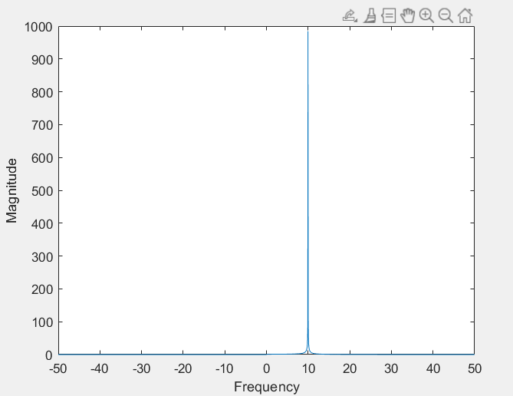

9.

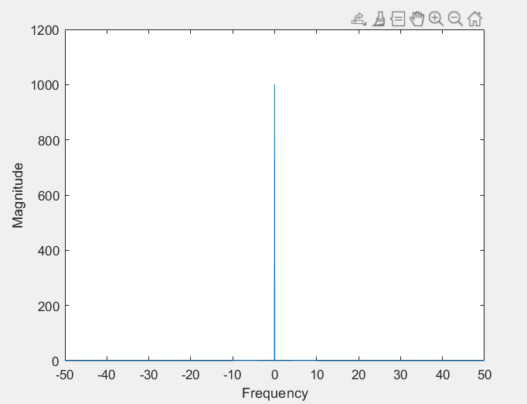

10.

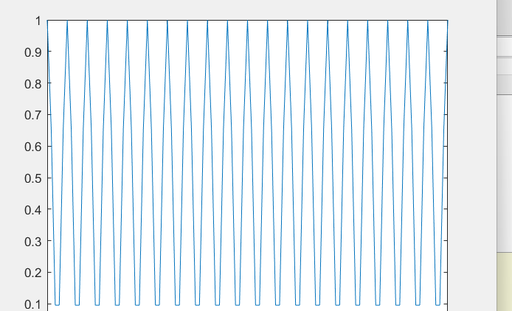

If we look at the inverse fft of the low frequency part of section 9 it is closer to the method used in this part. Among the mentioned methods, using ammod gave me the closest result to the original signal.

11.

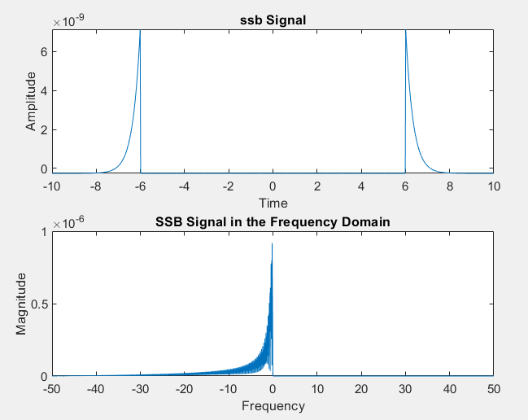

12.

13.

AM (Amplitude Modulation):

Both sidebands and the carrier are present.

Information is transmitted through variations in the amplitude of the carrier.

The AM signal retains the shape of the message signal in the time domain.

SSB (Single Sideband):

Only one sideband and the carrier are transmitted.

Bandwidth is utilized more efficiently.

The SSB signal consists of the selected sideband and the carrier.

The SSB-modulated signal in the time domain will have the same shape as the message signal, but without the carrier.

14.

The original signal:

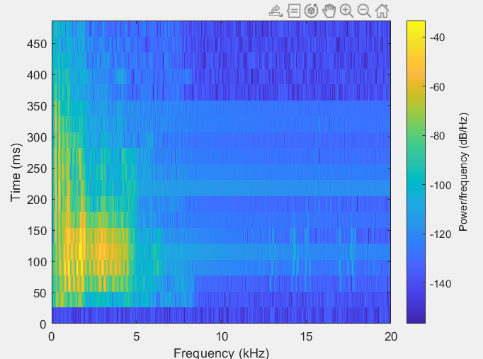

I have done the coding for the de-modulation of all three methods. But plotting took a long time. Please, check out the code.

Thanks :)