**گزارش تمرین کامپیوتری 3**

**سیستم های مخابراتی**

**تهیه­کننده:**

**زهرا ملکی**

**بهار 1403**

سوال 1)



integral_x = cumtrapz(t, x);

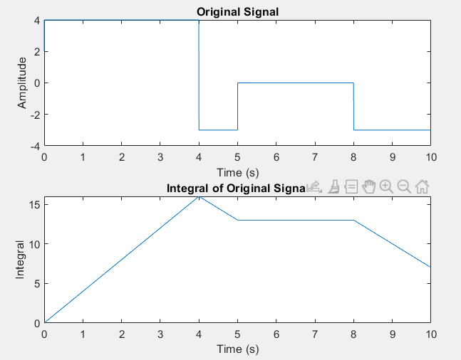



xc = cos(2*pi*fc*t + 2*pi*delta_f*integral_x);

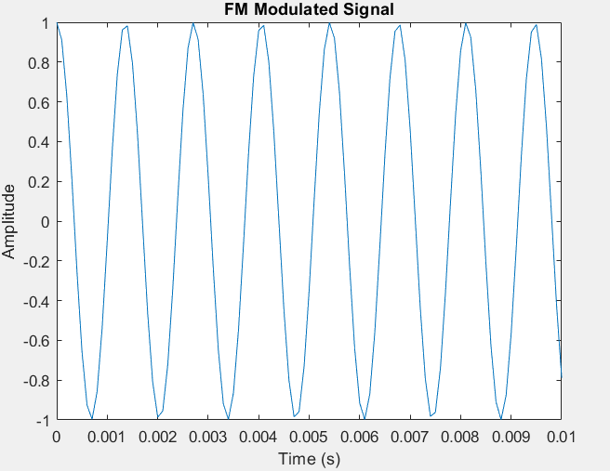



xc = fmmod(x, fc, fs, delta_f);

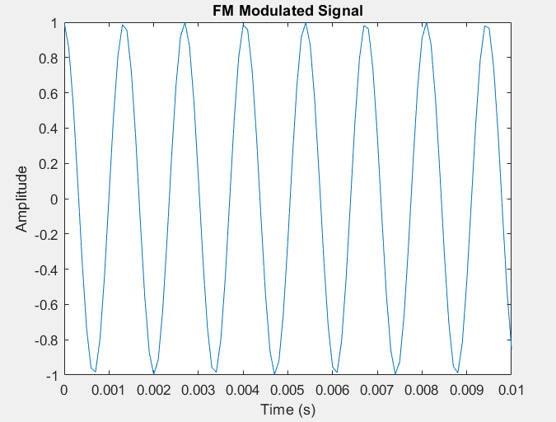



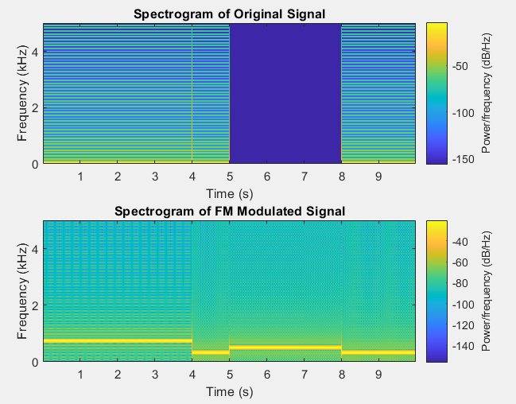

Which seems logical for these signals.



Band width_fm= 0.8 kHz-0.3 kHz = 500 Hz = 2 w (beta + 1)

w = 0.08 kHz approximately

Beta = 2.13



The system described below can be used as a frequency demodulator.

The input to the system is the frequency-modulated signal (xc). By applying the differentiation operation to the input, we convert the frequency-modulated signal into a frequency signal. This operation removes the constant term and transforms the signal into the difference between two consecutive samples.

After differentiation, by applying the absolute value operation to the frequency signal, we make all the samples positive. This step eliminates any information related to the phase change of the signal, leaving only the frequency information.

we pass the signal through a low-pass filter. The purpose of the low-pass filter is to remove any high-frequency components and noise, allowing only the demodulated signal to pass through.

we can set the cut of frequency of the low pass filter to be equal to the bandwidth of the original signal which is 0.08 kHz approximately.

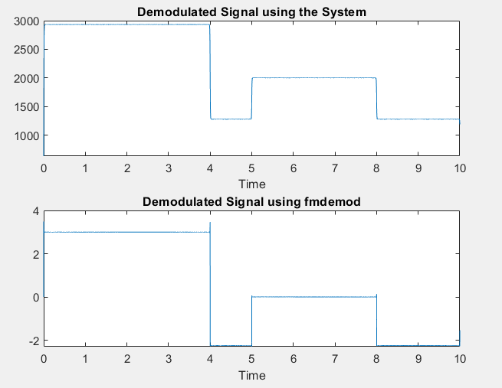

They both seem close to the original signal.

سوال 2)

x_modulated = pmmod(x, fc, fs,10 );

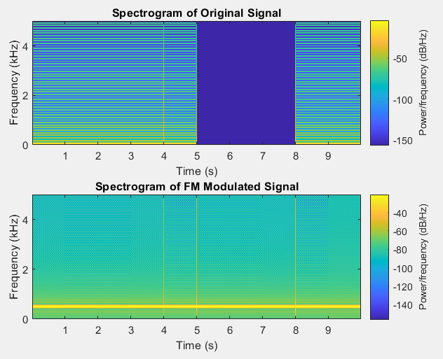



To prevent phase ambiguity in PM demodulation (Phase Modulation), some common techniques include:

Synchronized Pulses: Using synchronized pulses at the transmitter and receiver to establish a known reference phase for demodulation.

Pre-Emphasis and De-Emphasis: Applying pre-emphasis and de-emphasis techniques to the modulated signal, which adjust the signal amplitudes to minimize phase errors.

Differential Modulation: Using differential modulation schemes, such as Differential Phase Shift Keying (DPSK), where the information is encoded based on the phase difference between adjacent symbols. This reduces the sensitivity to absolute phase values.

Pilot Tones: Incorporating pilot tones, which are known reference signals inserted into the modulated signal, to aid in phase synchronization and eliminate phase ambiguity.

These techniques help mitigate phase ambiguity and improve the accuracy of PM demodulation, ensuring reliable signal recovery.

Differential modulation is a technique that encodes information based on the phase difference between adjacent symbols, rather than relying on absolute phase values. It reduces the impact of phase ambiguity in PM demodulation and improves robustness against phase errors.