**گزارش تمرین کامپیوتری 4**

**سیستم های مخابراتی**

**تهیه­کننده:**

**زهرا ملکی**

**تابستان 1403**



Hear is the generated signal:

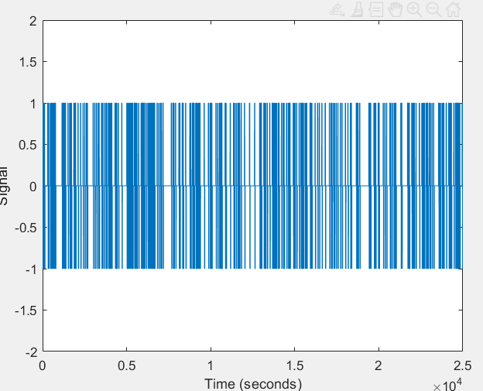

effective_bandwidth = 1 / Tb;

Effective Bandwidth: 0.02 Hz



power_noise = (norm(white_noise)^2) / (eta*Ts);

Power of Sampled White Noise: 0.39585

3/4.

For the previous binary sequence and a new one:

SNRe: -6.9745

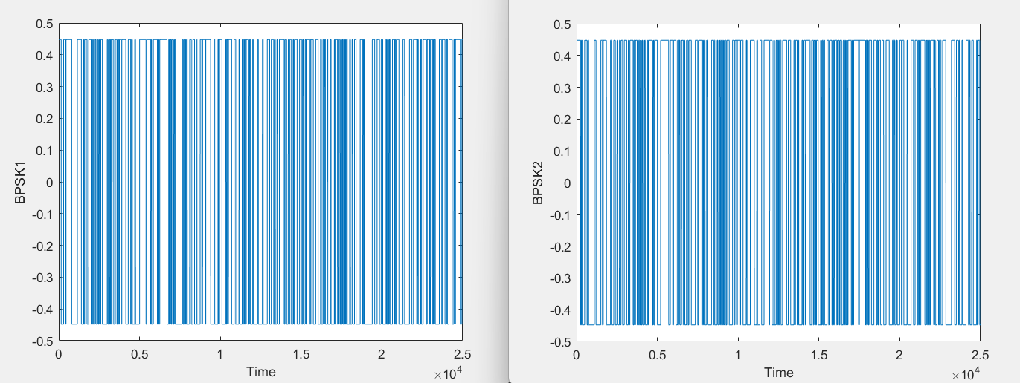

5.

noise_sequence = randn(1, 500*Tb/Ts);

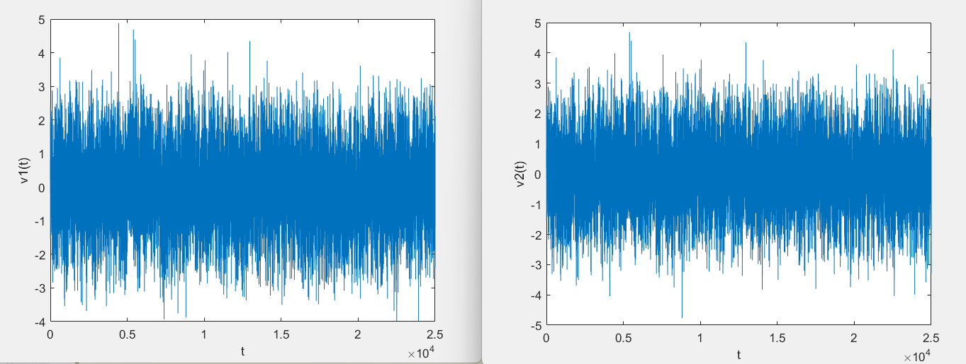

6.

Using scatter:

symb_I2 = bpsk_noise_sequence2 .* cos(10*pi*t_noise/Tb);

symb_Q2 = bpsk_noise_sequence2 .* sin(10*pi*t_noise/Tb);

scatter(symb_I2, symb_Q2);

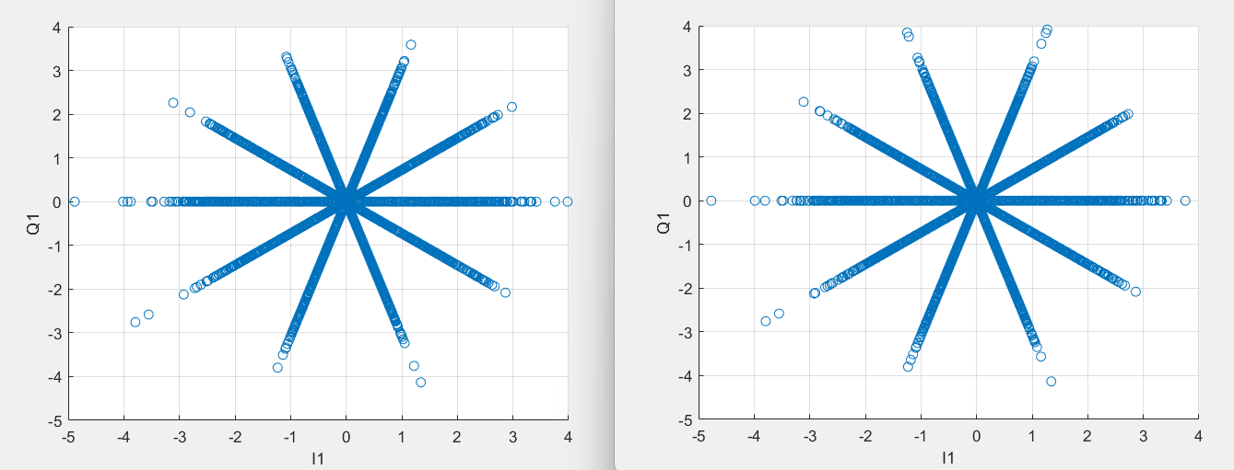

constellation = comm.ConstellationDiagram('Title','BPSK','ShowTrajectory',false,'SamplesPerSymbol',1);

and the result is two gifs like below:

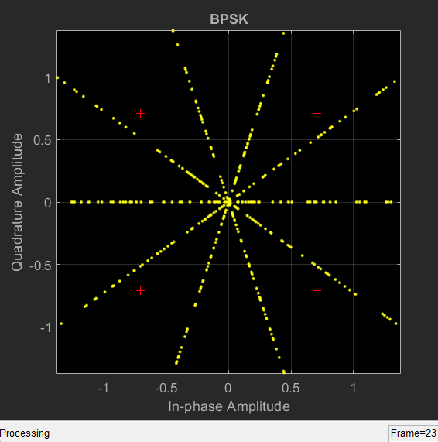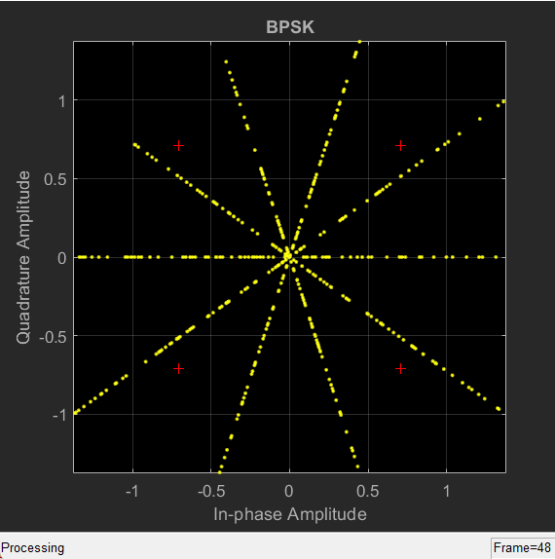

7.

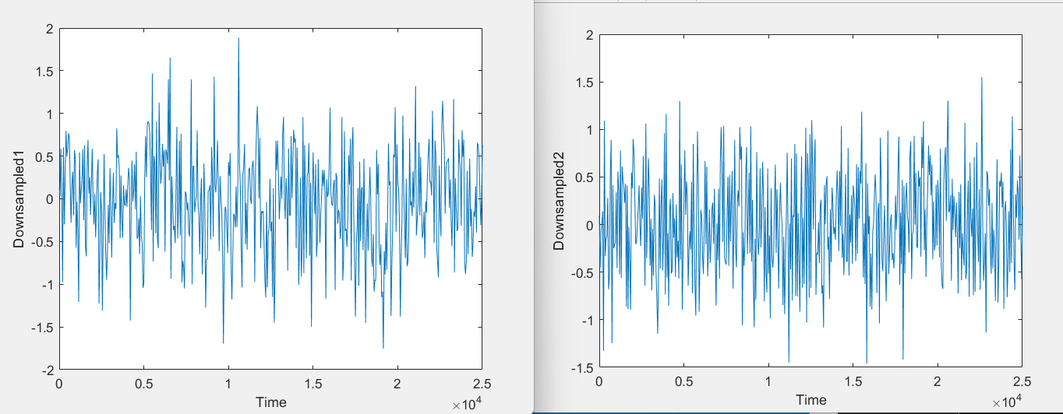

filteredSignal1 = conv(symb_I1 + 1j * symb_Q1, filterCoeff);

filteredNoise1 = conv(bpsk_noise_sequence1 .* cos(10*pi*t_noise/Tb), filterCoeff);

n=round(Tb / Ts);

downsampledSignal1 = filteredSignal1(1:n:end);

downsampledNoise1 = filteredNoise1(1:n:end);

8.

Threshold Estimate 1: 0.8000

Threshold Estimate 2: 0.7000

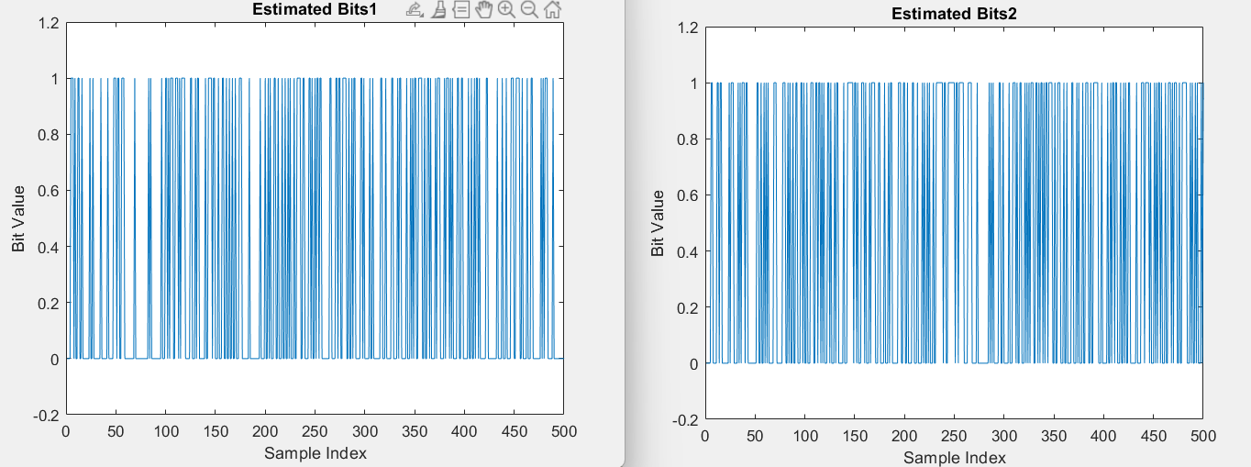

9.

SNRe: -10 -6 -2 2 6 10

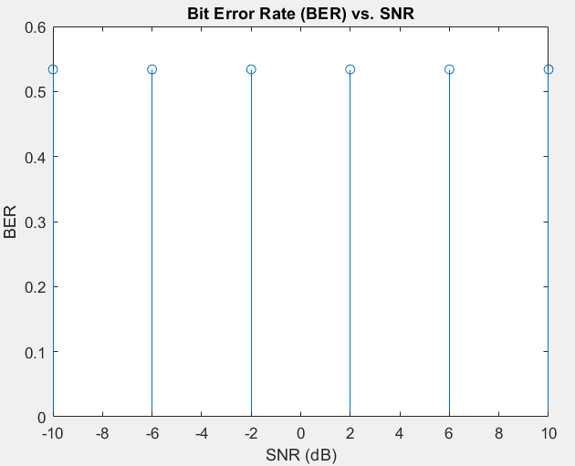

error_count = sum(abs(estimated_bits9 - binary_sequence));

BER(j) = error_count / 500;

10.

error_count = sum(abs(estimated_bits9 - binary_sequence));

error_count_total = error_count_total + error_count;

BER(j) = error_count_total / (500 * 50);

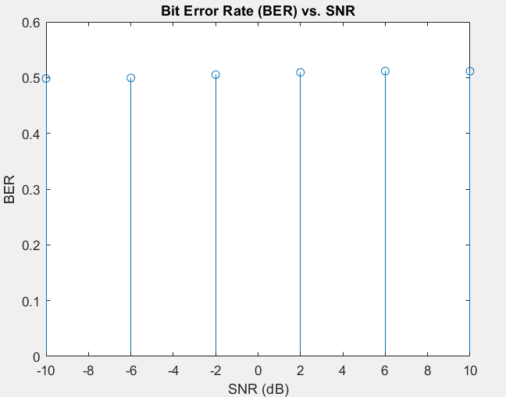

The theoretical BER for a BPSK (Binary Phase Shift Keying) modulation scheme in an AWGN (Additive White Gaussian Noise) channel can be calculated using the following formula:

BER = 0.5 * erfc(sqrt(10^(SNR/10)))

Which is compatible with the shown plot.

11.

offset_frequency = 0.001 * 1/Ts;

t_noise_offset = t_noise + offset_frequency;

symb_I11 = bpsk_noise_sequence1 .* cos(10*pi*t_noise_offset/Tb);

symb_Q11 = bpsk_noise_sequence1 .* sin(10*pi*t_noise_offset/Tb);

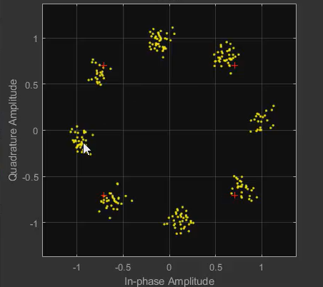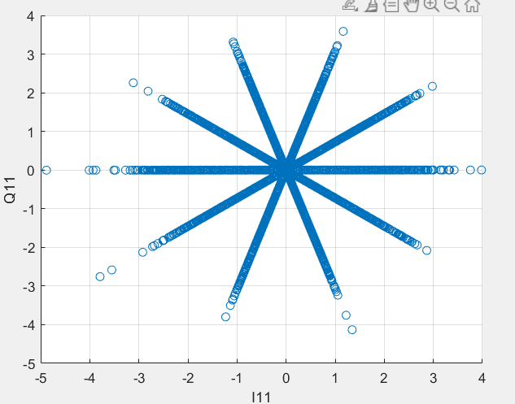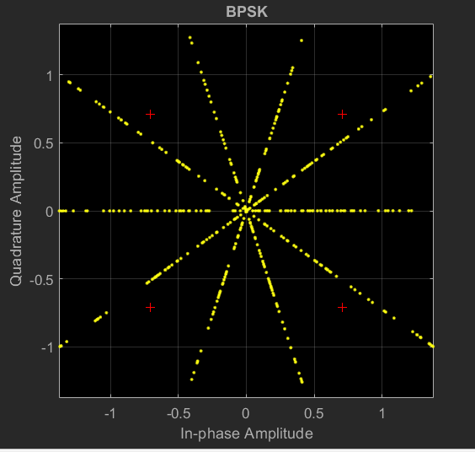

12.

Therefore, to determine an appropriate threshold for symbol detection in your specific system, you would need to perform empirical testing and conduct a more detailed analysis.

13.

 I suggest using a matched filter that is capable of handling frequency offset while maintaining stability.

To achieve stability against frequency offset, you can employ a Finite Impulse Response (FIR) filter. FIR filter is one of the stable filters that uses a sequence of coefficients (usually constant coefficients) to perform the filtering operation.

One of the methods for designing a frequency-matched FIR filter is through windowing. In this approach, we first determine the desired frequency response and then calculate the filter coefficients using a windowing function to apply appropriate weighting. After applying these coefficients to the input signal, the output signal will be frequency-matched to the desired frequency.