DB 1차 과제 보고서

12171628 방솔찬

연락처 010 7538 3823 bsc981111@naver.com

1 구현

각각의 쿼리문들은 execQuery함수와 execQuerySelect 함수를 통해서 실행하였습니다. . 두 함수 모두 처음에 SQLAllocStmt함수를 통해 statement 핸들을 할당 받고 할당 성공시에 SQLExecDirect함수를 통해 쿼리문을 수행하였습니다. 그 후에 쿼리문 수행이 성공적으로 끝났다면 해당 쿼리문을 출력한 후 execQuery 함수는 종료됩니다. 두 함수실행중 에러가 날시 try catch문을 통하여 error trace 를 출력하도록 하였습니다. createTables 함수를 통해서 기본적인 table생성을 하였고 init함수를 통해서 기본 값들을 집어넣었습니다 . 그리고 main문안 코드를 통해서 과제에 주어진 사항들을 수행하였습니다. 모든 쿼리문이 시행된 후에는 table들을 drop한뒤에 main 문을 종료하였습니다.

2 컴파일 환경 및 언어

JDBC를 이용하여 postgresql에 접근하였고 eclipse java 2019-09에서 java로 컴파일 하여 실행하였습니다.

3. 출력결과

1. Create the tables and insert the proper data based on the provided data. You should make the movie, actor, director, and customer tables first and insert data into other related tables.

2. Insert the proper data from the following statements.

2.1. Winona Ryder won the “Best supporting actor” award in 1994

2.2. Andrew Garfield won the “Best supporting actor” award in 2011

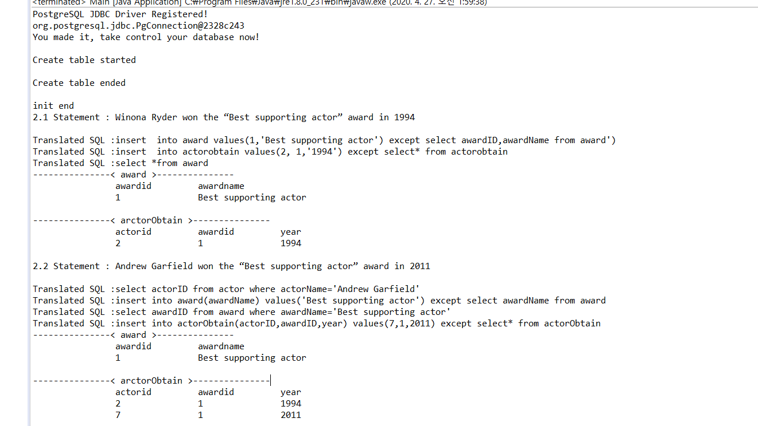

2.3. Jesse Eisenberg won the “Best main actor” award in 2011

2.4. Johnny Depp won the “Best villain actor” award in 2011

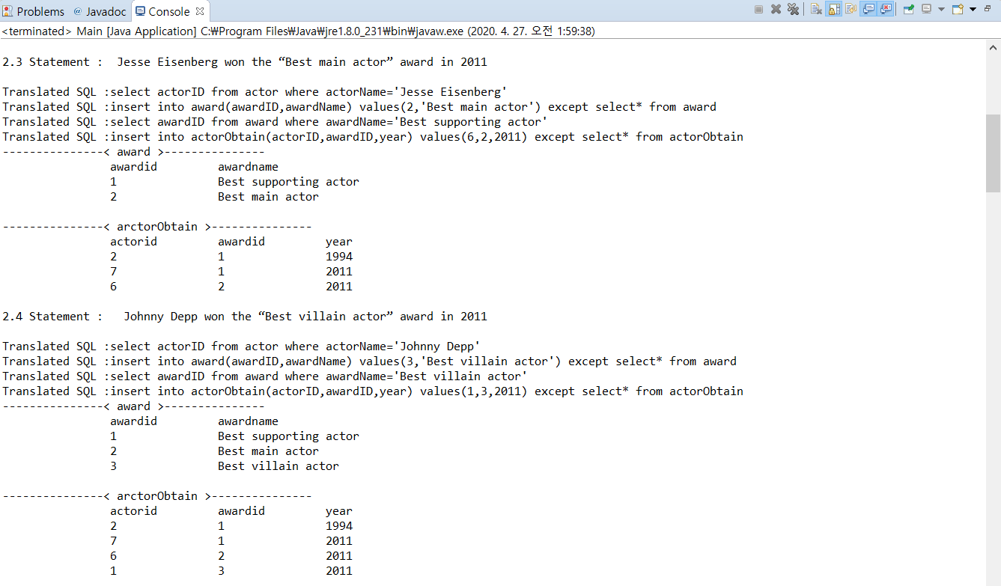

2.5. Edward Scissorhands won the “Best fantasy movie” award in 1991

2.6. The Dark Knight won the “Best picture” award in 2009

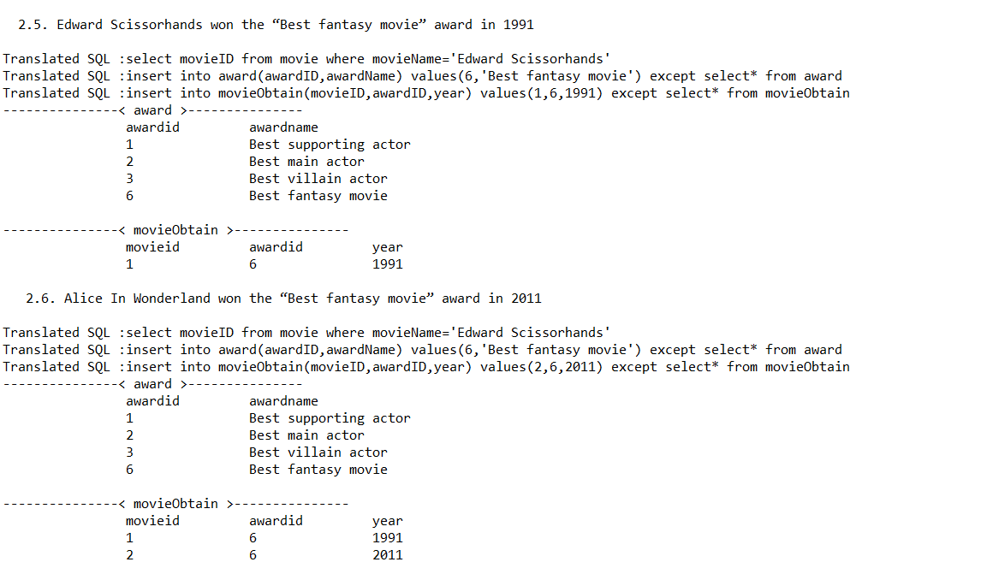

2.7. Alice In Wonderland won the “Best fantasy movie” award in 2011

2.8. David Fincher won the “Best director” award in 2011

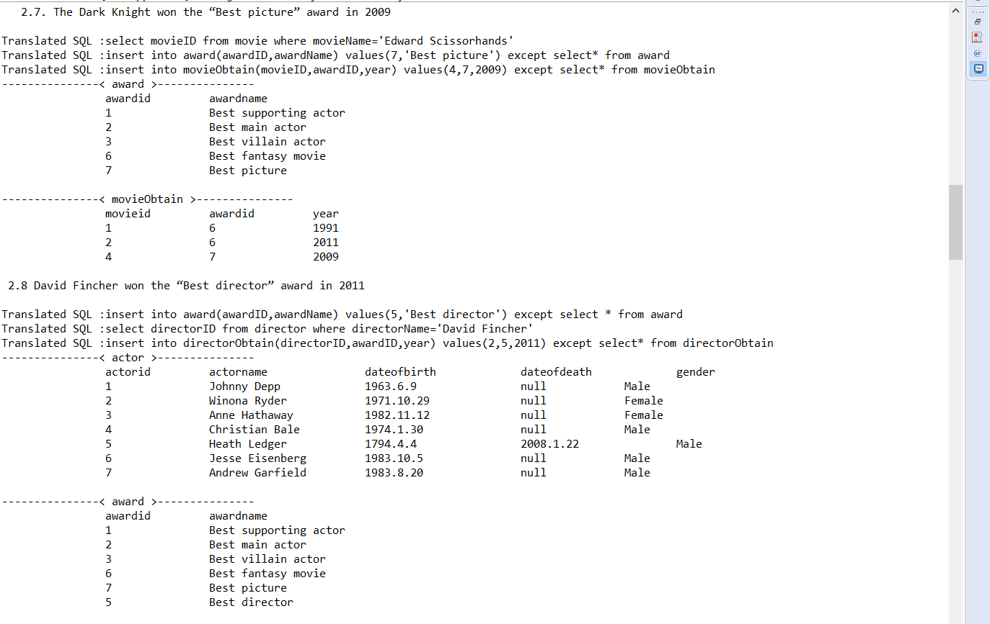

3. Insert data to the proper tables based on the following statements and update avgRate if necessary.

3.1 Bob rates 5 to “The Dark Knight”.

3.2 Bell rates 5 to the movies whose director is “Tim Burton”.

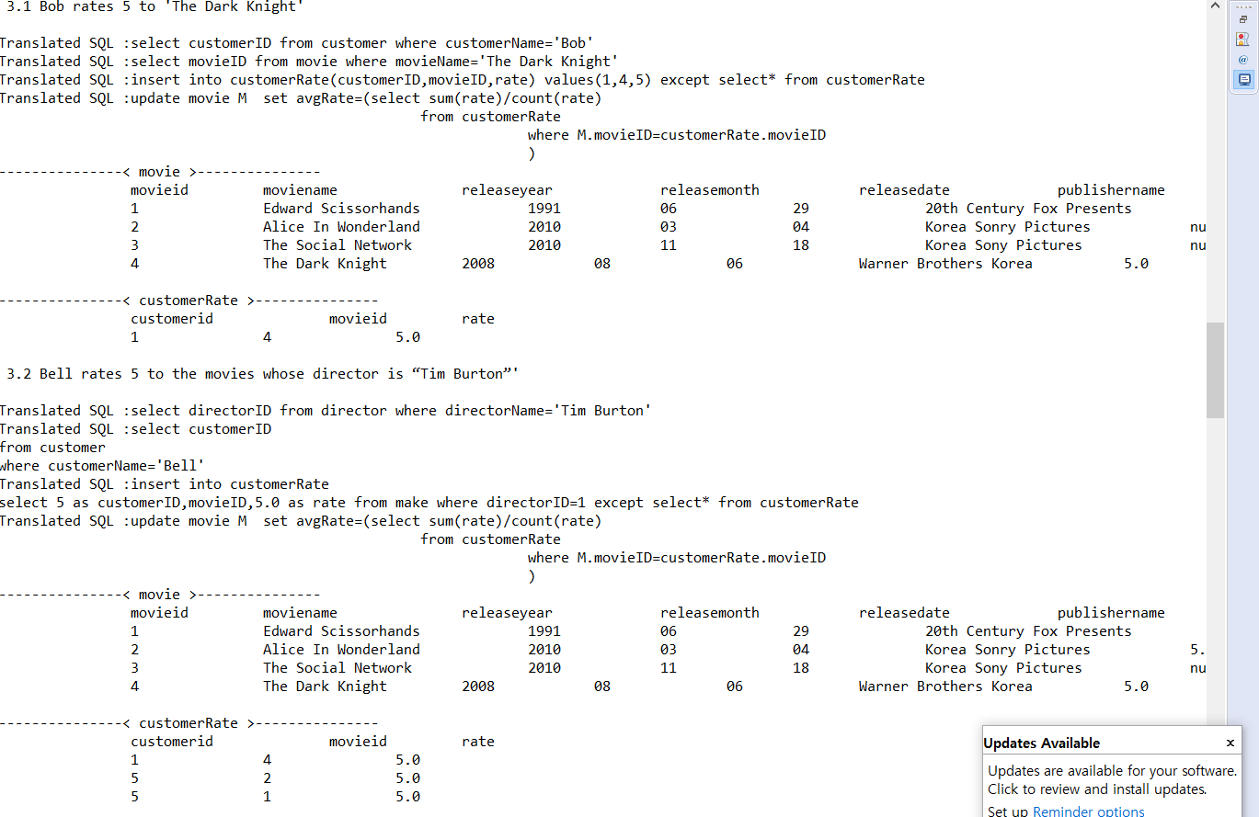

3.3 Jill rates 4 to the movies whose main actor is female.

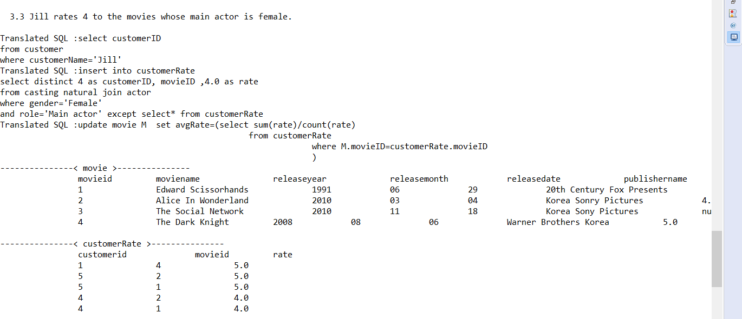

3.4 Jack rates 4 to the fantasy movies

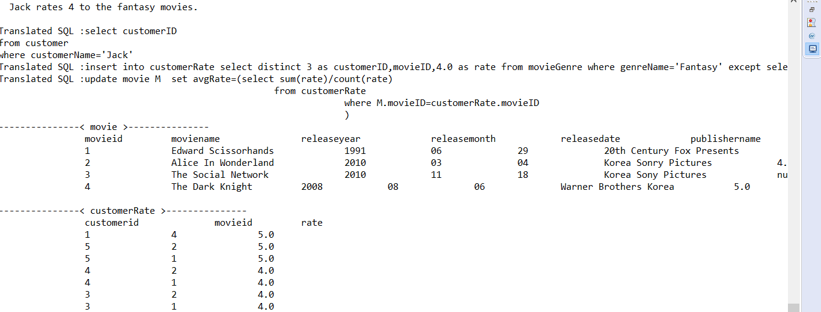

3.5 John rates 5 to the movies whose director won the “Best director” award

4. Select the names of the movies whose actor are dead.

5. Select the names of the directors who cast the same actor more than once.

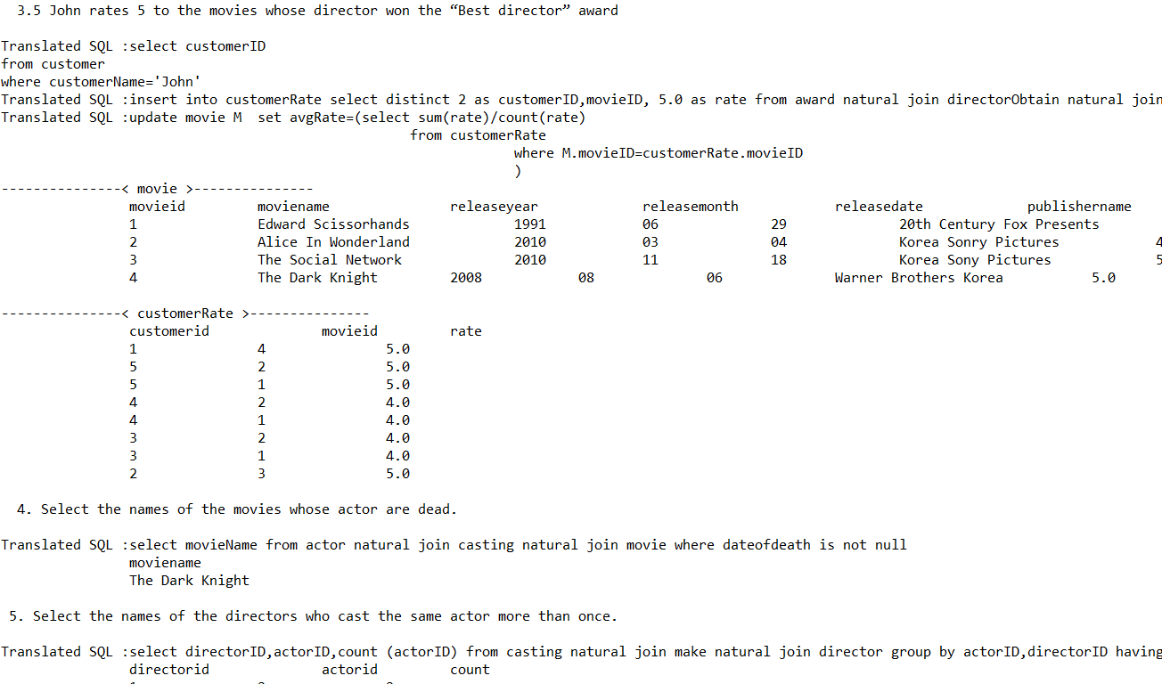

6. Select the names of the movies and the genres, where movies have the common genre.

7. Delete the movies which did not get any award (including all directors and actors) and delete data from related tables

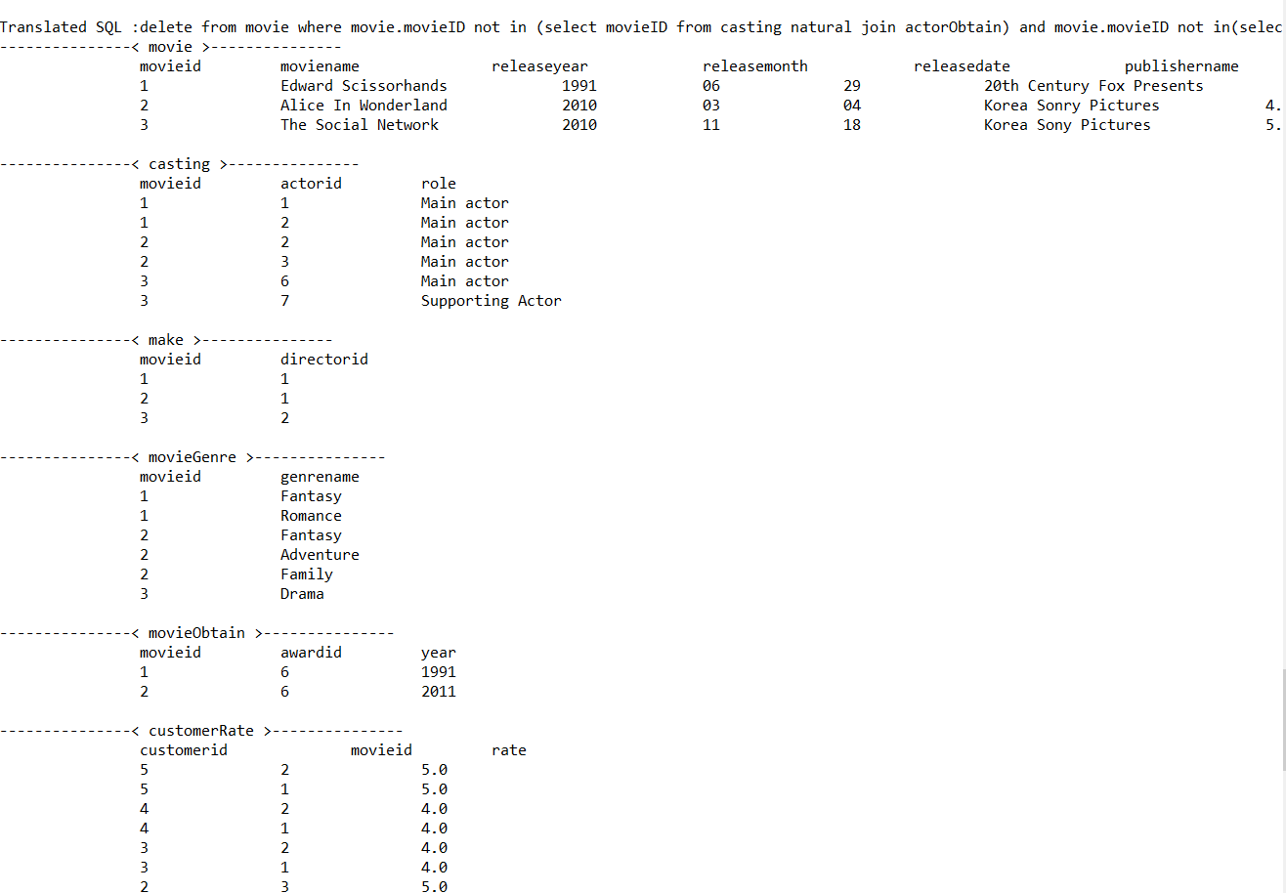

8. Delete all customers and delete data from related tables.

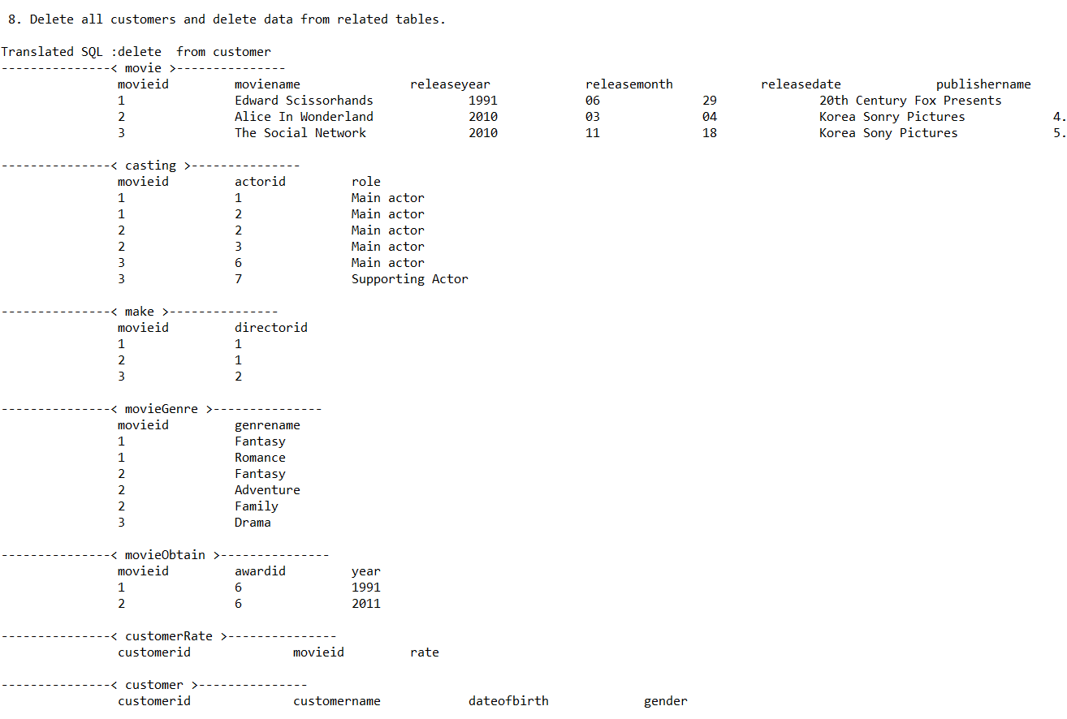

9. Delete all tables and data.

