# TASK FLOW 1: SETTING UP CHORES AND REWARDS

SCREEN 1: The welcome message appears on the first tab, and there will be a "log in" option at the bottom of the screen.

SCREEN 2: When user chooses ‘log in’

SCREEN 3: different account of the family members appears as different block

* LARA
* THOMPSON(HUSBAND)
* SARA
* EMMA

SCREEN 4: The next tab shows the username and password of Lara

SCREEN 5: Lara selects ‘add chores’ from homepage and enters all the

Details like chore name and description

SCREEN 6: Lara decides and chooses reward for completing chores

SCREEN 7: Lara sees the weekly and daily progress of her child in accomplishing Quests

# TASK FLOW 2: CHILD MONITERING

|  |  |
| --- | --- |
| User case name | Family Quest |
| Actor | Sara |
| Goal | To successfully finish the quest |
| Normal Scenarios | 1. Sara login as user |
|  | 1. Sara sees the quest for the particular day |
|  | 1. She went on the quest |
|  | 1. Sara finishes the quest |
|  | 1. Sara gets appreciation note from parents |
|  | 1. Sara inserts image as proof |
|  | 1. Sara sends the reward request that she is eligible for |

# 

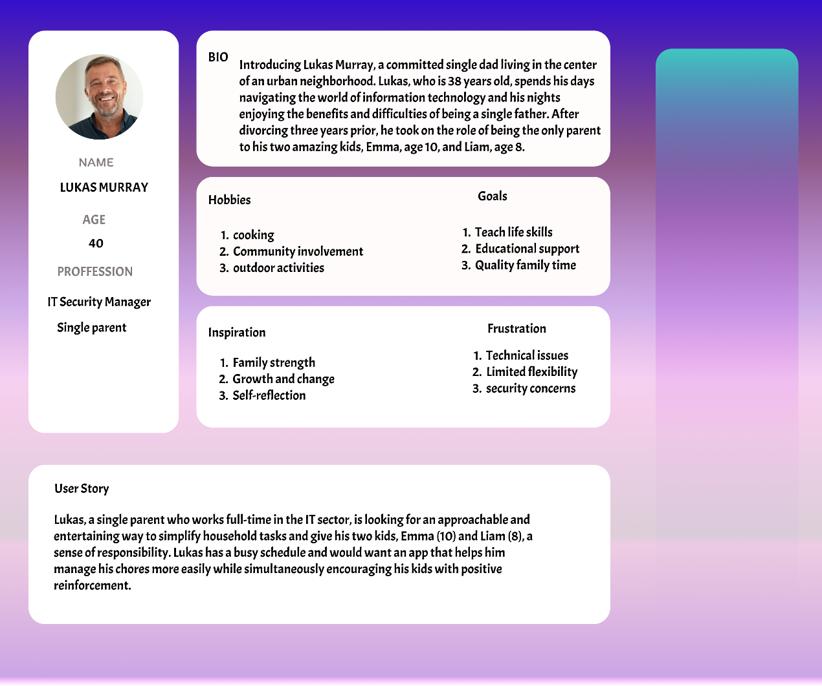

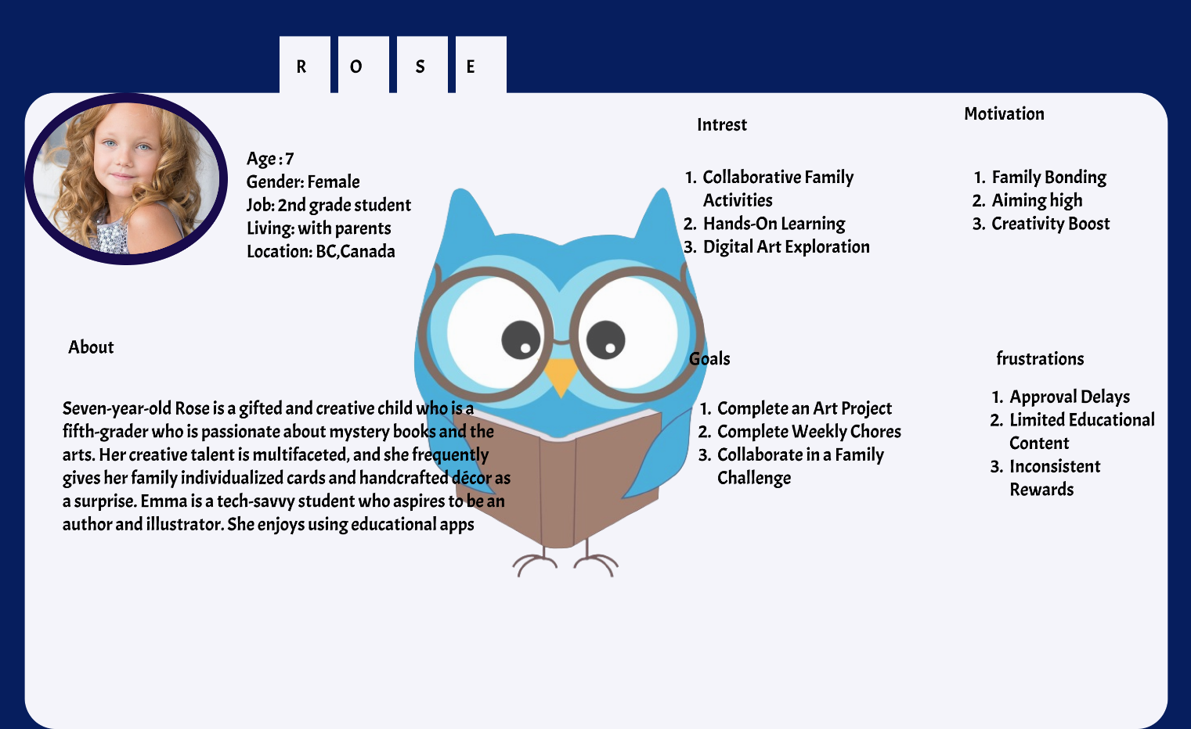

# TASK 2

# INDRODUCTION

This study outlines the procedures involved in developing a website so that it may be seen as comfortably as possible on any mobile device, regardless of the screen size. The website's primary purpose is to help parents monitor their children's chore completion with exciting prizes. This report also details how I developed a high-fidelity prototype for this website and how I made it user-interactive.

# Literature Review

Interactive design focuses on making a product's consumers, or at least the majority of them, happy, at least according to the majority of users who visit such websites. I made it very evident in this paper how important interactive design is, how consumers engage with mobile devices, and what issues users have with mobile design.

# HUMAN CENTERD DESIGN (HCD)

According to ISO 9241-210:2010(E**) “human-centered design is an approach to interactive systems that aims to make systems usable and useful by focusing on the users, their needs and requirements, and by applying human factors/ergonomics, and usability knowledge and techniques. This approach enhances effectiveness and efficiency, improves human well-being, user satisfaction, accessibility and sustainability; and counteracts possible adverse effects of use on human health, safety and performance**.”

# Research

Thinking like the user when developing something is known as user-centered design, or UCD. To create incredibly accessible and user-friendly websites and apps, design and development teams leverage data on user needs, goals, and feedback for that the primary step is to create persona s

Developing personas to provide your team with representations of the target audience for the website. A persona is a hypothetical person who resembles your ideal user in terms of behavior, goals, wants, abilities, background, and attitudes.

Personas are a useful tool for simulating customers and identifying necessary needs and user goals.

# Application

* **Understanding user**: Understanding the views of parents and kids is essential when developing an app to encourage kids to perform chores, therefore I've created two prototypes: one from a parent's perspective and the other from a child's.
* Personna development: I have selected a scenario with Lara Thompson and her two children, Emma and Sara, out of the three persona s stated above for this app.

# Design Principles

Design principles serve as a roadmap for how a user interface should show itself to users. It gives the designers advice on what to consider while creating designs in order to improve them—not for themselves, but for the end users—rather than instructing them on how to create the website or interface.

2.1 **Hick’s law** : According to Hick's Law, people prefer not to be overstimulated to the point that it prevents them from making decisions.

Application: I just designed four user-friendly screens for this app so that it would be simple and hassle-free for the user to use.

2.3 **Don Normans Design principles**

*“Everything has a personality: everything sends an emotional signal. Even where this was not the intention of the designer, the people who view the website infer personalities and experience emotions.” Don Norman, Grand Old Man of User Experience*

# 2.4 Task and Reward creation

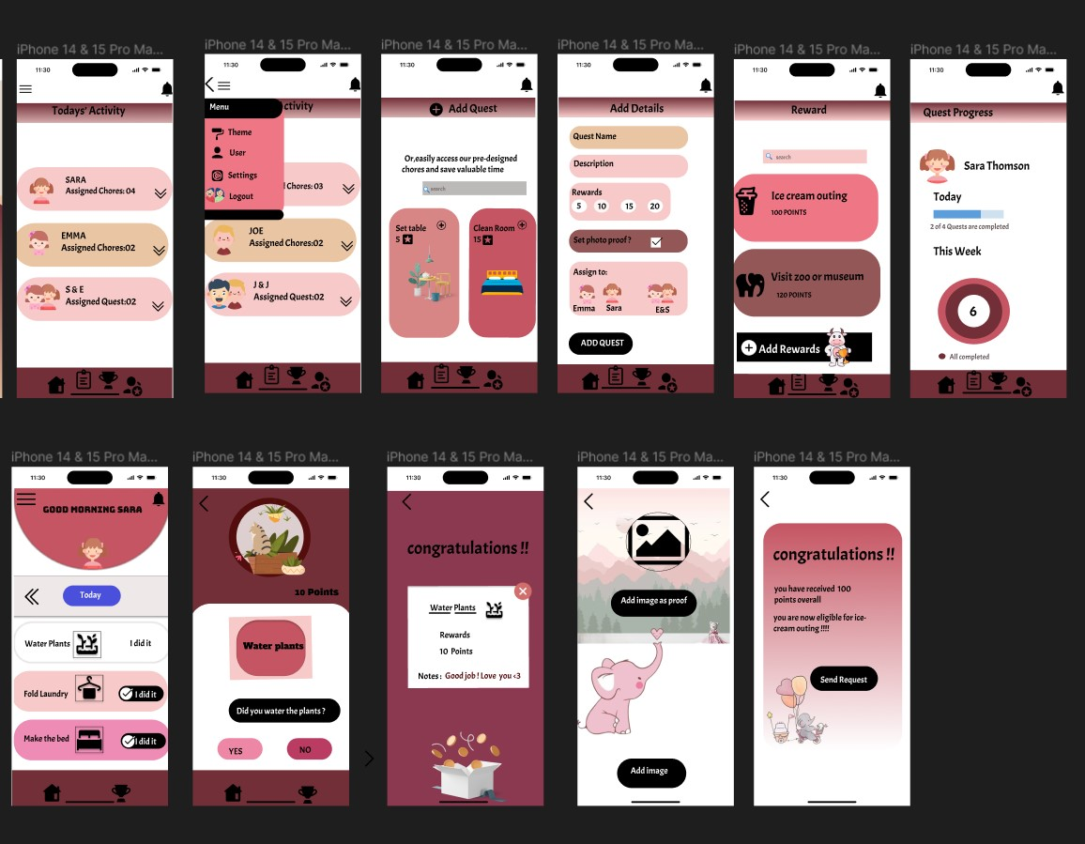

Fig 2.1

1. The parent can view the many chores allocated to each child by navigating to the chore screen. By, choosing the "add chores" button, the parent can further customize the tasks to their liking. Don Norman's philosophy states that a person must look for the goods they wish to purchase. However, same idea is implemented to the app in a similar way, allowing the user to search for chores and prizes. Parents can browse for prizes and customize it.
2. Collaborative work: parents can assign their children to chore teams and divide the points earned; this will strengthen their bonds and boost their sense of teamwork.
3. Kids can examine their point total and the number of chores allocated to them from the homepage. They can choose to set a photo as proof after finishing. They send the request to the parent

after they realize that they have finished the task and are now qualified for the prize.

# 2.4 Feedback Loop

A feedback loop is the section of a system where some or all of the output is fed back into the system to power subsequent processes. There are a minimum of four steps in every feedback loop. Input is generated in the first phase. Input is recorded and saved in the second phase. In the third stage, input is examined, and in the fourth stage, conclusions drawn from the examination are applied to decision-making.

Application: The idea of a feedback loop can be used in this situation since the fourth screen tracks children's progress on a daily and weekly basis, allowing parents to assess how involved their children have been during the week.

# 2.4 Fitts’s Law

Fitts’ law states that the amount of time required for a person to move a pointer (e.g., mouse cursor) to a target area is a function of the distance to the target divided by the size of the target. Thus, the longer the distance and the smaller the target’s size, the longer it takes.

Application: Since buttons and icons are important because they indicate action, providing the precise icons and buttons with the appropriate size is essential to preventing inadvertent clicks by users on adjacent items. below mentioned some icons that I have used in the prototype

Here are a few screenshots of the websites' high fidelity prototypes both from the perspective of parent and child

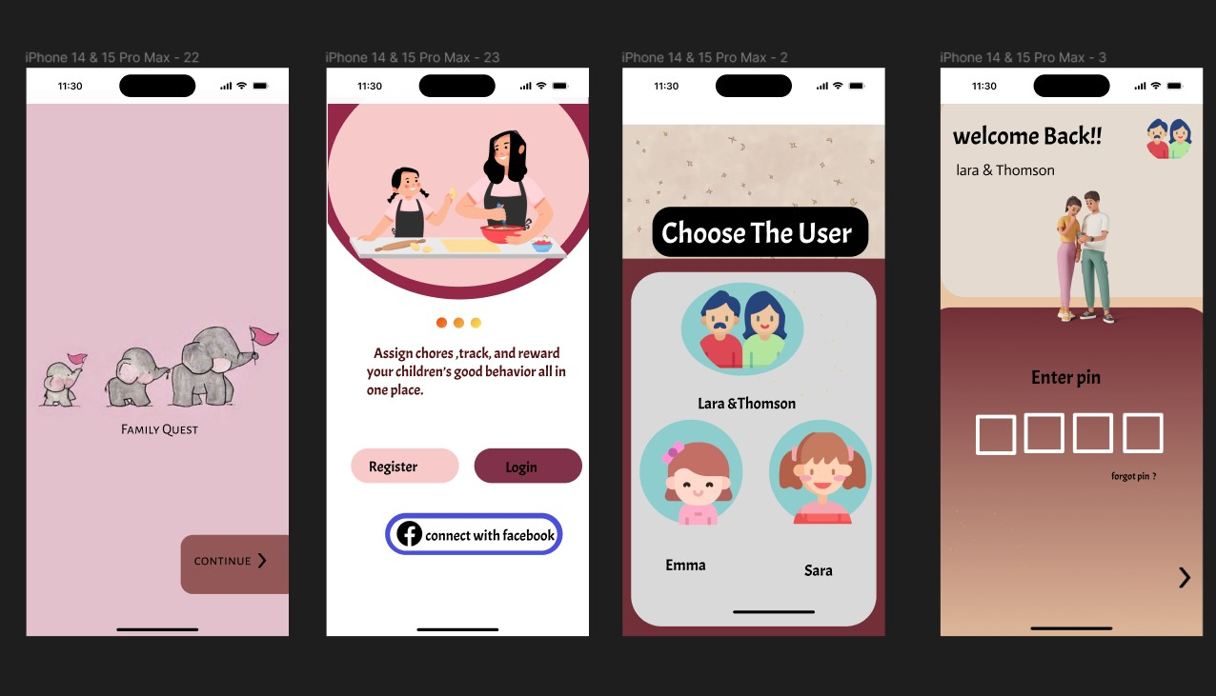

Fig 2.2

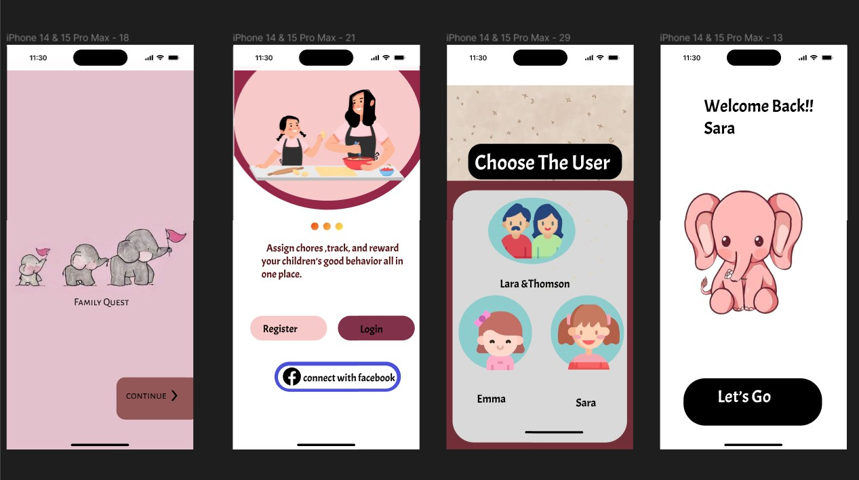

Fig 2.4

# 2.5Gestalt’s Principle

**gestalt theory is based on the idea that the human brain will attempt to simplify and organize complex images or**[**designs**](https://www.toptal.com/designers/creative-direction/art-vs-design)**that consist of many elements, by subconsciously arranging the parts into an organized system that creates a whole, rather than just a series of disparate elements.**

**Application**: Here, I used the colour pink as the inspiration for both prototypes. Given that children are the app's primary audience, it seems to reason that kids frequently exhibit a preference for neutral hues due to a variety of developmental stages, cognitive processes, and sensory experiences, if a user want to change the theme, they can do so by selecting a different one from the one on the site. This makes the app more visually appealing.

In accordance with the gestalt principles, I have arranged all of the content on separate screens, starting from the homepage and ending with the user selection, to prevent confusion or overwhelm when making decisions.

# 2.6Miller’s Law

 “The magical number seven, plus or minus two: some limits on our capacity for processing information”

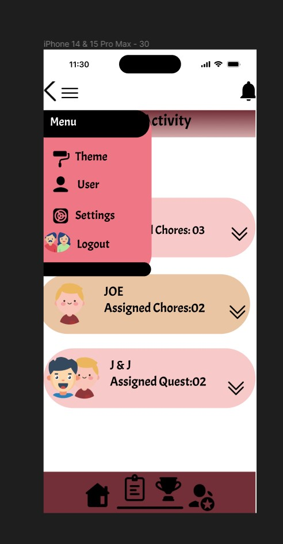

Fig 2.5

**Application**: Here, I've only included options that are pertinent to the users: changing the app's theme to make it more comfortable to use; changing the user, if necessary; changing the settings; and finally, logging out. By limiting the options, people would be less confused and more likely to recall.

The notification icon is used to accept reward request from children and receive notifications from them when they finish tasks.

# Task 3

Hierarchical Model

In order to assess the training requirements of an organization, Annett and Duncan (1967) developed the hierarchical task analysis (HTA). One useful technique for doing a thorough analysis of tasks is Hierarchical Task Analysis (HTA). Tasks are broken down into even more subtasks by HTA. A structured chart is then used to graphically display these duties. HTA comprises task identification, task categorization, task subtask identification, and model overall accuracy verification. Interface designers utilize HTA to create a task execution model that helps them visualize the operations, plans, goals, tasks, and subtasks that are crucial to the actions of users. For designers, HTA functions as a useful tool as well as an analytical framework. Here is a screenshot of the start quiz website's HTA.

1. Visibility of system status

Users can decide what to do next and what the outcome of their previous interactions was when they are aware of the present status of the system. 'Family Quest' allows children to checkmark chores as finished and allows parents to view their children's daily progress. The app's NEXT button guarantees that users will go to the next phase.

1. Match between the system and the real world

Family Quest is a chore app that is kid-friendly, including colourful buttons and interactive cartoon animal drawings. Each button has a different function on each screen, and we've positioned icons next to buttons to prevent confusion. For instance, choosing the rewards ice cream emblem is situated for an ice cream excursion. this categorizes the user to choose an ice cream outing

1. User control and freedom

Users make mistakes when doing actions. They require a "emergency exit" that is clearly defined so they can abandon the undesirable action without going through a lengthy procedure. Users of "family quest" have the option to start over by hitting the back symbol

1. Consistency and Standards

It shouldn't be up to users to figure out what certain phrases, circumstances, or behaviors mean. This suggests that each icon serves a distinct purpose so that users won't hesitate to click on them, much as the award icon indicates the process of choosing rewards. Menu icons display menu

1. Error Prevention

While effective error messages are crucial, the finest designs take extra care to avoid issues in the first place. For example, kids receive a "are you sure?" warning message after completing tasks, which helps them avoid making mistakes.

1. Recognition than recall

Reduce the amount of memory used by the user by making options, actions, and items visible. The 'Family Quest', the quest feature allows parents to monitor the quests their children have been assigned, and allows children to see which tasks they have finished or not. This helps users avoid memory problems as they are relieved of the burden of remembering which tasks they have assigned or accomplished.

1. Flexibility and efficiency of use

To ensure that the design can accommodate both beginner and expert users, shortcuts that are concealed from novice users may expedite the interaction for the expert user. The mission and prizes are customizable by the parents; they can search for the item or choose from pre-made themes.

1. Aesthetic and Minimalist Design

Information that is rarely or irrelevantly needed should not be present in interfaces. The "Family Quest" app has just necessary components from the login page to the very end, but it is friendly enough to encourage children to participate. For instance, upon completing a task, kids get appreciation note from parents that they have did good

1. Help users recognize, diagnose, and recover from errors

Family Quest is written in a language that is kid-friendly. To make it precise for the user, we used the fonts Acme and 24. It also provides solutions, such as a back button that allows the user to reload the page in the event that a mistake occurs.

1. Help and Documentation

This software is written in a kid-friendly way, and parents or kids can view tutorials to set up the program so that the icons and symbols can be used.

GOMS Model

An explanation of the skills required for a user to use a gadget or system, the knowledge of "how to do it" that a system has to perform in order to complete the specified tasks.

* Objectives: An objective the user attempts to achieve (action-object pair, for example, remove word) - Incorporate context
* Methods: - A well-learned series of actions to complete a task - How do you use this system to do it? (may take a while and be boring)
* Selection rules: Only when there are distinctly different approaches to achieve the same objective.
* Operators: are primarily determined by lower-level software and hardware. They include basic perceptual, cognitive, and motor acts that create change (external vs. mental); they also include action-object pairs (e.g., push a key, pick a menu, make a gesture, voice a command, etc.).

# EVALUTION

1. The product has an appealing appearance and was properly designed. Its contents were jam-packed with product usage of elements including colour, typography, and controls.
2. The appropriate usage of text size and colour was done so taking into account our target audience, which included both children and the elderly.
3. The pages are all easily navigable, which permits a gentle and sensible hierarchy of pages on top of one another.

appropriate communication with the user because there are always certain items or functions

# REFERENCES

<https://www.iso.org/standard/63462.html>

<https://www.nist.gov/itl/iad/visualization-and-usability-group/human-factors-human-centered-design>

<https://baymard.com/learn/user-centered-design>

<https://nulab.com/learn/design-and-ux/how-to-get-started-with-iterative-design-and-why-you-should/>

<https://www.techtarget.com/searchitchannel/definition/feedback-loop>

<https://pathumpmgux.medium.com/15-user-experience-principles-and-theories-80f19877bd5>

<https://www.interaction-design.org/literature/article/shneiderman-s-eight-golden-rules-will-help-you-design-better-interfaces>

<https://www.nngroup.com/articles/help-and-documentation/>