import matplotlib.pyplot as plt  
import numpy as np  
  
pp=[['T',0.9],['T',0.7],['N',0.65],['T',0.6],['N',0.5],['N',0.4],['N',0.4],['T',0.4],['N',0.35],['N',0.2]]  
aa=[0.9,0.7,0.65,0.6,0.5,0.4,0.4,0.4,0.35,0.2]  
  
recall=[]  
precision=[]  
TPR=[]  
FPR=[]  
  
for a in aa:  
 tp=0  
 fn=0  
 fp=0  
 tn=0  
 x=0  
 y=0  
  
 for p in pp:  
 if(p[0]=='T') and (p[1]>=a):  
 tp=tp+1  
 elif(p[0]=='T') and (p[1]<a):  
 fn=fn+1  
 elif (p[0] == 'N') and (p[1] >= a):  
 fp = fp + 1  
 elif (p[0] == 'N') and (p[1] < a):  
 tn=tn+1  
 x=float(tp)/(tp+fn)  
 y=float(tp)/(tp+fp)  
 fpr=float(fp)/(tn+fp)  
  
 recall.append(x)  
 precision.append(y)  
 TPR.append(x)  
 FPR.append(fpr)  
  
plt.figure(figsize=(5,5))  
plt.title('precision-recall curve',fontsize=16)  
plt.plot(recall,precision)  
plt.plot(recall,precision,'ro')  
plt.xlabel('Recall',fontsize=16)  
plt.ylabel('Precision',fontsize=16)  
plt.show()

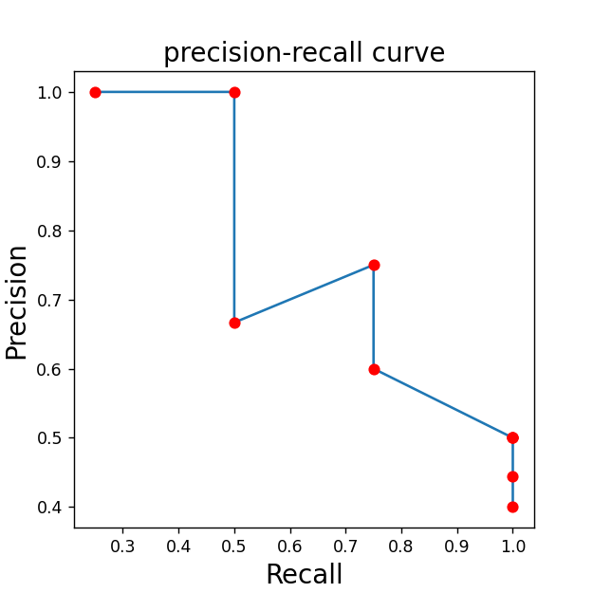

import matplotlib.pyplot as plt  
import numpy as np  
  
pp=[['T',0.9],['T',0.7],['N',0.65],['T',0.6],['N',0.5],['N',0.4],['N',0.4],['T',0.4],['N',0.35],['N',0.2]]  
aa=[0.9,0.7,0.65,0.6,0.5,0.4,0.4,0.4,0.35,0.2]  
  
recall=[]  
precision=[]  
TPR=[]  
FPR=[]  
  
for a in aa:  
 tp=0  
 fn=0  
 fp=0  
 tn=0  
 x=0  
 y=0  
  
 for p in pp:  
 if(p[0]=='T') and (p[1]>=a):  
 tp=tp+1  
 elif(p[0]=='T') and (p[1]<a):  
 fn=fn+1  
 elif (p[0] == 'N') and (p[1] >= a):  
 fp = fp + 1  
 elif (p[0] == 'N') and (p[1] < a):  
 tn=tn+1  
 x=float(tp)/(tp+fn)  
 y=float(tp)/(tp+fp)  
 fpr=float(fp)/(tn+fp)  
  
 recall.append(x)  
 precision.append(y)  
 TPR.append(x)  
 FPR.append(fpr)  
  
plt.figure(figsize=(5,5))  
plt.title('ROC curve',fontsize=14)  
plt.plot(FPR,TPR)  
plt.plot(FPR,TPR,'ro')  
plt.xlabel('TPR',fontsize=14)  
plt.ylabel('FPR',fontsize=14)  
plt.show()  
  
i=0  
auc=0  
while(i<9):  
 auc=auc+(FPR[i+1]-FPR[i])*(TPR[i]+TPR[i+1])  
 i=i+1  
auc=auc/2;  
print('auc=%.2f' % auc)

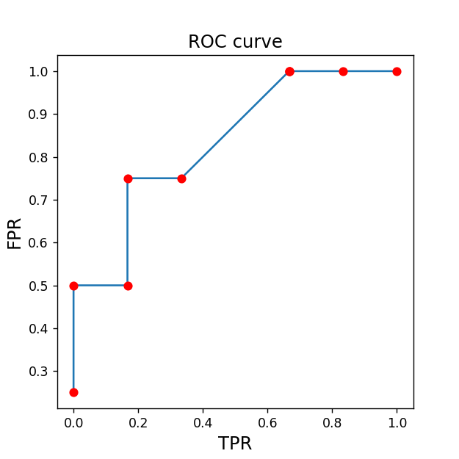



import matplotlib.pyplot as plt  
import numpy as np  
from sklearn.metrics import roc_curve  
from sklearn.metrics import auc  
  
y_true=np.asarray([[0,0,1],[0,1,0],[1,0,0],[0,0,1],[1,0,0],[0,1,0],[0,1,0],[0,1,0],[0,0,1],[0,1,0]])  
y_pred=np.asarray([[0.1,0.2,0.7],[0.1,0.6,0.3],[0.5,0.2,0.3],[0.1,0.1,0.8],[0.4,0.2,0.4],[0.6,0.3,0.1],[0.4,0.2,0.4],[0.4,0.1,0.5],[0.1,0.1,0.8],[0.1,0.8,0.1]])  
  
n_classes=len(y_true[1,:])  
fpr=dict()  
tpr=dict()  
roc_auc=dict()  
plt.figure(figsize=(10,10))  
for i in range(n_classes):  
 fpr[i],tpr[i], _ =roc_curve(y_true[:,i],y_pred[:,i])  
 roc_auc[i]=auc(fpr[i],tpr[i])  
 fpr["micro"], tpr["micro"], _ = roc_curve(y_true.ravel(), y_pred.ravel())  
  
for i in range(n_classes):  
 plt.subplot(2,2,i+1)  
 plt.title('ROC curve', fontsize=14)  
 plt.plot(fpr[i], tpr[i])  
 plt.plot(fpr[i], tpr[i], 'ro')  
 plt.xlabel('tpr', fontsize=14)  
 plt.ylabel('fpr', fontsize=14)  
plt.subplot(2,2,4)  
plt.plot(fpr["micro"], tpr["micro"])  
plt.show()

