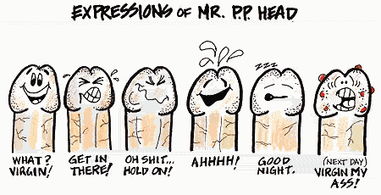

It ain't easy
being a dick.

I've got a head I
can’t think with.
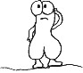
An eye I can't
see out of.

I have to hang
around with two
nuts all the time.
My closest neighbour
is a real asshole

My best friend
is a pussy and every time I get
excited I throw up!
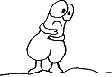
and worst of all my owner beats me!


Pass This On To Ten People Or
YOU Will Have A Real Bad Sex Life

