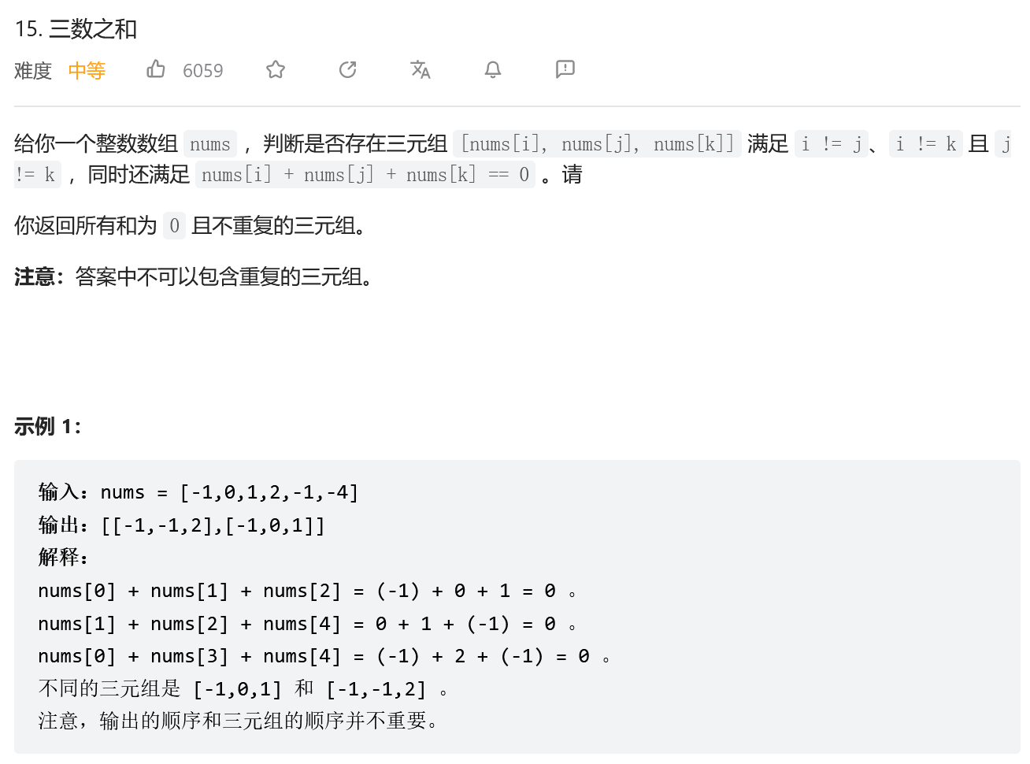
排序+双指针
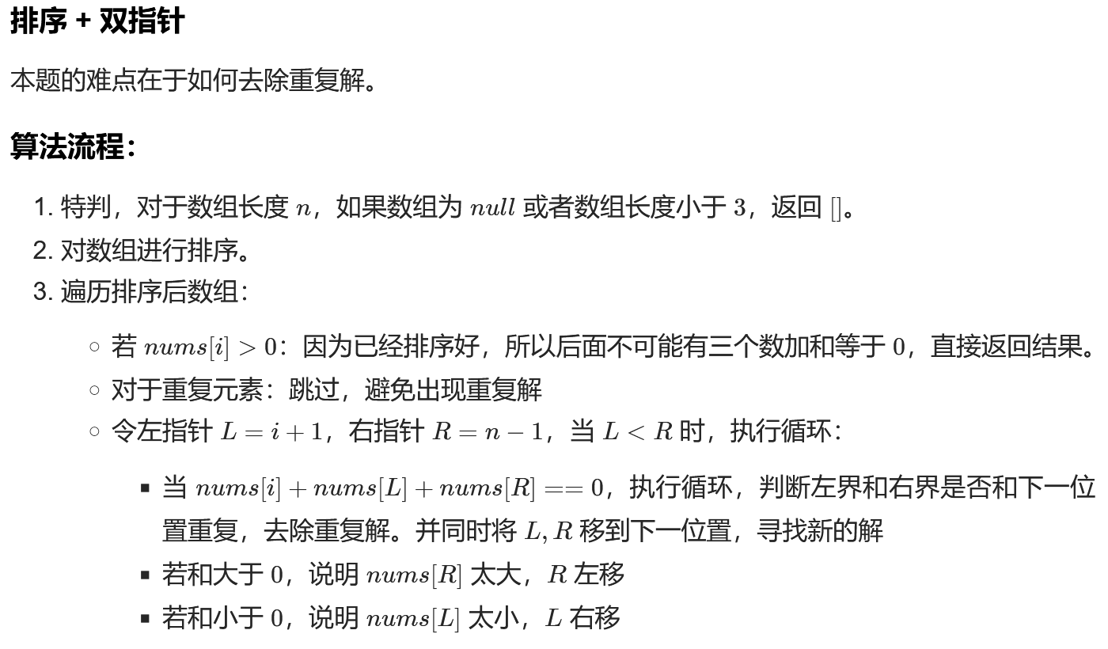

class Solution:
def threeSum(self, nums: List[int]) -> List[List[int]]:

n=len(nums)
res=[]
if(not nums or n<3):
return []
nums.sort()
res=[]
for i in range(n):
if(nums[i]>0):
return res
if(i>0 and nums[i]==nums[i-1]):
continue
L=i+1
R=n-1
while(L<R):
if(nums[i]+nums[L]+nums[R]==0):
res.append([nums[i],nums[L],nums[R]])
while(L<R and nums[L]==nums[L+1]):
L=L+1
while(L<R and nums[R]==nums[R-1]):
R=R-1
L=L+1
R=R-1
elif(nums[i]+nums[L]+nums[R]>0):
R=R-1
else:
L=L+1
return res

class Solution:
def threeSum(self, nums: [int]) -> [[int]]:
nums.sort()
res, k = [], 0
for k in range(len(nums) - 2):
if nums[k] > 0: break # 1. because of j > i > k.
if k > 0 and nums[k] == nums[k - 1]: continue # 2. skip the same `nums[k]`.
i, j = k + 1, len(nums) - 1
while i < j: # 3. double pointer
s = nums[k] + nums[i] + nums[j]
if s < 0:
i += 1
while i < j and nums[i] == nums[i - 1]: i += 1
elif s > 0:
j -= 1
while i < j and nums[j] == nums[j + 1]: j -= 1
else:
res.append([nums[k], nums[i], nums[j]])
i += 1
j -= 1
while i < j and nums[i] == nums[i - 1]: i += 1
while i < j and nums[j] == nums[j + 1]: j -= 1
return res
