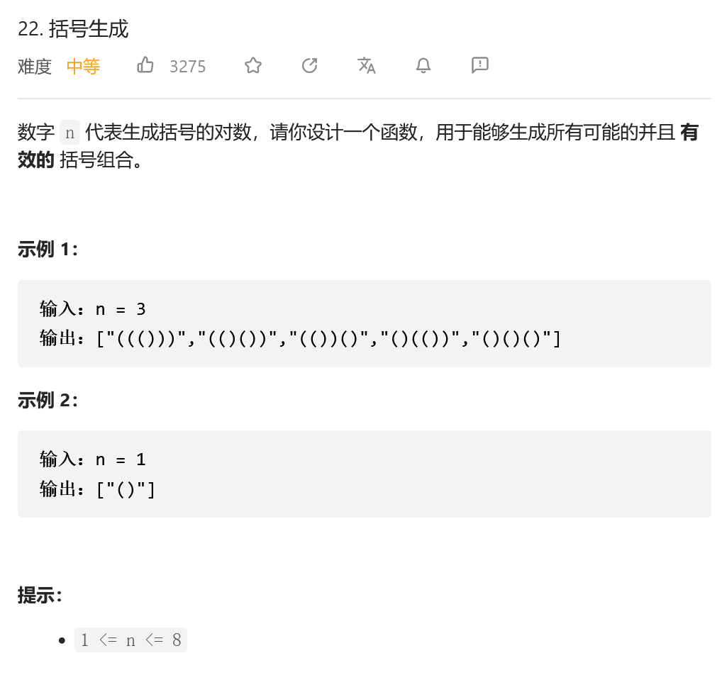
方法一：深度优先遍历
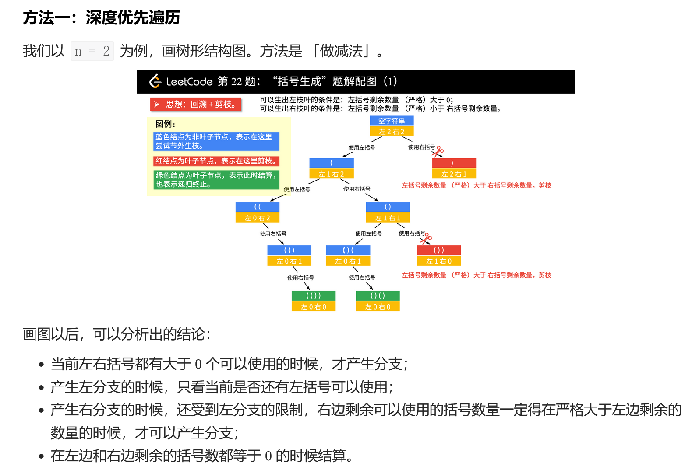
from typing import List
class Solution:
def generateParenthesis(self, n: int) -> List[str]:

res = []
cur_str = ''

def dfs(cur_str, left, right):
"""
:param cur_str: 从根结点到叶子结点的路径字符串
:param left: 左括号还可以使用的个数
:param right: 右括号还可以使用的个数
:return:
"""
if left == 0 and right == 0:
res.append(cur_str)
return
if right < left:
return
if left > 0:
dfs(cur_str + '(', left - 1, right)
if right > 0:
dfs(cur_str + ')', left, right - 1)

dfs(cur_str, n, n)
return res
