Software Documentation

for

Pet Shopping System

Group 8:

Do Trung Tin – CE130157

Le Duc An – CE130100

Vo Tan Anh – CE130040
October 3, 2019
Table of Content
I. Project Definition 6
II. User Requirement 6
II.1. List inputs to website: 6
II.2. List outputs expected from the website 6
II.3. Overview of processes involved in the website 7
II.4. Hardware and software required for implementing the project 7
III. Project Plan 8
III.1. Project Details: 8
IV. Project Initiation/ Requirement Document 9
IV.1. Deliverables 10
IV.2. Project Dependencies 10
IV.3. Major Project Milestones: 10
IV.4. Quantity Plan 10
V. Design pattern 11
V.1. System Organization 11
V.1.a. Use case diagram 11
V.1.b. Sequence Diagram 12
V.2. Database 14
V.2.a. Database diagram 14
V.2.b. Data dictionary 15
V.3. Interface 16
V.4. Execution Flow 23
V.4.a. Flowchart diagrams 23
VI. Process design 34
VI.1. Programming standards 34
VI.2. Standard for code writing style 34
VI.3. Standard for declaring variables 34
VI.4. Standards for function declarations 34
VI.5. Other standards 34
VII. Task Sheet 34
VIII. Project Review 37
IX. Final Checklist 38
X. Maintenance 38
X.1. Installation Manual 39
X.2. Maintenance 43

- Project Definition

Online shopping is no longer a strange concept to the present era with the development of online sales websites. In order to promote sales and brand development effectively, stores need a separate online sales system to serve customers.
We recognize that the demand for pet and supplies shopping is increasing and expanding. In order to develop the store system and meet customer needs, we seized this opportunity to develop an online shopping system for the store.

- User Requirement
  - List inputs to website:
- User information: id, first name, last name, phone number, email, address, city, password, role id, gender, username.
- Item information: category id, id, name, status, price per unit, tags, image, detail, quantity, supplier name.
- Order product information: order id, pet id, item id, quantity, price, id.
- Order information: id, date order, price, status.
- Order user information: user id, order id, id.
- Category information: id, category name, description, slug, level, category id.
- Order information: order id, username, order date, delivery date, delivery address, status, product id, quantity, total price.
- Role information: id, name.
- Pet information: id, name, description, gender, birth, price, color, image, vaccine, status, species id.
- Supplier information: id, name, description, status.

  - List outputs expected from the website
- Display information of user.
- Display information of role.
- Display information of item.
- Display information of order.
- Display information of category.
- Display information of pet.
- Display information of species.
- Display search result.
  - Overview of processes involved in the website
- Process registration.
- Process login and log out.
- Process view order history.
- Process order.
- Process search.
- Admin tool:
  - Add category, edit category.
  - Delete category.
  - Add pet, edit pet.
  - Delete pet.
  - Add user, edit user.
  - Delete user.
  - Add item, edit item.
  - Delete item.
  - Add supplier, edit supplier.
  - Delete supplier.

  - Hardware and software required for implementing the project
 | Client | Server
Hardware requirement | - CPU: Pentium IV 2.0 GHz or higher.  - RAM: 512MB or higher.  - HDD: 40GB or higher.  - Network interface card.  - CD ROM. | - CPU: Pentium IV 3.0 GHz or higher.  - RAM: 2GB or higher.  - HDD: 80GB or higher.  - Network interface card.  - CD ROM.
Software requirement | - Window 10 or below version.  - Web Browser  (IE 7 or higher, Firefox, Chrome, Apple Safari, … ) | - Window server 2003 or higher.  - IIS  - PHP  - SQL Server 2017

- Project Plan
  - Project Details:
  - Name of client: PSS – Pet Shopping Shop
  - Date of project plan:
- Start: October 3rd 2019
- Finish: October 15th 2019
  - Project Vision/ Objective:
The main purpose of the project is to quickly improve the system that provides users a website to shop online. Staff can easily update data on the system and manage quickly. The advanced functions of managing customer orders will be upgraded after the system is complete and can be operated for a long time.
  - Scope
Pet Shopping System will include an online web form to store pet stuff and pet data. Customer can use this web to ordering online.
PSS also include management application to store all data including customers. Employee can use this application to manage data in local store or online store.
PSS web single page application can run on any OS with a web browser and internet support, so users can use website with many options of devices: computer, iPad, smart phone.
User can easily browsing product and make an order.
  - Our Understanding of the Client Organizations:
PSS was established in 2019. Shop has address: 99, MauThan street, Ninh Kieu District, Can Tho City.
PSS sells original gift with the best customer care services.
  - Project Organization with Responsibilities and Authorities:

 | Member | Role | Responsibilities
1 | Do Trung Tin | Group leader
2 | Le Duc An | Member | Define problem, input, output, process.  Determinate how to see problem together.
3 | Vo Tan Anh | Member | Design interface  Design E-R model  Design database
- Project Initiation/ Requirement Document
- Software requirement specification form
- Software engineering – Ninth Edition (by Ian Somerville)
  - Deliverables
- CRS Document
- Design Document,
- Installation Manual
- User Manual
- Maintenance manual
- Code document( if client require)
- Site Map and Login Account.
  - Project Dependencies
- Limit resource and document.
  - Major Project Milestones:
- Definition problem ( from 10/10/2019 to 10/10/2019)
- Analysis ( from 10/10/2019 to 10/10/2019)
- Design ( from 15/10/2019 to 10/11/2019)
- Programing (from 25/10/2009 to 15/11/2019)
- Testing (from 15/11/2019 to 15/11/2019)
  - Quantity Plan
- Reviews Activities:
  - Meeting 3 times a week to review all function that done.
- Testing Activities:
  - Test code
  - Intergradation
  - Test link
- Backup and recovery strategies: Back up 3 time a week, back up with Google Drive, GitHub

- Design pattern
  - System Organization
    - Use case diagram
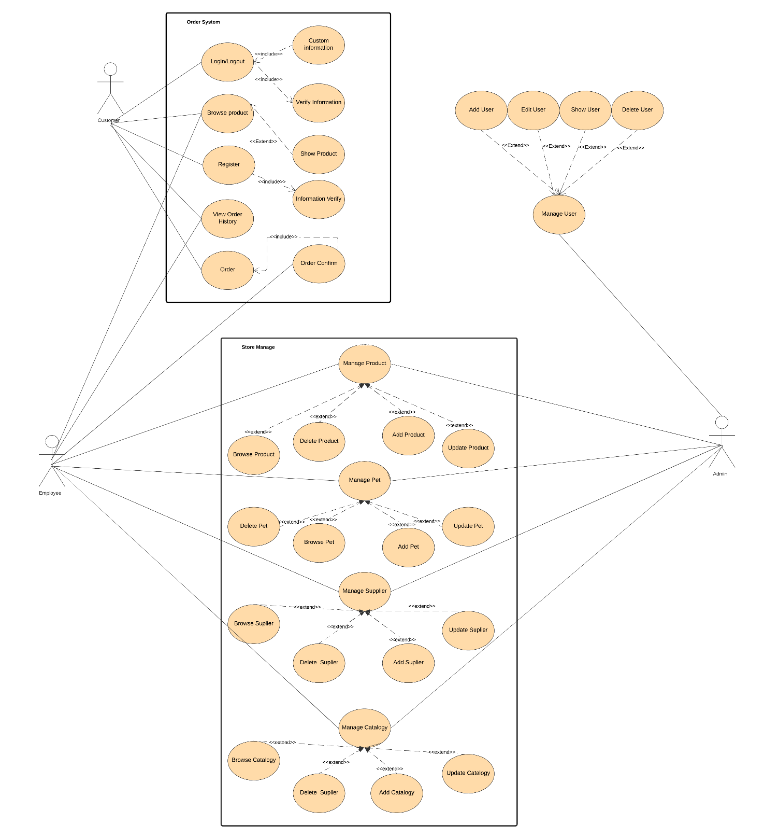

    - Sequence Diagram
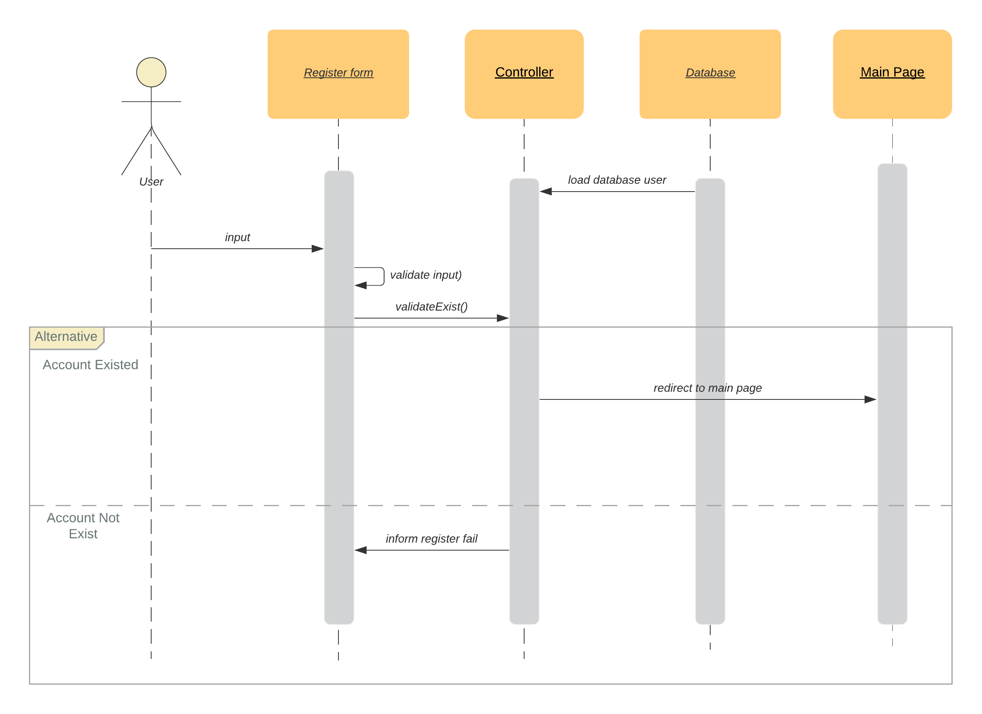
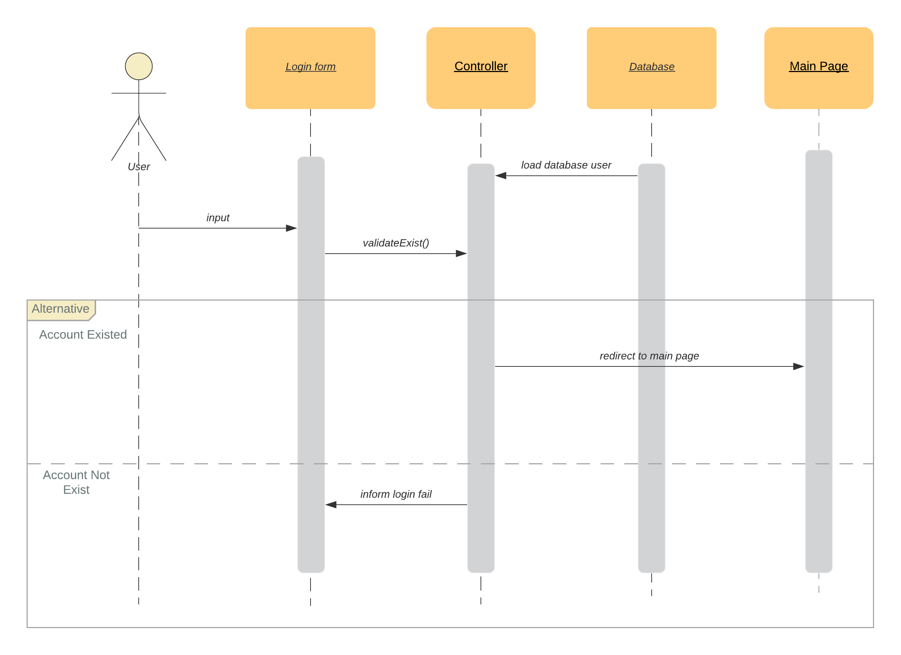
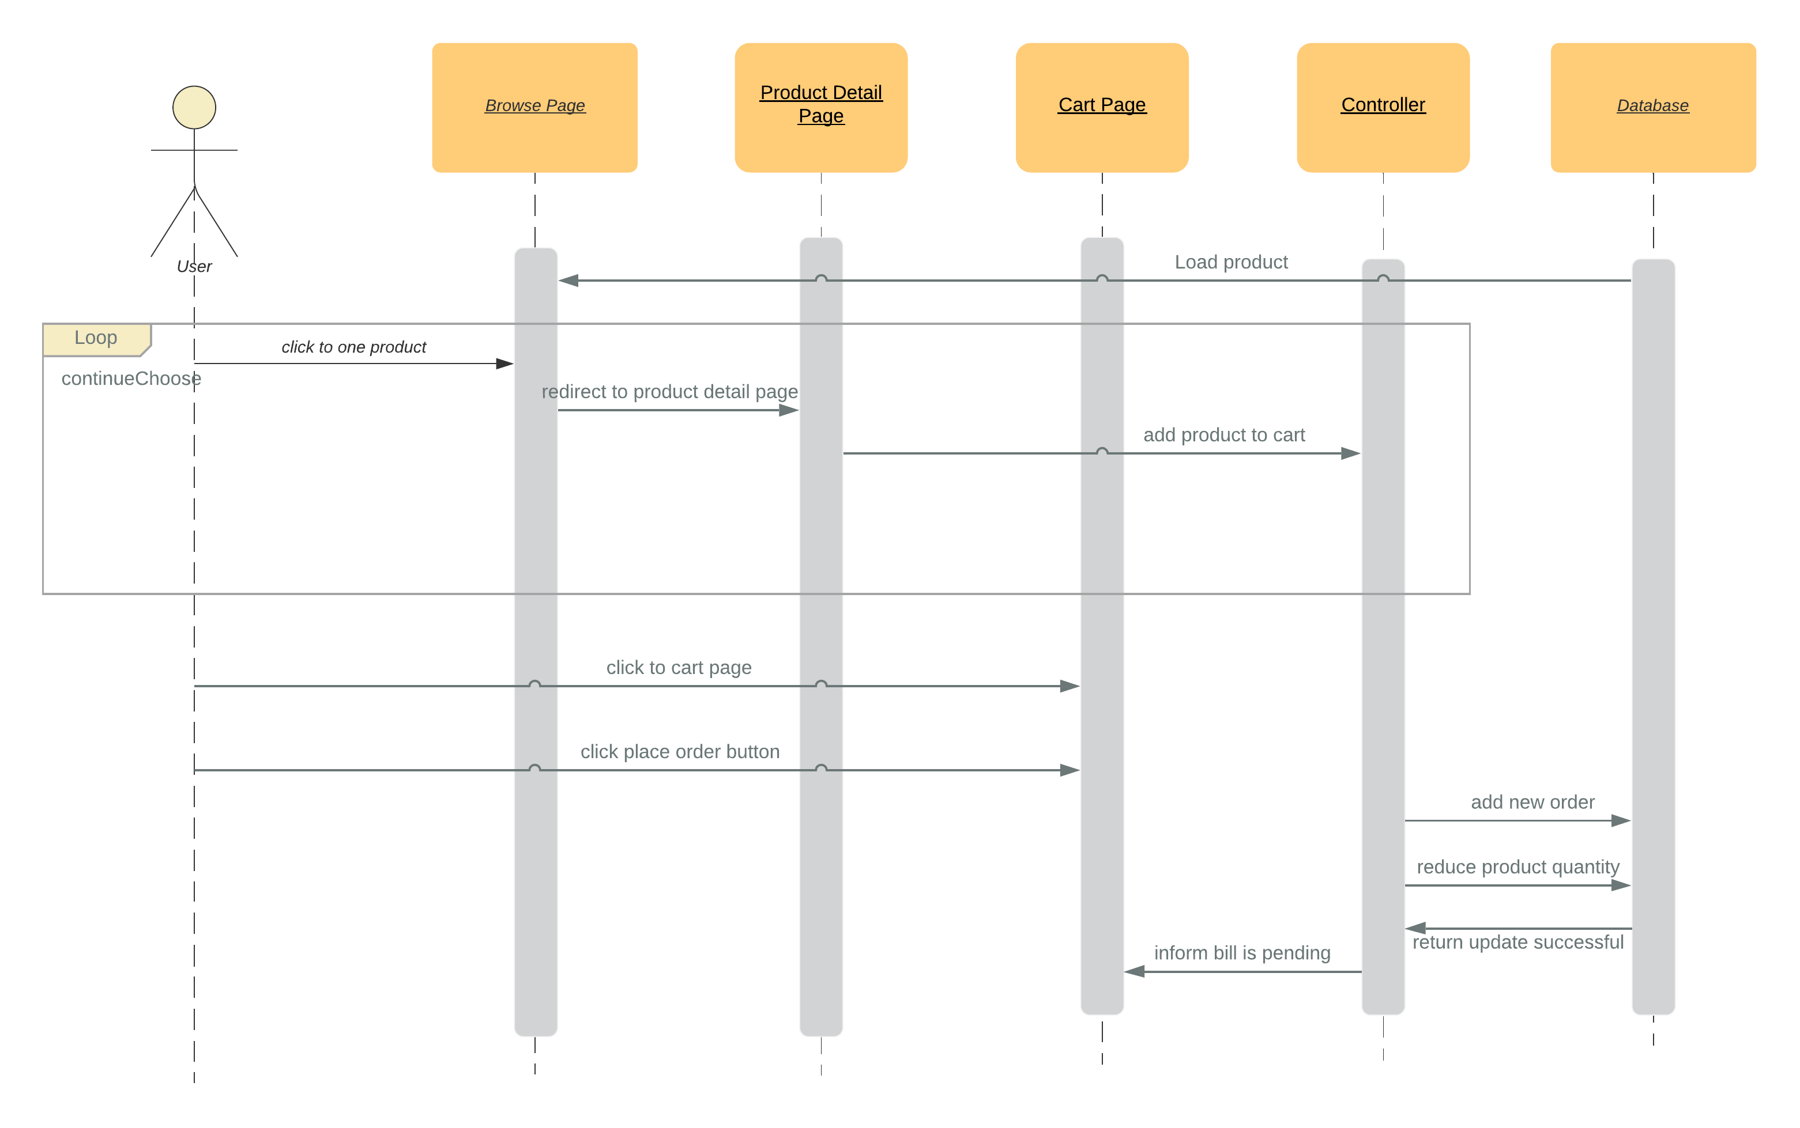
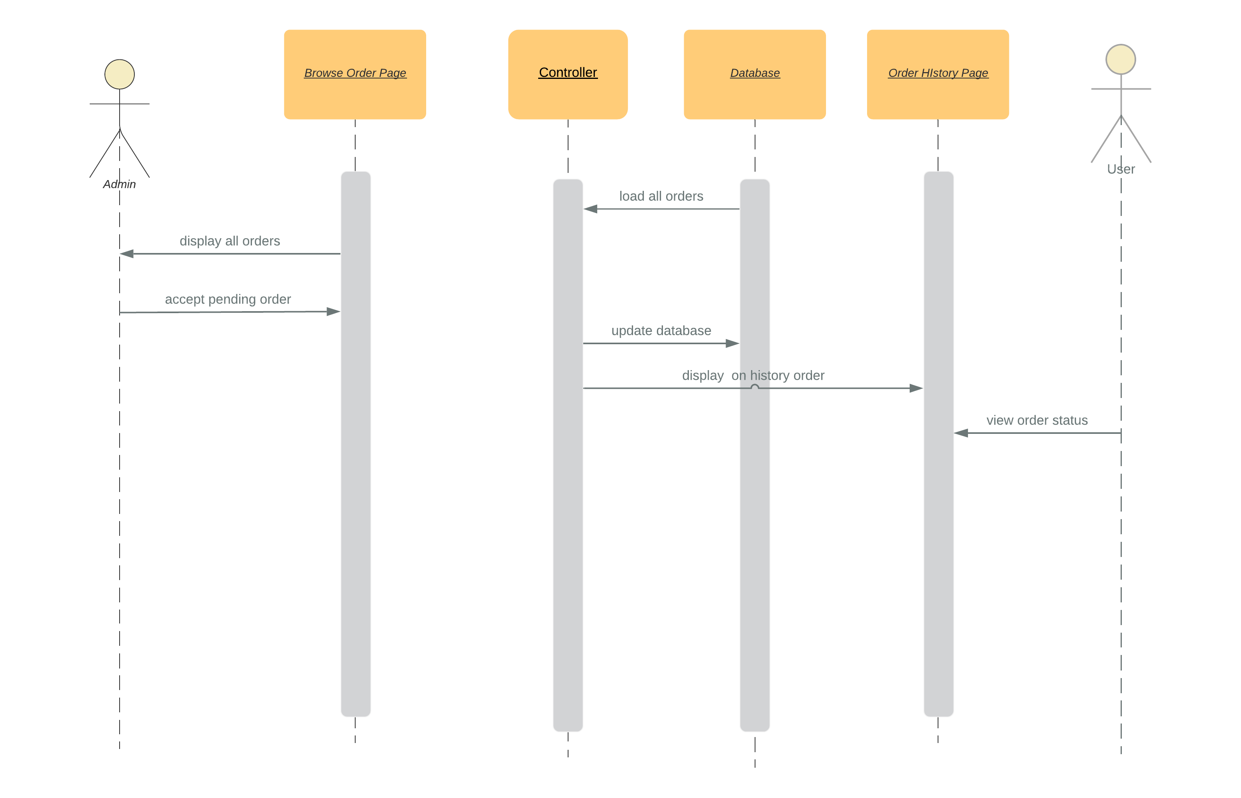
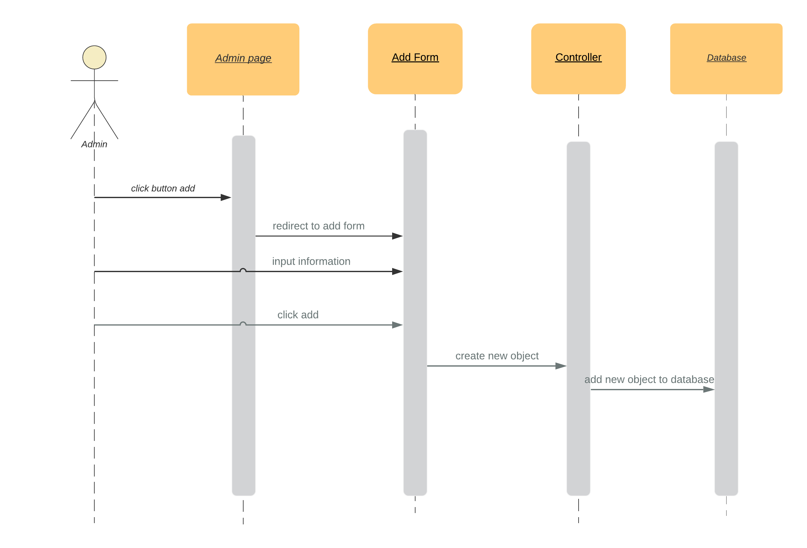
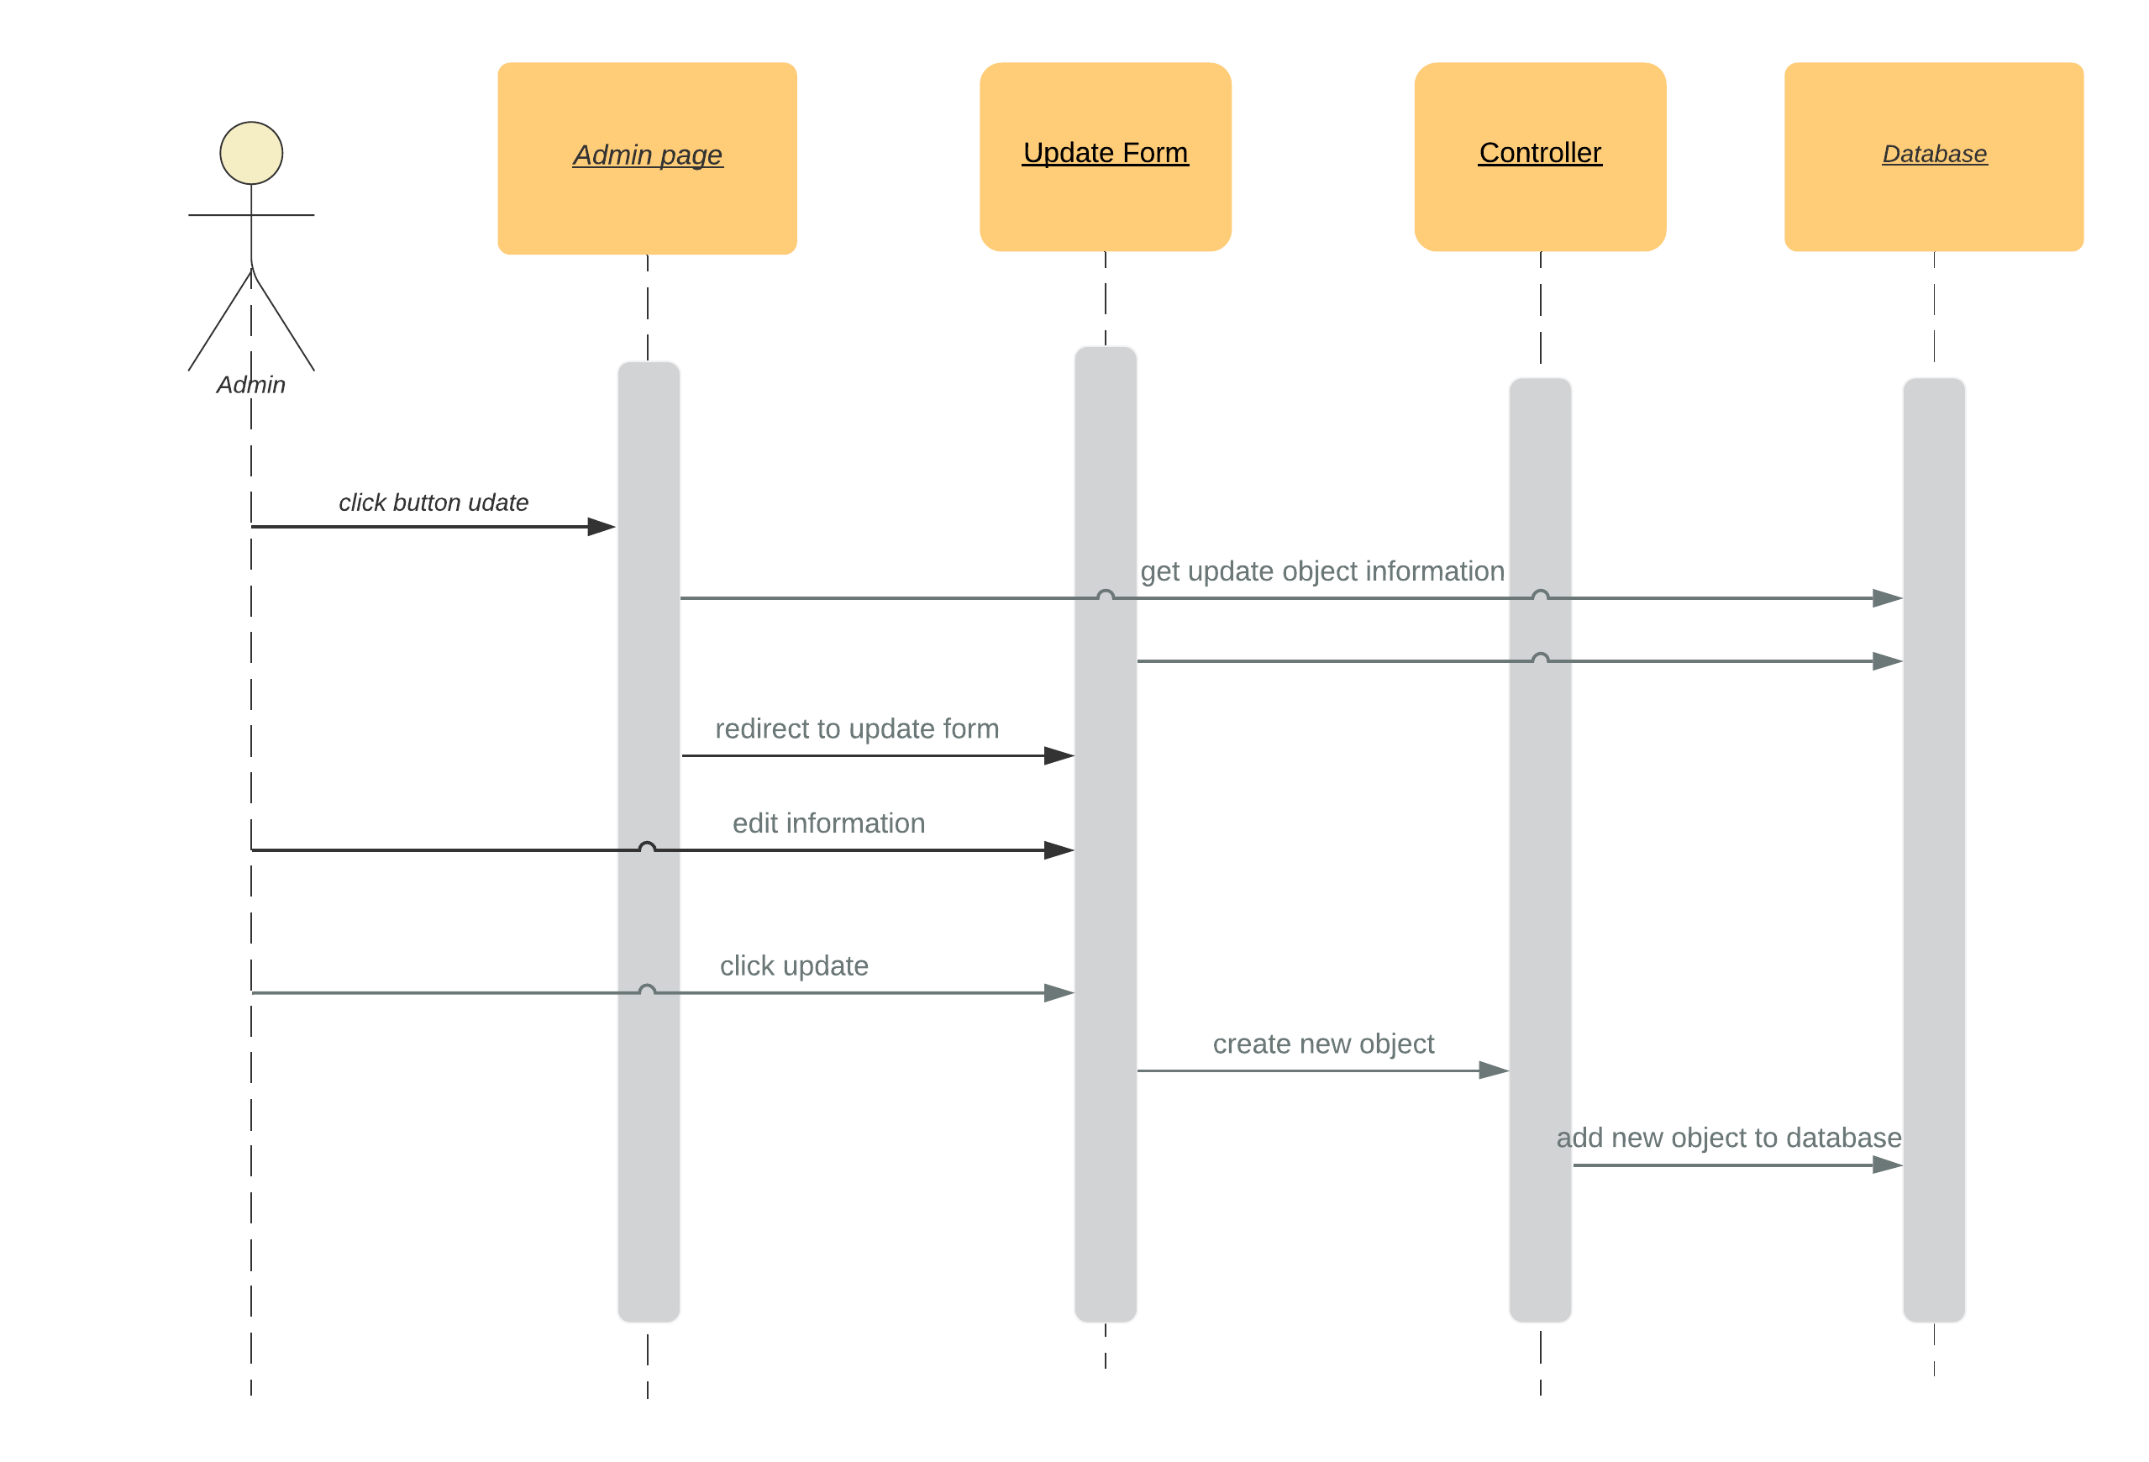
  - Database
    - Database diagram
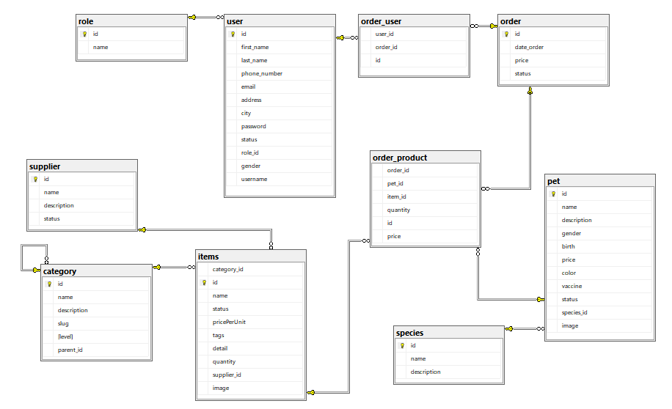
    - Data dictionary

Data Element | Description | Composition or Data Type | Length | Values
User id | Unique id that assign for single user | Integer
User name | User contact name | String | 255
User address | Address used for shipping | String | 255
User password | Password for user’s account | String | 10
User email | User contact email | String | 255
User phone | User contact phone | Integer | 12
Product id | Unique id that assign for single product | Integer
Product name | Name of product | String | 255
Product status | Status of product is available or not | Boolean
Product tag | Tag of product for searching. | String
Catalog id | Unique of catalog | Integer
Catalog name | Name of catalog | String
Catalog description | Detail descript for a catalog | String
Species id | Unique id of single species | Integer
Species name | Name of single species | String
Species description | Detail descript for single species | String
Pet id | Unique id for single pet | Integer
Pet birthday | Pet’s birthday | Date dd/mm/yyyy
Pet species id | Id for pet to find pet species | Integer
Pet image | Image for single pet
Item id | Unique id for single item | Integer
Item price per unit | Price of an item | Double
Item status | Status for item check if item is available or not. | Bool
Item detail | Description for single item | String
Item quantity | Total amount of item in inventory | integer
Item image | Image description for item | String

  - Interface

Form Name | Description | Control on the form
Admin Login | Page admin login | 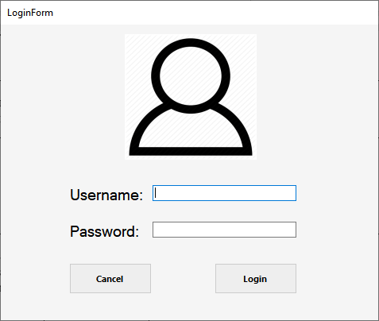

Add Category | Allow add category | 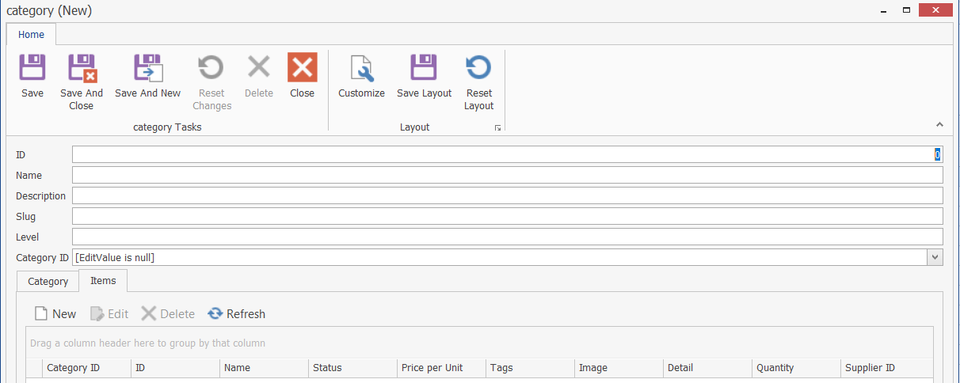
Edit Category | Allow change information category | 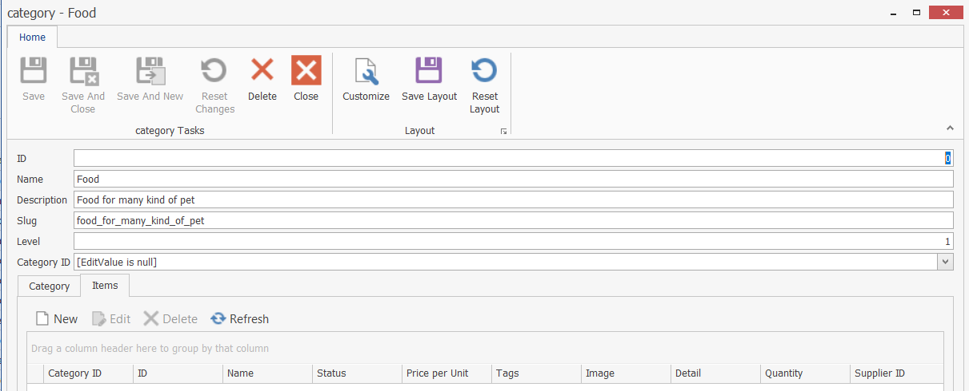
Display item | Display all item | 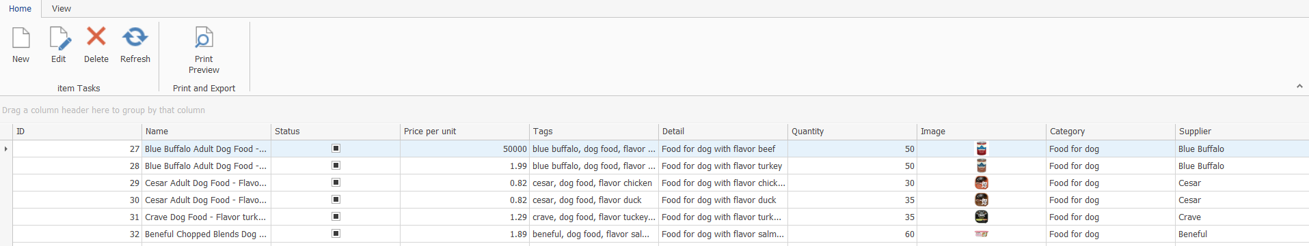

Add Item | Allow add item | 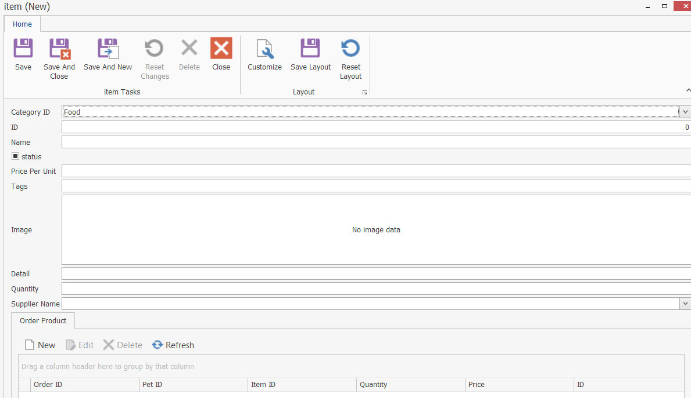
Edit item | Allow change information item | 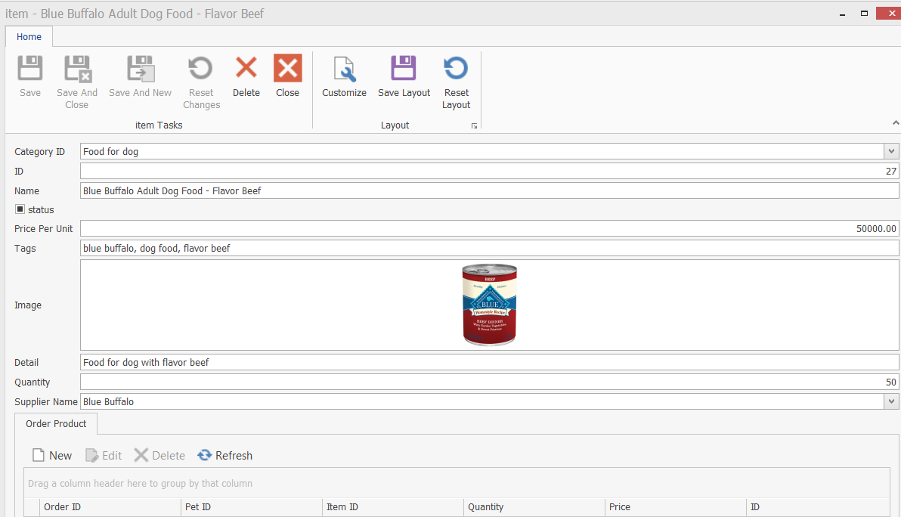

Add order | Allow add order | 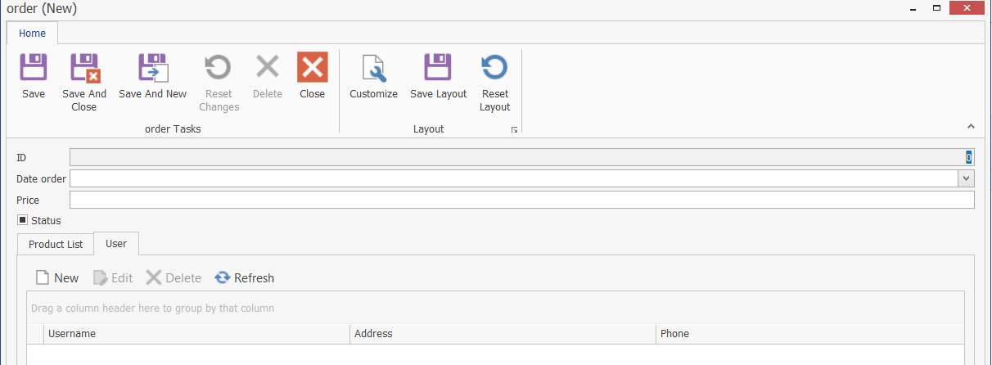
Edit order | Allow change information order | 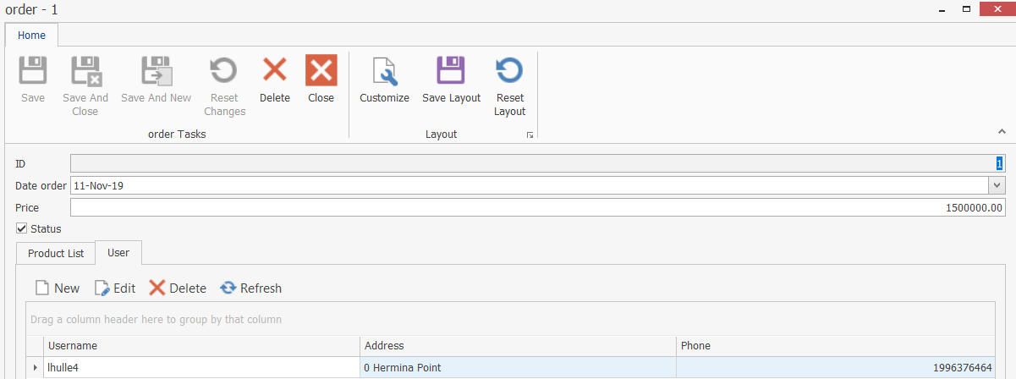
Add user | Allow add order | 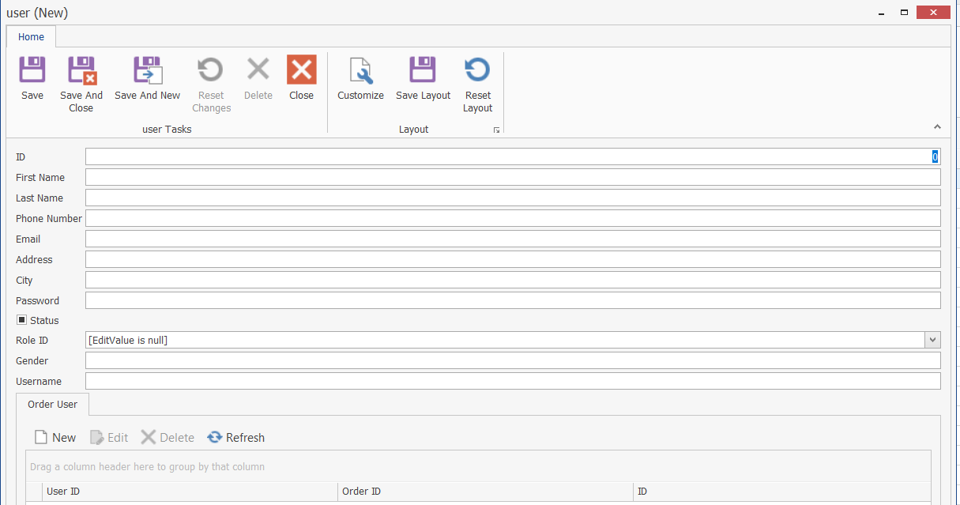
Edit user | Allow change information order | 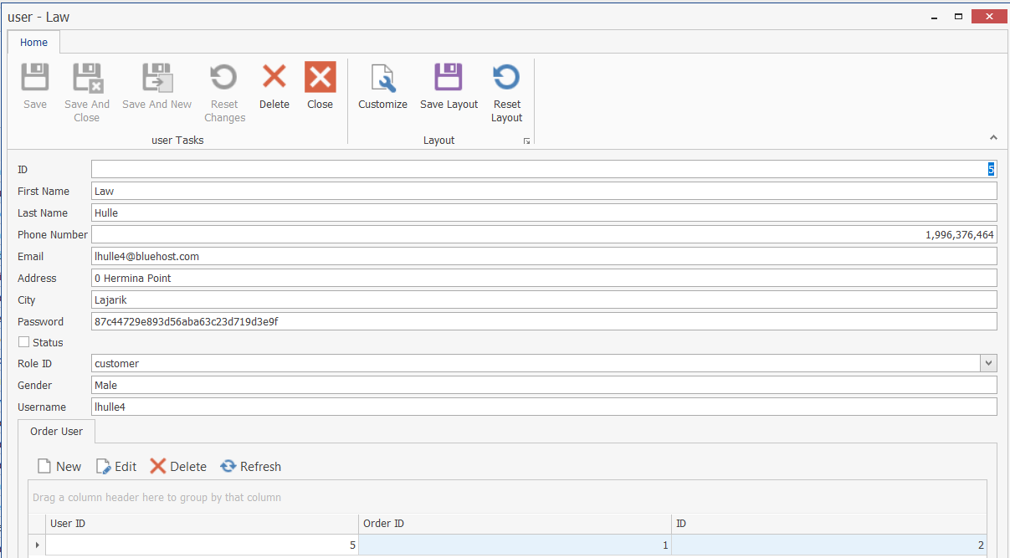
Add role | Allow add role | 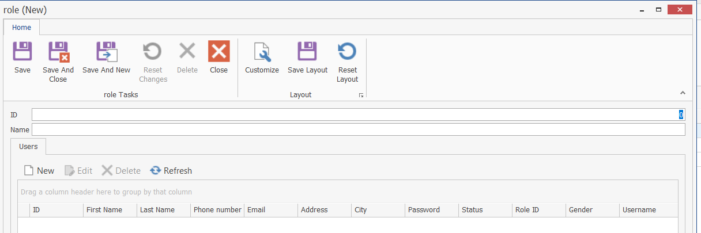
Edit role | Allow change information role | 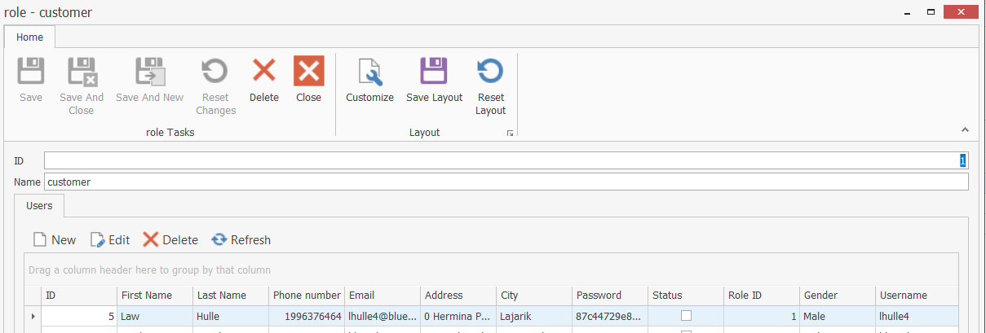
Add pet | Allow add pet | 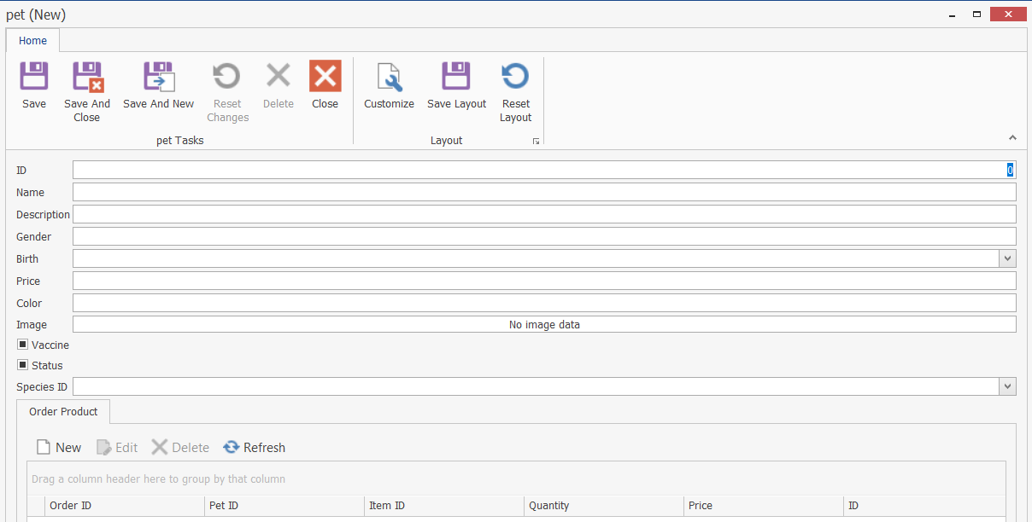
Edit pet | Allow change information pet | 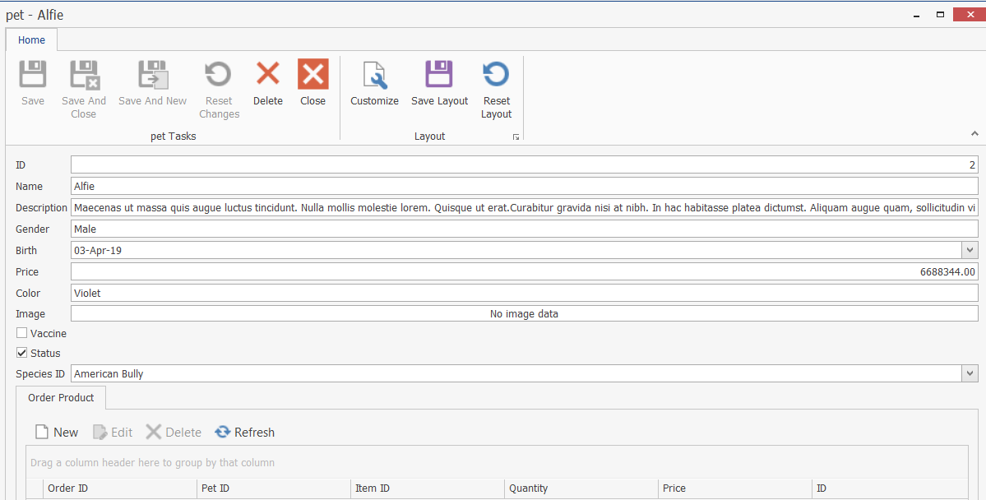
Add species | Allow add species | 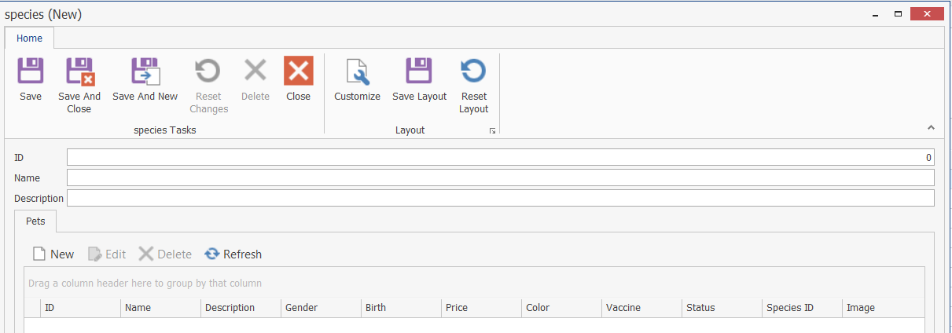
Edit species | Allow change information species | 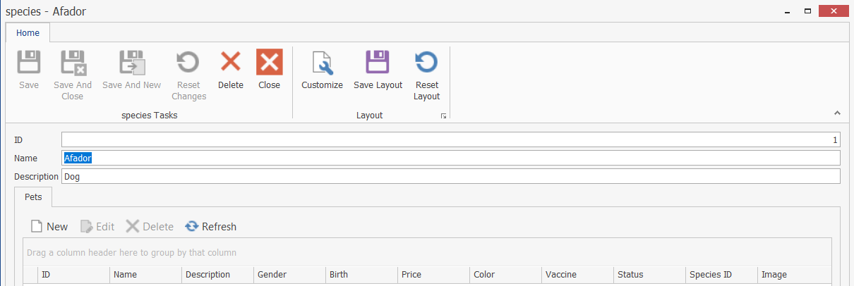
Add supplier | Allow add supplier | 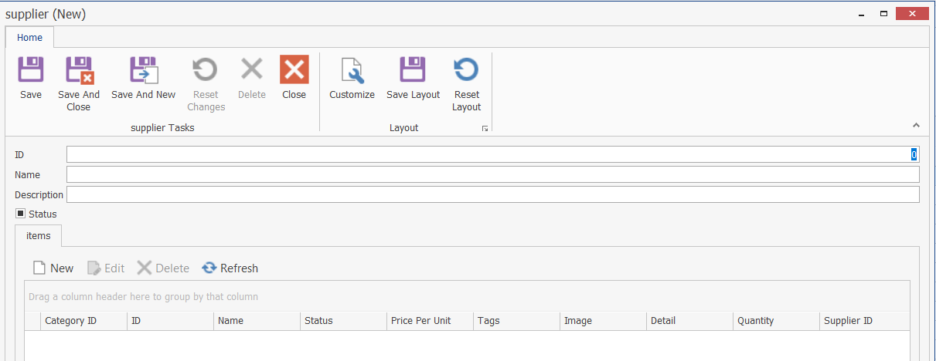
Edit supplier | Allow change information supplier | 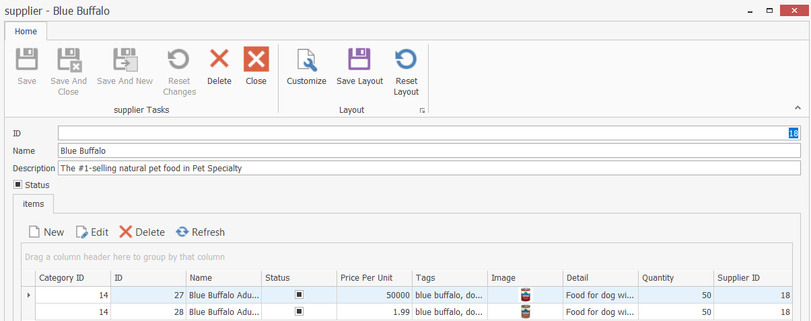

  - Execution Flow
    - Flowchart diagrams
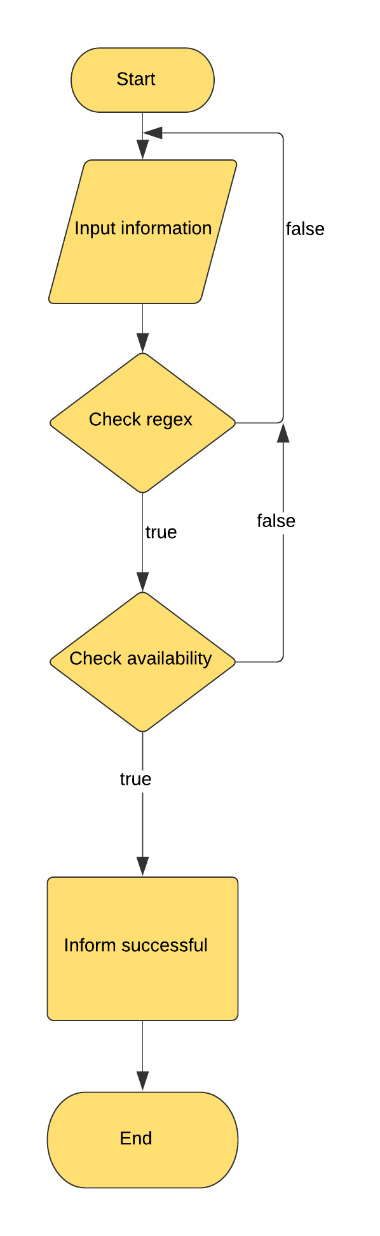
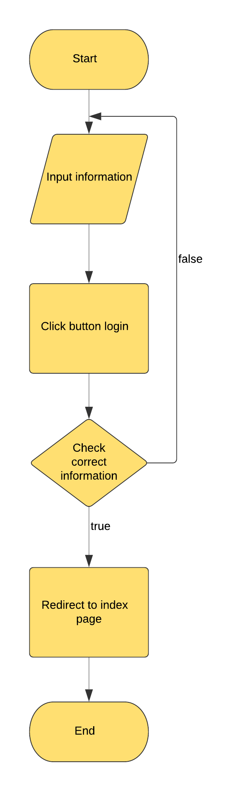
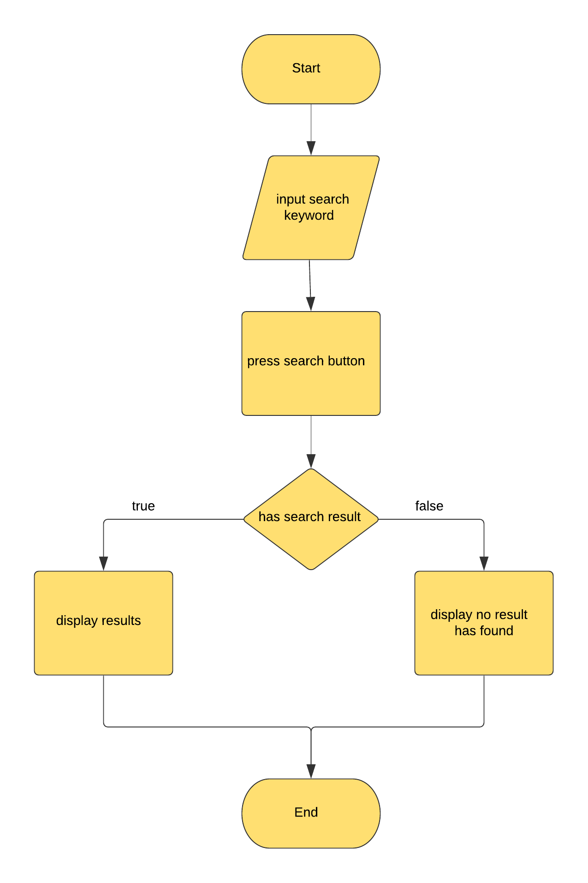
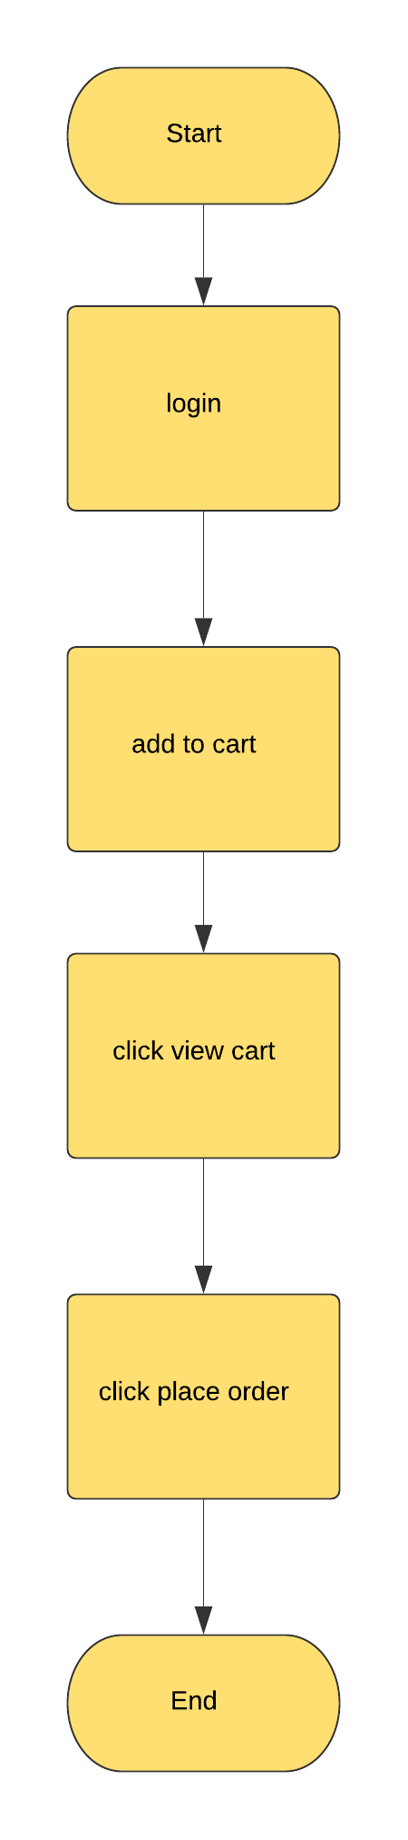
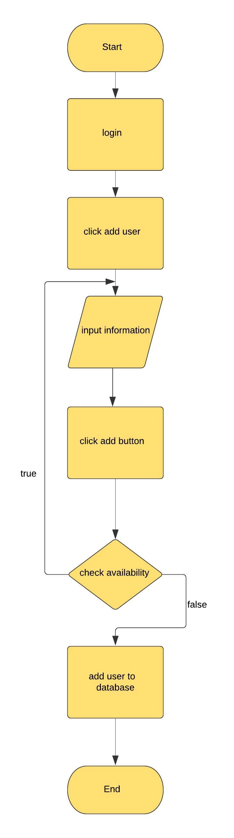
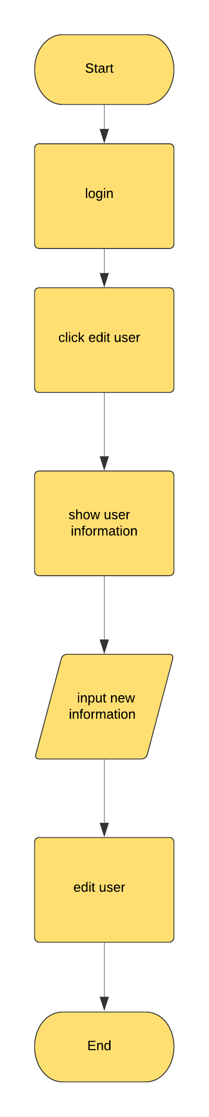
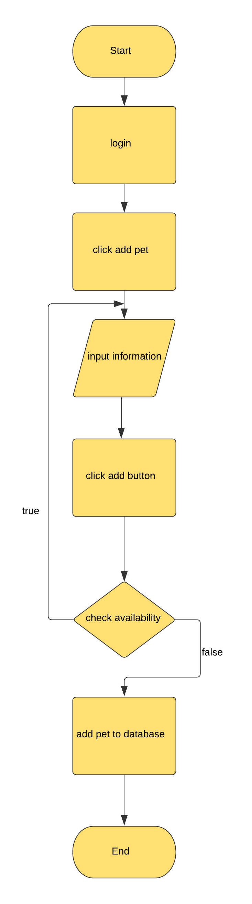
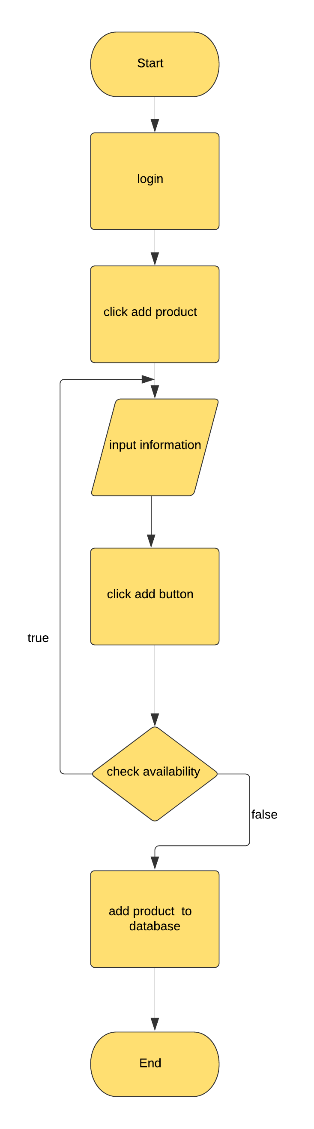
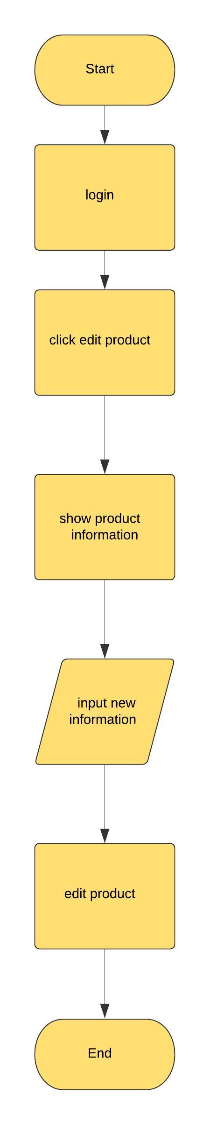
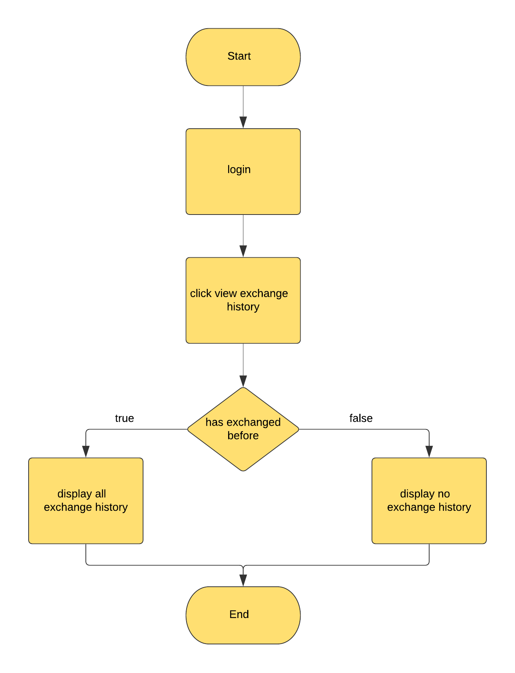

- Process design
  - Programming standards
The system shall use the current C# design.
  - Standard for code writing style
All HTML code shall conform to the HTML 5.0 standard
  - Standard for declaring variables
All variable must be declared before using it.
Variable name is short and meaning full.
Variable name with first character is A to Z, “$” and “_”.
Variable name is not contain space.
Not same with php and JavaScript keywords.
  - Standards for function declarations
Begin with “function” with keyword.
Open and close for every function.
Function name can’t same keywords.
  - Other standards

- Task Sheet

Project  Ref.No: | Project title | Activity plan  prepare by: |  | Date preparation  of activity plan:
Task sub  Division | Description | Planned  Start Date | Actual  Date | Actual Days | Team mate Names | Status
Document | Problem definition | 10/10/2019 | 11/10/2019 | 1 | Team | Complete
 | User requirement | 11/10/2019 | 11/10/2019 | 1 | Tin | Complete
 | Project Plan | 11/10/2009 | 12/10/2009 | 1 | Tin | Complete
 | Use case diagram | 15/10/2019 | 16/10/2019 | 1 | An | Complete
 | Sequence diagram | 17/10/2019 | 18/10/2019 | 1 | An | Complete
 | Database diagram | 17/10/2019 | 18/10/2019 | 1 | Anh | Complete
 | Data dictionary | 18/10/2019 | 18/10/2019 | 0 | Anh | Complete
 | Design client interface | 15/10/2019 | 15/10/2019 | 0 | Tin | Complete
 | Design admin interface | 15/10/2019 | 15/10/2019 | 0 | An | Complete
 | Flowchart diagrams | 20/10/2019 | 22/10/2019 | 2 | An | Complete
 | Coding client | 25/10/2019 | 25/10/2019 | 0 | Tin, Anh | Complete
 | Coding admin | 25/10/2019 | 25/10/2019 | 0 | An | Complete
 | Process design | 20/10/2019 | 20/10/2019 | 0 | Tin | Complete
 | Task sheet | 20/10/2019 | 20/10/2019 | 0 | Tin | Complete
 | Project review | 14/11/2019 | 14/11/2019 | 0 | Team | Complete
 | Final checklist | 15/11/2019 | 15/11/2019 | 0 | Team | Complete
 | Maintenance | 15/11/2019 | 15/11/2019 | 0 | Anh | Complete
 | Testing | 15/11/2019 | 15/11/2019 | 0 | Team | Complete

- Project Review

Date | Project plan activity/milestone | Work specification | Status the of activity | Remark | Responsibility
10/10/2019 | Analyst | Analyst system | Complete |  | All members
15/10/2019 | Design | Website | Complete |  | Tin, Anh
15/10/2019 | Design | Admin | Complete |  | An
25/10/2019 | Coding client | Programming | Complete |  | Tin, Anh
25/10/2019 | Coding admin | Programming | Complete |  | An
29/10/2019 | Coding Client | Programming | Complete |  | All members
30/10/2019 | Coding admin | Programming | Complete |  | All members
1/11/2019 | Coding | Programming | Complete |  | All members
5/11/2019 | Coding | Programming | Complete |  | All members
10/11/2019 | Coding | Programming | Complete |  | All members
14/11/2019 | Coding | Programming | Complete |  | All members

- Final Checklist
SI.No. | Functionality tested | Suggestion/Remark
1. | Have all the web pages been property linked and are they complete functional?
2. | Dose each web page meet its objective and purpose?
3. | Have all design and coding standards been followed and implemented?
4. | Is the GUI design consistent all over?
5. | Does the website’s functionality resolve the client problem and satisfy his needs complete?
6. | Have the hardware and software been correctly chosen?
7. | Additional feature and utilities that give value addition to the entire project.

- Maintenance
  - Installation Manual

1. Setup DevExpress Component 2019

- After downloaded DevExpress 2019, extract file and we will have this:
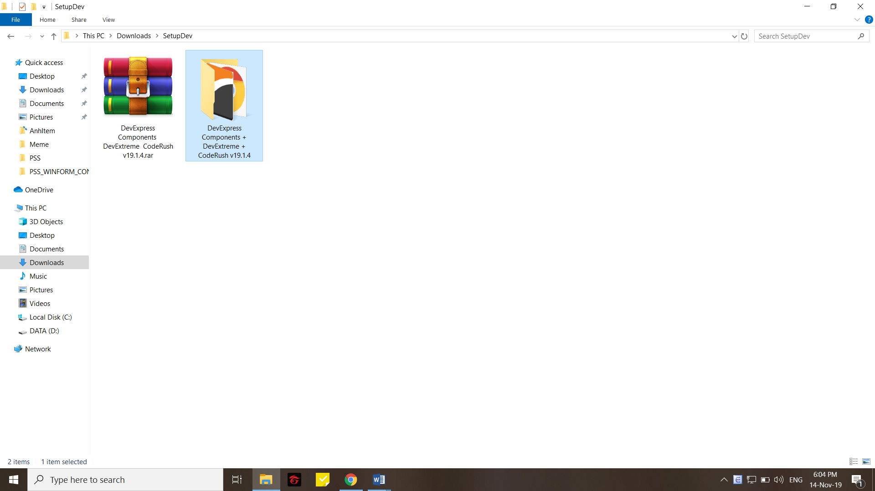

- Open file DevExpress Component we will have this:
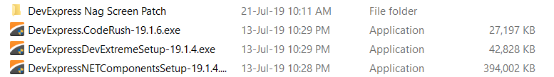

- Run file DevExpress.CodeRush-19.1.6.exe and then:
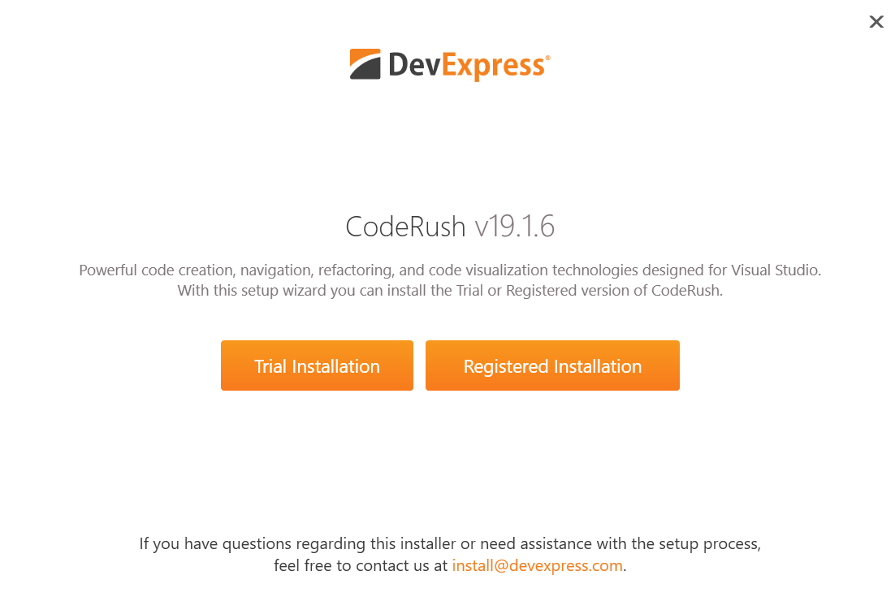

- Click Trial Installation and this window will show:
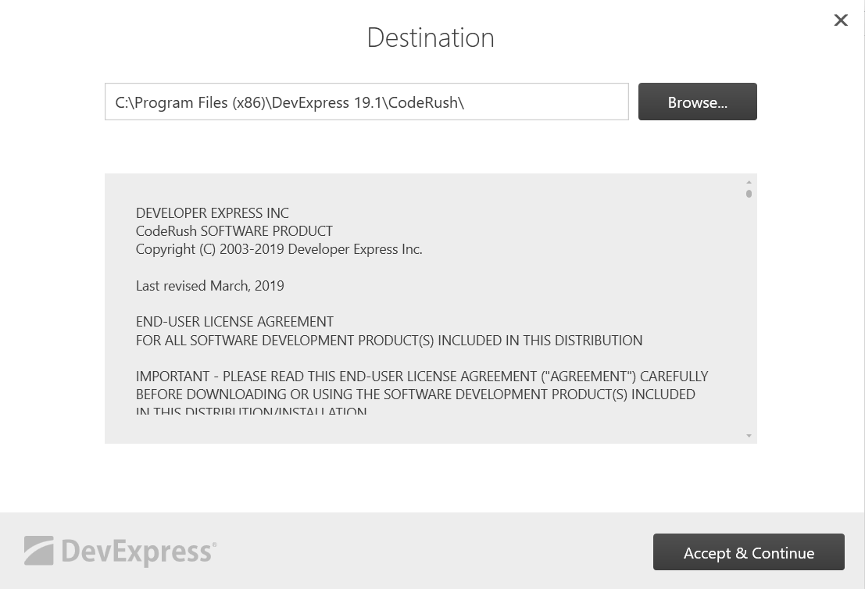

- Browse path which you want to locate this install and click Accept & Continue. This window will show. Choose “Yes” or “No” will be okay but recommend “No”. After that, click Install.
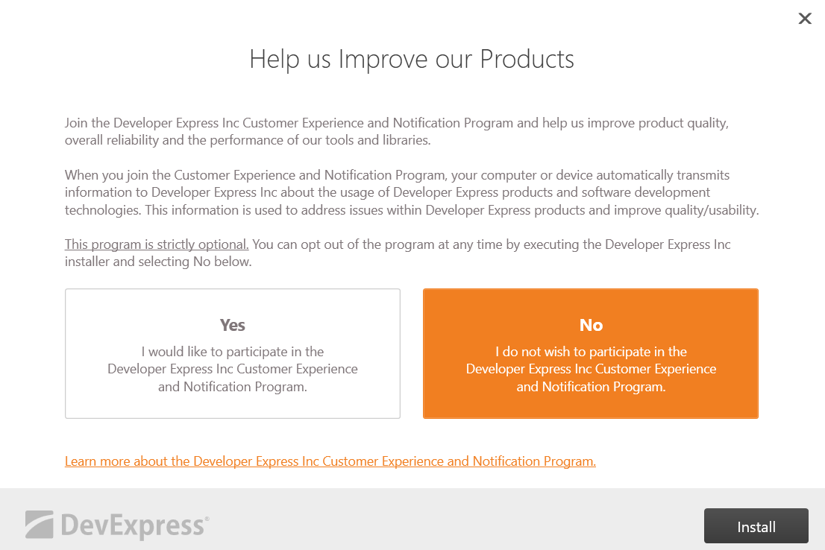

- Waiting for setup
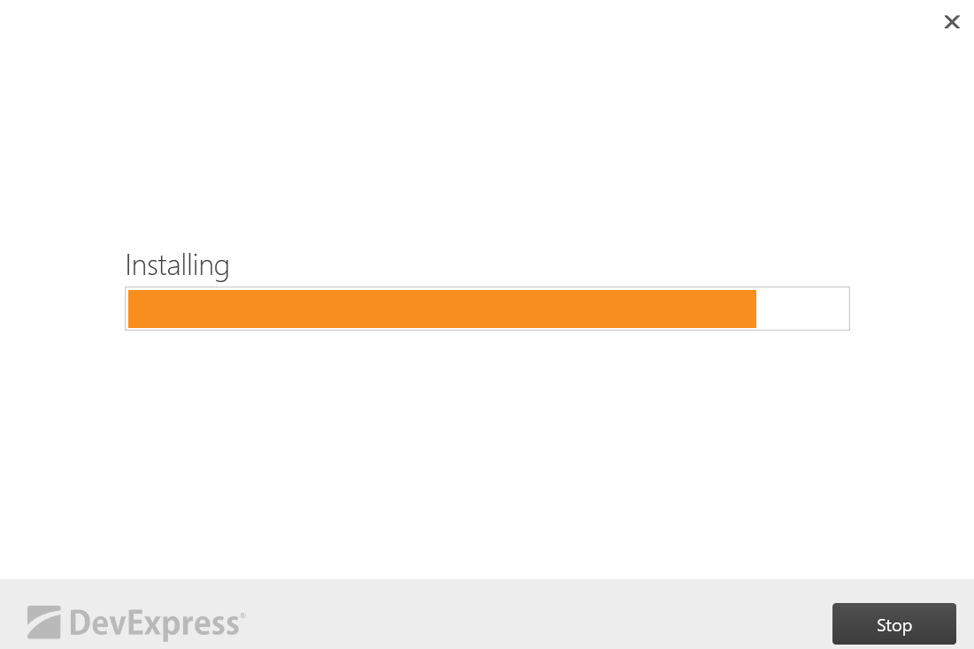
- Click Finish and you have been installed DevExpress.CodeRush-19.1.6.exe
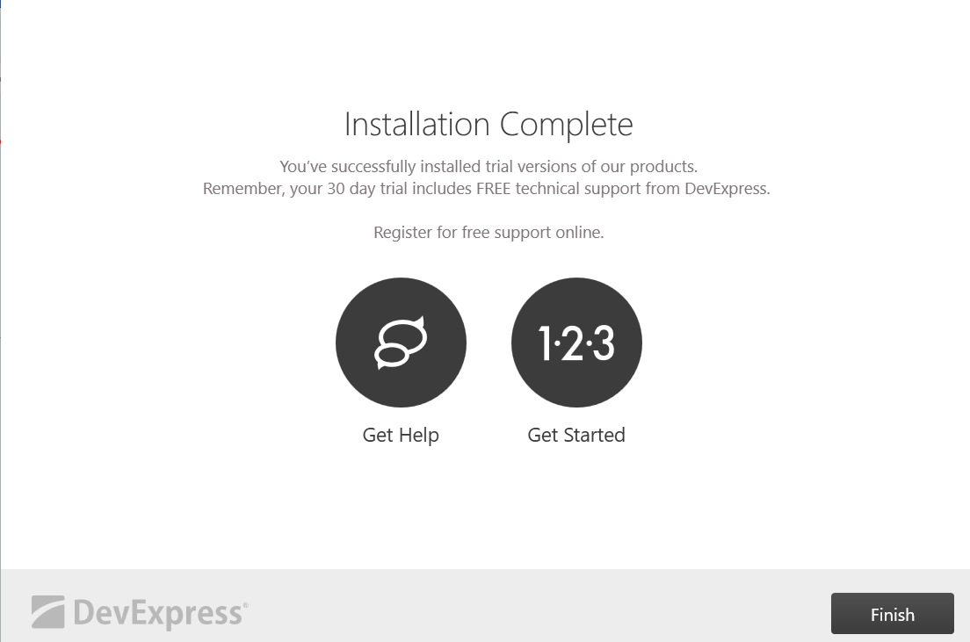

- Next, install DevExpressDevExtremeSetup-19.1.4.exe. Run file and click Trial Installation.
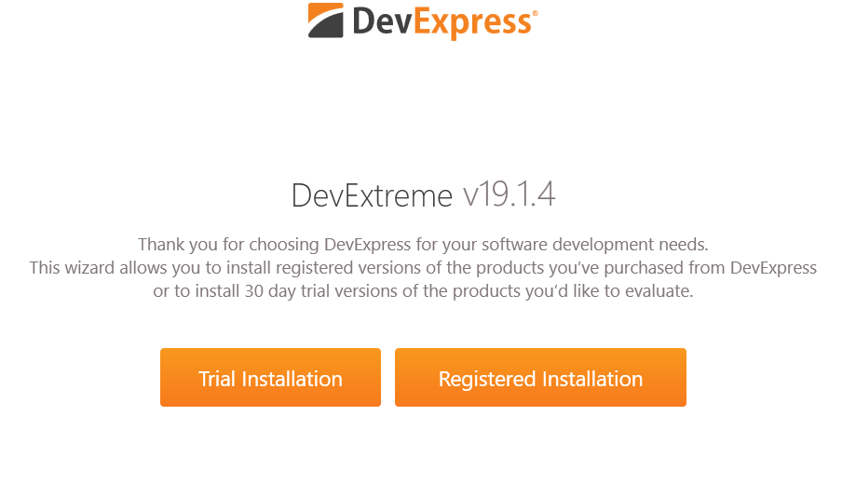

- Then, tick all option and click Next:
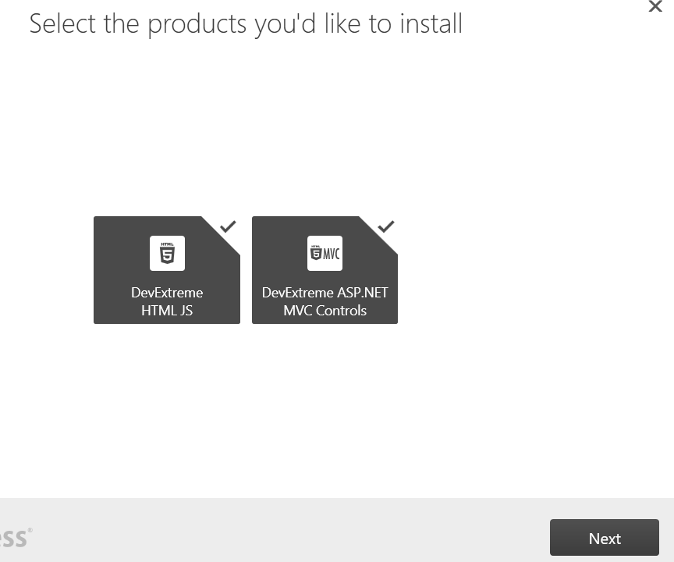

- Choose destination for this installation and click Accept& Continue:
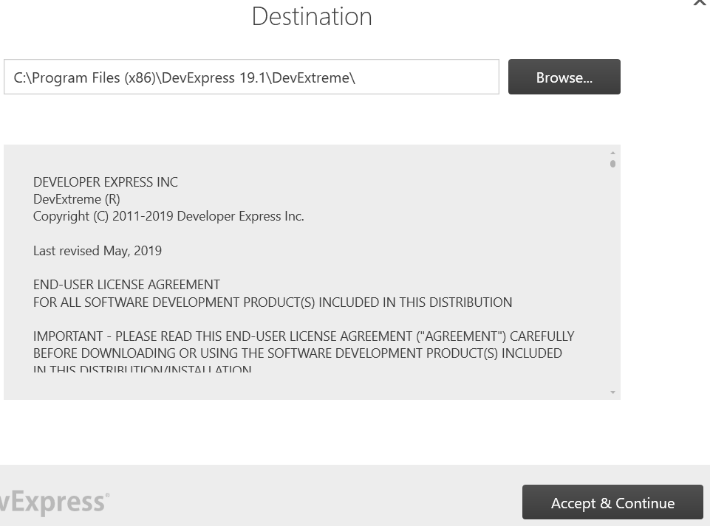

- Continue choose “No” and click Install:

- Waiting for installation
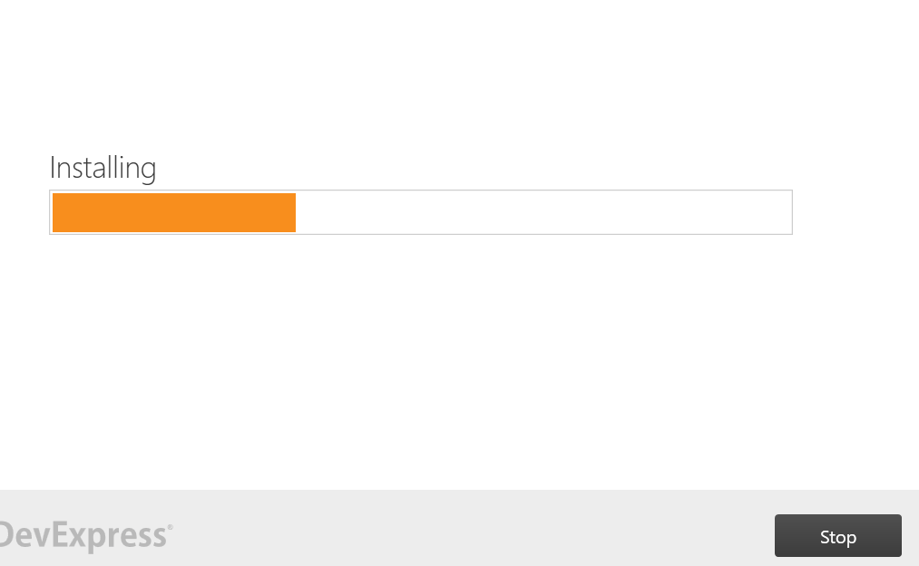

- Click Finish and you have been installed DevExpressDevExtremeSetup-19.1.4.exe
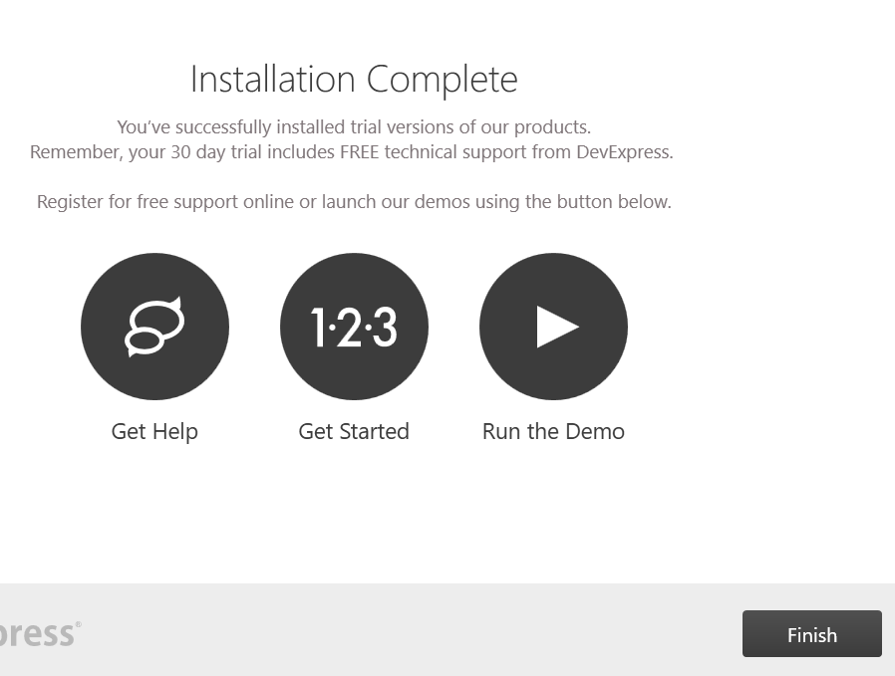

  - Maintenance
No document maintenance

