- getSession : http://localhost:8080/111/session
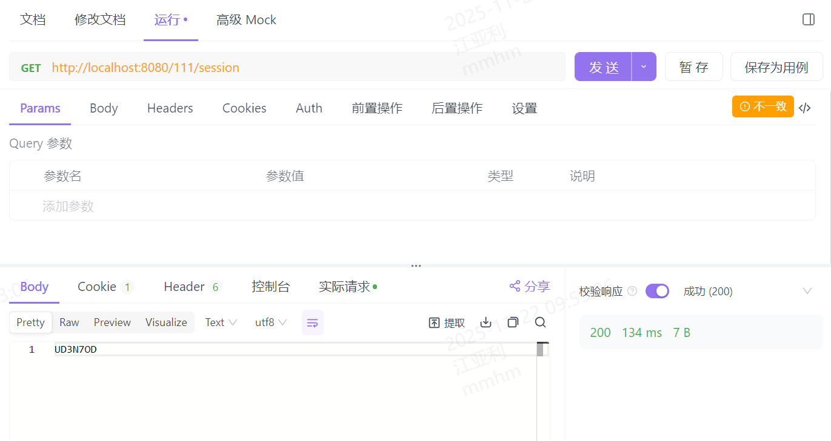
- addStake: http://localhost:8080/777/stake?sessionKey=UD3N7OD
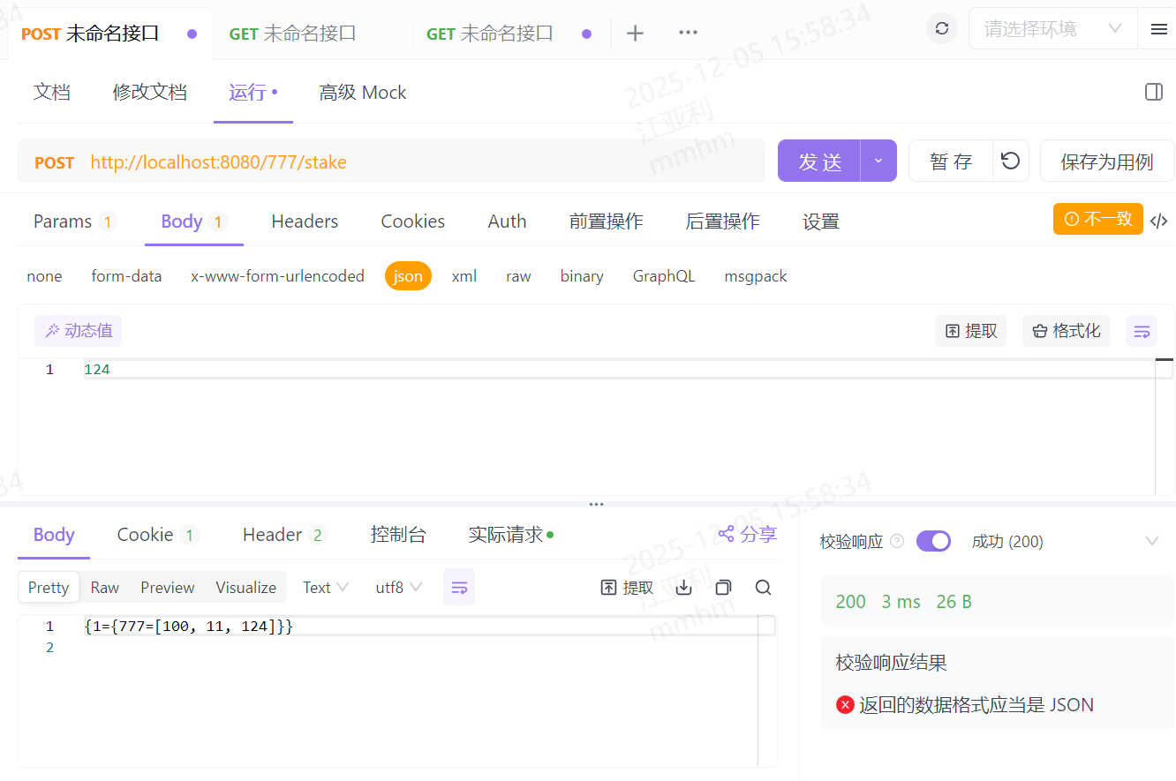
- getHighstakes: http://localhost:8080/777/highstakes
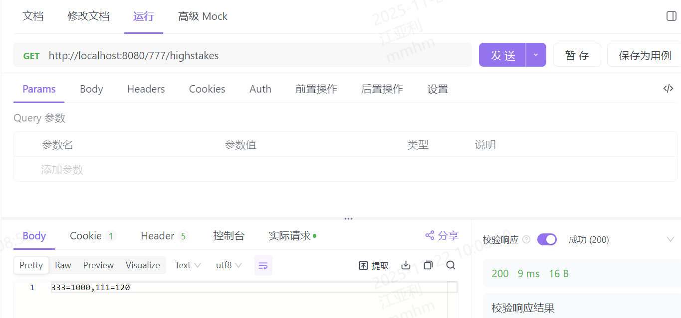

Code Implementation Description:
- Session retrieval logic: Query the session by customer ID to check if the corresponding key exists. If present, return it directly; otherwise, generate a random 7-character alphanumeric code, store it in the session with a 10-minute expiration time, and return the code;
- Bet amount generation logic:
a. Retrieve the value corresponding to the sessionKey from the session. If it does not exist, directly return "session timeout or does not exist"; otherwise, obtain the customerId.
b.Query the global Map<String, Map<String, List<BigDecimal>>> using customerId + betOfferId to check if a corresponding bet amount exists.
c. If it exists, directly add it to the existing List; otherwise, create a new List and return a success message
- Retrieve Bet Amount List:
a.Iterate through Map<String, Map<String, List<BigDecimal>>>, and obtain all List<BigDecimal> corresponding to customer IDs using betOfferId;
b.Sort List<BigDecimal> in descending order using Collections.sort, and find the maximum value in the current List<BigDecimal>;
c.Store the maximum value and customer ID in Map<String, BigDecimal>, and sort Map<String, BigDecimal> in descending order;
d.Traverse the top 20 elements of Map<String, BigDecimal>, concatenate them using StringBuffer, and return the result.

3.Code Structure Description:
1.com.bettingsystem.servlet：All Servlet Class Management
2.com.bettingsystem.util: Utility Class Management (Token Generation)

