Rose Lyn Pacuan BSIT-4 September 06, 2024

Prelim Seatwork #1: My Own Game and Its Assets

Instruction: Conceptualize your own game, define what will be the assets needed and create or grab over the internet sample designs for those assets. Do it in a Word Document.

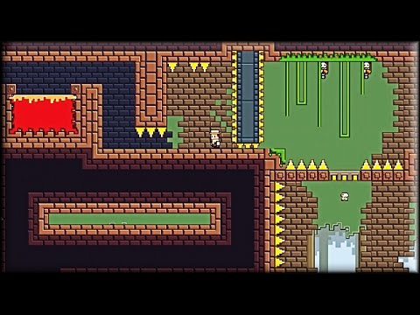**PIXEL QUEST** 2D platform where players navigate through various levels, overcome obstacles, and defeat enemies to rescue the kidnapped queen of the pixel kingdom.

**PLAYER CHARACTER**

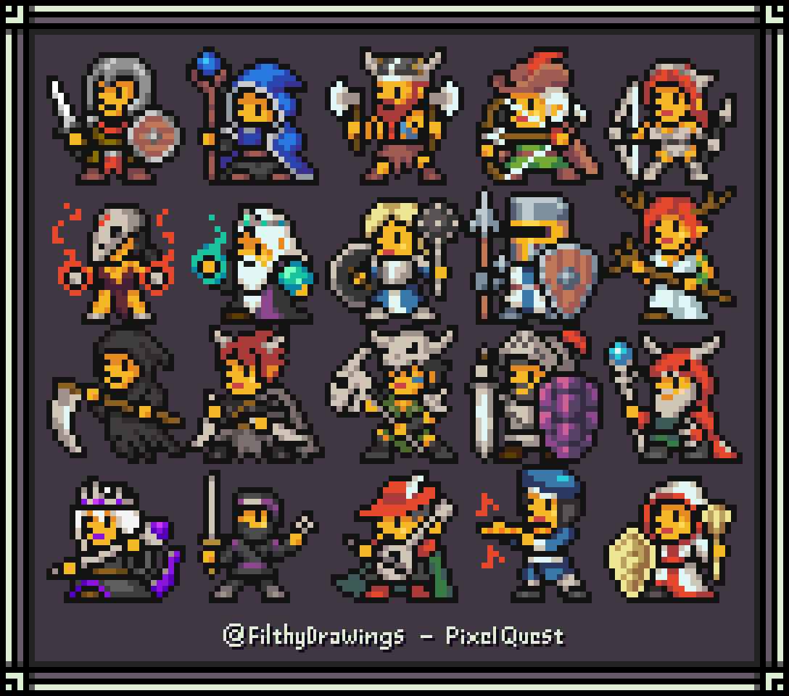

**TILES OR BACKGROUND**

Backgrounds can create a parallax effect, where foreground and background layers move at different speeds, enhancing the visual experience

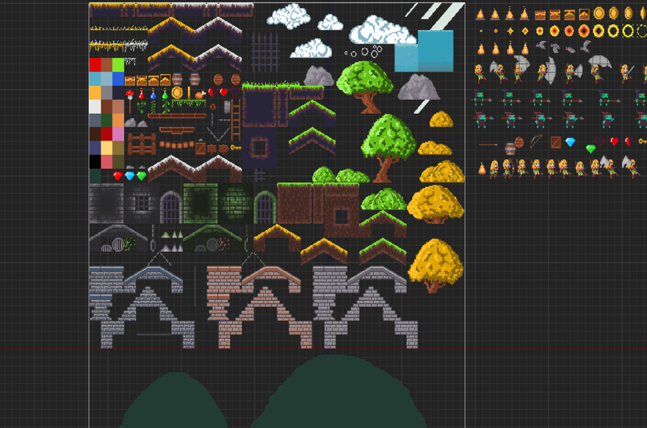

**OBJECTS**

interact with the player character to trigger events or changes in the game environment.

