Assignment 1
Regression Models
Rose Marie Tazbaz
Student ID: 25742507
2026 Autumn

36106 - Machine Learning Algorithms and Applications
Master of Data Science and Innovation
University of Technology of Sydney

Table of Contents

1. Business Understanding 2
a. Business Use Cases 2
2. Data Understanding 4
3. Data Preparation 5
4. Modeling 6
5. Evaluation 7
a. Results and Analysis 7
b. Business Impact and Benefits 7
c. Data Privacy and Ethical Concerns 7
6. Conclusion 9
7. References 10

Business Understanding

Business Use Cases
The main business use case of this project was to support a car resale business in Australia, that wants to provide customers with an estimated resale price for their vehicles, when they bring them to the dealership/shop or submit their vehicle details online (form). The goal is to help both customers and the reseller understand approximately how much the vehicle could sell for in the current market.
Currently, when customers want to sell their cars through a reseller, they usually don’t have a clear idea of the vehicle’s market value, as there are a lot of things to consider. This can create uncertainty and may reduce trust in the reseller’s pricing process. Customers may hesitate to list their vehicles if they feel that the estimated price is unfair or unrealistic. At the same time, the reseller may also have some issues determining an appropriate listing price quickly, which can slow down the process of selling vehicles.
This creates an opportunity for me, as a business consultant, to use machine learning to support the business owner’s decision. By analyzing historical vehicle listings and characteristics such as brand, model, kilometers driven, engine specifications, etc, a machine learning model could help identifying patterns that influence resale prices. The model can generate a data-driven price estimate for a vehicle with similar characteristics.
In practice, this system could be used when a customer submits information about the car they want to sell, either in person or through an online platform. The model would process the vehicle’s attributes/features and provide an estimated resale price based on similar vehicles in the dataset. This estimate can help the reseller quickly suggest a price range to the customer and start the selling process fast.
The main challenge motivating this project is that vehicle pricing is influenced by many different factors, and these relationships are not always easy to understand or to spot. Variables as vehicle age, brand reputation or fuel efficiency can all affect the final price. Manually analyzing these variables for every vehicle is time-consuming and inconsistent. That’s why machine learning algorithms are relevant in this context, because they can analyze large datasets and automatically identify patterns that influence vehicle prices, making the pricing process faster and consistent.

- Key Objectives
The main objective of this project is to develop a machine learning model capable of predicting the resale price of used vehicles based on their characteristics. The goal is to provide a price estimate that is close enough to the actual market value of the vehicle. In this project, prediction performance is primarily evaluated using RMSE (Root Mean Squared Error), since this metric represents the typical prediction error in monetary terms (AUD).
From a business perspective, the desired outcome is to provide useful price estimates that help customers understand the potential value of their vehicle and support the reseller in making faster pricing decisions. If the predicted prices are reasonably accurate, the system can increase customer confidence in the pricing process and potentially encourage more customers to list their vehicles through the reseller.
Several stakeholders are involved in this project. The primary stakeholder is the car reseller business owner, who wants a reliable system that can help estimate vehicle prices quickly and consistently. This system should support decision-making when setting listing prices and help reduce the time required to evaluate each vehicle.
Another important stakeholder group is the customers who want to sell their vehicles. These customers expect a transparent and realistic estimate of their vehicle’s resale value. Providing an approximate price estimate can help them decide whether to proceed with listing their vehicle.
To address these requirements, the project applies several machine learning approaches to identify which model performs best for this pricing problem. The workflow includes data exploration, feature selection, data cleaning, features engineering and model experimentation using algorithms such as linear regression, elastic net and K-Nearest neighbors. By comparing these models using performance metrics as RMSE, the project aims to identify the approach that produced the most reliable price estimates for the business scenario.
Overall, the project wants to demonstrate how machine learning can support data-driven pricing decisions in the vehicle resale market, improving the relationship between the car owner trying to sell their vehicle and the reseller.
answer very generic and naive so the answers can be applied to any proje

Data Understanding
The dataset used in this project contains information about used vehicles listed for resale in Australia. The purpose of the dataset is to analyze the relationship between vehicle features and their resale price in the market. Each row in the dataset represents a listing, and the columns contain different attributes describing the vehicle.
The data appears to come from vehicle listing records, which include information about the car itself as well as some additional information related to the seller or the listing. For example, the dataset includes technical vehicle features, like engine capacity, fuel type and kilometres driven, which are relevant for estimating the vehicle value. It also contains some personal or contact information related to the seller. These personal variables were removed during the data preparation stage because they are not relevant for predicting vehicle prices and could raise privacy concerns.
One limitation of the dataset is that some variables container missing values or inconsistent formats, for example, some numeric information was stores as text (doors was stored as “4 doors” instead of just 4), which required cleaning before the data could be used for modelling. Also, some vehicles had price values as “POA” which means Price on Application instead of a numeric value. Since this value doesn’t provide any information about the actual selling price, these rows were removed when preparing the dataset for the models. Another limitation is that the dataset contained large variability in vehicle prices, even for vehicles with similar features, which made price prediction more challenging. Finally, some variable contained overlapped information, like vehicle_description which grouped vehicle_brand, vehicle_model and manufacturing_year.
The dataset includes several features that are relevant for predicting the resale price of a vehicle. Some of the most important variables were:
- vehicle_brand: the manufacturer of the vehicle. Brand reputation often affects resale value.
- model_name: the specific vehicle model. Different models from the same brand can have very different market prices.
- manufacturing_year: indicates the age of the vehicle, which strongly influences resale price.
- vehicle_type: the type of car (SUV, sedan, hatchback, etc). Different types of vehicles tend to have different price ranges.
- kilometres_driven: shows how much the vehicle has been used. vehicles with higher mileage typically have lower resale value.
- engine_capacity: indicates engine size, which can affect performance and vehicle value.
- engine_cylinders: another indicator of engine performance.
- fuel_type: the type of fuel used (petrol or diesel).
- fuel_consumption: indicates fuel efficiency, which may influence buyer preferences.
- drive_type: shows whether the vehicle is front-wheel drive, rear-wheel drive or all-wheel drive.
- transmission_type: manual or automatic transmission
- doors and seats: provide information about vehicle size and practicality
- territory: extracted from the vehicle location to represent the Australian state or territory where the vehicle is listed.

The target variable for this project is price, which represents the resale price of the vehicle.
During the exploratory data analysis stage, several features were analyzed to better understand their distribution and relationship with price. For example, kilometres_driven and manufacturing_year were analyzed because they are numeric variables directly related to vehicle usage and age. The analysis showed that vehicles with higher mileage tend to have lower prices, which is consistent with expectations in the used car market. Manufacturing year also showed a strong relationship with price, since newer vehicles then to have higher resale value.

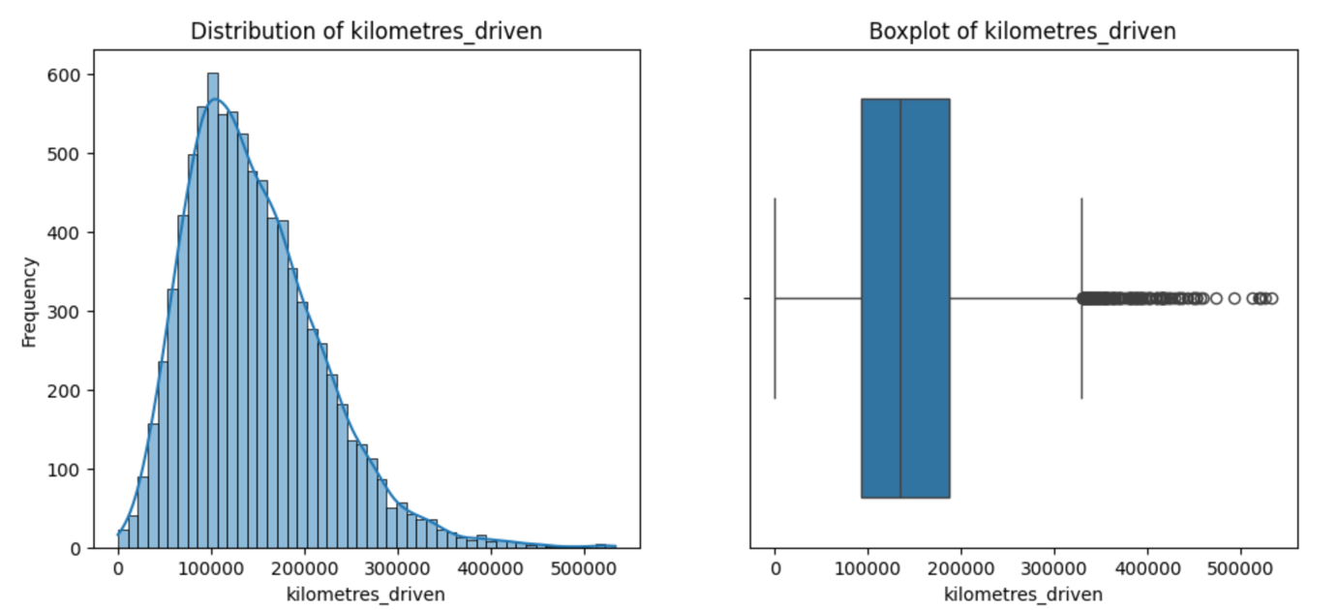

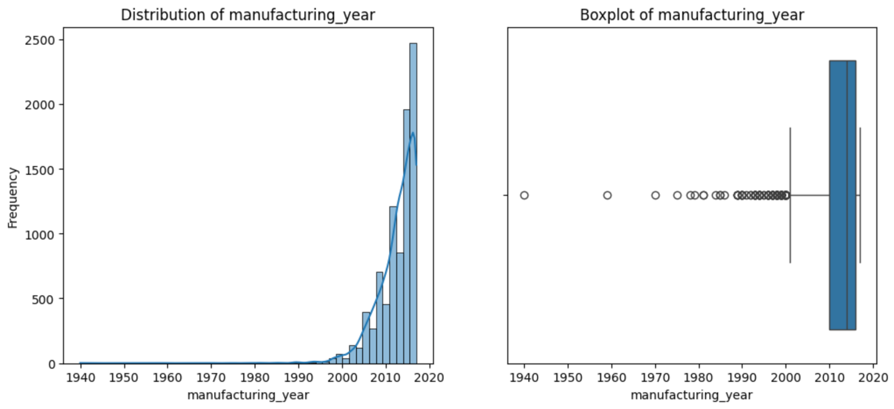

Other features such as vehicle_brand and vehicle_type were also analyzed to observe how price distributions vary between different brands and categories of vehicles. For example, some brands tend to have higher average prices due to reputation and perceived quality.
Overall, the exploratory analysis helped identify which variables are likely to be important for predicting vehicle prices. These insights guided the feature selection process and the development of machine learning models used later in the project.

Data Preparation
Before training the machine learning models, several data preparation steps were performed to ensure that the dataset could be used correctly for modeling. These steps included data cleaning, preprocessing, and feature engineering. The goal of this stage was to improve the quality of the dataset and ensure that the models receive consistent and meaningful input variables.
The first step involved data cleaning, since several variables in the dataset contained inconsistent formats or missing values. Some variables that should contain numerical information were stored as text. For example, the variables doors and seats contained values such as “4 doors” or “5 seats”. In these cases, the numerical part of the value was extracted and converted into numeric format so that it could be used by the machine learning models.
Other variables also required format adjustments. Some engine-related variables contained mixed text formats, such as engine_capacity, engine_cylinders, and fuel_consumption. The numerical values from these variables were extracted and converted into numeric format when possible so that they could be processed by the models.
The price variable, which is the target variable of the project, also required cleaning. Some rows contained the value “POA” (Price on Application) instead of a numeric value. Since this value does not represent a real price, those rows were removed from the dataset before training the models. This ensured that the models were trained only on observations with valid price values.
Missing values were also handled during this stage. For example, the variable vehicle_type had a small number of missing values. These were replaced using the most common category (mode) in the dataset. For numerical variables that contained missing values, imputation techniques such as replacing them with the median value were used during modeling. The median was chosen because it is less sensitive to extreme values.
Some variables were removed because they were not relevant for predicting vehicle price. These included personal information such as names, phone numbers, email addresses, and street details. These variables were not related to the pricing problem and were removed both to simplify the model and to protect personal information.
Feature engineering was also performed to create additional variables that could help the models identify useful patterns. One new feature created was territory, which was extracted from the location field and represents the Australian state or territory where the vehicle was listed. This feature may capture regional differences in vehicle prices.
Additional engineered features included engine_power_category, which groups vehicles based on engine capacity, high_mileage_vehicle, which indicates whether a vehicle has unusually high mileage, and efficiency, which provides a simplified measure related to fuel consumption. These features were created to help the models capture patterns that may not be immediately visible from the original variables.
Finally, the dataset was divided into training, validation, and testing datasets. The training dataset was used to train the machine learning models, the validation dataset was used during experimentation to compare model performance, and the testing dataset was reserved for final evaluation.
Overall, these preparation steps helped ensure that the dataset was clean, consistent, and suitable for training machine learning models capable of predicting vehicle resale prices.

Modeling
In this project, several machine learning algorithms were used to predict the resale price of vehicles. The goal of the modeling stage was to evaluate different approaches and determine which algorithm provides the most reliable price estimates for the business use case. Three main models were tested: Multivariate Linear Regression, Elastic Net Regression, and K-Nearest Neighbors (KNN).
The first model tested was Multivariate Linear Regression. This algorithm was selected because it is a simple and interpretable baseline model that allows us to understand the relationship between multiple features and the target variable (price). Linear regression assumes that the relationship between the independent variables and the target variable is approximately linear. In the context of vehicle pricing, this assumption can make sense because factors such as vehicle age, engine capacity, and kilometres driven often influence price in a relatively consistent way.
For this experiment, two versions of the linear regression model were tested: one with an intercept and one without an intercept. The purpose of this comparison was to evaluate whether forcing the model to pass through zero would affect performance. In practice, the model with an intercept performed significantly better, which indicates that the relationship between the variables and the vehicle price does not naturally pass through zero.
The second algorithm used was Elastic Net Regression. Elastic Net is an extension of linear regression that combines L1 (Lasso) and L2 (Ridge) regularization. This model was selected because it can help control overfitting and handle situations where multiple variables may be correlated. In vehicle datasets, many features such as engine size, fuel consumption, and engine cylinders can be related, so regularization can help stabilize the model.
Two Elastic Net models were trained using different hyperparameters. The main parameters adjusted were alpha, which controls the strength of the regularization, and l1_ratio, which determines the balance between Lasso and Ridge penalties. Testing different values allowed the experiment to observe how stronger or weaker regularization affects model performance.
The third algorithm used was K-Nearest Neighbors (KNN). Unlike linear models, KNN is a distance-based algorithm that predicts the price of a vehicle by looking at similar vehicles in the dataset. This model was selected because it can capture non-linear relationships between variables and price. In a real marketplace, similar cars with similar characteristics are often priced similarly, so this method can sometimes produce accurate predictions.
For the KNN experiment, two models were trained with different hyperparameters. The main parameter adjusted was k, which represents the number of neighbors used to make predictions. A smaller value of k focuses on very similar vehicles, while a larger value of k smooths the prediction by averaging over more vehicles.
Before training the models, feature scaling was applied when necessary. Scaling is especially important for algorithms that rely on distance calculations, such as KNN. Standardization was applied to ensure that variables with larger numerical ranges do not dominate the model’s calculations.
To evaluate model performance, several metrics were used, including MAE (Mean Absolute Error), RMSE (Root Mean Squared Error), and R². Among these metrics, RMSE was considered the most important for decision making, since it penalizes larger prediction errors more strongly. This is particularly relevant in the business context, because large pricing errors could negatively affect the trust of customers using the price estimation tool.
The validation dataset was used to compare the performance of the different models and hyperparameter configurations. Based on the results, the Linear Regression model with intercept showed the best performance, achieving the lowest RMSE compared to the other tested models. Elastic Net produced slightly worse results, and KNN showed the lowest performance among the three approaches.
Overall, testing multiple algorithms allowed the project to compare different modeling strategies and identify which method provides the most reliable predictions for estimating vehicle resale prices.regression, k-means algorith

Evaluation

Results and Analysis
During the experimentation phase, I evaluated three different machine learning approaches to predict vehicle resale prices: Multivariate Linear Regression, Elastic Net Regression, and K-Nearest Neighbors (KNN). The models were evaluated using the validation dataset in order to compare their performance and determine which approach produces the most reliable predictions.
To measure model performance, I used Mean Absolute Error (MAE), Root Mean Squared Error (RMSE), and R². Among these metrics, RMSE was considered the most important for decision making, since it penalizes large prediction errors more strongly. In the business context of this project, large pricing errors could negatively affect customer trust when using the vehicle price estimation tool.
The results of the experiments showed that the the Linear Regression model with intercept achieved the best performance among the tested models. This model produced the lowest RMSE, indicating that on average its predictions were closer to the real vehicle prices compared to the other algorithms. The Elastic Net models achieved slightly worse results, while the KNN models showed the highest prediction errors.
More specifically, the Linear Regression model achieved an RMSE of approximately 21,214, while Elastic Net produced RMSE values around 22,000–23,000 depending on the hyperparameter configuration. The KNN models produced the highest errors, with RMSE values above 25,000. This indicates that the distance-based approach used by KNN was less effective for predicting vehicle prices in this dataset.

These results suggest that the relationship between the selected features and vehicle price is largely linear, which explains why linear regression performed better than the other algorithms. Many important variables such as manufacturing year, engine capacity, kilometres driven, and vehicle type tend to influence vehicle price in a relatively consistent and predictable way. Because of this, a linear model was able to capture these relationships effectively.
Another insight from the experiments is that increasing model complexity did not necessarily improve performance. Although Elastic Net introduces regularization and KNN can capture non-linear patterns, neither model outperformed the simpler linear regression approach. This suggests that the dataset structure may already be well suited for linear modeling.
From a business perspective, these results are important because they show that a relatively simple and interpretable model can already provide useful price estimations. This is beneficial for the car reseller business, since simpler models are easier to maintain, explain, and deploy in production systems.
Overall, the experimentation phase demonstrated that Multivariate Linear Regression provides the most reliable performance for this prediction task, while Elastic Net and KNN offered limited improvements or higher prediction errors. These insights help guide the selection of the final model and suggest that future improvements should focus on improving data quality or adding additional relevant features rather than increasing model complexity.
Instructions: Present the results of the model evaluation. Analyze and compare the performance of each model, highlighting the key insights gained during the experimentation phases. Discuss the implications of these insights on the project's goals and potential areas for further improvement. I if they are good fit for a regression

Business Impact and Benefits
The final model selected for this project was the Linear Regression model with intercept, since it achieved the best performance during the experimentation phase. This model produced the lowest RMSE compared to Elastic Net and KNN, which indicates that its predictions are generally closer to the real resale prices of vehicles.
From a business perspective, the main objective of the project was to support a car reseller business that wants to provide price estimates to customers who are considering selling their vehicles through the platform. By offering a data-driven price estimate, the business can improve customer confidence and attract more sellers to list their cars.
The results of the model show that it can provide reasonably accurate price estimates for a large portion of vehicles. For example, the analysis of prediction errors shows that approximately 54% of the predictions fall within $5,000 of the actual selling price, around 73% fall within $10,000, and nearly 89% fall within $20,000 of the real price. These results suggest that in most cases the model can generate price estimates that are close enough to give customers a useful reference when deciding whether to sell their vehicle.
This can create several benefits for the business. First, providing an estimated price can make the selling process more transparent and less uncertain for customers, which may encourage more people to list their vehicles on the platform. Second, having an estimated price helps the reseller price vehicles more efficiently, which may reduce the time needed to sell each vehicle. Faster sales can improve inventory turnover and potentially increase overall revenue for the business.
Another benefit is that the model can support better decision making for pricing strategies. Instead of relying only on manual estimation or market intuition, the reseller can use the model to obtain consistent price suggestions based on vehicle characteristics such as age, engine capacity, mileage, and vehicle type.
Although the model still produces some prediction errors, the results indicate that it can already provide useful guidance for pricing decisions. Large errors may still occur for some vehicles, particularly in cases where rare models or unusual configurations are present. However, these cases represent a smaller portion of the dataset.
Overall, the implementation of this machine learning model has the potential to generate significant business value by improving price estimation accuracy, increasing customer trust, and helping the reseller sell vehicles more efficiently. With further improvements, such as adding more market data or additional vehicle features, the accuracy of the model could be improved even further, increasing its usefulness for the business.

business impacts

Data Privacy and Ethical Concerns
When working with datasets, it is important to think about privacy and ethical issues. In this project, the original dataset contained some variables that included personal information, such as names, email addresses, phone numbers, and street addresses. These variables are not related to the price of a vehicle, so they were removed during the data preparation stage. Removing these variables helps protect the privacy of individuals and also prevents the model from using information that is not relevant to the prediction task.
Another point related to privacy is the location data. The dataset originally included more detailed location information. Instead of using the full location, a new variable called territory was created by extracting only the Australian state or territory. This allows the model to capture possible regional differences in car prices without using detailed information that could identify a specific person.
There are also some ethical considerations when using a model like this. The model predicts an estimated price for a vehicle, but it is not always perfectly accurate. If the prediction is too low, a seller might accept a lower price than they could have received. If the prediction is too high, the car might take longer to sell. Because of this, the model should be used as a price guidance tool, not as the only decision when setting the final price.
Another possible concern is related to representation in the dataset. If the dataset contains fewer vehicles from certain regions or communities, the model may be less accurate for those areas. This could potentially affect regions with higher Indigenous populations in Australia if they are underrepresented in the data. For this reason, it is important that future data collection includes vehicles from different regions so that the model works fairly across the whole country.
Finally, transparency is important when using machine learning models in business. Customers should know that the predicted price is only an estimate based on previous data. Making this clear helps build trust and ensures that the model is used responsibly.
Overall, the project tried to reduce privacy risks by removing personal data, simplifying location information, and thinking about how the model could affect different groups of people.

Conclusion
This project focus was to develop a machine learning model capable of estimating the resale price of used vehicles. The objective was to support a car reseller business that wants to provide price estimates to customers who are considering selling their vehicles. By offering an approximate price before listing the car, the business can reduce uncertainty for sellers and potentially attract more people to use the platform.
Throughout the project, several stages were completed, including data exploration, data preparation, feature engineering, and model experimentation. During the data preparation stage, several issues in the dataset were identified and corrected, such as inconsistent formats, missing values, and irrelevant variables. New features were also created to capture additional information that could help the models identify patterns related to vehicle pricing.
Three different machine learning approaches were tested: Multivariate Linear Regression, Elastic Net Regression, and K-Nearest Neighbors (KNN). These models were selected to compare different types of learning approaches, including linear models and a distance-based algorithm. The models were evaluated using metrics such as MAE, RMSE, and R², with RMSE used as the main metric for decision making, since it penalizes larger prediction errors more strongly.
The results showed that the Multivariate Linear Regression model with intercept achieved the best performance among the models tested. This suggests that many of the relationships between the selected features and vehicle price can be reasonably explained using a linear relationship. Elastic Net produced similar but slightly weaker results, while KNN showed the lowest performance.
From a business perspective, the results indicate that the model can already provide useful price estimates for a large portion of vehicles. This can help the car reseller offer guidance to customers about the potential value of their cars. Providing this information may increase customer confidence and make the selling process easier, which could help the business attract more sellers and sell vehicles more efficiently.
Although the model shows promising results, there are still opportunities for improvement. Future work could include using larger datasets, adding more relevant vehicle characteristics, or incorporating external market data such as demand trends or regional market conditions. Additional experimentation with other machine learning algorithms or further hyperparameter tuning may also help improve prediction accuracy.
Another potential improvement would be to integrate the model into the reseller’s platform as a price estimation tool. However, the model should be used as a support tool rather than a final pricing decision, allowing human experts to review and adjust prices when necessary.
Overall, the project successfully demonstrates how machine learning can support pricing decisions in the used vehicle market. While the model is not perfect, it provides a strong foundation for building a data-driven pricing system that can help businesses make more informed decisions.

References
Breiman, L. (2001). Statistical Modeling: The Two Cultures. Statistical Science, 16(3), 199–215. http://www.jstor.org.ezproxy.lib.uts.edu.au/stable/2676681

Wu, X., Kumar, V., Ross Quinlan, J., Ghosh, J., Yang, Q., Motoda, H., McLachlan, G. J., Ng, A., Liu, B., Yu, P. S., Zhou, Z., Steinbach, M., Hand, D. J., & Steinberg, D. (2008). Top 10 algorithms in data mining. Knowledge and Information Systems, 14(1), 1-37. https://doi.org/10.1007/s10115-007-0114-2

