NAME: ROSEMARY NYAGA.
REG NO: BIT/2025/68221.

LOG BOOK FOR THE PROJECT OF MOBILE APP DEVELOPMENT
WEEK 1: INSTALLATION AND FLUTTER APP
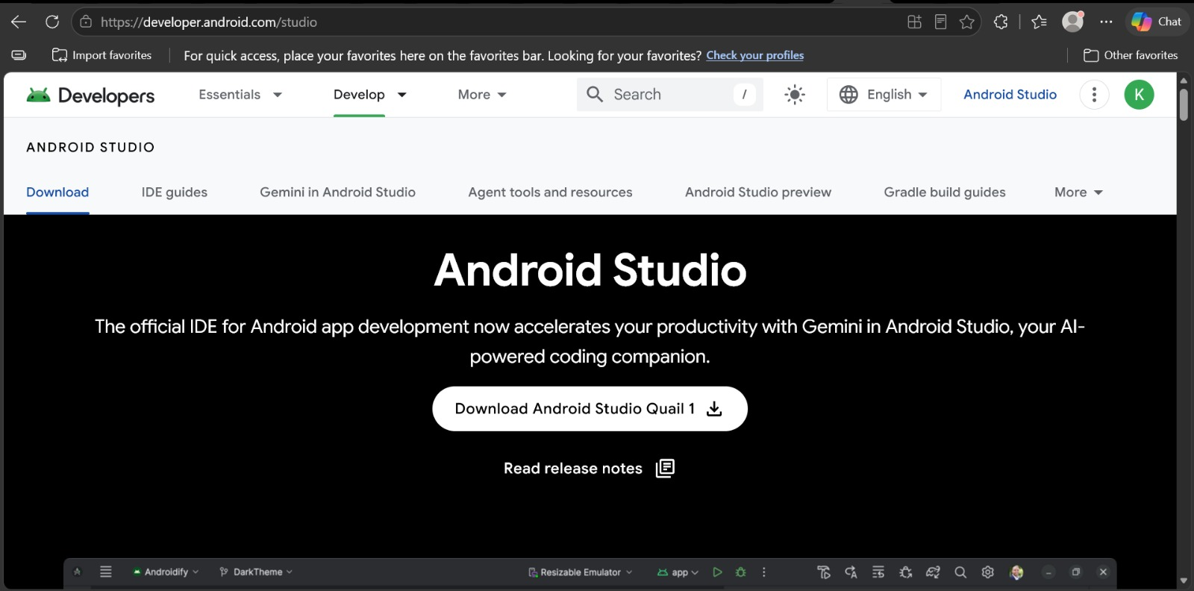
Objectives of Installing Flutter
- To set up a mobile application development environment for creating Android and iOS applications.
- To install the Flutter SDK required for developing Flutter applications.
- To install and configure Android Studio as the development tool for coding and testing applications.
- To install Android SDK and Emulator for running and testing Flutter apps.
- To verify that all development tools are working correctly using the flutter doctor command.
- To prepare the computer for Flutter application development and project creation.
- To gain practical skills in configuring software development tools.
- To create a foundation for designing, developing, testing, and deploying mobile applications.

CHALLENGES:
- The Flutter SDK was not installed correctly or some files were missing.
- The computer could not recognize Flutter commands such as flutter doctor.
- Android Studio took a long time to install due to its large size.
- Some Android SDK components failed to download.
- The Android Emulator failed to start or was very slow.
- Slow internet caused delays when downloading Flutter packages and SDK components.
- Insufficient disk space for Flutter, Android Studio, and SDK files.
SOLUTION:
- Reinstalled missing components.
- Configured environment variables correctly.
- Used a stable internet connection.
- Followed Flutter Doctor recommendations.
- Freed up storage space and restarted the emulator.
CREATION OF FLUTTER APP:
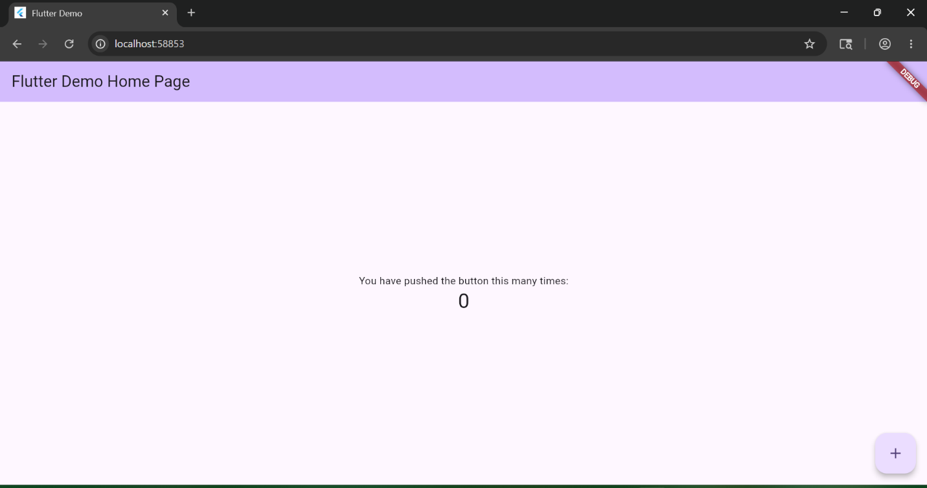

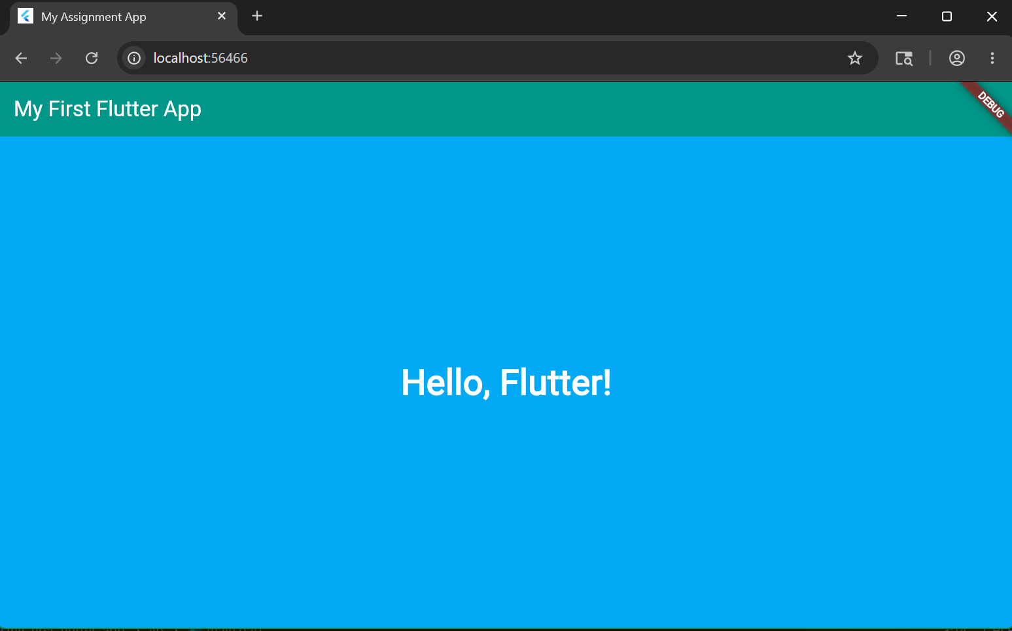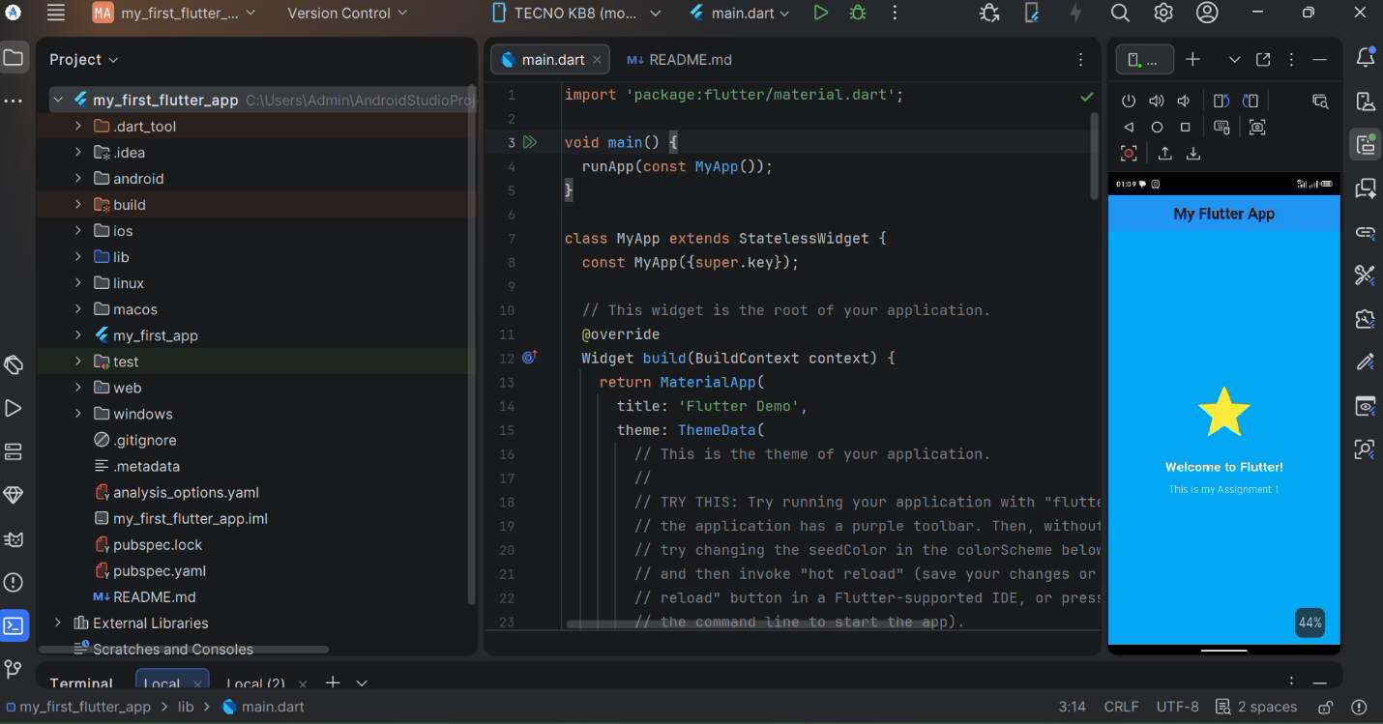

WEEK 2: BUILDING A MINI STUDENT MANAGEMENT APP
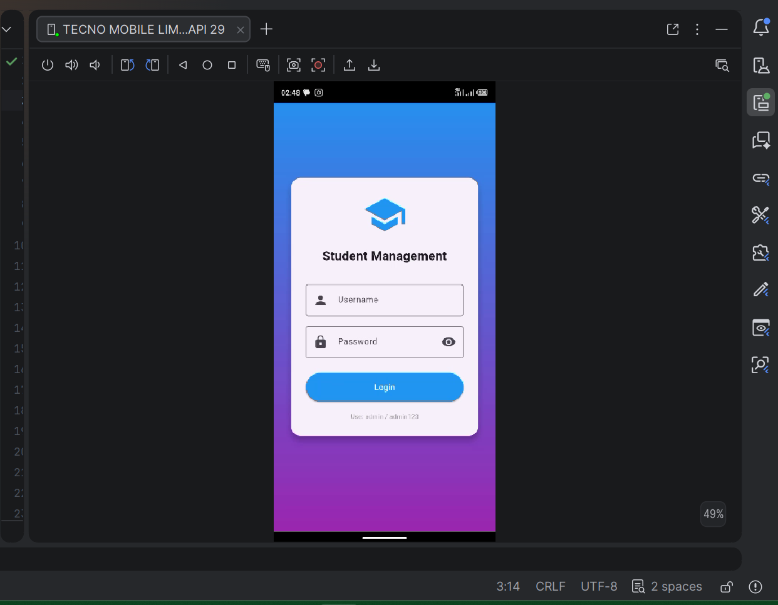
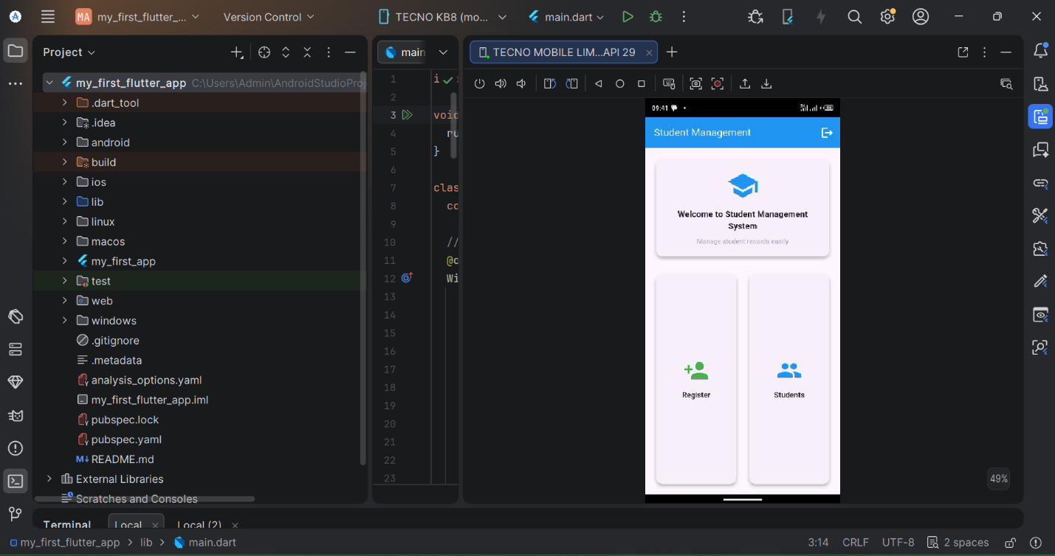
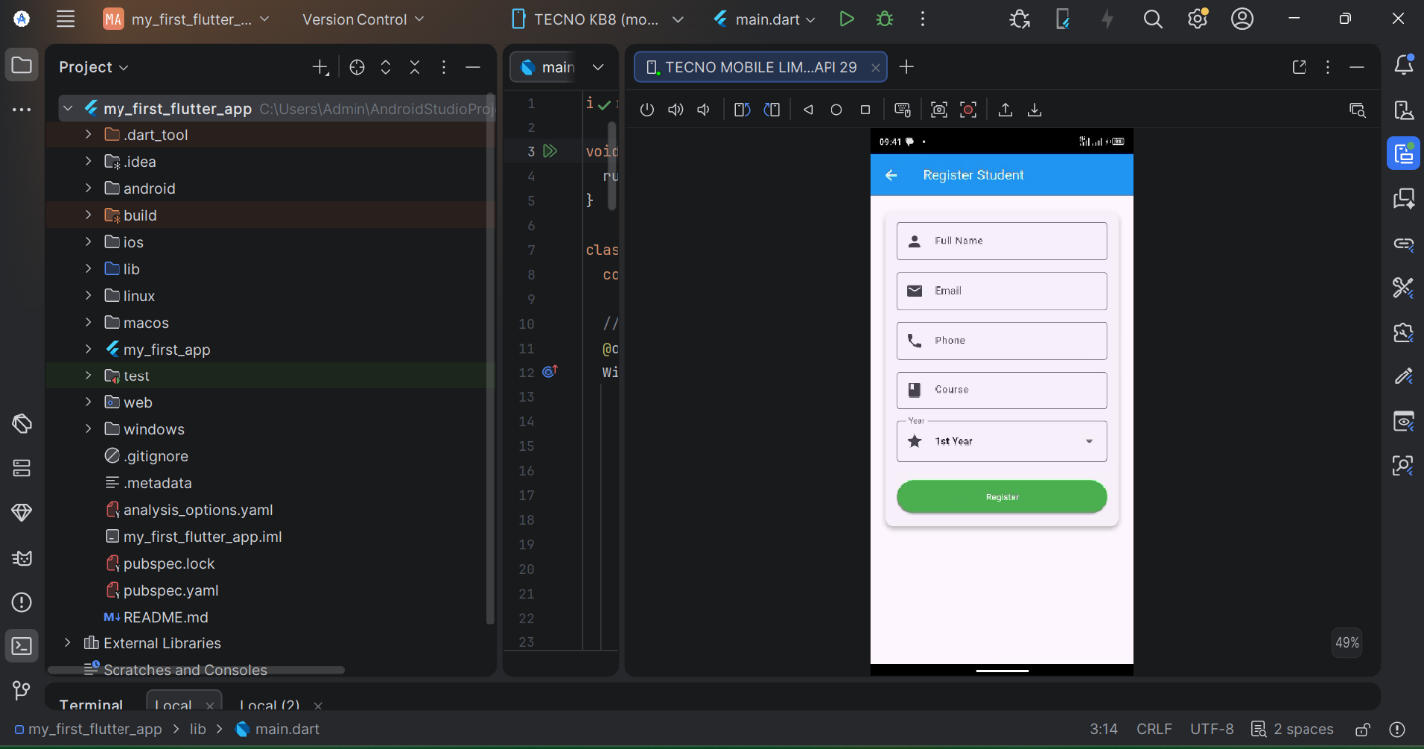
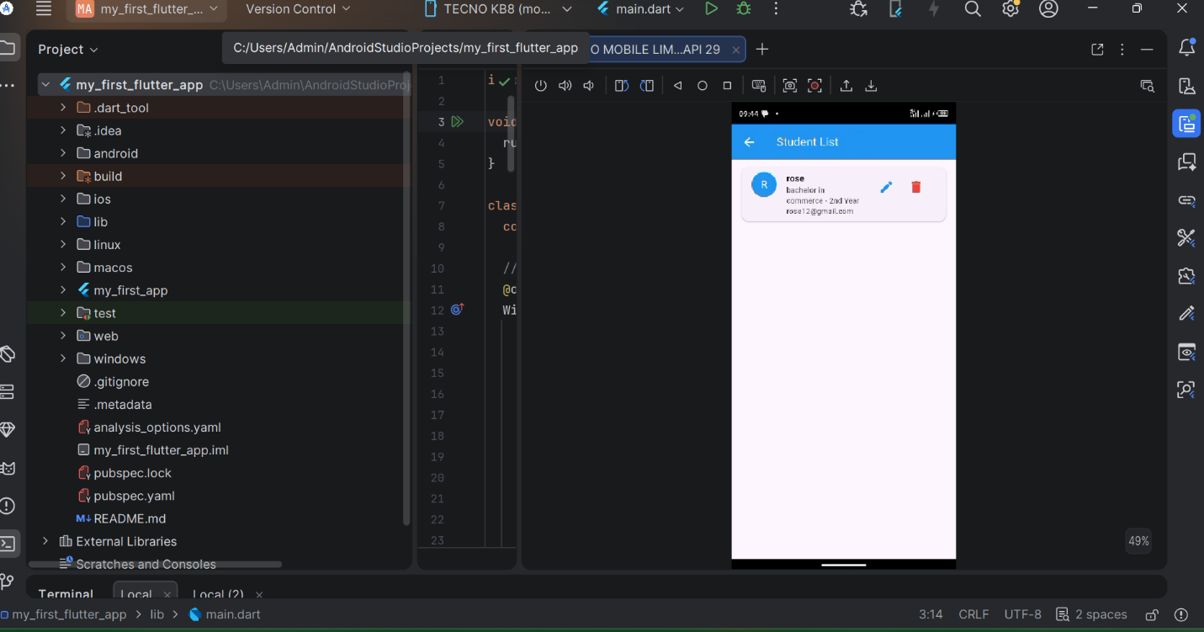
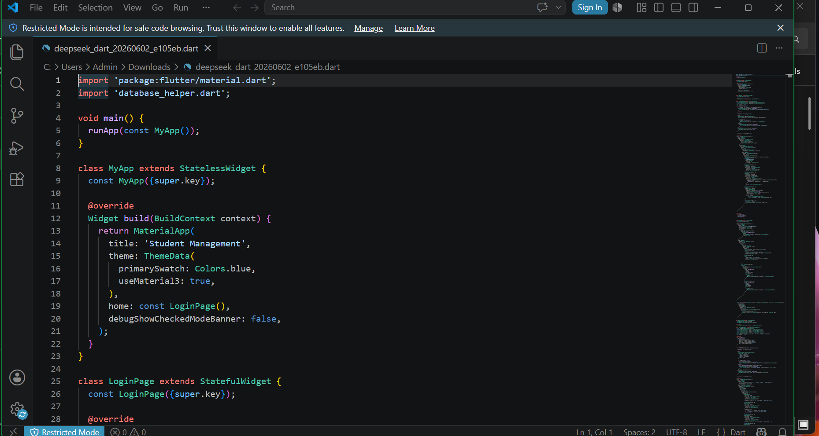
Week 3
UL PROTOTYPE OF MINI STUDENT MANAGEMENT SYSTEM
ff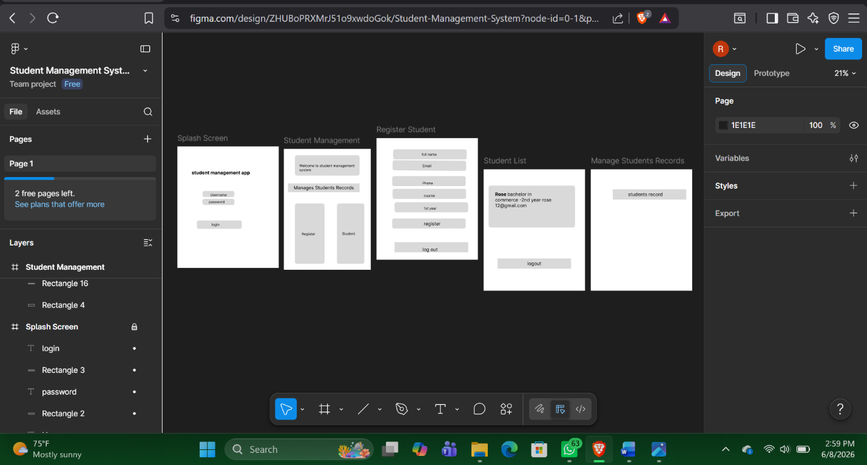
figure 1.1
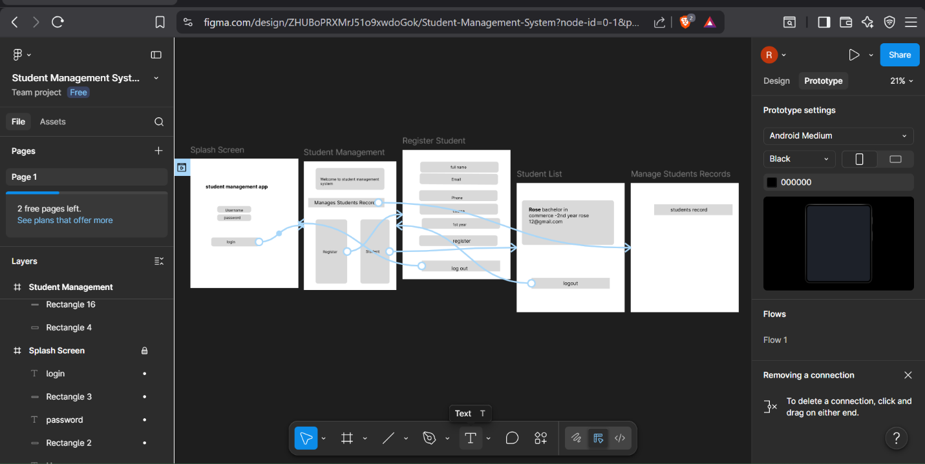
Figure 1.2
FINAL INDUSRY PROJECT
ZURI SALON APP
LOGIN
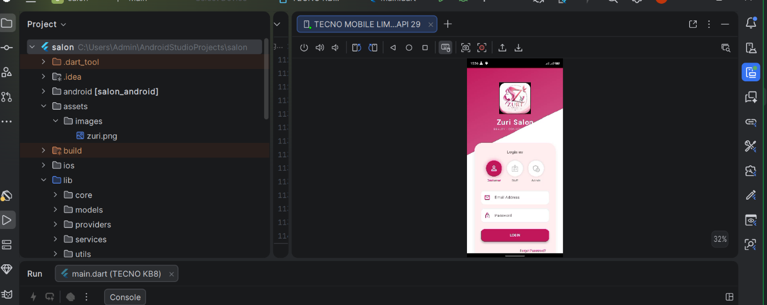

CUSTOMERS DASHBOARD
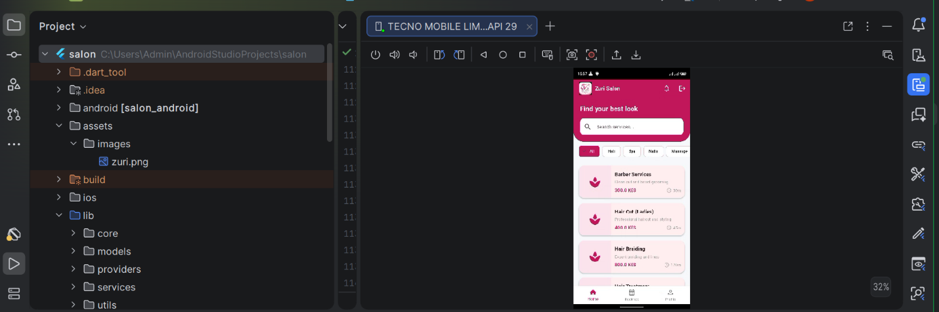
Figure 1.2

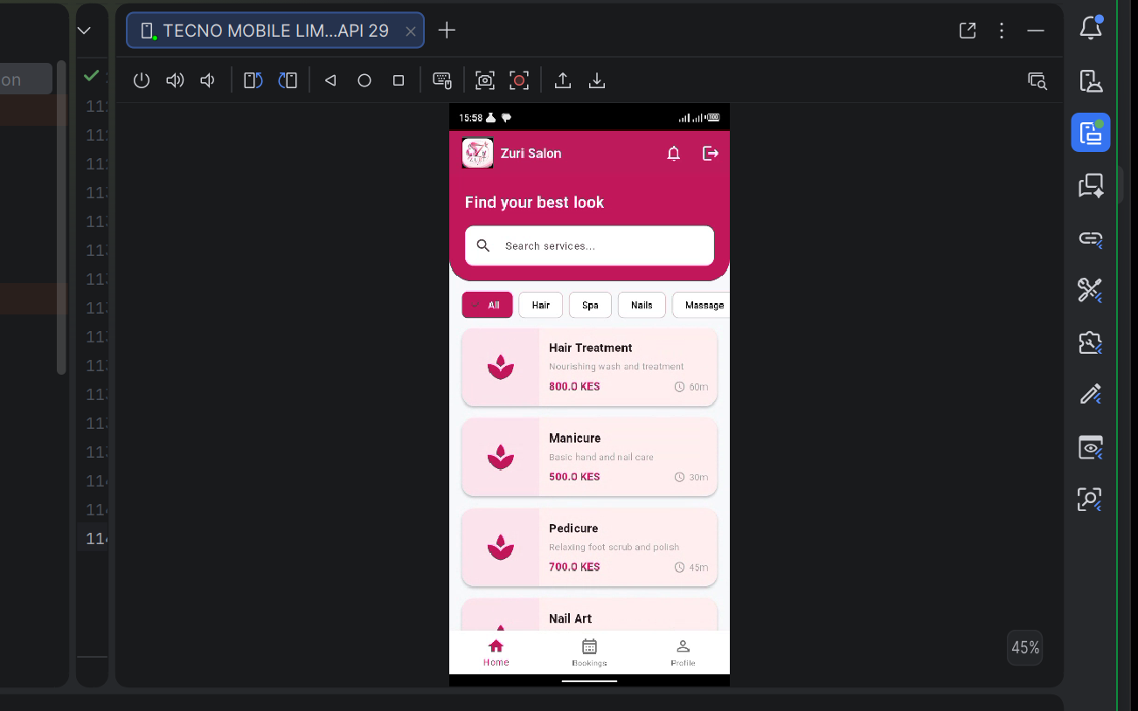
Figure1.3
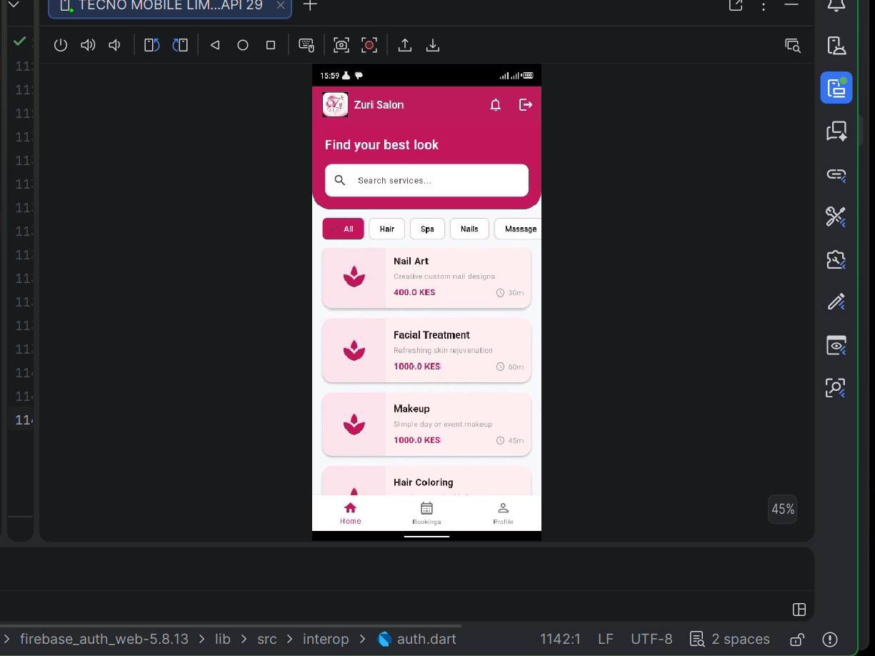
Figure1.4

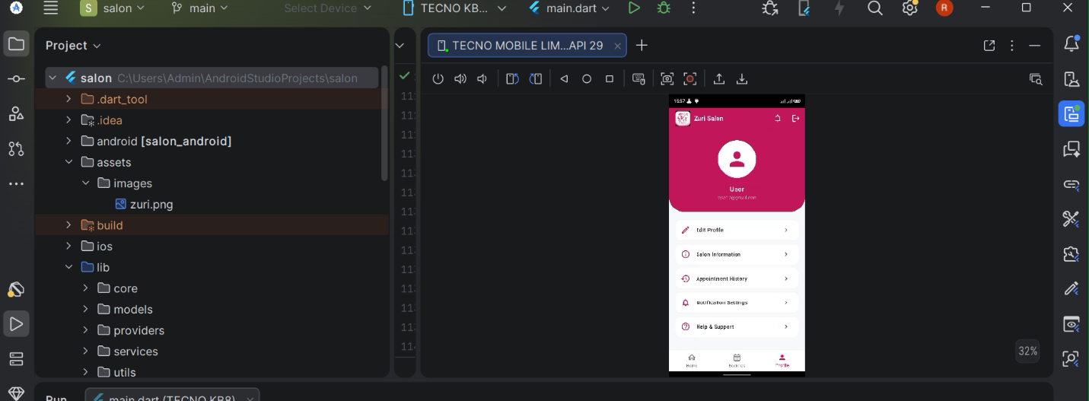
Figure1.5

Staff Dashboard

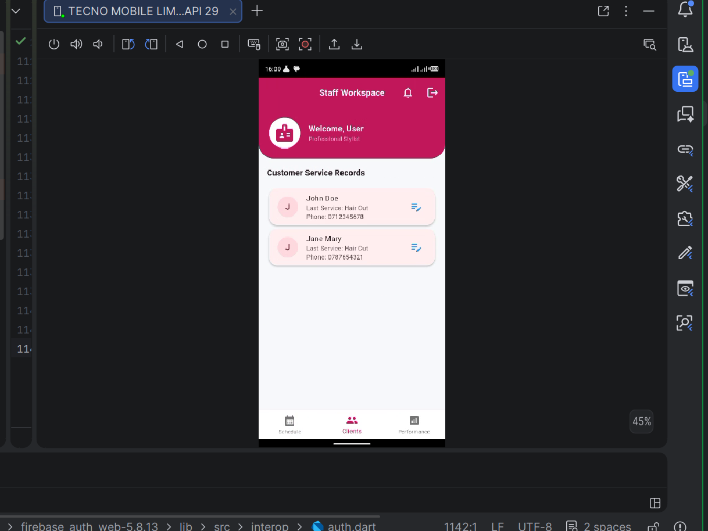
Figure 1.6
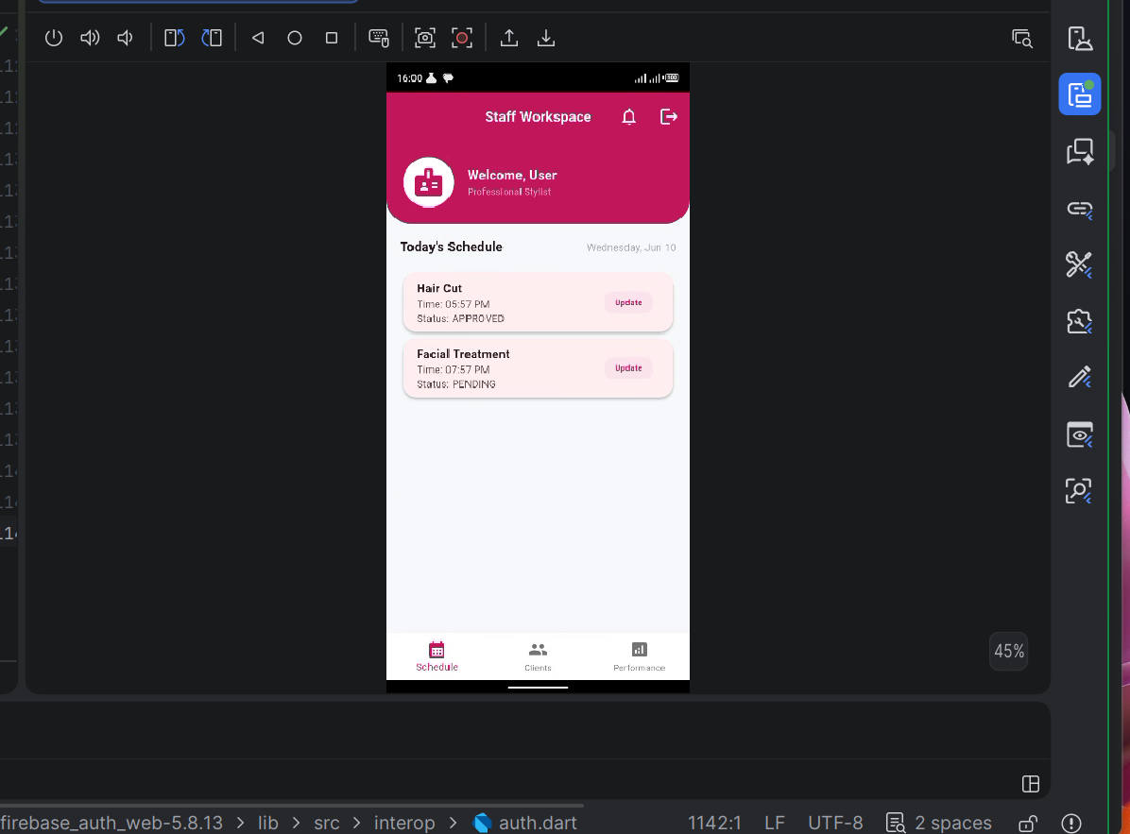
Figure1.7

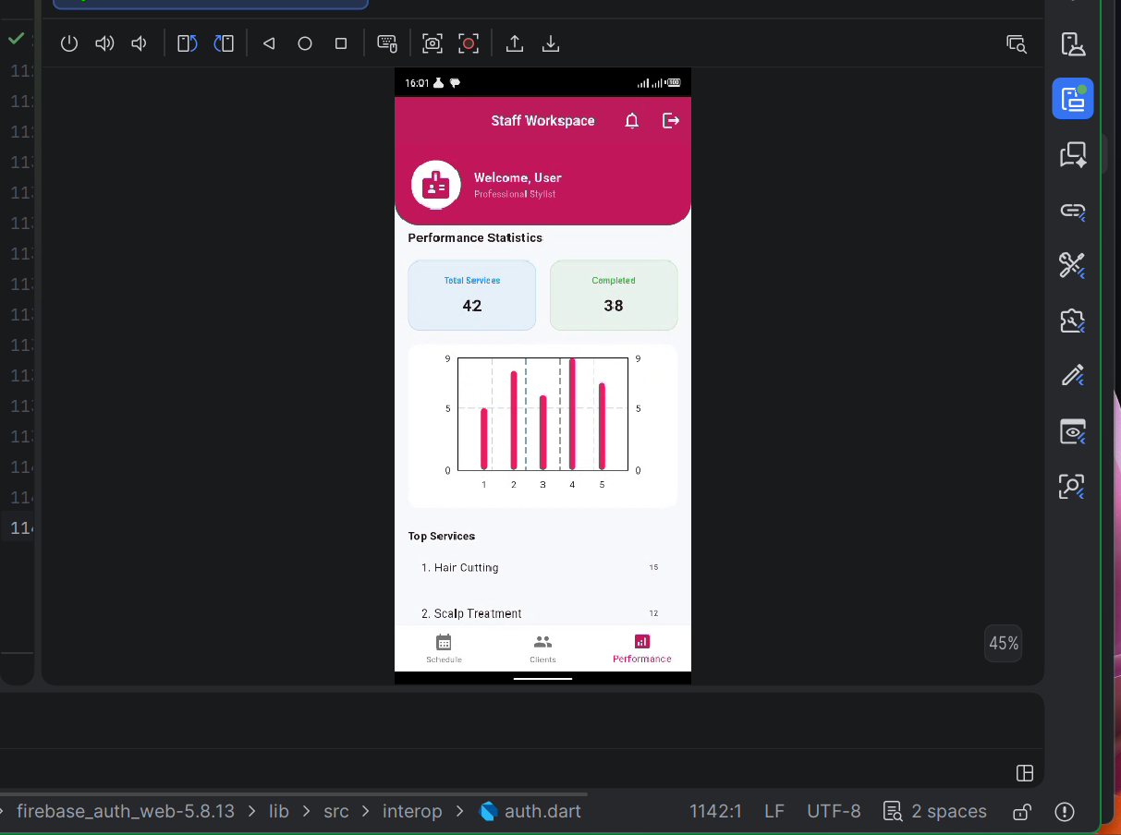
Figure1.8

Admin dashboard

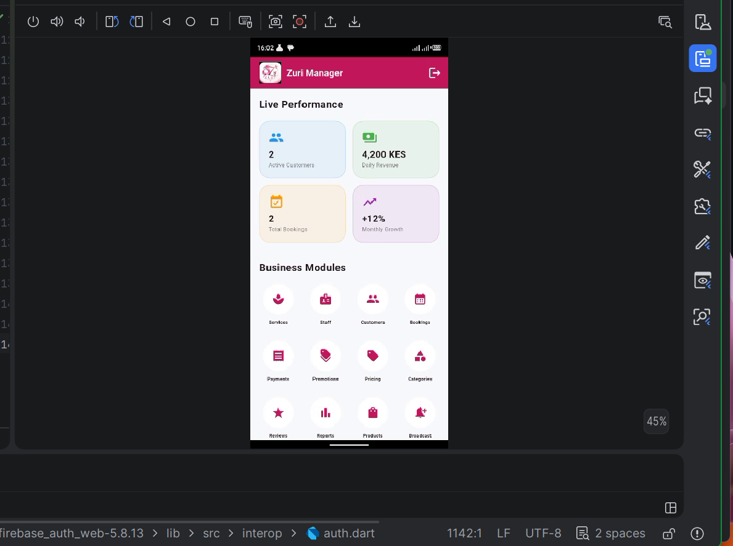
Figure 1.9
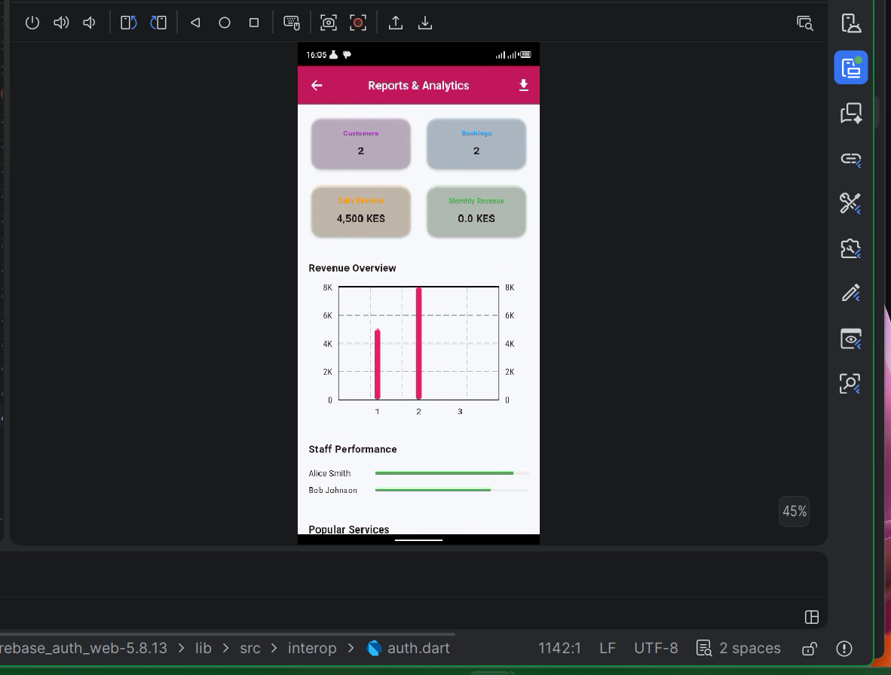
FIGURE 2.0

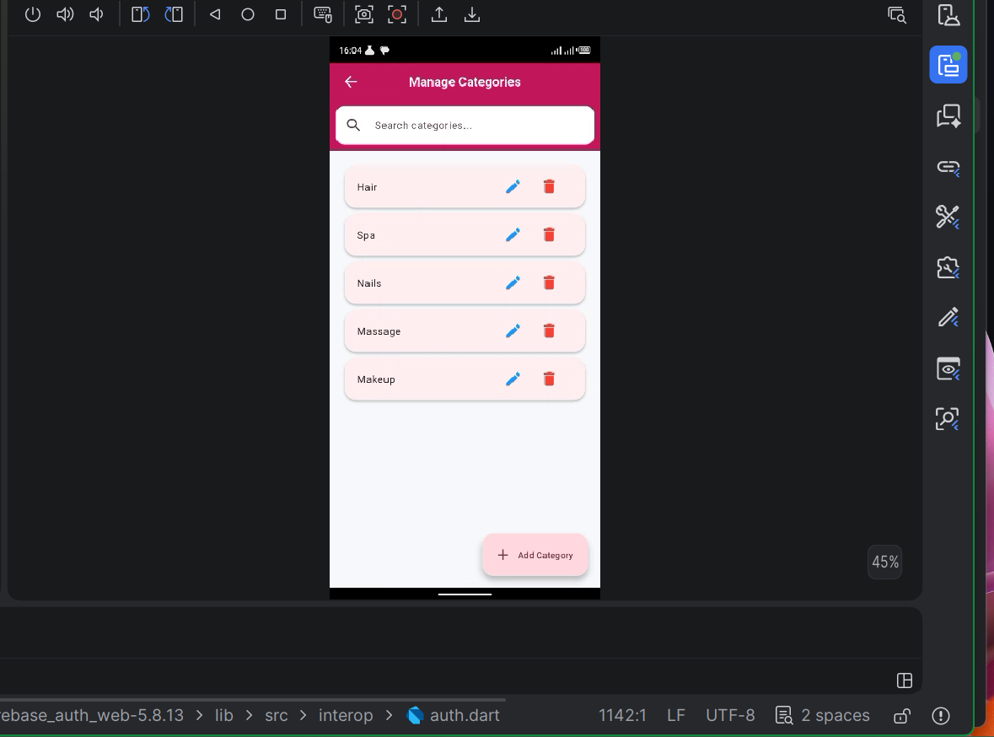
FIGURE2.1

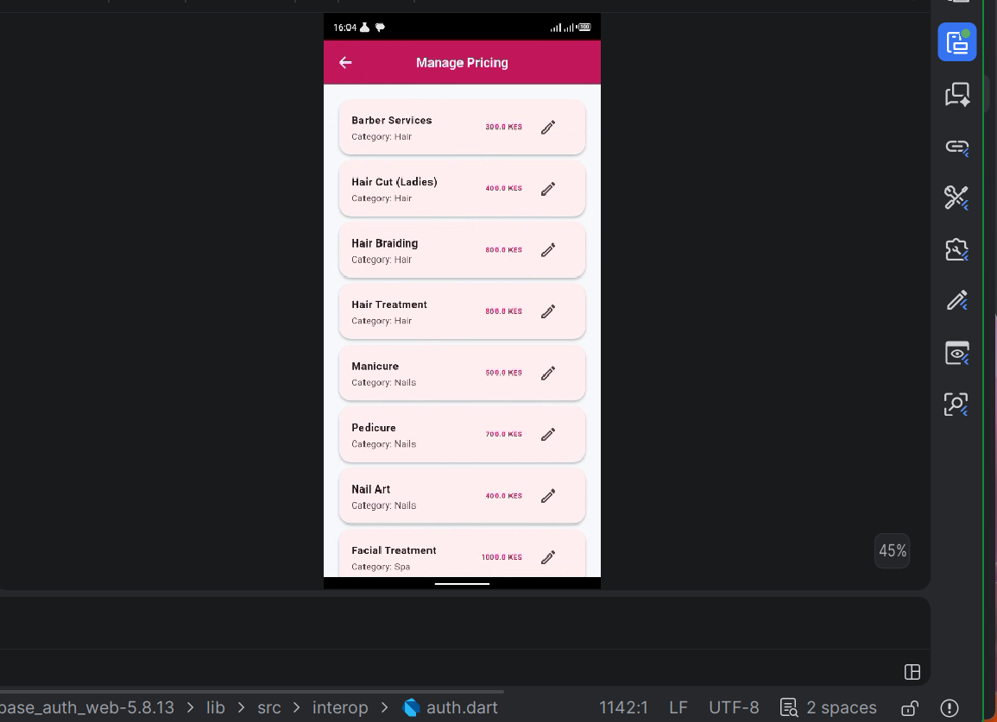
FIGURE 2.2
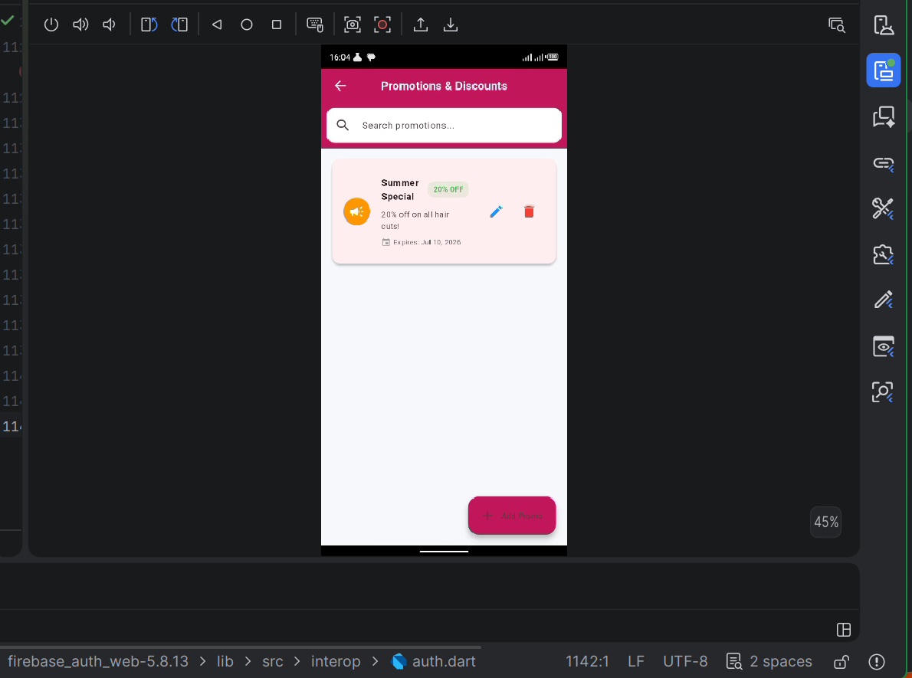
FIGURE 2.3
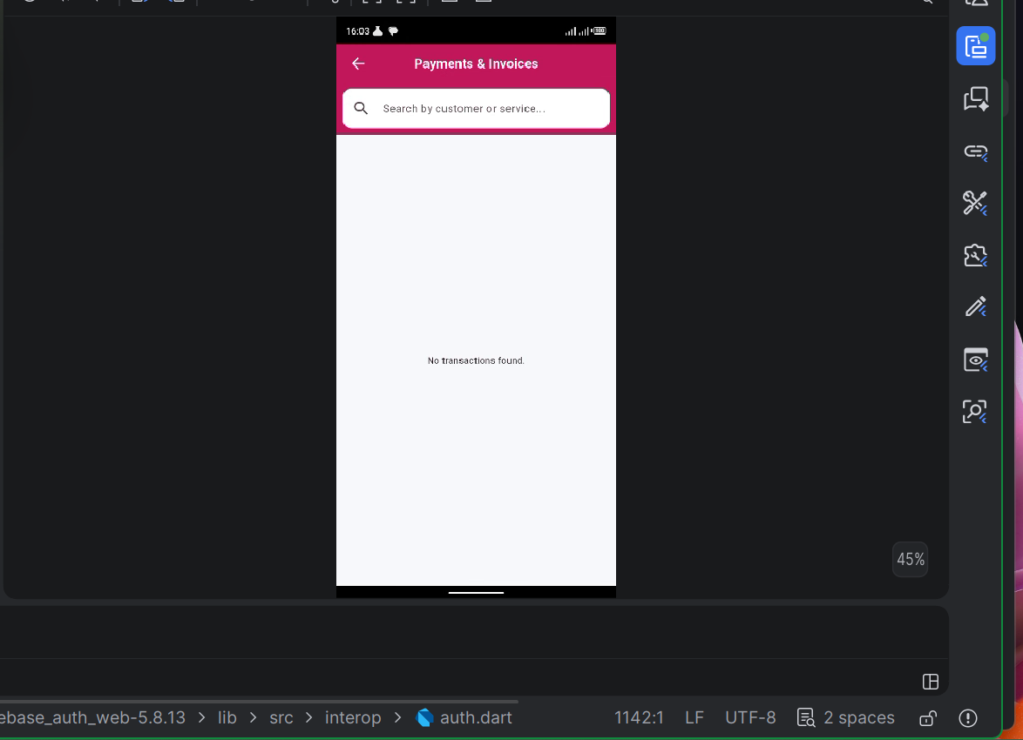
FIGURE 2.4
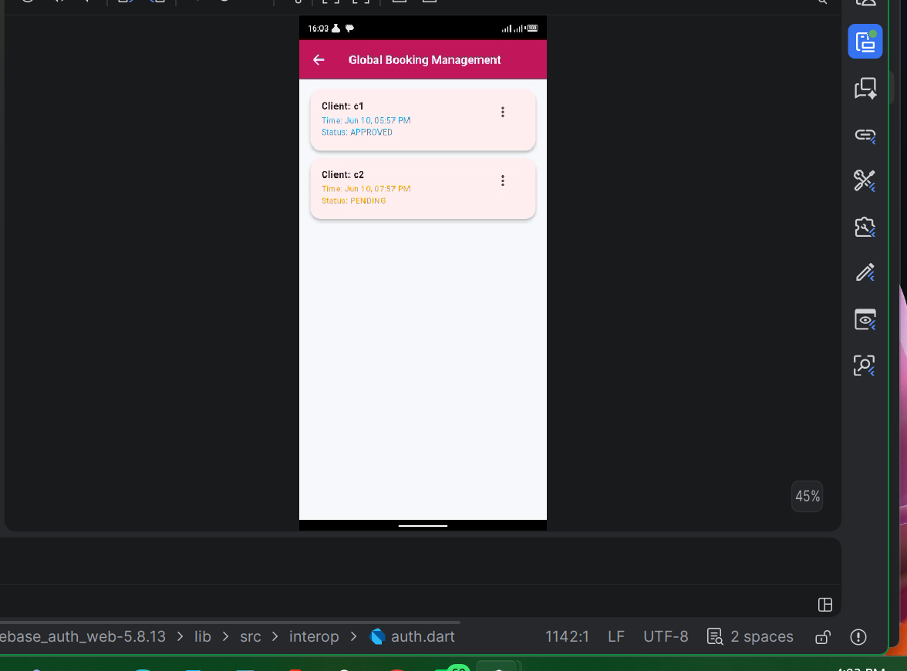
FIGURE 2.5
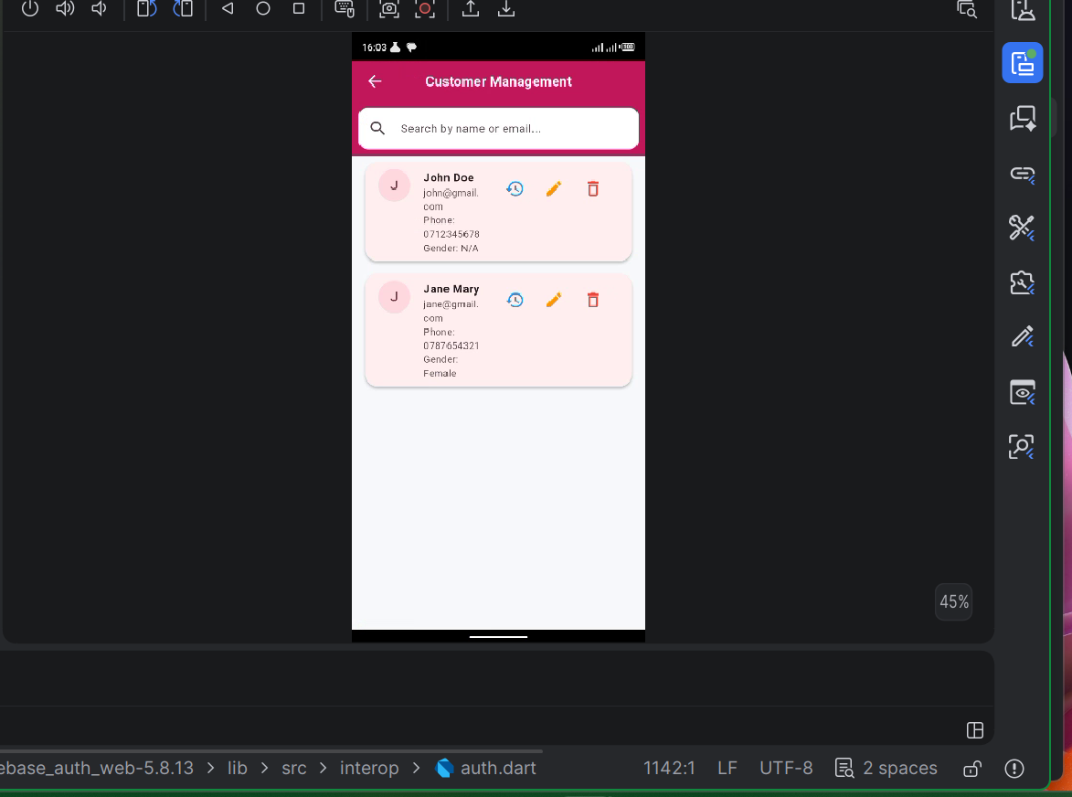
FIGURE 2.6

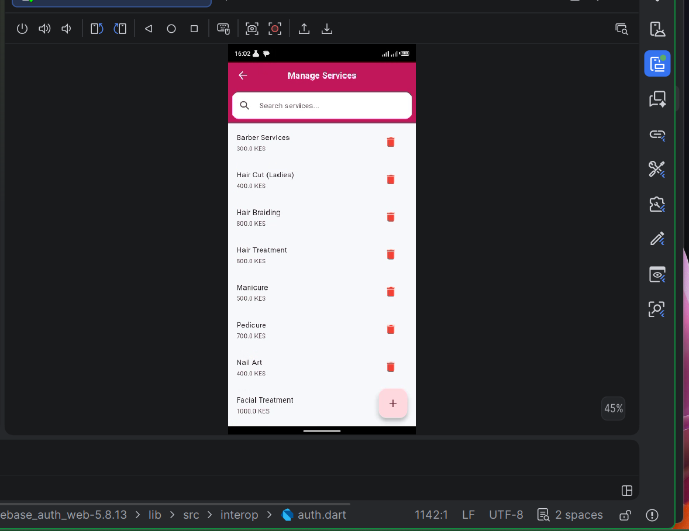
FIGURE 2.7

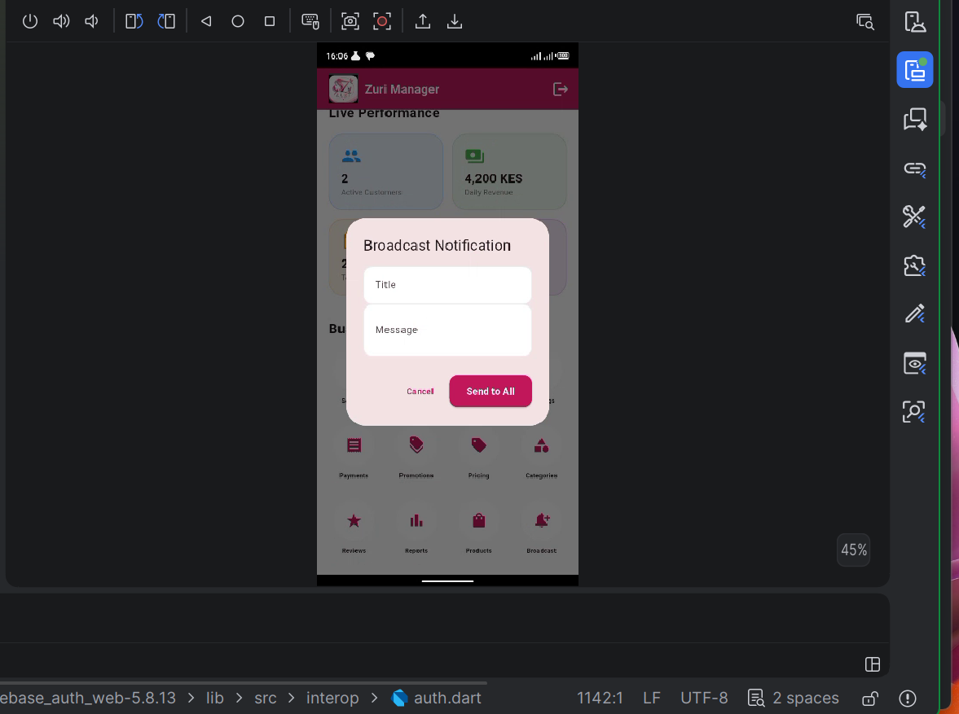
FIGURE 2.8

