

**Revv AI**

**Business Requirement Document**

**Version 1.0**



Copyright (c) 2005-2020

Kott Software Pvt Ltd., Global Tech Center,

Jyothirmaya IT Building, Infopark,

Kochi – 682030, India.

All rights reserved.

This document is the confidential and proprietary information of Kott Software Pvt Ltd, ("Confidential Information"). You shall not disclose such confidential information and shall use it only in accordance with the terms of the license agreement you entered into with Kott Software Pvt Ltd

Revisions

|  |  |  |  |  |  |
| --- | --- | --- | --- | --- | --- |
| Version | Author (s) | Reviewer | Approver | Description | Date (dd/mm/yyyy) |
| 1.0 | Prem Raj S |  |  | Initial version | 30-01-2025 |

Table of Contents

1 Introduction 4

1.1 Purpose 4

1.2 Scope 4

1.3 Definitions, Acronyms and Abbreviations 4

2 Revv AI Project Overview 5

2.1 Introduction 5

2.2 General Overview 6

2.3 Application Overview 6

2.3.1 Application URLs 6

2.4 Functional Features 6

3 Application Functionlities 7

3.1 User Management 7

3.1.1 Create User 7

3.1.2 Manage Users 8

3.2 Stock Management 9

3.2.1 Create Stock 9

3.2.2 Listings / Stock List 14

3.2.3 Edit Stock 15

3.3 Dashboard 15

1. Introduction
   1. Purpose

The purpose of this document is to provide a detailed overview of the **Revv AI Project**, focusing on its functionalities, system architecture, and business requirements. This document serves as a guide for stakeholders, developers, and testers to understand the project scope and objectives.

* 1. Scope

Revv AI acts as an intermediary platform connecting car leasing companies, rental companies, banks, and corporate sellers with established car auction platforms such as **IAAI** and **Manheim**. The system facilitates the seamless listing, auctioning, and tracking of vehicle stock.

* 1. Definitions, Acronyms and Abbreviations

The following terms/abbreviations are used throughout the document.

|  |  |  |
| --- | --- | --- |
| **No** | **Term** | **Description** |
|  | Revv AI | Name of the project |
|  | Kott Software | Name of the company |
|  | IAAI | Car auction house/Handles salvage vehicles |
|  | Manheim | Car auction house/Handles vehicles in good condition |
|  | Element | Leasing company/fleet management |
|  | Emkay | Leasing company/fleet management |
|  | ADESA |  |
|  | Copart |  |

1. Revv AI Project Overview
   1. Introduction

Revv AI is a **web-based AI-driven auction facilitation platform** designed to automate and streamline the process of vehicle resale through trusted auction houses.

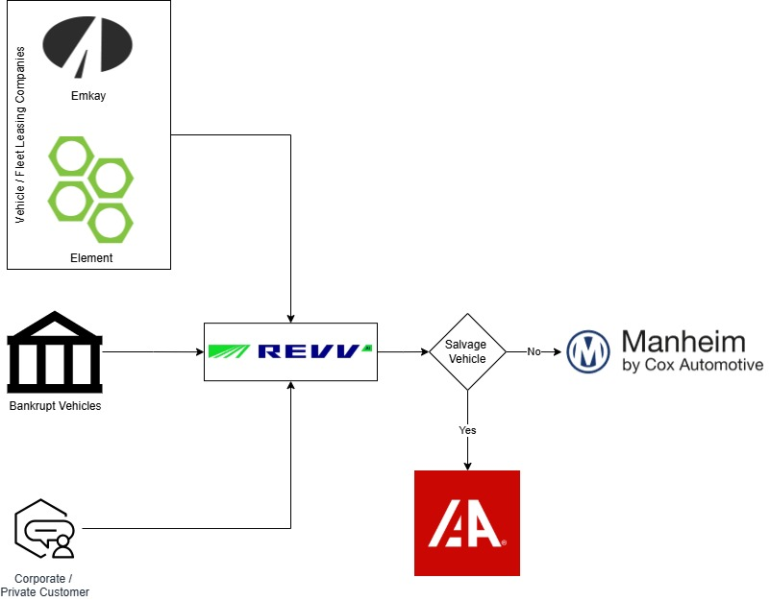

* 1. General Overview

The project is designed to enhance efficiency, minimize manual intervention, and optimize decision-making using data analytics and AI-driven recommendations.

* 1. Application Overview
* **Revv AI** provides a bridge between sellers and auction houses.
* It supports **bulk stock uploads**, **AI-based auction recommendations**, and **automated workflows**.
* The platform integrates with APIs such as **NHTSA** for vehicle details verification.
  + 1. Application URLs
* [ReVV](https://revv.vin/)
* [ReVV QA](https://app-revvapp-qa-eastus.azurewebsites.net/)
  1. Functional Features
* User Management: Role-based access control and user permissions.
* Stock Management: Adding, editing, and tracking stock.
* Auction Integration: Auto-matching stock with the most suitable auction.
* Dashboard & Reporting: Real-time stock status and financial summaries.

1. Application Functionalities
   1. User Management

Users can be created with role-specific permissions, ensuring data security and controlled access

* + 1. Create User

Following the fields in page.

* **Role & Details Tab**:
  + Types of Roles: Revv Power User, Customer Agent, Account Manager, Power User, Supervisor, and Agent.
    - Revv Power User, Customer Agent, Account Manager
      * These roles are primarily managed within the Revv organization.
      * The controls like Assign Organization, Tier 2, Tier 3 are disabled for these users
      * **Revv Power User & Account Manager** mostly have the below permissions
        + Create new users
        + Edit existing users
        + Deactivate user
        + Password reset link
      * Customer Agent – Vehicle information can view
    - Power User, Supervisor, and Agent
      * These roles are assigned to users outside the Revv organization, such as those from sellers like Element, Emkay, and Enterprise.
      * These users can edit the existing users, but they can’t create the users
      * Power User
        + Edit existing users
        + Deactivate user
        + Password reset link
        + Create stocks and assign to auctions
        + Manage pickup/transport
        + Manage conditioning and repairs
        + History and close stock files
      * Supervisor & Agent
        + Create stocks and assign to auctions
        + Manage pickup/transport
        + Manage conditioning and repairs
        + History and close stock files
  + Basic details captured: First Name, Last Name, Email, Title, Other Number, Mobile Number.
  + Organization details:
    - Assign Organization (Predefined values fetched from the backend)
    - Tier 2 (Predefined values fetched from the backend)
    - Tier 3 (Predefined values fetched from the backend)
* **Permissions Tab**:
  + Enable all permissions or assign stock-specific permissions:
    - Create stocks and assign to auction.
      * This is used to provide permission to create the stock
    - Manage pickup/transport.
      * This is used to provide permission to edit the stock
    - Manage conditioning and repairs.
    - View history and close files.
      * This is used to provide permission to filters in listings page
    - Confirm Tab: Final confirmation before saving details.

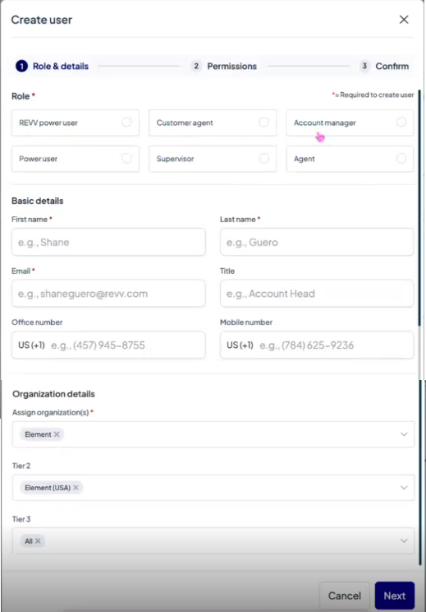 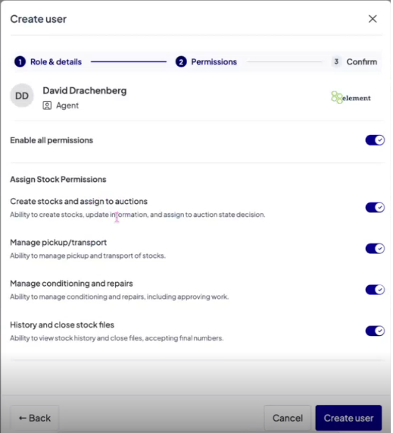

* + 1. Manage Users

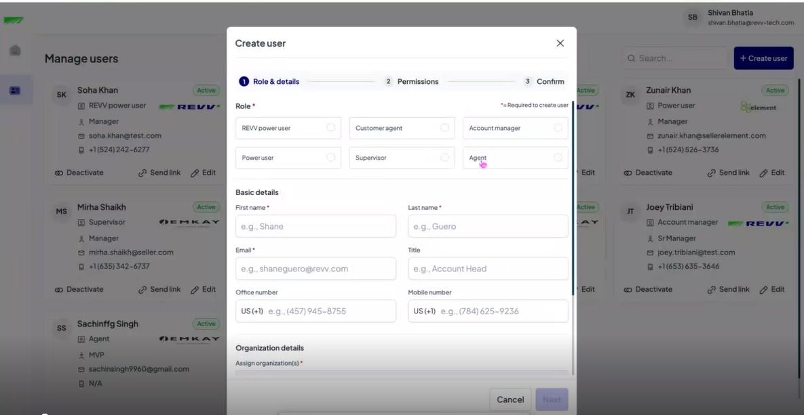

* 1. Stock Management

Users can add and manage stock, including:

* Vehicle Identification: VIN decoding via NHTSA API.
* Vehicle Details: Year, Make, Model, Color, Mileage.
* Condition Assessment: , damage comments.
* Auction Assignment: Set floor price, choose auction house.

Vehicle Light System (Auction Readiness Indicator):

* Green: Good condition, seller responsible for issues.
* Yellow: Average condition, specific functional features mentioned.
* Red: Sold "as is" with no guarantees.
* Blue: Requires additional information.

Vehicle Tracking - Helps identify vehicle status:

* Sold
* In Sale
* Auction Prep (Inspector assesses vehicle condition and assigns light status.)
* In Transport
* Assigned
* Cancelled
* Cancel Pending

CR Score:

* Rating assigned during vehicle inspection.
* Calculated based on mileage, tire condition, and engine condition.

MMR (Manheim Market Report):

* Reflects sales value from Manheim application.
  + 1. Create Stock
* **Office**: Dropdown control to choose office details.
* **VIN** (Vehicle Identification Number):
  + VIN decoding feature using **NHTSA** API to fetch vehicle details from the registration portal.
* **Vehicle Details:** 
  + Year
  + Make
  + Model
  + Series
  + Color
  + Mileage
  + Seller Stock ID
  + Run & Drive Status
  + Condition Comments
  + Vehicle Photos
* **Transport Information:** 
  + Type of transport
  + Availability for pickup
  + Pickup Notes
  + Any required payment of fees at pickup
  + Pickup Fee Notes
* **Location Details:** 
  + Location Type
  + Location Name
  + Address Line 1 & 2
  + Country, State, City, Zip Code
* **Contact Details:** 
  + Primary contact details
    - First name, Last name, Phone number 1, Phone number 2, Email, Fax
  + Secondary contact details
    - First name, Last name, Phone number 1, Phone number 2, Email, Fax
* **Assign Auction House**
  + Set floor price
  + Revv Recommended Auction
  + System suggests providers (IAAI [Salvage Auction] / Manheim).
  + Auction house
  + Auction branch

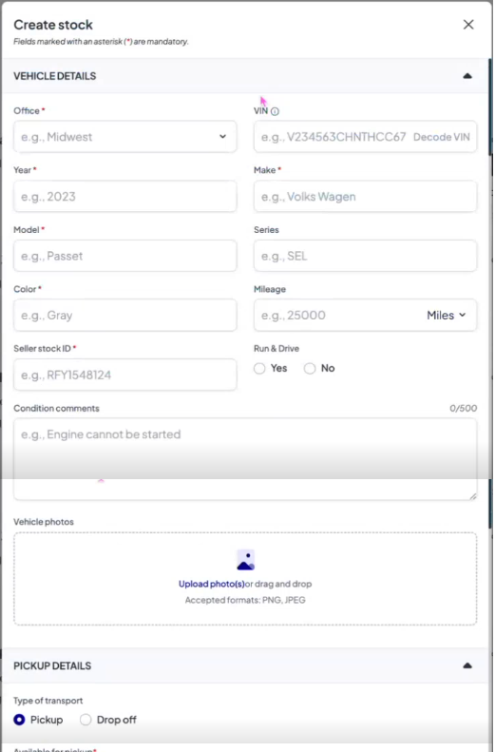

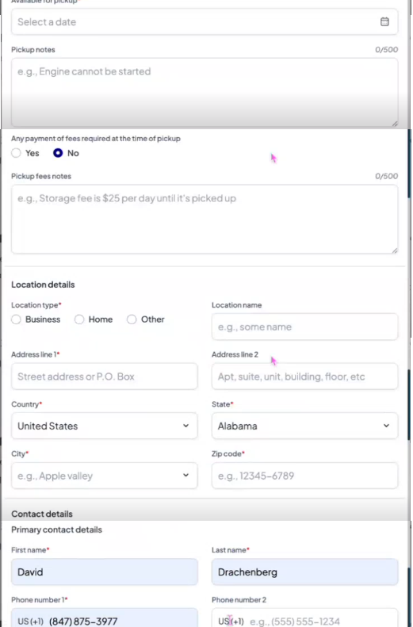

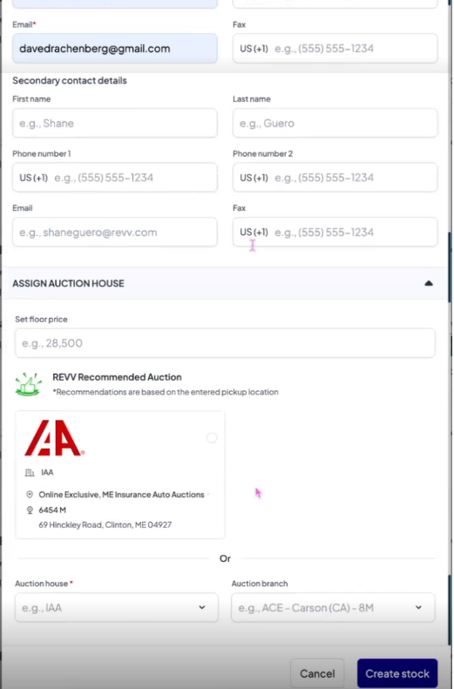

* + 1. Listings / Stock List

Stock listings include:

* Search & Filters: Users can filter stock by auction status, condition, and location.
* Vehicle Light System (Auction Readiness Indicator):
  + Green: Good condition, seller responsible for issues.
  + Yellow: Average condition, specific functional features mentioned.
  + Red: Sold "as is" with no guarantees.
  + Blue: Requires additional information.

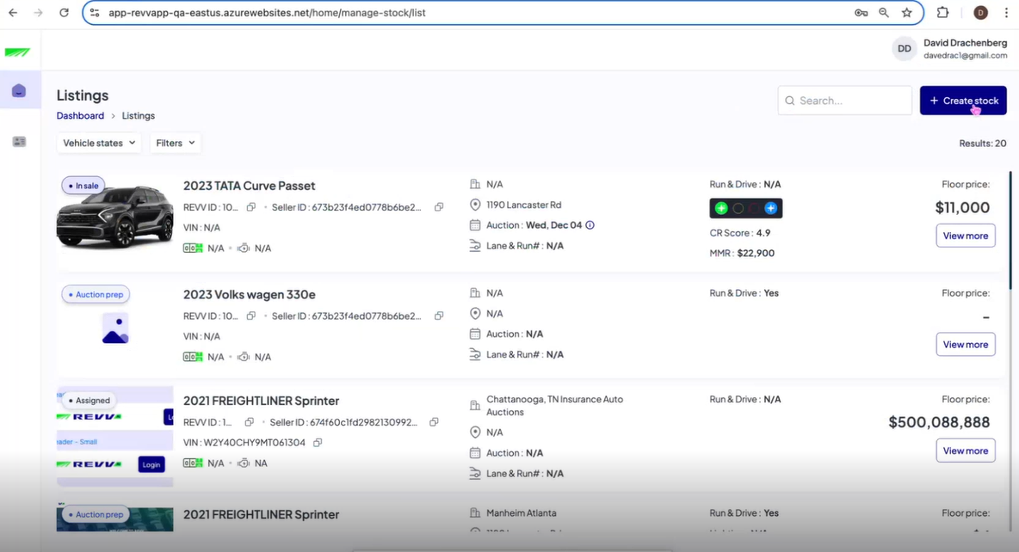

* + 1. Edit Stock

Users can modify vehicle details.

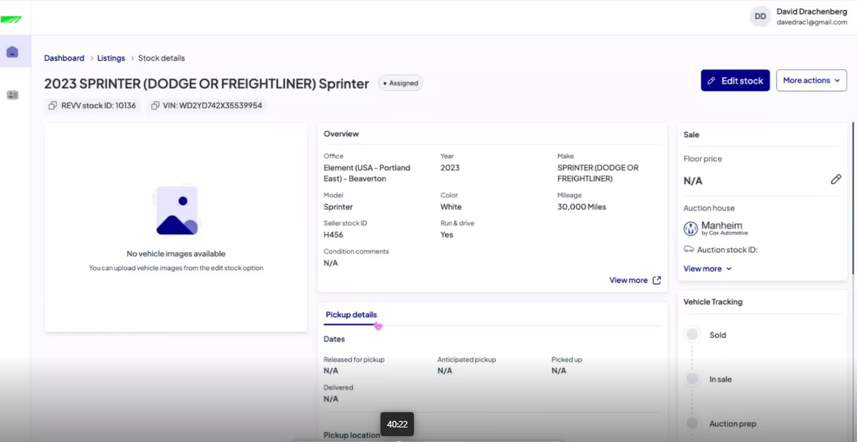

* 1. Dashboard

The dashboard provides:.

* Floor price needed
* In Sale
* Auction Prep

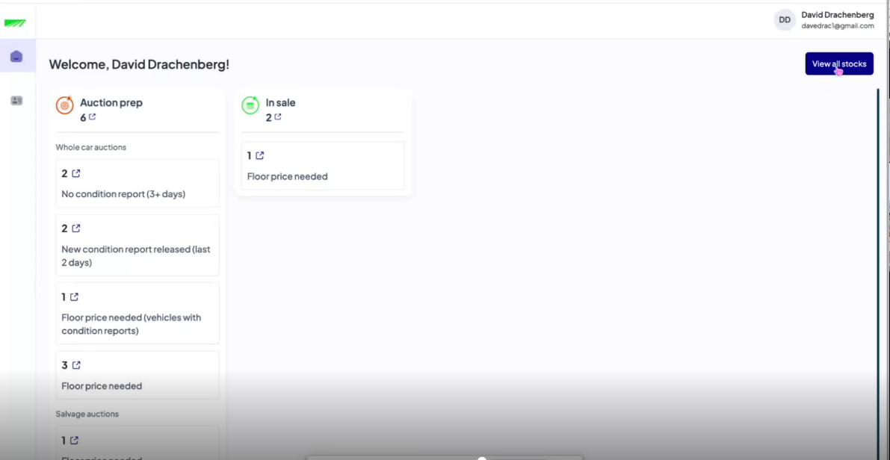

----------------------------| End Of Document |---------------------------