**Chapter III**

**RESEARCH METHODOLOGY**

This chapter encompasses the research design, subject of the study, research instrument, research procedure, and statistical treatment in establishing the solar powered rice crop thresher. Testing procedure and data gathering are also included in this chapter.

**Research Locale**

The solar powered rice crop thresher will be installed and utilized in the municipality of ________. The target audience of the product are the local farmers residing in _________.

**Unit Analysis/ Respondents/ Treatments**

The unit analysis of this research is the production of rice crop through the process of threshing and the time allotted in its production. The local farmers and rice manufacturers are the main respondents of this study.

**Research Design**

The methods, set-ups, and design of the prototype involved in this study were intended by the researchers to provide an economically and efficiently suitable design for the assembly and fabrication. The concepts were constructed with relevance to related studies and literatures.

This research study entitled “Solar Powered Rice Crop Thresher” employs an experimental type of research in order to differentiate which process or method is more effective and efficient to be implemented. As it is defined, experimental research employs two variables, the first one being a constant in order to measure the difference with the second set. With relevance to this research study, this type of research suits the objectives of the paper which is to assess the performance of the solar powered rice crop thresher and to identify certain differences between the traditional method of production in relation to time consumed in the production and the overall quantity and quality of the finished product.

**Research Instrument**

The researchers utilized articles, journals, books, unpublished thesis, and past studies in order to gather information and data to have a feasible design for the solar powered rice crop thresher.

The use of tables was present in order to differentiate and compare the gathered information or data through testing.

**Mechanical Tools**

The following mechanical tools were utilized, during the experimentation phase, in order to gather necessary information to satisfy the objectives of this study.

1. **Stopwatch/ Timer** is used to determine the duration of the process of threshing of the rice crop.
2. **Weighing Scale** is used to identify the weight of the crop produced after threshing in comparison to the traditional method of threshing.

**Procedure Data Collection**

The following are the steps or procedures the researchers followed during the experimentation phase in order to produce rice crop through the designed solar powered rice crop thresher.

1. Power the solar powered rice crop thresher by exposing it directly under the sun for about 15 minutes.
2. While the thresher is being powered, rice crops will be gathered from local farmers
3. Once the rice crops were gathered, the thresher is turned on manually by the researchers.
4. The gathered rice crops is then inserted manually by the researchers.
5. Then the finished product or the paddy rice exits the machine and is directly observed for quality check.
6. Once the quality matches the standard output, it is then transferred to sacks ready to be transported for commercial purposes.
7. The machine will then be cleaned and turned off but will remain in the field for recharging purposes for the next threshing process.

**Statistical Treatment**

The following statistical tools will help the researchers in achieving the set objectives of this research study. T-test is a type of inferential statistic used to determine if there is a significant difference between the means of two groups, which may be related in certain features. Wherein the T-test is critical in determining whether there are notable differences between the designed solar powered rice crop thresher and an existing rice crop thresher in terms of the overall time of production and output.

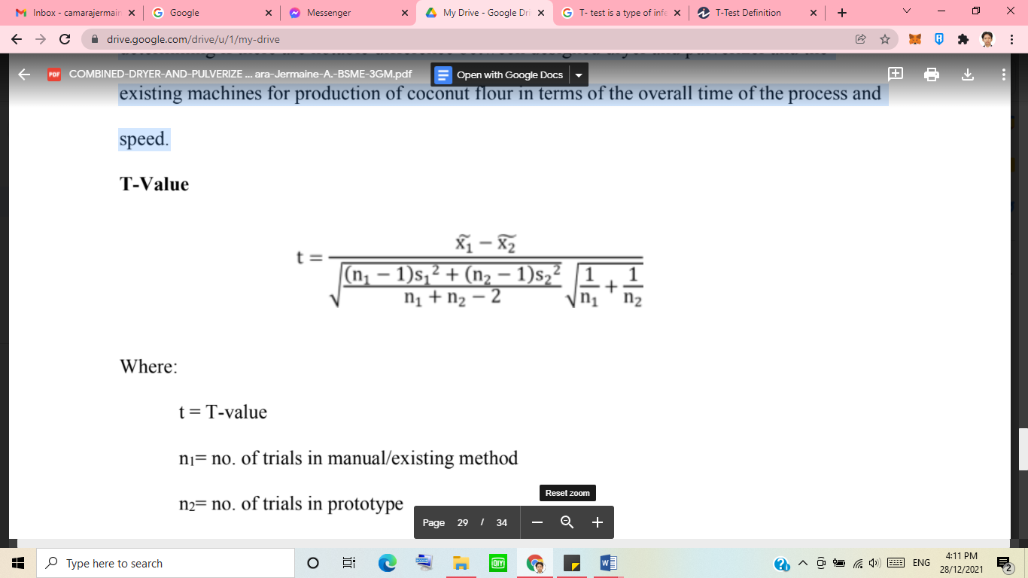**T-Value**

Where:

t = T-Value

n1 = no. of trials in existing method/machine

n2 = no. of trials in prototype

x̃1 = mean of time in existing method/machine

x̃2 = mean of time in prototype

s1 = standard deviation of the time in existing method/machine

s2 = standard deviation of the time in prototype

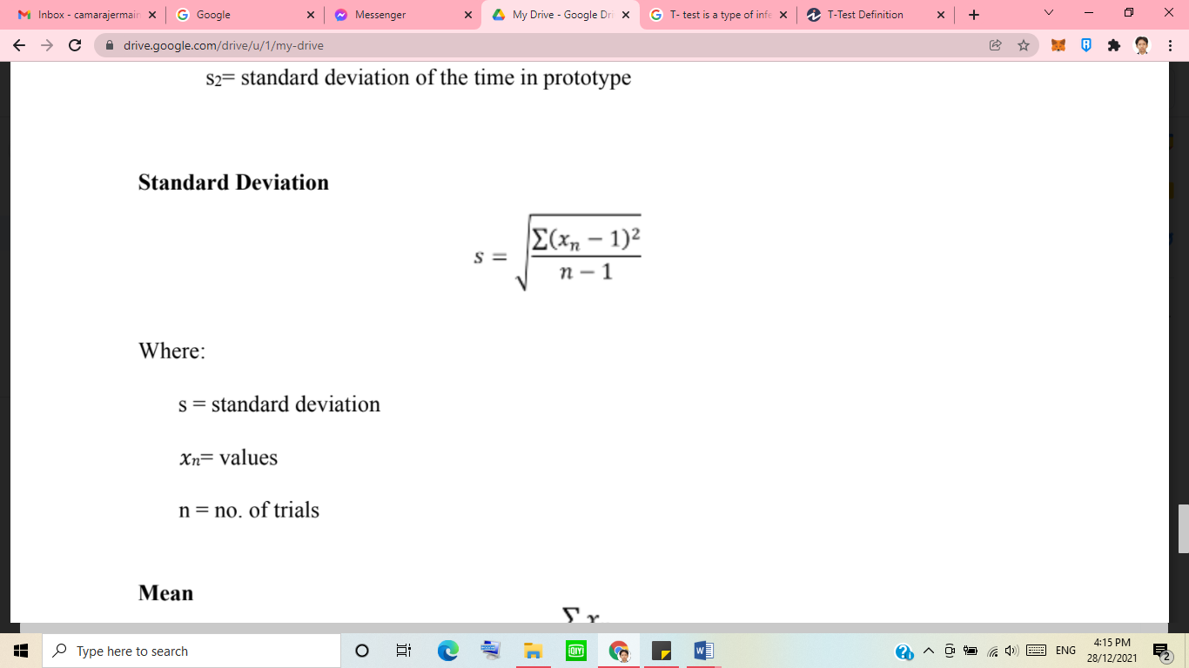**Standard Deviation**

Where:

S = Standard deviation

*X*n = Values

N = no. of trials

**Mean**

Where:

X̃ = mean

Xn = values

**Degree of Freedom**

*df =n1+n2-2*

Where:

Df = degree of freedom

N = number of trials