20MCA241-Data Science Lab

QUESTION-1. Below is a table of student’s scores out of 100 on their Maths and English tests. Plot a scatter graph from this data.

(i) Provide appropriate label to co-ordinates and Title
(ii) Display description of graph in upper right corner
(iii) Use different shapes and colors for representing marks of each subject.

Maths | 38 | 62 | 18 | 75 | 38 | 59 | 66 | 92 | 52 | 75 | 48
English | 74 | 44 | 85 | 19 | 88 | 69 | 50 | 33 | 29 | 32 | 56

PROGRAM

import matplotlib.pyplot as plt
import numpy as np

plt.title("Marks")
plt.xlabel("Maths Mark")
plt.ylabel("English Mark")

x = np.array([38,62,18,75,38,59,66,92,52,75,48])
y = np.array([38,62,18,75,38,59,66,92,52,75,48])
plt.scatter(x,y, color = 'red')

y = np.array([74,44,85,19,88,69,50,33,29,32,56])
y = np.array([74,44,85,19,88,69,50,33,29,32,56])
plt.scatter(x,y, color = 'blue')

plt.show()

OUTPUT

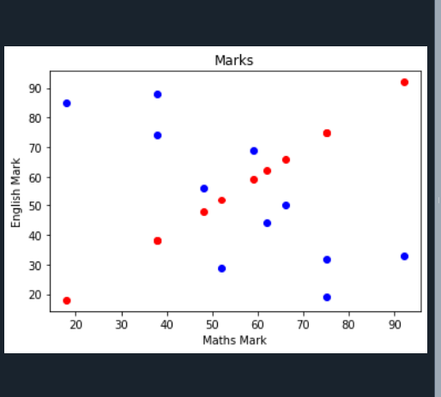

QUESTION-2. Write a Python program that accepts a 10 digit mobile number, and find the digits which are absent in a given mobile number

PROGRAM

mobile = input('enter a mobile number: ' )
all = '0123456789'
print('missing digits are ', set(all) – set(mobile))

OUTPUT

