Helical Turns: Part 1, Turn Conditions

W. Premerlani and Peter Hollands, May 1, 2015

This document is part one of a three part document describing the theory and implementation of helical turn controls. This part summarizes the theoretical foundation for achieving steady, coordinated, helical turns around a vertical axis with a fixed wing aircraft. It develops the conditions that a steady coordinated helical turn must satisfy. This technique is a more general approach than is presently used for turn control in MatrixPilot. The new control has the following features:

- The technique is related to "virtual pose" in which the 9 elements of the direction cosine matrix are specified for the desired attitude of the aircraft. For the control described in this document, only the 3 elements in the bottom row are specified. This establishes the pitch and roll orientation only. Yaw orientation is not specified. However, yaw rate is specified and controlled.
- The technique does not assume that the aircraft is nearly level. Controls will work appropriately for any orientation whatsoever.
- In addition to controlling turn rate, this method will also provide stabilization for any desired attitude of the aircraft. This method treats all orientations uniformly, by simply specifying the desired values for the bottom row of the matrix.
- The new method works well with flying wings even if the navigation gains are set rather high.
- The new method is not subject to flipping an aircraft over if the navigation gain is set aggressively.

The controls will execute a smooth helical turn around the earth frame vertical axis using a fly-by-wire (or, if you will, a virtual pose) technique. Earth frame yaw rotation rate and pitch attitude are specified either from pilot inputs in fly-by-wire mode, or by the navigation controls in waypoint mode. Depending on pitch attitude, the turn is climbing, descending, or level. Only the three elements in the bottom row of the direction cosine are used in the computations, which proceed as follows:

- The desired vertical axis turn rate is specified as an input.
- The desired rotation rate in the body frame for the desired earth frame rotation rate and the actual orientation of the aircraft is computed. The actual value of the bottom row of the direction cosine matrix (DCM) is the actual earth vertical axis as seen in the body frame. Therefore, the desired rotation rate vector in the body frame is the desired earth frame turning rate multiplied by the bottom row of the actual DCM.
- The values of the bottom row the DCM required to achieve the desired turn rate and pitch attitude are computed from the desired pitch of the helix, the desired turn rate, and the airspeed.
- The actual and desired values of the bottom row of the DCM, and the actual and desired rotation rates in the body frame, are used as inputs to a controller for the flight control surfaces.

As of this date, fly-by-wire and navigation controls based on this new approach have been implemented and tested in MatrixPilot, demonstrating smooth and tight turns even with the aircraft inverted.

In developing the math, the assumption is made that the angles of attack and sideslip are zero. This is a very rough approximation for the sideslip angle when the commanded turn rate is changing, but is a reasonable approximation during a steady turn, because the action of the controls will produce a coordinated turn without much sideslip.

The actual angle of attack is hardly every zero, but much of the math to follow is valid even when the angle of attack is not zero. The only part that changes a bit is the relationship between the pitch attitude and rate of climb or descent. The changes in the math required for a nonzero angle of attack are discussed in a separate document.

All vectors are in the UDB coordinate system, rotation rates are in radians per second, counter clockwise is positive.

The desired earth frame vertical axis turn rate in radians per second is specified:

Equation 1

The turn is specified entirely in terms of the rotation rate of the orientation of the aircraft with respect to the earth vertical axis. Depending on the magnitude and direction of the wind, the rotation rate of the course over ground vector is not the same as the rotation rate of the aircraft attitude. In the case of fly-by-wire, the pilot will have to compensate for the wind by increasing commanded turn rate when turning with the wind, and by decreasing commanded turn rate when turning into the wind. For autonomous navigation, it is possible to account for the wind elegantly within the framework of the present theory, but that has not been implemented and tested yet. As it stands now, navigation control is based on the IMU course over ground vector without needing to take into account the wind, so this might be a moot point. The plan is to first implement the technique described in this report and see how well it works in windy conditions before making a decision whether or not to implement modulation of the turn rate target based on wind speed and air speed.

The desired pitch is specified as the ratio of the vertical component of the air speed vector in the earth frame, divided by the magnitude of the earth frame horizontal air speed:

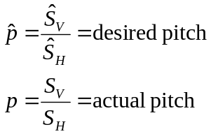 Equation 2

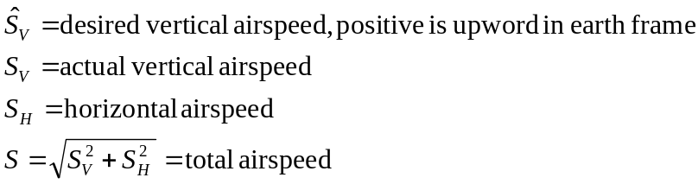

Next, denote the actual bottom row of the DCM as follows:

Equation 3

Recall that the bottom row of the DCM is the earth frame vertical axis projected into the body frame.

To simplify the math that is to follow, I will rename the three elements of the bottom row of DCM as the scalers X, Y, and Z:

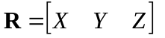 Equation 4

Note that the sum of the squares of X, Y and Z is equal to 1.

The desired body frame rotation rate vector is related to the actual vertical orientation and the desired earth frame rotation rate around the vertical axis by:

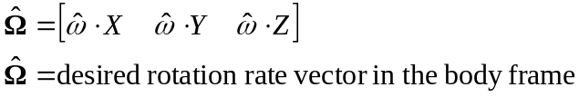 Equation 5

Equation 5 can be understood more easily by first considering a simpler case: a steady turn in the horizontal plane. In that case the airspeed vector and the acceleration vector are both in the horizontal plane. Because the airspeed vector is constant in magnitude, the acceleration vector must be perpendicular to it. The axis of the turn is perpendicular to the plane of the turn. The plane of the turn is horizontal. Hence the axis of the turn is vertical in the earth frame. Therefore the rotation rate vector of the aircraft is parallel to the earth vertical axis. Since the bottom row of the DCM is the mapping of the earth vertical axis to the body frame, in the body frame the rotation rate vector must be proportional to the bottom row of the DCM.

It is also possible to prove that equation 5 must hold during a steady turn in the horizontal plane. For such a turn, roll and pitch attitude do not change, only yaw changes. The bottom row of the DCM contain roll and pitch information only. Therefore they do not change during a steady horizontal turn. The kinematics of the DCM leads to the update equation in which the time rate of change of the bottom row of the DCM is equal to the cross product of the bottom row of the DCM with the rotation rate vector in the body frame. In order for the result of the cross product to be zero, the rotation rate vector in the body frame must be parallel to the bottom row of the DCM.

Equation 5 has several interesting implications for a steady turn in which the bottom row of the DCM (the tilt) does not change. In other words, in order to maintain a given roll and pitch orientation, there must be rotation around all three axes in the aircraft frame of reference. The third (Z) component around the vertical axis is obvious, it represents yaw rotation in the body frame. After all, the plane must yaw in order to turn. The first component (X) is a little less obvious, but it does not take too much thought to realize it must be there. The second (Y) component took a little while for the author to believe, but it must be there as well whenever the plane is not level, that is whenever the turn is ascending or descending at a constant rate.

One implication of the (Y) component of rotation is that if the roll rate feedback term is used with ailerons, the present MatrixPilot controls introduce a small variation in roll attitude during an ascending or descending turn. That is because the roll rate feedback will bias the roll rate toward zero, even though it is required for the turn. As a result, the controls will tend to roll into an ascending turn, and roll out of a descending turn.

There are other implications of equation 5 for fixed wing aircraft that do not have rudder, elevator, and ailerons. For aircraft that do have all three control surfaces, it is possible to achieve all three elements of the desired rotation rate. The rudder can be used for the majority of yaw rate in the body frame, elevator for pitch rate, and aileron for roll rate. But how is it possible to satisfy equation 5 if rudder control is not used, if rudder is missing (flying wing), or if there are no ailerons?

For planes with no ailerons, the wing generally has dihedral, so yawing the aircraft also causes it to roll. However, there are only two degrees of freedom as a result. As a consequence, there is a definite relationship among X, Y, and Z during a turn.

Another interesting situation arises if the rudder is not used for control. The question arises, what causes the aircraft to achieve yaw rotation? The answer is, there is some amount of side slip during the turn, creating an airflow perpendicular to the rudder. You might argue that the elevator helps with the turn, but a little thought will show in the body frame, the elevator mainly creates (X) axis rotation, not (Z). Of course, for very tight turns, (Z) goes to zero, and in that case, there is no yaw rate in the body frame.

Finally, the question arises for flying wings, what causes them to turn? In other words, what causes the requisite yaw rate in the body frame? Some flying wings have vertical fins that act as fixed rudders. For flying wings without any vertical fins, it is the author's speculation that the key is the fact that the center of gravity is forward of the center of pressure, so gravity and aerodynamic forces can generate a yaw torque.

The math for computing the orientation required to accomplish the turn is developed next. The goal is to determine an orientation that produces an acceleration in the horizontal plane of the earth frame of reference, perpendicular to the fuselage of the aircraft. In the other two perpendicular directions, the goal is to balance the forces of lift, thrust, and gravity.

Start with the equations for the horizontal acceleration associated with the turn rate. There are several equivalent expressions:

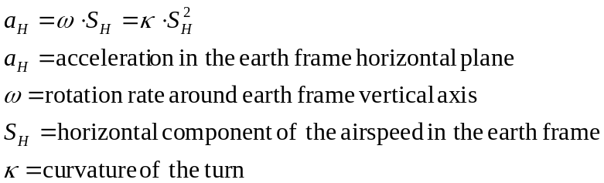 Equation 6

Both actual and desired values will be considered. Equation 6 presents us with three obvious methods for controlling the turn. We may specify the desired acceleration, the desired rotation rate, or the desired curvature. A reasonable way to control the turns is by specifying the desired turn rate. In that case, the desired horizontal acceleration is given by:

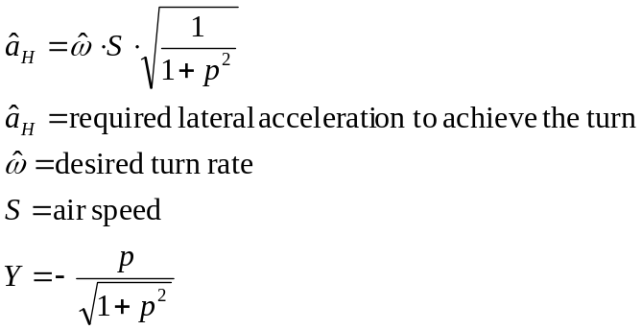 Equation 7

Note the square root factor that reduces the acceleration that would otherwise be required to achieve the turn, due to the pitch. To see how the factor arises, it is helpful to understand that the second column of the DCM is the fuselage direction in the earth frame, with the first two elements indicating the horizontal components.

Next, we need to compute the attitude of the aircraft that, taken in conjunction with the turn rate, will result in the desired lateral acceleration, with acceleration in the other two perpendicular directions equal to zero. In order to achieve that, certain values of lift, drag, and thrust will be required in the body frame. The angle of attack of the wing will automatically adjust to produce the needed lift. The speed control will adjust the throttle to balance thrust and drag such that there is no (or little) change in airspeed.

It can be shown that the lift and net thrust needed to balance gravity are given by:

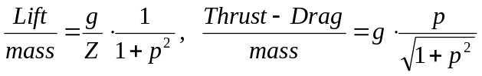 Equation 8
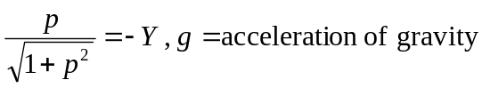

The several steps required to go from equation 7 to equation 8 are summarized in Appendix 1.

The lift and drag forces are perpendicular in the body frame. The vertical and horizontal forces are perpendicular in the earth frame. Therefore the square of the earth frame horizontal force is equal to the square of the lift, plus the square of the thrust, minus the square of gravity. That leads to the following relationship:

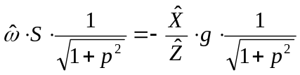 Equation 9

The several steps required to go from equation 8 to equation 9 are summarized in Appendix 2. Equation 9 leads to the following relationships that the elements of the bottom row of the DCM must satisfy to achieve the desired turn:

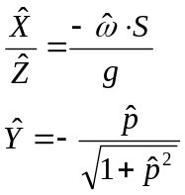 Equation 10

Equation 10 can be implemented in a few steps. The following is the first step:

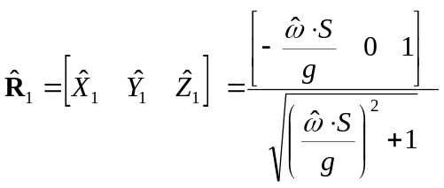 Equation 11

In other words, the first step computes roll only. Start with the roll parameter placed in the X element, place 1 in the Z element, and normalize. This will result in a first pass result with Y equal to zero, and the sum of the squares of X and Z elements equal to 1. Then, insert the desired value of pitch in the Y element, and renormalize. The ratio of X/Z will be preserved, and the second part of equation 10 will be satisfied:

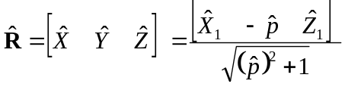 Equation 12

Equation 12 applies for right side up flight. Inverted flight can easily be achieved by simply flipping the signs of the first and last elements in the vector.
Appendix 1: Derivation of equation 8

This section summarizes the math leading up to equation 8. It assumed angle of attack is zero, and that the controls perform coordinated turns so side slip is zero. Therefore the velocity vector in the earth frame is the velocity magnitude times the second column of the direction cosine matrix. In other words, the velocity vector is parallel to the body frame y axis. It is not assumed that the acceleration along the earth frame vertical axis is zero. It is not assumed the propeller thrust vector is aligned with the body frame y axis, it may be angled up or down.

For convenience we define the pitch as the ratio of vertical to horizontal velocity, with positive values for ascent:

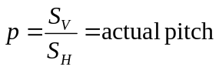 Equation A1.1
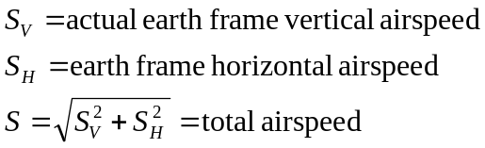

Also note that:

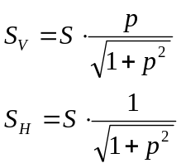 Equation A1.2

Next, denote the actual bottom row of the DCM as follows:

Equation A1.3

Recall that the bottom row of the DCM is the earth frame vertical axis projected into the body frame.

To simplify the math that is to follow, we will rename the three elements of the bottom row of DCM as the scalers X, Y, and Z:

Equation A1.4

Note that the sum of the squares of X, Y and Z is equal to 1.

Y can be computed from p as follows:

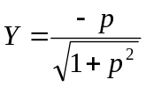 Equation A1.5

Similarly, p can be computed from Y:
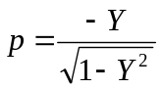 Equation A1.6

The starting point of the analysis is to compute the time rate of change of the airspeed. In the most general case, airspeed is not constant. The rate of change is most easily computed in the body frame along the body frame y axis, in which case the net force along that axis is the projection of the propeller thrust along that axis, minus the drag force, minus the projection of gravity force along the body frame y axis:

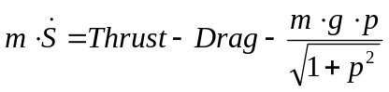 Equation A1.7
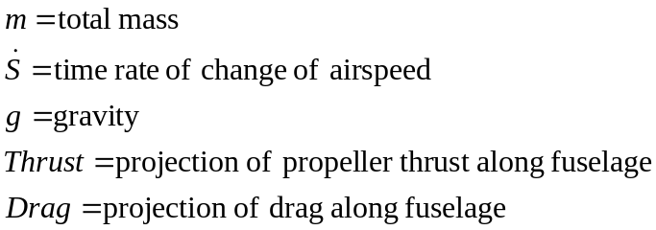
In order to determine how much lift is required in the body frame Z axis, or in other words, the force generated by the wing that is perpendicular to the wing, we need to analyze the acceleration of the plane along the earth vertical axis. This is obtained by multiplying equation A1.7 by the projection factor p/sqrt(1+p*p) from equation A1.2 to obtain:

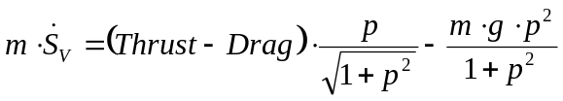 Equation A1.8

Now, mass time the time rate of change of earth vertical speed is equal to the sum of the earth frame vertical forces. There are three forces to consider and project onto the earth frame vertical axis: body frame lift, body frame thrust-drag, and earth frame gravity. In the earth frame, the projection of body frame lift onto the vertical axis is Z times the lift. The projection of thrust-drag is thrust-drag times p/sqrt(1+p*p). Gravity projects purely along the earth vertical axis. This leads to a net force along the earth vertical axis given by:

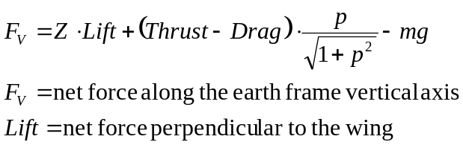 Equation A1.9

Note that lift includes all forces that are perpendicular to the wing in the body frame, including wing forces and elevator forces, and the contribution from the propeller if its axis is not parallel to the fuselage.

Setting equation A1.8 equal to equation A1.9 produces:

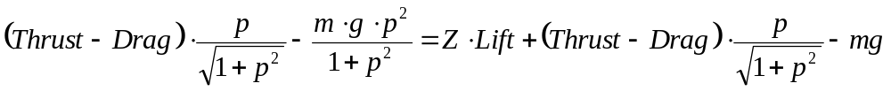 Equation A1.10

Note that the thrust-drag terms are the same on both sides of equation A1.10, so they can be removed, producing:

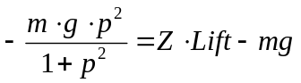 Equation A1.11

Equation A1.11 can be rearranged to:

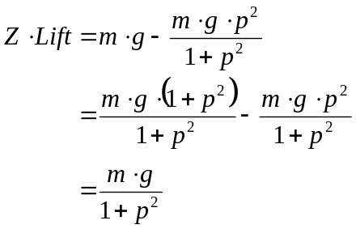 Equation A1.12

The final step is to divide equation A.12 by Z and by m to produce:
It can be shown that the lift and net thrust needed to balance gravity are given by:

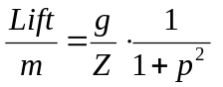 Equation A1.13

Note that we have not made any assumptions regarding thrust and drag.

Appendix 2: Derivation of equation 9

This document summarizes the math leading up to equation 9. It assumed angle of attack is zero, and that the controls perform coordinated turns so side slip is zero. Therefore the velocity vector in the earth frame is the velocity magnitude times the second column of the direction cosine matrix. In other words, the velocity vector is parallel to the body frame y axis. It is not assumed that the acceleration along the earth frame vertical axis is zero. It is not assumed the propeller thrust vector is aligned with the body frame y axis, it may be angled up or down.

For convenience we define the pitch as the ratio of vertical to horizontal velocity, with positive values for ascent:

Equation A2.1

Also note that:

Equation A2.2

Next, denote the actual bottom row of the DCM as follows:

Equation A2.3

Recall that the bottom row of the DCM is the earth frame vertical axis projected into the body frame.

To simplify the math that is to follow, we will rename the three elements of the bottom row of DCM as the scalers X, Y, and Z:

Equation A2.4

Note that the sum of the squares of X, Y and Z is equal to 1.

Y can be computed from p as follows:

Equation A2.5

Similarly, p can be computed from Y:
Equation A2.6

The starting point of the math that produced equation 9 are the following equations:

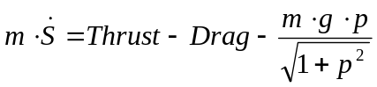 Equation A2.7
Equation A2.8
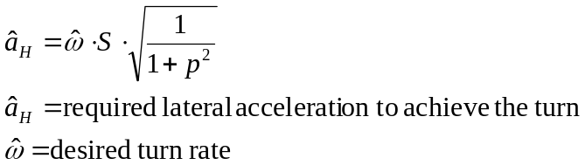 Equation A2.9

It is possible to continue with the most general assumptions of equation A2.7, but to simplify the math, take the time rate of change of the airspeed to be zero. In that case, equation A2.7 becomes:
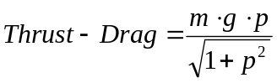 Equation A2.10

Next, recognize that a rotational transformation preserves vector magnitudes. Therefore, the magnitude of the net aerodynamic force vector on the aircraft is the same in both earth and body frame of reference. In the body frame, there are two perpendicular components, lift and drag. In the earth frame, there are two perpendicular components, a horizontal force required to accelerate horizontally, and a vertical force to oppose gravity. Therefore the square of the horizontal earth force must be equal to the sum of the squares of two body frame forces, minus the square of gravity. This produces equation A2.11:

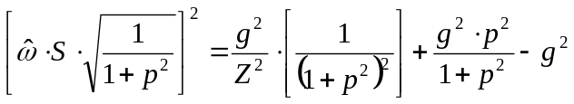 Equation A2.11

Equation A2.11 can be rearranged slightly as:

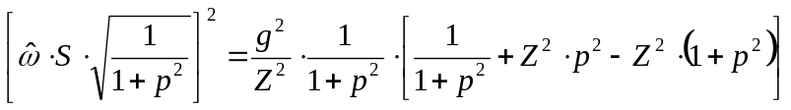Equation A2.12

Equation A2.12 can be simplified a little by canceling two of the terms:

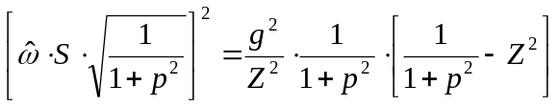 Equation A2.13

Next take advantage of the following identity:

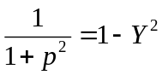 Equation A2.14

Use equation A2.14 to substitute for one of the terms inside the square bracket on the right:

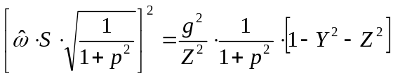 Equation A2.15

Now, it is identically true that:

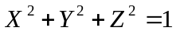 Equation A2.16

Therefore:

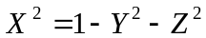 Equation A2.17

Substitute A2.17 into A2.15 to produce:

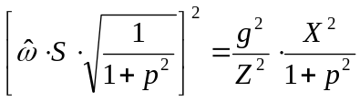 Equation A2.18

Take the square root of both sides, taking care with the sign relationship between X and turning rate, to obtain:
Equation A2.19

