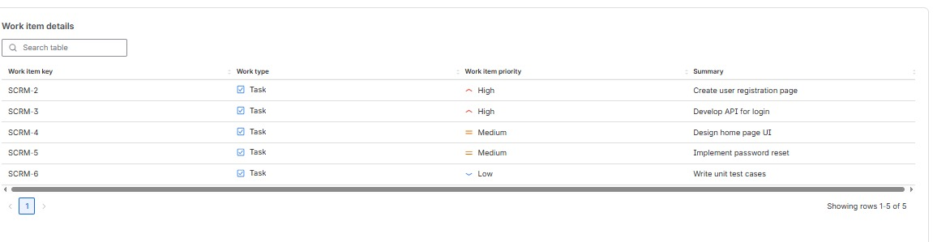
Rosenivitha J 192424009
SCRUM EXP

