ROSENIVITHA J - 192424009

**EXP 10: Write the python program to implement A* algorithm**

**AIM:**

To Write the python program to implement A* algorithm.

**PROGRAM:**

import heapq

def astar(start, goal, grid):

rows, cols = len(grid), len(grid[0])

moves = [(-1,0),(1,0),(0,-1),(0,1)]

pq = [(0 + abs(goal[0]-start[0]) + abs(goal[1]-start[1]), 0, start, [start])]

visited = set()

while pq:

f, g, (x,y), path = heapq.heappop(pq)

if (x,y) in visited:

continue

visited.add((x,y))

if (x,y) == goal:

print("Path:", path)

print("Cost:", g)

return

for dx,dy in moves:

nx, ny = x+dx, y+dy

if 0<=nx<rows and 0<=ny<cols and grid[nx][ny]==0:

heapq.heappush(pq, (g+1 + abs(goal[0]-nx)+abs(goal[1]-ny), g+1, (nx,ny), path+[(nx,ny)]))

# Example grid (0 = free, 1 = obstacle)

grid = [

[0,0,0,0],

[1,1,0,1],

[0,0,0,0],

[0,1,1,0]

]

astar((0,0),(3,3),grid)

OUTPUT:

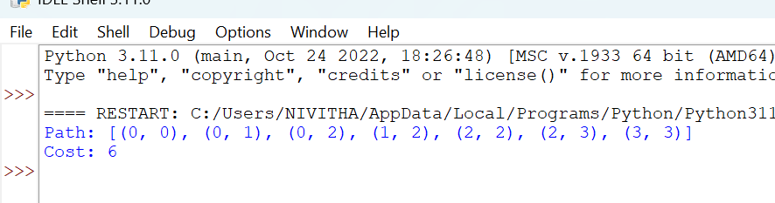

**RESULT:**

Thus, the output is verified for to implement A* algorithm.