ROSENIVITHA J - 192424009

**EXP 11: Write the python program for Map Coloring to implement CSP**

**AIM:**

To Write the python program for Map Coloring to implement CSP.

**PROGRAM:**

def map_coloring(graph, colors, assignment={}):

if len(assignment) == len(graph):

return assignment

node = [n for n in graph if n not in assignment][0]

for color in colors:

if all(assignment.get(neigh) != color for neigh in graph[node]):

assignment[node] = color

result = map_coloring(graph, colors, assignment)

if result:

return result

del assignment[node]

return None

# Example: map of 4 regions

graph = {

'A':['B','C'],

'B':['A','C','D'],

'C':['A','B','D'],

'D':['B','C']

}

colors = ['Red','Green','Blue']

solution = map_coloring(graph, colors)

print("Map Coloring Solution:", solution)

OUTPUT:

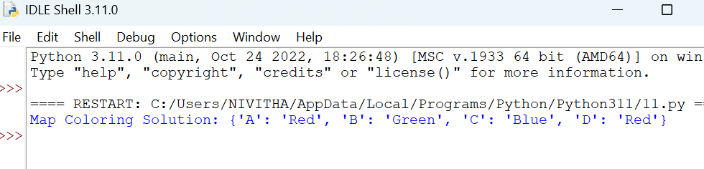

**RESULT:**

Thus, the output is verified for Map Coloring to implement CSP.