ROSENIVITHA J - 192424009

**EXP 12: Write the python program for Tic Tac Toe game**

**AIM:**

To Write the python program for Tic Tac Toe game

**PROGRAM:**

def print_board(board):

for row in board:

print(" | ".join(row))

print()

def check_win(board, player):

for row in board:

if all(s==player for s in row): return True

for col in range(3):

if all(board[row][col]==player for row in range(3)): return True

if all(board[i][i]==player for i in range(3)) or all(board[i][2-i]==player for i in range(3)):

return True

return False

board = [[" "]*3 for _ in range(3)]

moves = [(0,0),(1,1),(0,1),(1,0),(0,2)] # example moves

player = 'X'

for r,c in moves:

board[r][c] = player

if check_win(board, player):

print(f"Player {player} wins!")

break

player = 'O' if player=='X' else 'X'

print_board(board)

OUTPUT:

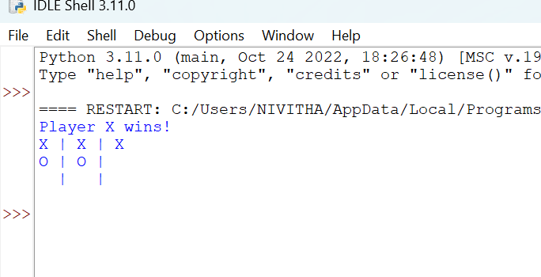

**RESULT:**

Thus, the output is verified for Tic Tac Toe game.