ROSENIVITHA J - 192424009

**EXP 14: Write the python program to implement Apha & Beta pruning algorithm for gaming**

**AIM:**

To Write the python program to implement Apha & Beta pruning algorithm for gaming

**PROGRAM:**

def alphabeta(board, depth, alpha, beta, is_max):

if check_win(board,'X'): return 1

if check_win(board,'O'): return -1

if all(cell != " " for row in board for cell in row): return 0

if is_max:

best = -float('inf')

for i in range(3):

for j in range(3):

if board[i][j]==" ":

board[i][j]="X"

best = max(best, alphabeta(board,depth+1,alpha,beta,False))

board[i][j]=" "

alpha = max(alpha,best)

if beta <= alpha: break

return best

else:

best = float('inf')

for i in range(3):

for j in range(3):

if board[i][j]==" ":

board[i][j]="O"

best = min(best, alphabeta(board,depth+1,alpha,beta,True))

board[i][j]=" "

beta = min(beta,best)

if beta <= alpha: break

return best

# Example usage

board = [["X","O","X"],["O","X"," "],[" "," ","O"]]

print("Best score with Alpha-Beta for X:", alphabeta(board,0,-float('inf'),float('inf'),True))

OUTPUT:

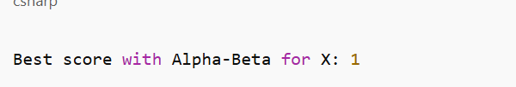

**RESULT:**

Thus, the output is verified to implement Apha & Beta pruning algorithm for gaming.