ROSENIVITHA J - 192424009

**EXP 15: Write the python program to implement Decision Tree**

**AIM:**

To Write the python program to implement Decision Tree

**PROGRAM:**

from sklearn import tree

# Example dataset: [Weather, Temperature] -> Play

# 0=Sunny,1=Rainy ; 0=Hot,1=Cool ; Play: 0=No,1=Yes

X = [[0,0],[0,1],[1,0],[1,1]]

y = [0,1,1,1]

clf = tree.DecisionTreeClassifier()

clf = clf.fit(X,y)

print("Prediction for Sunny & Hot:", clf.predict([[0,0]]))

OUTPUT:

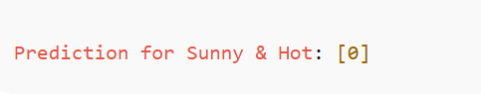

**RESULT:**

Thus, the output is verified to implement Decision Tree.