ROSENIVITHA J - 192424009

**EXP 16: Write the python program to implement Feed forward neural Network**

**AIM:**

To Write the python program to implement Feed forward neural Network.

**PROGRAM:**

import numpy as np

# Sigmoid activation

def sigmoid(x):

return 1/(1+np.exp(-x))

# Derivative of sigmoid

def sigmoid_derivative(x):

return x*(1-x)

# Input dataset

X = np.array([[0,0],[0,1],[1,0],[1,1]])

y = np.array([[0],[1],[1],[0]]) # XOR problem

# Initialize weights randomly

np.random.seed(1)

input_neurons, hidden_neurons, output_neurons = 2, 4, 1

W1 = np.random.rand(input_neurons, hidden_neurons)

W2 = np.random.rand(hidden_neurons, output_neurons)

# Training (feedforward + backprop)

for epoch in range(10000):

hidden_input = np.dot(X, W1)

hidden_output = sigmoid(hidden_input)

final_input = np.dot(hidden_output, W2)

output = sigmoid(final_input)

error = y - output

d_output = error * sigmoid_derivative(output)

d_hidden = d_output.dot(W2.T) * sigmoid_derivative(hidden_output)

W2 += hidden_output.T.dot(d_output)

W1 += X.T.dot(d_hidden)

print("Final Output after training:")

print(output.round(3))

OUTPUT:

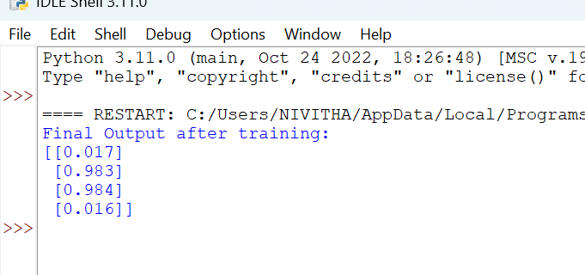

**RESULT:**

Thus, the output is verified Feed forward neural Network.