ROSENIVITHA J - 192424009

**EXP 17: Write a Prolog Program to Sum the Integers from 1 to n.**

**AIM:**

To Write a Prolog Program to Sum the Integers from 1 to n.

**PROGRAM:**

sum(1,1).

sum(N,S) :-

N>1,

N1 is N-1,

sum(N1,S1),

S is S1+N.

OUTPUT:

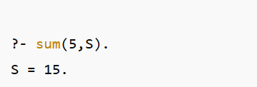

**RESULT:**

Thus, the output is verified Prolog Program to Sum the Integers from 1 to n.