ROSENIVITHA J - 192424009

**EXP 2: Write the python program to solve 8-Queen problem**

**AIM:**

Write the python program to solve 8-Queen problem

**PROGRAM:**

# 8-Queen Problem using Backtracking

N = 8

def print_board(board):

for row in board:

print(" ".join(row))

print("\n")

def is_safe(board, row, col):

# Check column

for i in range(row):

if board[i][col] == 'Q':

return False

# Check left diagonal

i, j = row-1, col-1

while i >= 0 and j >= 0:

if board[i][j] == 'Q':

return False

i -= 1

j -= 1

# Check right diagonal

i, j = row-1, col+1

while i >= 0 and j < N:

if board[i][j] == 'Q':

return False

i -= 1

j += 1

return True

def solve_nqueen(board, row):

if row == N:

print_board(board)

return True

res = False

for col in range(N):

if is_safe(board, row, col):

board[row][col] = 'Q'

res = solve_nqueen(board, row+1) or res

board[row][col] = '.'

return res

board = [['.' for _ in range(N)] for _ in range(N)]

solve_nqueen(board, 0)

OUTPUT:

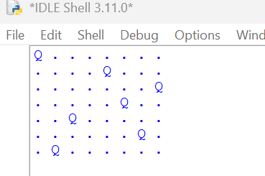

**RESULT:**

Thus, the output is verified for 8-Queen problem.