ROSENIVITHA J - 192424009

**EXP 20: Write a Prolog Program for PLANETS DB.**

**AIM:**

To Write a Prolog Program for PLANETS DB.

**PROGRAM:**

% 20. Prolog Program for Planets DB

planet(mercury, 57, 0.39).

planet(venus, 108, 0.72).

planet(earth, 150, 1.0).

planet(mars, 228, 1.52).

planet(jupiter, 778, 5.20).

planet(saturn, 1427, 9.58).

planet(uranus, 2871, 19.18).

planet(neptune, 4497, 30.07).

% Format: planet(Name, Distance_from_Sun_in_million_km, AU).

**Sample Query:**

?- planet(mars,D,A).

OUTPUT:

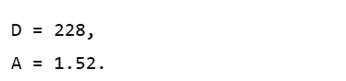

**RESULT:**

Thus, the output is verified Prolog Program PLANETS DB.